UNITED STATES

SECURITIES AND EXCHANGE COMMISSION

Washington, D.C. 20549

_____________

FORM 10-Q

_____________

Quarterly Report Pursuant to Section 13 or 15(d)

of the Securities Exchange Act of 1934

For the quarterly period ended June 30, 2015

Commission File Number 000-23186

_____________

BIOCRYST PHARMACEUTICALS, INC.

(Exact name of registrant as specified in its charter)

_____________

DELAWARE | 62-1413174
(State of other jurisdiction of | (I.R.S. Employer
incorporation or organization) | Identification No.)
4505 Emperor Blvd., Suite 200
Durham, North Carolina | 27703
(Address of principal executive offices) | (Zip Code)
(919) 859-1302
(Registrant’s telephone number, including area code)
_____________

Indicate by check mark whether the registrant (1) has filed all reports required to be filed by Section 13 or 15(d) of the Securities Exchange Act of 1934 during the preceding 12 months (or for such shorter period that the registrant was required to file such reports), and (2) has been subject to such filing requirements for the past 90 days. Yes ☒ No ☐

Indicate by check mark whether the registrant has submitted electronically and posted on its corporate Web site, if any, every Interactive Data File required to be submitted and posted pursuant to Rule 405 of Regulation S-T during the preceding 12 months (or for such shorter period that the registrant was required to submit and post such files). Yes ☒ No ☐

Indicate by check mark whether the registrant is a large accelerated filer, an accelerated filer, or a non- accelerated filer or a smaller reporting company. See the definitions of “large accelerated filer,” “accelerated filer” and “smaller reporting company” in Rule 12b-2 of the Exchange Act.

Large accelerated filer

x

Accelerated filer

☐

Non-accelerated filer

☐

(Do not check if a smaller reporting company)

Smaller reporting company

☐

Indicate by check mark whether the registrant is a shell company (as defined in Rule 12b-2 of the Exchange Act).

Yes

☐

No

☒

The number of shares of Common Stock, par value $0.01, of the Registrant outstanding as of July 31, 2015 was 73,239,379.

BIOCRYST PHARMACEUTICALS, INC.

INDEX

 |  |  |  |  |  |  |  | Part I. Financial Information |  |  |  |  |  | Page No.
Item 1. Financial Statements: |  |  |  |  |  |  |  |  |  |  |  |  |  |  |  | 3
 | Consolidated Balance Sheets — June 30, 2015 and December 31, 2014 |  |  |  |  |  |  |  |  |  |  |  |  |  |  | 3
 | Consolidated Statements of Comprehensive Income (Loss) — Three and Six Months Ended June 30, 2015 and 2014 |  |  |  |  |  |  |  |  |  |  |  |  |  |  | 4
 | Consolidated Statements of Cash Flows — Six Months Ended June 30, 2015 and 2014 |  |  |  |  |  |  |  |  |  |  |  |  |  |  | 5
 | Notes to Consolidated Financial Statements |  |  |  |  |  |  |  |  |  |  |  |  | 6
Item 2. |  | Management’s Discussion and Analysis of Financial Condition and Results of Operations |  |  |  |  |  |  |  |  |  |  |  | 19
Item 3. |  | Quantitative and Qualitative Disclosures About Market Risk |  |  |  |  |  |  |  |  |  |  |  | 31
Item 4. |  | Controls and Procedures |  |  |  |  |  |  |  |  |  |  |  | 32
 |  |  |  |  |  |  |  | Part II. Other Information
Item 1A. Risk Factors |  |  |  |  |  |  |  |  |  |  |  |  |  | 32
Item 6. |  | Exhibits |  |  |  |  |  |  |  |  |  |  |  | 47
Signatures |  |  |  |  |  |  |  |  |  |  |  |  |  | 48
EX-10.1
EX-10.2
EX-10.3
EX-10.4

EX-10.5

EX-10.6

EX-10.7

EX-10.8

EX-31.1

EX-31.2

EX-32.1

EX-32.2

 | PART I. FINANCIAL INFORMATION
Item 1. Financial Statements
 | BIOCRYST PHARMACEUTICALS, INC.
 | CONSOLIDATED BALANCE SHEETS
 | June 30, 2015 and December 31, 2014
 | (In thousands, except per share data)
 |  |  | 2015 |  |  | 2014
 |  |  | (Unaudited) |  |  | (Note 1)
 | Assets
 | Cash and cash equivalents | $ | 76,781 |  | $ | 54,540
 | Restricted cash |  | 1,569 |  |  | 150
 | Investments |  | 17,584 |  |  | 18,232
 | Receivables from collaborations |  | 4,296 |  |  | 3,849
 | Receivables from product sales |  | — |  |  | 5,641
 | Inventory |  | 1,308 |  |  | 683
 | Prepaid expenses and other current assets |  | 5,449 |  |  | 6,172
 | Deferred collaboration expense |  | 101 |  |  | 76
 | Total current assets |  | 107,088 |  |  | 89,343
 | Investments |  | 36,059 |  |  | 41,116
 | Furniture and equipment, net |  | 1,047 |  |  | 207
 | Deferred collaboration expense |  | 288 |  |  | 177
 | Other assets |  | 5,699 |  |  | 6,031
 | Total assets | $ | 150,181 |  | $ | 136,874
 | Liabilities and Stockholders’ Equity
 | Accounts payable | $ | 3,822 |  | $ | 2,849
 | Accrued expenses |  | 19,001 |  |  | 11,329
 | Interest payable |  | 4,450 |  |  | 6,029
 | Deferred collaboration revenue |  | 6,453 |  |  | 1,481
 | Deferred product sales revenue |  | 46 |  |  | 5,605
 | Non-recourse notes payable |  | 30,000 |  |  | 30,000
 | Total current liabilities |  | 63,772 |  |  | 57,293
 | Deferred collaboration revenue |  | 9,959 |  |  | 3,552
 | Deferred rent |  | 361 |  |  | 394
 | Stockholders’ equity:
 | Preferred stock, $0.001 par value; shares authorized — 5,000; no shares issued and outstanding |  | — |  |  | —
 | Common stock, $0.01 par value: shares authorized — 200,000; shares issued and outstanding — 73,168 in 2015
 | and 71,955 in 2014 |  | 732 |  |  | 720
 | Additional paid-in capital |  | 553,610 |  |  | 542,943
 | Accumulated other comprehensive loss |  | (92) |  |  | (130)
 | Accumulated deficit |  | (478,161) |  |  | (467,898)
 | Total stockholders’ equity |  | 76,089 |  |  | 75,635
 | Total liabilities and stockholders’ equity | $ | 150,181 |  | $ | 136,874
 | See accompanying notes to consolidated financial statements.
3

BIOCRYST PHARMACEUTICALS, INC.

CONSOLIDATED STATEMENTS OF COMPREHENSIVE INCOME (LOSS)

Periods Ended June 30, 2015 and 2014

(In thousands, except per share data-Unaudited)

 |  |  | Three Months |  |  |  |  |  | Six Months
 | 2015 |  |  |  |  | 2014 |  |  | 2015 |  |  | 2014
Revenues
Product sales, net | $ |  | — | $ |  | — |  | $ | 537 |  | $ | —
Royalty revenue |  |  | 132 |  |  | 125 |  |  | 1,650 |  |  | 1,946
Collaborative and other research and development |  |  | 25,710 |  |  | 1,341 |  |  | 30,481 |  |  | 2,978
Total revenues |  |  | 25,842 |  |  | 1,466 |  |  | 32,668 |  |  | 4,924
Expenses
Cost of products sold |  |  | — |  |  | — |  |  | 15 |  |  | —
Research and development |  |  | 16,524 |  |  | 11,067 |  |  | 33,644 |  |  | 20,250
General and administrative |  |  | 3,534 |  |  | 2,013 |  |  | 7,595 |  |  | 3,601
Royalty |  |  | 442 |  |  | 5 |  |  | 502 |  |  | 78
Total operating expenses |  |  | 20,500 |  |  | 13,085 |  |  | 41,756 |  |  | 23,929
Income (loss) from operations |  |  | 5,342 |  |  | (11,619) |  |  | (9,088) |  |  | (19,005)
Interest and other income |  |  | 116 |  |  | 19 |  |  | 233 |  |  | 36
Interest expense |  |  | (1,306) |  |  | (1,225) |  |  | (2,621) |  |  | (2,467)
Gain (loss) on foreign currency derivative |  |  | 749 |  |  | (1,824) |  |  | 1,213 |  |  | (3,350)
Net income (loss) | $ |  | 4,901 | $ |  | (14,649) |  | $ | (10,263) |  | $ | (24,786)
Basic net income (loss) per common share |  | $ | 0.07 |  | $ | (0.23) |  | $ | (0.14) |  | $ | (0.40)
Diluted net income (loss) per common share
Diluted net income (loss) per common share |  | $ | 0.06 |  | $ | (0.23) |  | $ | (0.14) |  | $ | (0.40)
Weighted average shares outstanding, basic |  |  | 72,642 |  |  | 63,647 |  |  | 72,492 |  |  | 61,629
Weighted average shares outstanding, diluted |  |  | 76,760 |  |  | 63,647 |  |  | 72,492 |  |  | 61,629
Unrealized gain (loss) on available for sale investments |  |  | (102) |  |  | 1 |  |  | 38 |  |  | (1)
Comprehensive income (loss) | $ |  | 4,799 | $ |  | (14,648) |  | $ | (10,225) |  | $ | (24,787)

See accompanying notes to consolidated financial statements.

4

BIOCRYST PHARMACEUTICALS, INC.

CONSOLIDATED STATEMENTS OF CASH FLOWS

Six Months Ended June 30, 2015 and 2014

(In thousands-Unaudited)

 |  | 2015 |  |  | 2014
Operating activities
Net loss | $ | (10,263) |  | $ | (24,786)
Adjustments to reconcile net loss to net cash provided by (used in) operating activities:
Depreciation and amortization |  | 94 |  |  | 97
Stock-based compensation expense |  | 5,934 |  |  | 5,129
Amortization of debt issuance costs |  | 220 |  |  | 220
Change in fair value of foreign currency derivative |  | 332 |  |  | 3,350
Changes in operating assets and liabilities:
Receivables |  | 5,194 |  |  | 1,218
Inventory |  | (625) |  |  | —
Prepaid expenses and other assets |  | 769 |  |  | (408)
Deferred collaboration expense |  | (136) |  |  | 30
Accounts payable and accrued expenses |  | 8,612 |  |  | (247)
Interest payable |  | (1,579) |  |  | (81)
Deferred revenue |  | 5,820 |  |  | (583)

 | Net cash provided by (used in) operating activities | 14,372 |  | (16,061)
 | Investing activities
 | Acquisitions of furniture and equipment | (934) |  | (7)
 | Change in restricted cash | (1,419) |  | 1
 | Purchases of investments | (19,407) |  | (12,651)
 | Sales and maturities of investments | 24,884 |  | 20,900

 | Net cash provided by investing activities |  |  | 3,124 |  |  | 8,243
 | Financing activities
 | Sale of common stock, net |  |  | 1,175 |  |  | 106,600
 | Exercise of stock options |  |  | 3,399 |  |  | 4,145
 | Employee stock purchase plan sales |  |  | 171 |  |  | 128
 | Payment of foreign currency derivative collateral |  |  | — |  |  | (2,700)
 | Net cash provided by financing activities |  |  | 4,745 |  |  | 108,173
 | Increase in cash and cash equivalents |  |  | 22,241 |  |  | 100,355
 | Cash and cash equivalents at beginning of period |  |  | 54,540 |  |  | 21,164
 | Cash and cash equivalents at end of period | $ |  | 76,781 |  | $ | 121,519
 |  | See accompanying notes to consolidated financial statements.
 |  | 5

BIOCRYST PHARMACEUTICALS, INC.

NOTES TO CONSOLIDATED FINANCIAL STATEMENTS (Unaudited)

(In thousands, except per share amounts)

Note 1 — Significant Accounting Policies

The Company

BioCryst Pharmaceuticals, Inc. (the “Company”) is a biotechnology company that designs, optimizes and develops novel small molecule drugs that block key enzymes involved in the pathogenesis of diseases. The Company focuses on the treatment of rare diseases in which significant unmet medical needs exist and align with its capabilities and expertise. The Company was incorporated in Delaware in 1986 and its headquarters is located in Durham, North Carolina. The Company integrates the disciplines of biology, crystallography, medicinal chemistry and computer modeling to discover and develop small molecule pharmaceuticals through the process known as structure-guided drug design. BioCryst has incurred losses and negative cash flows from operations since inception.

Based on its current operating plans, the Company expects it has sufficient liquidity, with its existing cash and investments of $131,993, to continue its planned operations into 2017. The Company’s liquidity needs, and ability to address those needs, will largely be determined by the success of its product candidates and key development and regulatory events in the future. In order to continue its operations substantially beyond 2017 it will need to: (1) successfully secure or increase U.S. Government funding of its programs, including procurement contracts; (2) out-license rights to certain of its products or product candidates, pursuant to which the Company would receive cash milestones; (3) raise additional capital through equity or debt financings or from other sources; (4) obtain additional product candidate regulatory approvals, which would generate revenue and cash flow; (5) reduce spending on one or more research and development programs; and/or (6) restructure operations. The Company retains the ability to offer for sale approximately $150,000 of securities, including common stock, preferred stock, depositary shares, stock purchase contracts, warrants, and units from its effective shelf S-3 registration statement, which it filed with the Securities and Exchange Commission on March 3, 2015. Additionally, the Company retains the ability to offer for sale approximately $10,000 of securities, including common stock, preferred stock, depositary shares, stock purchase contracts, warrants and units from its effective shelf S-3 registration statement, which it filed with the Securities and Exchange Commission on November 6, 2013. The Company will continue to incur operating losses and negative cash flows until revenues reach a level sufficient to support ongoing operations.

Basis of Presentation

The consolidated financial statements include the accounts of the Company and its wholly-owned subsidiary, JPR Royalty Sub LLC (“Royalty Sub”). Royalty Sub was formed in connection with a $30,000 financing transaction the Company completed on March 9, 2011. See Note 4, Royalty Monetization, for a further description of this transaction. All intercompany transactions and balances have been eliminated.

The Company’s consolidated financial statements have been prepared in accordance with accounting principles generally accepted in the United States (“U.S. GAAP”) for interim financial reporting and the instructions to Form 10-Q and do not include all of the information and footnotes required by U.S. GAAP for complete financial statements. Such financial statements reflect all adjustments that are, in management’s opinion, necessary to present fairly, in all material respects, the Company’s consolidated financial position, results of operations, and cash flows. There were no adjustments other than normal recurring adjustments.

These financial statements should be read in conjunction with the financial statements for the year ended December 31, 2014 and the notes thereto included in the Company’s 2014 Annual Report on Form 10-K. Interim operating results are not necessarily indicative of operating results for the full year. The balance sheet as of December 31, 2014 has been derived from the audited consolidated financial statements included in the Company’s most recent Annual Report on Form 10-K.

Reclassifications

Certain balance sheet amounts as of December 31, 2014 have been reclassified to conform to the 2015 presentation.

Cash and Cash Equivalents

The Company generally considers cash equivalents to be all cash held in commercial checking accounts, certificates of deposit, money market accounts or investments in debt instruments with maturities of three months or less at the time of purchase. The carrying value of cash and cash equivalents approximates fair value due to the short-term nature of these items.

6

Restricted Cash

Restricted cash as of June 30, 2015 reflects $150 the Company is required to maintain in an interest bearing certificate of deposit to serve as collateral for a corporate credit card program, $18 in royalty revenue paid by Shionogi & Co., Ltd. (“Shionogi”) designated for interest on the PhaRMA Notes (defined in Note 4) and $1,401 the Company is required to maintain as collateral for a letter of credit associated with the lease execution and build-out of its new Birmingham research facilities.

Investments

The Company invests in high credit quality investments in accordance with its investment policy, which is designed to minimize the possibility of loss. The objective of the Company’s investment policy is to ensure the safety and preservation of invested funds, as well as maintaining liquidity sufficient to meet cash flow requirements. The Company places its excess cash with high credit quality financial institutions, commercial companies, and government agencies in order to limit the amount of its credit exposure. In accordance with its policy, the Company is able to invest in marketable debt securities that may consist of U.S. Government and government agency securities, money market and mutual fund investments, municipal and corporate notes and bonds, commercial paper and asset or mortgage-backed securities, among others. The Company’s investment policy requires it to purchase high-quality marketable securities with a maximum individual maturity of three years and requires an average portfolio maturity of no more than 18 months. Some of the securities the Company invests in may have market risk. This means that a change in prevailing interest rates may cause the principal amount of the investment to fluctuate. To minimize this risk, the Company schedules its investments with maturities that coincide with expected cash flow needs, thus avoiding the need to redeem an investment prior to its maturity date. Accordingly, the Company does not believe it has a material exposure to interest rate risk arising from its investments. Generally, the Company’s investments are not collateralized. The Company has not realized any significant losses from its investments.

The Company classifies all of its investments as available-for-sale. Unrealized gains and losses on investments are recognized in comprehensive loss, unless an unrealized loss is considered to be other than temporary, in which case the unrealized loss is charged to operations. The Company periodically reviews its investments for other than temporary declines in fair value below cost basis and whenever events or changes in circumstances indicate that the carrying amount of an asset may not be recoverable. The Company believes the individual unrealized losses represent temporary declines primarily resulting from interest rate changes. Realized gains and losses are reflected in interest and other income in the Consolidated Statements of Comprehensive Income (Loss) and are determined using the specific identification method with transactions recorded on a settlement date basis. Investments with original maturities at date of purchase beyond three months and which mature at or less than 12 months from the balance sheet date are classified as current. Investments with a maturity beyond 12 months from the balance sheet date are classified as long-term. At June 30, 2015, the Company believes that the costs of its investments are recoverable in all material respects.

The following tables summarize the fair value of the Company’s investments by type. The estimated fair value of the Company’s fixed income investments are classified as Level 2 in the fair value hierarchy as defined in U.S. GAAP. These valuations are based on observable direct and indirect inputs, primarily quoted prices of similar, but not identical, instruments in active markets or quoted prices for identical or similar instruments in markets that are not active. These fair values are obtained from independent pricing services which utilize Level 2 inputs.

 |  |  |  |  |  |  |  |  | June 30, 2015
 |  |  |  |  |  |  |  |  | Gross |  |  | Gross
 |  |  | Amortized |  |  | Accrued |  |  | Unrealized |  |  | Unrealized |  |  | Estimated
 |  |  | Cost |  |  | Interest |  |  | Gains |  |  | Losses |  |  | Fair Value
 | Obligations of U.S. Government and its agencies | $ | 9,649 |  | $ | 16 |  | $ | 2 |  | $ | (6) |  | $ | 9,661
 | Corporate debt securities |  | 28,830 |  |  | 197 |  |  | 14 |  |  | (34) |  |  | 29,007
 | Certificates of deposit |  | 15,030 |  |  | 13 |  |  | 3 |  |  | (71) |  |  | 14,975
 | Total investments | $ | 53,509 |  | $ | 226 | $ |  | 19 | $ |  | (111) | $ |  | 53,643
 |  |  |  |  | 7

 |  |  |  |  |  |  |  | December 31, 2014
 |  |  |  |  |  |  |  |  | Gross |  |  | Gross
 |  |  | Amortized |  |  | Accrued |  |  | Unrealized |  |  | Unrealized |  |  | Estimated
 |  |  | Cost |  |  | Interest |  |  | Gains |  |  | Losses |  |  | Fair Value
 | Obligations of U.S. Government and its agencies | $ | 20,307 |  | $ | 22 |  | $ | — |  | $ | (23) |  | $ | 20,306
 | Corporate debt securities |  | 27,152 |  |  | 151 |  |  | 5 |  |  | (47) |  |  | 27,261
 | Certificates of deposit |  | 11,838 |  |  | 6 |  |  | — |  |  | (63) |  |  | 11,781
 | Total investments | $ | 59,297 |  | $ | 179 | $ |  | 5 | $ |  | (133) | $ |  | 59,348
 | The following table summarizes the scheduled maturity for the Company’s investments at June 30, 2015 and December 31, 2014.
 |  |  |  |  |  |  |  |  |  |  |  | 2015 |  |  | 2014
 | Maturing in one year or less |  |  |  |  |  |  |  |  |  | $ | 17,584 |  | $ | 18,232
 | Maturing after one year through two years |  |  |  |  |  |  |  |  |  |  | 23,012 |  |  | 25,459
 | Maturing after two years |  |  |  |  |  |  |  |  |  |  | 13,047 |  |  | 15,657
 | Total investments |  |  |  |  |  |  |  |  | $ |  | 53,643 | $ |  | 59,348

Receivables from Collaborations

Receivables from collaborations are recorded for amounts due to the Company related to reimbursable research and development costs from the U.S. Department of Health and Human Services or royalty receivables from Shionogi & Co. Ltd. These receivables are evaluated to determine if any reserve or allowance should be established at each reporting date. At June 30, 2015 and December 31, 2014, the Company had the following receivables.

 |  |  |  |  |  | June 30, 2015
 |  |  | Billed |  |  | Unbilled |  |  | Total
U.S. Department of Health and Human Services |  | $ | 2,258 |  | $ | 2,011 |  | $ | 4,269
Shionogi & Co. Ltd. |  |  | 27 |  |  | — |  |  | 27
Total receivables | $ |  | 2,285 | $ |  | 2,011 | $ |  | 4,296

 |  |  |  |  |  | December 31, 2014
 |  |  |  | Billed |  |  | Unbilled |  |  |  | Total
 | U.S. Department of Health and Human Services |  | $ | — |  | $ | 2,778 |  |  | $ | 2,778
 | Shionogi & Co. Ltd. |  |  | 1,071 |  |  | — |  |  |  | 1,071
 | Total receivables | $ |  | 1,071 | $ |  | 2,778 |  | $ |  | 3,849

Monthly invoices are submitted to the U.S. Department of Health and Human Services related to reimbursable research and development costs. The Company is also entitled to monthly reimbursement of indirect costs based on rates stipulated in the underlying contract. The Company’s calculations of its indirect cost rates are subject to audit by the U.S. Government.

Receivables from Product Sales

Receivables from product sales are recorded for amounts due to the Company related to sales of RAPIVAB®. These receivables are evaluated to determine if any reserve or allowance should be established at each reporting date.

8

Inventory

At June 30, 2015 and December 31, 2014, the Company’s inventory consisted of RAPIVAB finished goods inventory and work in process. Inventory is stated at the lower of cost, determined under the first-in, first-out (“FIFO”) method, or market. The Company expenses costs related to the production of inventories as research and development expenses in the period incurred until such time it is believed that future economic benefit is expected to be recognized, which generally is reliant upon receipt of regulatory approval. Upon regulatory approval, the Company will capitalize subsequent costs related to the production of inventories.

During 2014, in connection with the Food and Drug Administration (“FDA”) approval of RAPIVAB, the Company began capitalizing costs associated with the production of RAPIVAB commercial inventories.

 | The Company’s inventory consisted of the following at June 30, 2015 and December 31, 2014:
 |  | 2015 |  |  |  |  | 2014
 | Work in process |  | $ | — |  | $ | 267
 | Finished Goods |  |  | 1,308 |  |  | 416
 | Net inventories | $ |  | 1,308 | $ |  | 683
 | Patents and Licenses

The Company seeks patent protection on all internally developed processes and products. All patent related costs are expensed to general and administrative expenses when incurred as recoverability of such expenditures is uncertain.

Accrued Expenses

The Company generally enters into contractual agreements with third-party vendors who provide research and development, manufacturing, and other services in the ordinary course of business. Some of these contracts are subject to milestone-based invoicing and services are completed over an extended period of time. The Company records liabilities under these contractual commitments when it determines an obligation has been incurred, regardless of the timing of the invoice. This process involves reviewing open contracts and purchase orders, communicating with applicable Company personnel to identify services that have been performed on its behalf and estimating the level of service performed and the associated cost incurred for the service when the Company has not yet been invoiced or otherwise notified of actual cost. The majority of service providers invoice the Company monthly in arrears for services performed. The Company makes estimates of accrued expenses as of each balance sheet date in its financial statements based on the facts and circumstances. The Company periodically confirms the accuracy of its estimates with the service providers and makes adjustments if necessary. Examples of estimated accrued expenses include:

- fees paid to Clinical Research Organizations (“CROs”) in connection with preclinical and toxicology studies and clinical trials;

- fees paid to investigative sites in connection with clinical trials;

- fees paid to contract manufacturers in connection with the production of our raw materials, drug substance and drug products; and

- professional fees.

The Company bases its expenses related to clinical trials on its estimates of the services received and efforts expended pursuant to contracts with multiple research institutions and CROs that conduct and manage clinical trials on the Company’s behalf. The financial terms of these agreements are subject to negotiation, vary from contract to contract and may result in uneven payment flows. Payments under some of these contracts depend on factors such as the successful enrollment of patients and the completion of clinical trial milestones. In accruing service fees, the Company estimates the time period over which services will be performed and the level of effort expended in each period. If the actual timing of the performance of services or the level of effort varies from the estimate, the Company will adjust the accrual accordingly. As of June 30, 2015 and December 31, 2014, the carrying value of accrued expenses approximates their fair value due to their short-term settlement.

Income Taxes

The liability method is used in the Company’s accounting for income taxes. Under this method, deferred tax assets and liabilities are determined based on differences between financial reporting and tax bases of assets and liabilities and are measured using the enacted tax rates and laws that are expected to be in effect when the differences are expected to reverse.

9

Accumulated Other Comprehensive Income (Loss)

Accumulated other comprehensive income (loss) is comprised of unrealized gains and losses on investments available-for-sale and is disclosed as a separate component of stockholders’ equity. Amounts reclassified from accumulated other comprehensive income (loss) are recorded as interest and other income on the Consolidated Statements of Comprehensive Income (Loss). During the six months ended June 30, 2015, realized gains of $12 were reclassified out of accumulated other comprehensive income (loss). No reclassifications out of accumulated other comprehensive income (loss) were recorded during the six months ended June 30, 2014.

Revenue Recognition

The Company recognizes revenues from collaborative and other research and development arrangements, royalties and product sales when realized or realizable and earned. Revenue is realized or realizable and earned when all of the following criteria are met: (i) persuasive evidence of an arrangement exists; (ii) delivery has occurred or services have been rendered; (iii) the seller’s price to the buyer is fixed or determinable; and (iv) collectability is reasonably assured.

Collaborative and Other Research and Development Arrangements and Royalties

Revenue from license fees, royalty payments, event payments, and research and development fees are recognized as revenue when the earnings process is complete and the Company has no further continuing performance obligations or the Company has completed the performance obligations under the terms of the agreement. Fees received under licensing agreements that are related to future performance are deferred and recognized over an estimated period determined by management based on the terms of the agreement and the products licensed. Revisions to revenue or profit estimates as a result of changes in the estimated revenue period are recognized prospectively.

Under certain of the Company’s license agreements, the Company receives royalty payments based upon its licensees’ net sales of covered products. The Company recognizes royalty revenues when it can reliably estimate such amounts and collectability is reasonably assured.

For arrangements that involve the delivery of more than one element, each product, service and/or right to use assets is evaluated to determine whether it qualifies as a separate unit of accounting. This determination is based on whether the deliverable has “stand-alone value” to the customer. The consideration that is fixed or determinable is then allocated to each separate unit of accounting based on the relative selling price of each deliverable. The estimated selling price of each deliverable is determined using the following hierarchy of values: (i) vendor-specific objective evidence of fair value, (ii) third-party evidence of selling price (“TPE”) and (iii) best estimate of selling price (“BESP”). The BESP reflects our best estimate of what the selling price would be if the deliverable was regularly sold by the Company on a stand-alone basis. In most cases the Company expects to use TPE or BESP for allocating consideration to each deliverable. The consideration allocated to each unit of accounting is recognized as the related goods or services are delivered, limited to the consideration that is not contingent upon future deliverables. Analyzing the arrangement to identify deliverables requires the use of judgment, and each deliverable may be an obligation to deliver services, a right or license to use an asset, or another performance obligation.

In June 2015, the Company entered into a License Agreement (the “Agreement”) granting CSL Limited (“CSL”) and its affiliates worldwide rights, excluding

Israel, Japan, Korea and Taiwan, to develop, manufacture and commercialize RAPIVAB. The Agreement provides for various types of payments, including a non-

refundable upfront fee, milestone payments, and future royalties. Analysis of the Agreement identified three deliverables: (i) license rights, (ii) inventory and (iii)

regulatory support to obtain Canadian and European Union (“EU”) marketing approvals. The Company received an upfront payment of $33,740 from CSL of which

$7,000 was determined to be contingent upon EU marketing approval and will be deferred until that time. Approximately $21,777 of the upfront payment was allocated

to the license rights and recognized as revenue in the current quarter. Approximately $3,740 of the upfront payment was allocated to the pending sale of inventory and

was deferred. This deferred revenue will be recognized when the inventory transfer is complete. Approximately $1,223 of this revenue will be recognized over the

expected period of involvement in these regulatory support activities.

Milestone payments are recognized as licensing revenue upon the achievement of specified milestones if (i) the milestone is substantive in nature and the achievement of the milestone was not reasonably assured at the inception of the agreement; and (ii) the fees are non-refundable. Any milestone payments received prior to satisfying these revenue recognition criteria are recorded as deferred revenue.

Under the terms of the Agreement, the Company may receive up to $12,000 in additional payments related to the successful achievement of regulatory milestones, including marketing approval (i) by the FDA for a pediatric indication, (ii) by the EMA for an adult indication in the European Union and (iii) by Health Canada for an adult indication in Canada. The Company evaluated each event based payment under the provisions of ASU 2010-17, Milestone Method of Revenue Recognition, and determined that each event based payment met the criteria to be considered substantive and represents a milestone under the milestone method of accounting. No event based payments were achieved during the periods presented.

Reimbursements received for direct out-of-pocket expenses related to research and development costs are recorded as revenue in the Consolidated Statements of Comprehensive Income (Loss) rather than as a reduction in expenses. Under the Company’s contracts with the Biomedical Advanced Research and Development Authority within the United States Department of Health and Human Services (”BARDA/HHS”) and the National Institute of Allergy and Infectious Diseases (“NIAID/HHS”), revenue is recognized as reimbursable direct and indirect costs are incurred.

10

Product Sales

The Company recognizes revenue for sales of RAPIVAB when title and substantially all the risks and rewards of ownership have transferred to the customer, which generally occurs on the date of shipment from our specialty distributors, utilizing the Sell-Through revenue recognition methodology. Product sales are recognized when there is persuasive evidence that an arrangement exists, title has passed, the price is fixed and determinable, and collectability is reasonably assured. Product sales are recognized net of estimated allowances, discounts, sales returns, chargebacks and rebates. In the United States, the Company sells RAPIVAB to specialty distributors, who in turn, sell to physician offices, hospitals and federal, state and commercial health care organizations. With the completion of the CSL worldwide license of RAPIVAB, CSL will be primarily responsible for sales of RAPIVAB other than U.S. Government stockpiling sales and the Company’s commercial sales will be minimal.

Sales deductions consist of statutory rebates to state Medicaid, Medicare and other government agencies and sales discounts (including trade discounts and distribution service fees). These deductions are recorded as reductions from revenue from RAPIVAB in the same period as the related sales with estimates of future utilization derived from historical experience adjusted to reflect known changes in the factors that impact such reserves.

The Company utilizes data from external sources to help it estimate gross-to-net sales adjustments as they relate to the recognition of revenue for RAPIVAB sold. Externally sourced data includes, but is not limited to, information obtained from specialty distributors with respect to their inventory levels and their sell-through to customers, as well as information from third-party suppliers of market research data to the pharmaceutical industry.

The Company accounts for these sales deductions in accordance with authoritative guidance on revenue recognition when consideration is given by a vendor to a customer.

The Company has categorized and described more fully the following significant sales deductions, all of which involve estimates and judgments, which the Company considers to be critical accounting estimates, and require it to use information from external sources.

Rebates and Chargebacks

Statutory rebates to state Medicaid agencies and Medicare are based on statutory discounts to RAPIVAB’s selling price. As it can take up to nine months or more for information to be received on actual usage of RAPIVAB in Medicaid and other governmental programs, the Company maintains reserves for amounts payable under these programs relating to RAPIVAB sales.

Chargebacks claimed by specialty distributors are based on the differentials between product acquisition prices paid by the specialty distributors and lower government contract pricing paid by eligible customers covered under federally qualified programs.

The amount of the reserve for rebates and chargebacks is based on multiple qualitative and quantitative factors, including the historical and projected utilization levels, historical payment experience, changes in statutory laws and interpretations as well as contractual terms, product pricing (both normal selling prices and statutory or negotiated prices), changes in prescription demand patterns and utilization of the Company’s product through public benefit plans, and the levels of RAPIVAB inventory in the distribution channel. The Company acquires prescription utilization data from third-party suppliers of market research data to the pharmaceutical industry. The Company updates its estimates and assumptions each period and records any necessary adjustments to its reserves. Settlements of rebates and chargebacks typically occur within nine months from point of sale. To the extent actual rebates and chargebacks differ from the Company’s estimates, additional reserves may be required or reserves may need to be reversed, either of which would impact current period product revenue.

Discounts and Sales Incentives

Discounts and other sales incentives primarily consist of Inventory Management Agreement (“IMA”) Fees. Per contractual agreements with the Company’s specialty distributors, the Company provides an IMA fee based on a percentage of their purchases of RAPIVAB. The IMA fee rates are set forth in individual contracts. The Company tracks sales to these distributors each period and accrues a liability relating to the unpaid portion of these fees by applying the contractual rates to such product sales.

Product Returns

The Company does not record a product return allowance as it does not offer the ability to return goods once a bonafide shipment has been accepted by a specialty distributor.

Advertising

The Company engages in very limited distribution and direct-response advertising when promoting RAPIVAB.

11

The Company recorded the following revenues for the three and six months ended June 30, 2015 and 2014:

 |  |  | Three Months |  |  |  |  |  | Six Months
 |  |  | 2015 |  |  | 2014 |  |  | 2015 |  |  | 2014
 | Product sales, net | $ | — |  | $ | — |  | $ | 537 |  | $ | —
 | Royalty revenue |  | 132 |  |  | 125 |  |  | 1,650 |  |  | 1,946
 | Collaborative and other research and development revenues:
 | U.S. Department of Health and Human Services |  | 3,731 |  |  | 1,045 |  |  | 8,206 |  |  | 2,386
 | Shionogi (Japan) |  | 296 |  |  | 296 |  |  | 592 |  |  | 592
 | CSL Limited |  | 21,683 |  |  | — |  |  | 21,683 |  |  | —
 | Total collaborative and other research and development revenues |  | 25,710 |  |  | 1,341 |  |  | 30,481 |  |  | 2,978
 | Total revenues | $ | 25,842 | $ |  | 1,466 | $ |  | 32,668 | $ |  | 4,924
 | Research and Development Expenses

The Company’s research and development costs are charged to expense when incurred. Research and development expenses include all direct and indirect development costs related to the development of the Company’s portfolio of product candidates. Advance payments for goods or services that will be used or rendered for future research and development activities are deferred and capitalized. Such amounts are recognized as expense when the related goods are delivered or the related services are performed. Research and development expenses include, among other items, personnel costs, including salaries and benefits, manufacturing costs, clinical, regulatory, and toxicology services performed by CROs, materials and supplies, and overhead allocations consisting of various administrative and facilities related costs. Most of the Company’s manufacturing and clinical and preclinical studies are performed by third-party CROs. Costs for studies performed by CROs are accrued by the Company over the service periods specified in the contracts and estimates are adjusted, if required, based upon the Company’s on-going review of the level of services actually performed.

Additionally, the Company has license agreements with third parties, such as Albert Einstein College of Medicine of Yeshiva University (“AECOM”), Industrial Research, Ltd. (“IRL”), and the University of Alabama at Birmingham (“UAB”), which require fees related to sublicense agreements or maintenance fees. The Company expenses sublicense payments as incurred unless they are related to revenues that have been deferred, in which case the expenses are deferred and recognized over the related revenue recognition period. The Company expenses maintenance payments as incurred.

Deferred collaboration expenses represent sub-license payments, paid to the Company’s academic partners upon receipt of consideration from various commercial partners, and other consideration paid to our academic partners for modification to existing license agreements. These deferred expenses would not have been incurred without receipt of such payments or modifications from the Company’s commercial partners and are being expensed in proportion to the related revenue being recognized. The Company believes that this accounting treatment appropriately matches expenses with the associated revenue.

Stock-Based Compensation

All share-based payments, including grants of stock option awards and restricted stock unit awards, are recognized in the Company’s Consolidated Statements of Comprehensive Income (Loss) based on their fair values. The fair value of stock option awards is estimated using the Black-Scholes option pricing model. The fair value of restricted stock unit awards is based on the grant date closing price of the common stock. Stock-based compensation cost is recognized as expense on a straight-line basis over the requisite service period of the award. In addition, we have outstanding performance-based stock options for which no compensation expense is recognized until “performance” has occurred.

Interest Expense and Deferred Financing Costs

Interest expense for the three months ended June 30, 2015 and 2014 was $1,306 and $1,225, respectively, and for the six months ended June 30, 2015 and 2014 was $2,621 and $2,467, respectively, and relates to the issuance of the PhaRMA Notes (defined in Note 4). Costs directly associated with the issuance of the PhaRMA Notes have been capitalized and are included in other current assets on the Consolidated Balance Sheets. These costs are being amortized to interest expense over the term of the PhaRMA Notes using the effective interest rate method. Amortization of deferred financing costs included in interest expense was $110 for each of the three months ended June 30, 2015 and 2014, and $220 for each of the six months ended June 30, 2015 and 2014.

12

Currency Hedge Agreement

In connection with the issuance by Royalty Sub of the PhaRMA Notes, the Company entered into a Currency Hedge Agreement (defined in Note 4) to hedge certain risks associated with changes in the value of the Japanese yen relative to the U.S. dollar. The Currency Hedge Agreement does not qualify for hedge accounting treatment; therefore, mark-to-market adjustments are recognized in the Company’s Consolidated Statements of Comprehensive Income (Loss). Cumulative mark-to-market adjustments for the six months ended June 30, 2015 and 2014 resulted in losses of $332 and $3,350, respectively. Mark-to-market adjustments are determined by a third party pricing model that uses quoted prices in markets that are not actively traded and for which significant inputs are observable directly or indirectly, representing Level 2 in the fair value hierarchy as defined by U.S. GAAP. In addition, the Company realized a currency exchange gain of $1,545 during the first six months of 2015 associated with the exercise of a U.S. Dollar/Japanese yen currency option.

The Company is also required to post collateral in connection with the mark-to-market adjustments based on thresholds defined in the Currency Hedge Agreement. As of June 30, 2015 and December 31, 2014, no hedge collateral was posted under the agreement.

Net Income (Loss) Per Share

Net income (loss) per share is based upon the weighted average number of common shares outstanding during the period. Diluted income (loss) per share is equivalent to basic net income (loss) per share for all periods presented herein, except for the three months ended June 30, 2015 for which diluted income per share is $0.06 and basic income per share is $0.07 per share.

A reconciliation of the weighted average number of shares outstanding used in calculating diluted earnings per share is as follows:

 |  | Three Months Ended |  |  |  |  | Six Months Ended
 |  | June 30, |  |  |  |  | June 30,
 |  | 2015 |  |  | 2014 |  | 2015 |  |  | 2014
 | Weighted average shares outstanding, basic | 72,642 |  |  | 63,647 |  | 72,492 |  |  | 61,629
 | Weighted average dilutive stock options and restricted stock units | 4,118 |  |  | - |  | - |  |  | -
 | Weighted average shares outstanding, diluted | 76,760 |  |  | 63,647 |  | 72,492 |  |  | 61,629

The calculation of diluted earnings per share for the three months ended June 30, 2014 does not include 3,688 of such potential common shares, as their impact would be anti-dilutive. The calculation of diluted earnings per share for the six months ended June 30, 2015 and 2014 does not include 4,038 and 3,849, respectively, of such potential common shares, as their impact would be anti-dilutive.

Use of Estimates

The preparation of financial statements in conformity with U.S. GAAP requires the Company to make estimates and assumptions that affect the amounts reported in the financial statements. Actual results could differ from those estimates.

Significant Customers and Other Risks

The Company relies primarily on three specialty distributors to purchase and supply the majority of RAPIVAB. These three pharmaceutical specialty distributors accounted for greater than 90% of all RAPIVAB product sales to date and accounted for predominantly all of the Company’s outstanding receivables from product sales. The loss of one or more of these specialty distributors as a customer could negatively impact the commercialization of RAPIVAB. However, the Company will utilize these specialty distributors on a limited basis subsequent to the CSL transaction as CSL will be responsible for commercial sales on a worldwide basis with the exception of Israel, Japan, Korea and Taiwan.

The Company’s primary source of revenue that has an underlying cash flow stream is the reimbursement of RAPIVAB (i.e., peramivir) and BCX4430 development expenses, which was earned under cost-plus-fixed-fee contracts with BARDA/HHS and NIAID/HHS, respectively. The Company relies on BARDA/HHS and NIAID/HHS to reimburse predominantly all of the development costs for its RAPIVAB and BCX4430 programs. Accordingly, reimbursement of these expenses represents a significant portion of the Company’s collaborative and other research and development revenues. The completion, as with the June 30, 2014 BARDA/HHS peramivir development contract, or termination of the NIAID/HHS and BARDA/HHS BCX4430 programs/collaboration could negatively impact the Company’s future Consolidated Statements of Comprehensive Income (Loss) and Cash Flows. In addition, the Company also recognizes royalty revenue from the net sales of RAPIACTA; however, the underlying cash flow from these royalty payments goes directly to pay the interest, and then the principal, on the Company’s non-recourse notes payable. Payment of the interest and the ultimate repayment of principal of these notes will be entirely funded by future royalty payments derived from net sales of RAPIACTA. The Company’s drug development activities are performed by a limited group of third party vendors. If any of these vendors were unable to perform their services, this could significantly impact the Company’s ability to complete its drug development activities.

Risks from Third Party Manufacturing and Distribution Concentration

The Company relies on single source manufacturers for active pharmaceutical ingredient and finished product manufacturing of RAPIVAB. Additionally, the Company relies upon a single third party to provide warehousing and distribution services for RAPIVAB. Delays in the manufacture or distribution of any product could adversely impact the commercial revenue and future procurement stockpiling of RAPIVAB.

Credit Risk

Cash equivalents and investments are financial instruments which potentially subject the Company to concentration of risk to the extent recorded on the Consolidated Balance Sheets. The Company deposits excess cash with major financial institutions in the United States. Balances may exceed the amount of insurance provided on such deposits. The Company believes it has established guidelines for investment of its excess cash relative to diversification and maturities that maintain safety and liquidity. To minimize the exposure due to adverse shifts in interest rates, the Company maintains a portfolio of investments with an average maturity of approximately 18 months or less. Other than product sale receivables discussed above, the majority of the Company’s receivables from collaborations are due from the U.S. Government, for which there is no assumed credit risk.

13

Recent Accounting Pronouncements

In April 2015, the FASB issued ASU No. 2015-03, Simplifying the Presentation of Debt Issuance Costs. This standard amends existing guidance to require the presentation of debt issuance costs in the balance sheet as a deduction from the carrying amount of the related debt liability instead of a deferred charge. It is effective for annual reporting periods beginning after December 15, 2015. Early adoption is permitted. The Company does not expect this ASU will have a material impact on its consolidated financial statements.

In May 2014, the FASB issued ASU 2014-09 – Revenue from Contracts with Customers, which provides a single, comprehensive revenue recognition model for all contracts with customers. The core principal of this ASU is that an entity should recognize revenue when it transfers promised goods or services to customers in an amount that reflects the consideration to which the entity expects to be entitled in exchange for those goods or services. This ASU also requires additional disclosure about the nature, amount, timing and uncertainty of revenue and cash flows arising from customer contracts, including significant judgments and changes in judgments and assets recognized from costs incurred to obtain or fulfill a contract. In July 2015, the FASB finalized a one year delay in the effective date of this standard, which will now be effective January 1, 2018, however early adoption is permitted any time after the original effective date, January 1, 2017. Companies can transition to the new standard under the full retrospective method or the modified retrospective method. The Company is currently evaluating the impact this ASU will have on its consolidated financial statements.

Note 2 — Stock-Based Compensation

As of June 30, 2015, the Company had two stock-based employee compensation plans, the Stock Incentive Plan (“Incentive Plan”) and the Employee Stock Purchase Plan (“ESPP”), both which were amended and restated in March 2014 and approved by the Company’s stockholders in May 2014. Stock-based compensation expense of $5,934 ($5,840 of expense related to the Incentive Plan and $94 of expense related to the ESPP) was recognized during the first six months of 2015, while $5,129 ($5,020 of expense related to the Incentive Plan and $109 of expense related to the ESPP) was recognized during the first six months of 2014.

There was approximately $15,169 of total unrecognized compensation cost related to non-vested stock option awards and restricted stock unit awards granted by the Company as of June 30, 2015. That cost is expected to be recognized as follows: $3,164 during the remainder of 2015, $5,192 in 2016, $4,396 in 2017, $2,277 in 2018 and $140 in 2019. In addition, the Company has approximately $11,982 of unrecognized compensation cost related to outstanding performance-based stock options for which no compensation expense is recognized until “performance” has occurred and the award vests. At the time of vesting, compensation expense will be recognized.

Stock Incentive Plan

The Company grants stock option awards and restricted stock unit awards to its employees, directors, and consultants under the Incentive Plan. Under the Incentive Plan, stock option awards are granted with an exercise price equal to the market price of the Company’s stock at the date of grant. Commencing March 1, 2011, stock option awards granted to employees generally vest 25% each year until fully vested after four years. In January 2013, the Company made retention grants of stock option awards and restricted stock units. These awards vest 50% each year until fully vested after two years. In August 2013 and December 2014, the Company issued 1,032 and 1,250 performance-based stock options, respectively. These awards vest upon successful completion of specific development milestones. As of June 30, 2015, 75% of the August 2013 grants have vested based upon achievement of three milestones: (1) successful completion of the OPuS-1 clinical trial for which vesting occurred in the second quarter of 2014, (2) FDA approval of RAPIVAB for which vesting occurred in the fourth quarter of 2014, and (3) initiation of a Phase 1 clinical trial to evaluate the safety, pharmacokinetics and pharmacodynamics of orally-administered BCX-7353 in healthy volunteers for which vesting occurred in the second quarter of 2015. Thus, as of June 30, 2015, 25% of the August 2013 performance-based grants and 100% of the December 2014 performance-based grants remain unvested and no compensation expense has been recognized for these portions of the previously issued performance-based grants. Stock option awards granted to non-employee directors of the Company generally vest monthly over one year. All stock option awards have contractual terms of 5 to 10 years. The vesting exercise provisions of all awards granted under the Incentive Plan are subject to acceleration in the event of certain stockholder-approved transactions, or upon the occurrence of a change in control as defined in the Incentive Plan.

14

 | Related activity under the Incentive Plan is as follows:
 |  |  |  |  |  |  | Weighted
 |  |  |  |  |  |  | Average
 |  | Awards |  | Options |  |  | Exercise
 |  | Available |  | Outstanding |  |  | Price
 | Balance December 31, 2014 | 2,362 |  | 9,605 |  | $ | 6.21
 | Restricted stock unit awards granted | (153) |  | — |  |  | —
 | Restricted stock unit awards cancelled | 1 |  | — |  |  | —
 | Stock option awards granted | (1,135) |  | 1,135 |  |  | 11.98
 | Stock option awards exercised | — |  | (933) |  |  | 4.26
 | Stock option awards cancelled | 28 |  | (28) |  |  | 9.05
 | Balance June 30, 2015 | 1,103 |  | 9,779 | $ |  | 7.06

For stock option awards granted under the Incentive Plan during the first six months of 2015 and 2014, the fair value was estimated on the date of grant using a Black-Scholes option pricing model and the assumptions noted in the table below. The weighted average grant date fair value per share of the awards granted during the first six months of 2015 and 2014 was $8.21 and $8.11, respectively. The fair value of the stock option awards is amortized to expense over the vesting periods using a straight-line expense attribution method. The following table summarizes the key assumptions used by the Company to value the stock option awards granted during the first six months of 2015 and 2014. The expected life is based on the average of the assumption that all outstanding stock option awards will be exercised at full vesting and the assumption that all outstanding stock option awards will be exercised at the midpoint of the current date (if already vested) or at full vesting (if not yet vested) and the full contractual term. The expected volatility represents the historical volatility on the Company’s publicly traded common stock. The Company has assumed no expected dividend yield, as dividends have never been paid to stock or option holders and will not be paid for the foreseeable future. The weighted average risk-free interest rate is the implied yield currently available on zero-coupon government issues with a remaining term equal to the expected term.

Weighted Average Assumptions for Stock Option Awards Granted to

Employees and Directors under the Incentive Plan

2015 |  |  |  | 2014
Expected Life in Years |  | 5.6 |  | 5.5
Expected Volatility |  | 83% |  | 87%
Expected Dividend Yield |  | 0.0% |  | 0.0%
Risk-Free Interest Rate |  | 1.5% |  | 1.6%

Employee Stock Purchase Plan

The Company has reserved a total of 1,475 shares of common stock to be purchased under the ESPP, of which 519 shares remain available for purchase at June 30, 2015. Eligible employees may authorize up to 15% of their salary to purchase common stock at the lower of 85% of the beginning or 85% of the ending price during six-month purchase intervals. No more than 3 shares may be purchased by any one employee at the six-month purchase dates and no employee may purchase stock having a fair market value at the commencement date of $25 or more in any one calendar year. The Company issued 20 shares during the first six months of 2015 under the ESPP. Compensation expense for shares purchased under the ESPP related to the purchase discount and the “look-back” option were determined using a Black-Scholes option pricing model.

Note 3 — Collaborative and Other Research and Development Contracts

U.S. Department of Health and Human Services (“BARDA/HHS”). In January 2007, BARDA/HHS awarded the Company a $102,661, four-year contract for the advanced development of peramivir for the treatment of influenza. During 2009, peramivir clinical development shifted to focus on intravenous delivery and the treatment of hospitalized patients. To support this focus, a September 2009 contract modification was awarded to extend the i.v. peramivir program and to increase funding by $77,191. On February 24, 2011, the Company announced that BARDA/HHS had awarded it a $55,000 contract modification, intended to fund completion of the Phase 3 development of i.v. peramivir for the treatment of patients hospitalized with influenza. That contract modification brought the total contract award from BARDA/HHS to $234,852 and provided funding to support the filing of a NDA to seek regulatory approval for i.v. peramivir in the U.S. In December 2013, BioCryst submitted an NDA filing for i.v. peramivir to the FDA and the NDA was approved in December 2014. The BARDA/HHS contract expired on June 30, 2014 according to its terms.

15

On March 31, 2015, the Company announced that the Biomedical Research and Development Authority within the U.S. Department of Health and Human Services’ Office of the Assistant Secretary for Preparedness and Response (“ASPR”) awarded BioCryst a contract for the continued development of BCX4430 as a potential treatment for diseases caused by RNA pathogens, including filoviruses. This BARDA/HHS contract includes a base contract of $12,134 to support BCX4430 drug manufacturing, as well as $22,855 in additional development options that can be exercised by the government, bringing the potential value of the contract to $34,989. As of June 30, 2015, a total of $11,157 has been awarded under exercised options within this contract.

National Institute of Allergy and Infectious Diseases (“NIAID/HHS”). In September 2013, NIAID/HHS contracted with the Company for the development of BCX4430 as a treatment for Marburg virus disease. NIAID/HHS, part of the National Institutes of Health, made an initial award of $5,000 to the Company. The total funding under this contract as of June 30, 2015 could be up to $30,472, if all contract options are exercised by NIAID/HHS, over a five year period. The goals of this contract, including amendments, are to file IND applications for intravenous and intramuscular BCX4430 for the treatment of Marburg virus disease, to study BCX4430 as a treatment for Ebola virus disease and to conduct an initial Phase 1 human clinical trial. As of June 30, 2015, a total of $26,346 has been awarded under exercised options within this contract. BCX4430 is the lead compound in the Company’s BSAV research program.

The contracts with BARDA/HHS and NIAID/HHS are cost-plus-fixed-fee contracts. That is, the Company is entitled to receive reimbursement for all costs incurred in accordance with the contracts provisions that are related to the development of peramivir and BCX4430 plus a fixed fee, or profit. BARDA/HHS and NIAID/HHS will make periodic assessments of progress and the continuation of the contract is based on the Company’s performance, the timeliness and quality of deliverables, and other factors. The government has rights under certain contract clauses to terminate these contracts. These contracts are terminable by the government at any time for breach or without cause.

CSL Limited (“CSL”). On June 16, 2015, the Company and Seqirus UK Limited ("SUL"), a limited company organized under the laws of the United Kingdom and a subsidiary of CSL, a company organized under the laws of Australia, entered into a License Agreement (the "Agreement") granting SUL and its affiliates worldwide rights to develop, manufacture and commercialize RAPIVAB (peramivir injection) for the treatment of influenza except for the rights to conduct such activities in Israel, Japan, Korea and Taiwan (the permitted geographies together constituting the "Territory"). RAPIVAB is an intravenous treatment for acute uncomplicated influenza and is currently licensed for use in the United States, Japan and Korea. RAPIVAB is the first and only intravenous influenza treatment in the world and was approved by the U.S. Food and Drug Administration in December 2014 for the treatment of acute uncomplicated influenza in patients 18 years and older who have been symptomatic for no more than two days. The Company retains all rights and associated economics to procure pandemic stockpiling orders for RAPIVAB from the U.S. Government, while SUL has the right to pursue government stockpiling outside the U.S.

Pursuant to the Agreement, RAPIVAB will be commercialized by CSL's subsidiary, bioCSL, which specializes in influenza prevention through the supply of seasonal and pandemic vaccine to global markets. bioCSL will manufacture, commercialize and exercise decision-making authority with respect to the development and commercialization of RAPIVAB within the Territory and be responsible for all related costs, including sales and promotion. The Company will exercise sole decision-making authority with regard to the development and commercialization of RAPIVAB outside of the Territory and is responsible for all associated costs.

In December 2013, the Company submitted a New Drug Application ("NDA") to the FDA. Under the terms of the Agreement, the Company is responsible for fulfilling all post-marketing approval commitments in connection with the FDA's approval of the NDA, and upon fulfillment will transfer ownership of and financial responsibility for the NDA to SUL. Pursuant to potential rights to sell RAPIVAB in Canada and the European Union, the Company is also responsible for regulatory filings and interactions with the Health Products and Food Branch of Health Canada ("Health Canada") and the European Medicines Agency ("EMA") until marketing approval for RAPIVAB is obtained and assigned to SUL. In accordance with the Agreement, the Company and SUL will also form a joint steering committee, composed of an equal number of representatives from each party, to oversee, review and coordinate the conduct and progress of the commercialization of RAPIVAB in the Territory and any additional development.

Under the terms of the Agreement, the Company received an upfront payment of $33,740, and may receive up to $12,000 in additional milestone payments related to the successful achievement of regulatory milestones, including marketing approval (i) by the FDA for a pediatric indication, (ii) by the EMA for an adult indication in the European Union and (iii) by Health Canada for an adult indication in Canada. The Company is also entitled under the Agreement to receive tiered royalties at a percentage rate beginning in the mid-teens contingent upon meeting minimum thresholds of net sales, as well as a low-thirties percentage of the gross profit from government stockpiling purchases made outside the U.S. Specifically, the Company receives tiered royalties at a percentage rate in the mid-teens to low-forties on net sales in the U.S. during a Contract Year (defined as July 1- June 30) and tiered royalties at a percentage rate in the mid-teens to mid-twenties on net sales in the Territory, other than in the U.S., during a Calendar Year, each subject to certain downward adjustments for circumstance or events impacting the overall market opportunity. SUL's royalty payment obligations commence on the date of the Agreement and expire, on a country-by-country basis, upon the later of (i) the expiration of legal exclusivity in such country and (ii) ten years from the date of the Agreement (the "Royalty Term"). The Company developed RAPIVAB under a license from UAB and will owe sublicense payments to them on any future milestone payments and/or royalties received by the Company from SUL.

16

The term of the Agreement shall continue on a country-by-country basis until the expiration of the last-to-expire Royalty Term in any such country in the Territory. Either party may terminate the Agreement in its entirety if the other party breaches a payment obligation, otherwise materially breaches the Agreement, subject to applicable cure periods, or if the other party suffers an insolvency event. The Company may also terminate the Agreement if SUL or any of its affiliates seek to challenge the validity of the Company's patents. Termination does not affect a party's rights which have accrued prior thereto, but there are no stated payments in connection with termination other than payments of obligations previously accrued. For all terminations exercised by the Company, the Agreement provides for the termination of any sublicenses granted by SUL to third parties, and in the case of termination by the Company for cause, the ceasing of SUL's activities with respect to RAPIVAB, the discontinued use of all Company intellectual property and the termination of licenses and rights previously granted to SUL. If requested by the Company, SUL shall also promptly sell to the Company all licensed product it then holds in stock, otherwise, SUL may continue to sell such licensed product for designated periods.

Shionogi & Co., Ltd. (“Shionogi”). In February 2007, the Company entered into an exclusive license agreement with Shionogi to develop and commercialize peramivir in Japan for the treatment of seasonal and potentially life-threatening human influenza. Under the terms of the agreement, Shionogi obtained rights to injectable formulations of peramivir in Japan. The Company developed peramivir under a license from UAB and will owe sublicense payments to them on any future milestone payments and/or royalties received by the Company from Shionogi. In October 2008, the Company and Shionogi amended the license agreement to expand the territory covered by the agreement to include Taiwan and to provide rights for Shionogi to perform a Phase 3 clinical trial in Hong Kong. Shionogi has commercially launched peramivir under the commercial name RAPIACTA in Japan. Shionogi submitted an NDA to the Taiwan FDA in late 2013.

Green Cross Corporation (“Green Cross”). In June 2006, the Company entered into an agreement with Green Cross to develop and commercialize peramivir in Korea. Under the terms of the agreement, Green Cross will be responsible for all development, regulatory, and commercialization costs in Korea. The Company received a one-time license fee of $250. The license also provides that the Company will share in profits resulting from the sale of peramivir in Korea, including the sale of peramivir to the Korean government for stockpiling purposes. Furthermore, Green Cross will pay the Company a premium over its cost to supply peramivir for development and any future marketing of peramivir products in Korea.

Mundipharma International Holdings Limited (“Mundipharma”). In February 2006, the Company entered into an exclusive, royalty bearing right and license agreement with Mundipharma for the development and commercialization of forodesine, a Purine Nucleoside Phosphorylase (“PNP”) inhibitor, for use in oncology (the “Original Agreement”). Under the terms of the license agreement, as amended, Mundipharma obtained worldwide rights to forodesine.

Albert Einstein College of Medicine of Yeshiva University and Industrial Research, Ltd. (“AECOM” and “IRL” respectively). In June 2000, the Company licensed a series of potent inhibitors of PNP from AECOM and IRL, (collectively, the “Licensors”). The lead product candidates from this collaboration are forodesine and ulodesine. The Company has obtained worldwide exclusive rights to develop and ultimately distribute these, or any other, product candidates that might arise from research on these inhibitors. The Company has the option to expand the Agreement to include other inventions in the field made by the investigators or employees of the Licensors. The Company agreed to use commercially reasonable efforts to develop these drugs. In addition, the Company has agreed to pay certain milestone payments for each licensed product (which range in the aggregate from $1,400 to almost $4,000 per indication) for future development of these inhibitors, single digit royalties on net sales of any resulting product made by the Company, and to share approximately one quarter of future payments received from other third-party partners, if any. In addition, the Company has agreed to pay annual license fees, which can range from $150 to $500, that are creditable against actual royalties and other payments due to the Licensors. This agreement may be terminated by the Company at any time by giving 60 days advance notice or in the event of material uncured breach by the Licensors.

In May 2010, the Company amended the licensee agreement through which the Company obtained worldwide exclusive rights to develop and ultimately distribute any product candidates that might arise from research on a series of PNP inhibitors, including forodesine and ulodesine. Under the terms of the amendment, the Licensors agreed to accept a reduction of one-half in the percentage of future payments received from third-party sub licensees of the licensed PNP inhibitors that must be paid to the Licensors. This reduction does not apply to (i) any milestone payments the Company may receive in the future under its license agreement dated February 1, 2006 with Mundipharma and (ii) royalties received from its sub licensees in connection with the sale of licensed products, for which the original payment rate will remain in effect. The rate of royalty payments to the Licensors based on net sales of any resulting product made by the Company remains unchanged.

In consideration for these modifications in 2010, the Company issued to the Licensors shares of its common stock with an aggregate value of $5,911 and paid the Licensors $90 in cash. Additionally, at the Company’s sole option and subject to certain agreed upon conditions, any future non-royalty payments due to be paid by it to the Licensors under the license agreement may be made either in cash, in shares of its common stock, or in a combination of cash and shares.

17

On November 17, 2011, the Company further amended its agreements with the Licensors whereby the Licensors agreed to accept a reduction of one-half in the percentage of Net Proceeds (as defined) received by the Company under its Amended and Restated Agreement with Mundipharma that will be paid to AECOM/IRL.

On June 19, 2012, the Company further amended its agreements with AECOM/IRL whereby the parties clarified the definition of the field with respect to PNP inhibition and AECOM/IRL agreed to exclusive worldwide license of BCX4430 to BioCryst for any antiviral use.

At its sole option and subject to certain agreed upon conditions, any future non-royalty payments due to be paid by the Company to AECOM/IRL under the license agreement may be made either in cash, in shares of the Company’s common stock, or in a combination of cash and shares.

On January 6, 2014, the Carbohydrate Chemistry Research Team from Callaghan Innovation Research Limited (“CIRL”), formerly Industrial Research Limited, transferred to Victoria University of Wellington (“VUW”) to establish the Ferrier Research Institute. The intellectual property rights relating to this research team, and the contracts relating to that intellectual property were transferred to a wholly owned subsidiary of VUW, including the contracts to which BioCryst is a party. The parties executed novation agreements in order to effectuate the transfer. Except for a substitution of parties, the terms and conditions of the contracts are substantially the same.

The University of Alabama at Birmingham (“UAB”). The Company currently has agreements with UAB for influenza neuraminidase and complement inhibitors. Under the terms of these agreements, UAB performed specific research for the Company in return for research payments and license fees. UAB has granted the Company certain rights to any discoveries in these areas resulting from research developed by UAB or jointly developed with the Company. The Company has agreed to pay single digit royalties on sales of any resulting product and to share in future payments received from other third-party partners. The Company has completed the research under the UAB agreements. These two agreements have initial 25-year terms, are automatically renewable for five-year terms throughout the life of the last patent and are terminable by the Company upon three months’ notice and by UAB under certain circumstances. Upon termination both parties shall cease using the other parties’ proprietary and confidential information and materials, the parties shall jointly own joint inventions and UAB shall resume full ownership of all UAB licensed products. There is currently no activity between the Company and UAB on these agreements, but when the Company licenses this technology, such as in the case of the Shionogi, Green Cross and CSL agreements, or commercializes products related to these programs, the Company will owe sublicense fees or royalties on amounts it receives.

Note 4 — Royalty Monetization

Overview

On March 9, 2011, the Company completed a $30,000 financing transaction to monetize certain future royalty and milestone payments under the Shionogi Agreement, pursuant to which Shionogi licensed from the Company the rights to market RAPIACTA in Japan and, if approved for commercial sale, Taiwan. The Company received net proceeds of $22,691 from the transaction after transaction costs of $4,309 and the establishment of a $3,000 interest reserve account by Royalty Sub, available to help cover interest shortfalls in the future. All of the interest reserve account has been fully utilized with the September 2012 interest payment.

As part of the transaction, the Company entered into a purchase and sale agreement dated as of March 9, 2011 with Royalty Sub, whereby the Company transferred to Royalty Sub, among other things, (i) its rights to receive certain royalty and milestone payments from Shionogi arising under the Shionogi Agreement, and

- the right to receive payments under a Japanese yen/US dollar foreign currency hedge arrangement (as further described below, the “Currency Hedge Agreement”) put into place by the Company in connection with the transaction. Royalty payments will be paid by Shionogi in Japanese yen and milestone payments will paid in U.S. dollars. The Company’s collaboration with Shionogi was not impacted as a result of this transaction.

Non-Recourse Notes Payable

On March 9, 2011, Royalty Sub completed a private placement to institutional investors of $30,000 in aggregate principal amount of its PhaRMA Senior Secured 14.0% Notes due 2020 (the “PhaRMA Notes”). The PhaRMA Notes were issued by Royalty Sub under an Indenture, dated as of March 9, 2011 (the “Indenture”), by and between Royalty Sub and U.S. Bank National Association, as Trustee. Principal and interest on the PhaRMA Notes issued are payable from, and are secured by, the rights to royalty and milestone payments under the Shionogi Agreement transferred by the Company to Royalty Sub and payments, if any, made to Royalty Sub under the Currency Hedge Agreement. The PhaRMA Notes bear interest at 14% per annum, payable annually in arrears on September 1st of each year (the “Payment Date”). The Company remains entitled to receive any royalties and milestone payments related to sales of peramivir by Shionogi following repayment of the PhaRMA Notes.

Royalty Sub’s obligations to pay principal and interest on the PhaRMA Notes are obligations solely of Royalty Sub and are without recourse to any other person, including the Company, except to the extent of the Company’s pledge of its equity interests in Royalty Sub in support of the PhaRMA Notes. The Company may, but is not obligated to, make capital contributions to a capital account that may be used to redeem, or on up to one occasion pay any interest shortfall on, the PhaRMA Notes.

18

On September 1, 2014, Royalty Sub was unable to pay the full amount of interest payable to avoid an event of default. Accordingly, the PhaRMA Notes and related accrued interest have been classified as current liabilities on the Consolidated Balance Sheet. As a result of the event of default under the PhaRMA Notes, the holders of the PhaRMA Notes may pursue acceleration of the PhaRMA Notes, may foreclose on the collateral securing the PhaRMA Notes and the equity interest in Royalty Sub and exercise other remedies available to them under the Indenture in respect of the PhaRMA Notes. In such event, the Company may not realize the benefit of future royalty payments that might otherwise accrue to it following repayment of the PhaRMA Notes and it might otherwise be adversely affected. Due to the non-recourse nature of the PhaRMA Notes, in the event of any potential acceleration or foreclosure, the primary impact to the Company would be the loss of future royalty payments from Shionogi and legal costs associated with retiring the PhaRMA Notes. In addition, the Company may incur costs associated with liquidating the related Currency Hedge Agreement, which would no longer be required in the event of foreclosure, or if the PhaRMA Notes cease to be outstanding. As the PhaRMA Notes are the obligation of Royalty Sub and non-recourse to the Company, the event of default of the PhaRMA Notes is not expected to have a significant impact on the Company’s future results of operations or cash flows.

The Indenture does not contain any financial covenants. The Indenture includes customary representations and warranties of Royalty Sub, affirmative and negative covenants of Royalty Sub, Events of Default and related remedies, and provisions regarding the duties of the Trustee, indemnification of the Trustee, and other matters typical for indentures used in structured financings of this type.

As of June 30, 2015, the aggregate fair value of the PhaRMA Notes was estimated to be approximately 50% of its carrying value of $30,000. The estimated fair value of the PhaRMA Notes is classified as Level 2 in the fair value hierarchy as defined in U.S. GAAP.

The PhaRMA Notes are redeemable at the option of Royalty Sub at any time at a redemption price equal to the outstanding principal balance of the PhaRMA Notes being redeemed plus accrued and unpaid interest through the redemption date on the PhaRMA Notes being redeemed.

Foreign Currency Hedge

In connection with the issuance by Royalty Sub of the PhaRMA Notes, the Company entered into a Currency Hedge Agreement to hedge certain risks associated with changes in the value of the Japanese yen relative to the U.S. dollar. Under the Currency Hedge Agreement, the Company has the right to purchase dollars and sell yen at a rate of 100 yen per dollar for which the Company may be required to pay a premium in each year from 2015 through 2020, provided the Currency Hedge Agreement remains in effect. A payment of $1,950 will be required if, on May 18 of the relevant year, the U.S. dollar is worth 100 yen or less as determined in accordance with the Currency Hedge Agreement.

The Currency Hedge Agreement does not qualify for hedge accounting treatment; therefore, mark-to-market adjustments are recognized in the Company’s Consolidated Statement of Comprehensive Income (Loss). Cumulative mark-to-market adjustments resulted in losses of $796 and $1,824 for the three months ended June 30, 2015 and 2014, respectively and losses of $332 and $3,350 for the six months ended June 30, 2015 and 2014, respectively. During the second quarter of 2015, the Company realized a currency exchange gain of $1,545 associated with the exercise of a U.S. Dollar/Japanese yen currency option. The Company is also required to post collateral in connection with the mark-to-market adjustments based on defined thresholds. As of June 30, 2015 and December 31, 2014, no collateral was posted under the Currency Hedge Agreement. The Company will not be required at any time to post collateral exceeding the maximum premium payments remaining payable under the Currency Hedge Agreement. As of June 30, 2015, the maximum amount of hedge collateral the Company may be required to post is $9,750.

Note 5 — Stockholders’ Equity

On March 3, 2015, the Company filed a $150,000 shelf registration statement on Form S-3 with the SEC. This shelf registration statement became effective upon filing and allows the Company to sell securities, including common stock, preferred stock, depository shares, stock purchase contracts, warrants and units, from time to time at prices and on terms to be determined at the time of sale.

On November 6, 2013, the Company filed a $125,000 shelf registration statement on Form S-3 with the SEC. This shelf registration statement was declared effective in November 2013 and allows the Company to sell securities, including common stock, preferred stock, depository shares, stock purchase contracts, warrants and units, from time to time at prices and on terms to be determined at the time of sale. The Company has $10,000 remaining under this shelf registration.

Item 2. Management’s Discussion and Analysis of Financial Condition and Results of Operations

This Quarterly Report on Form 10-Q contains statements of a forward-looking nature relating to future events or the future financial performance of BioCryst. Such statements are only predictions and the actual events or results may differ materially from the results discussed in the forward-looking statements. Factors that could cause or contribute to such differences include those discussed below and elsewhere in this report, as well as those discussed in other filings made by the Company with the Securities and Exchange Commission, including the Company’s Annual Report on Form 10-K, Quarterly Reports on Form 10-Q and Current Reports on Form 8-K. See “Information Regarding Forward-Looking Statements.”

19

Cautionary Statement

The discussion herein contains forward-looking statements within the meaning of Section 21E of the Securities Exchange Act of 1934, as amended, which are subject to the “safe harbor” created in Section 21E. Forward looking statements regarding our financial condition and our results of operations that are based upon our consolidated financial statements, which have been prepared in accordance with accounting principles generally accepted within the United States (“U.S. GAAP”), as well as projections for the future. The preparation of these financial statements requires our management to make estimates and judgments that affect the reported amounts of assets, liabilities, revenues and expenses, and related disclosure of contingent assets and liabilities. We evaluate our estimates on an ongoing basis. Our estimates are based on historical experience and on various other assumptions that are believed to be reasonable under the circumstances. The results of our estimates form the basis for making judgments about the carrying values of assets and liabilities that are not readily apparent from other sources.

We operate in a highly competitive environment that involves a number of risks, some of which are beyond our control. We are subject to risks common to biotechnology and biopharmaceutical companies, including risks inherent in our drug discovery, drug development and commercialization efforts, clinical trials, uncertainty of regulatory actions and marketing approvals, reliance on collaborative partners, enforcement of patent and proprietary rights, the need for future capital, competition associated with products, potential competition associated with our products and product candidates and retention of key employees. In order for any of our product candidates to be commercialized, it will be necessary for us, or our collaborative partners, to conduct clinical trials, demonstrate efficacy and safety of the product candidate to the satisfaction of regulatory authorities, obtain marketing approval, enter into manufacturing, distribution and marketing arrangements, and obtain market acceptance and adequate reimbursement from government and private insurers. We cannot provide assurance that we will generate significant revenues or achieve and sustain profitability in the future. In addition, we can provide no assurance that we will have sufficient funding to meet our future capital requirements. Statements contained in Management’s Discussion and Analysis of Financial Condition and Results of Operations and elsewhere in this report which are not historical facts are, or may constitute, forward-looking statements. Forward-looking statements involve known and unknown risks that could cause our actual results to differ materially from expected results. The most significant known risks are discussed in the section entitled “Risk Factors.” Although we believe the expectations reflected in the forward-looking statements are reasonable, we cannot guarantee future results, levels of activity, performance or achievements. We caution you not to place undue reliance on any forward-looking statements.

Our revenues are difficult to predict and depend on numerous factors, including the prevalence and severity of influenza in regions for which peramivir has received regulatory approval, seasonality of influenza, ongoing discussions with government agencies regarding future RAPIVAB and/or BCX4430 development and stockpiling procurement, as well as entering into, or modifying, licensing agreements for our product candidates. Furthermore, revenues related to our collaborative development activities are dependent upon the progress toward and the achievement of developmental milestones by us or our collaborative partners.

Our operating expenses are also difficult to predict and depend on several factors, including research and development expenses (and whether these expenses are reimbursable under government contracts), drug manufacturing, and clinical research activities, the ongoing requirements of our development programs, and the availability of capital and direction from regulatory agencies, which are difficult to predict. Management may be able to control the timing and level of research and development and general and administrative expenses, but many of these expenditures will occur irrespective of our actions due to contractually committed activities and/or payments.

As a result of these factors, we believe that period to period comparisons are not necessarily meaningful and you should not rely on them as an indication of future performance. Due to all of the foregoing factors, it is possible that our operating results will be below the expectations of market analysts and investors. In such event, the prevailing market price of our common stock could be materially adversely affected.

Overview

We are a biotechnology company that designs, optimizes and develops novel small molecule drugs that block key enzymes involved in the pathogenesis of diseases. We focus on the treatment of rare diseases in which significant unmet medical needs exist and align with our capabilities and expertise. We integrate the disciplines of biology, crystallography, medicinal chemistry and computer modeling to discover and develop small molecule pharmaceuticals through the process known as structure-guided drug design.

Critical Accounting Policies and Estimates

The accompanying discussion and analysis of our financial condition and results of operations are based upon our consolidated financial statements and the related disclosures, which have been prepared in accordance with U.S. GAAP. The preparation of these consolidated financial statements requires us to make estimates and judgments that affect the reported amounts of assets, liabilities, revenues, expenses and related disclosure of contingent assets and liabilities. We evaluate our estimates, judgments and the policies underlying these estimates on a periodic basis, as situations change, and regularly discuss financial events, policies, and issues with members of our audit committee and our independent registered public accounting firm. We routinely evaluate our estimates and policies regarding revenue recognition, administration, inventory and manufacturing, taxes, stock-based compensation, research and development, consulting and other expenses and any associated liabilities.

20

Recent Corporate Highlights

RAPIVAB (peramivir injection)

RAPIVAB was approved by the FDA on December 19, 2014 for the treatment of acute uncomplicated influenza in adult patients who have been symptomatic for no more than two days. We have elected the “Sell-Through” revenue recognition methodology and recognized approximately $537,000 of RAPIVAB product sales in the first six months of 2015. With the approval and commercial availability of RAPIVAB, we have moved our focus to obtaining a stock-piling procurement contract with the U.S. Government to realize the strategic value of this program.

On June 16, 2015, we and Seqirus UK Limited, a limited company organized under the laws of the UK ("SUL") and a subsidiary of CSL Limited, a company organized under the laws of Australia ("CSL"), entered into a License Agreement (the "Agreement") granting SUL and its affiliates worldwide rights to develop, manufacture and commercialize RAPIVAB (peramivir injection) for the treatment of influenza except for the rights to conduct such activities in Israel, Japan, Korea and Taiwan (the permitted geographies together constituting the "Territory"). RAPIVAB is an intravenous treatment for acute uncomplicated influenza and is currently licensed for use in the United States, Japan and Korea. RAPIVAB is the first and only intravenous influenza treatment in the world. We retain all rights and associated economics to procure pandemic stockpiling orders for RAPIVAB from the U.S. government, while SUL has the right to pursue government stockpiling outside the U.S.

Pursuant to the Agreement, RAPIVAB will be commercialized by CSL's subsidiary, bioCSL, which specializes in influenza prevention through the supply of seasonal and pandemic vaccine to global markets. bioCSL will manufacture, commercialize and exercise decision-making authority with respect to the development and commercialization of RAPIVAB within the Territory and be responsible for all related costs, including sales and promotion. We will exercise sole decision-making authority with regard to the development and commercialization of RAPIVAB outside of the Territory and are responsible for all associated costs.

Under the terms of the Agreement, we are responsible for fulfilling all post-marketing approval commitments in connection with the FDA's approval of the NDA, and upon fulfillment we will transfer ownership of and financial responsibility for the NDA to SUL. Pursuant to potential rights to sell RAPIVAB in Canada and the European Union, we are also responsible for regulatory filings and interactions with the Health Products and Food Branch of Health Canada ("Health Canada") and the European Medicines Agency ("EMA") until marketing approval for RAPIVAB is obtained and assigned to SUL. In accordance with the Agreement, we and SUL will also form a joint steering committee, composed of an equal number of representatives from each party, to oversee, review and coordinate the conduct and progress of the commercialization of RAPIVAB in the Territory and any additional development.

Under the terms of the Agreement, we received an upfront payment of $33.7 million, and we may receive up to $12.0 million in additional milestone payments related to the successful achievement of regulatory milestones, including marketing approval (i) by the FDA for a pediatric indication, (ii) by the EMA for an adult indication in the European Union and (iii) by Health Canada for an adult indication in Canada. We are also entitled under the Agreement to receive tiered royalties at a percentage rate beginning in the mid-teens contingent upon meeting minimum thresholds of net sales, as well as a low-thirties percentage of the gross profit from government stockpiling purchases made outside the U.S. Specifically, we receive tiered royalties at a percentage rate in the mid-teens to low-forties on net sales in the U.S. during a Contract Year (defined as July 1 – June 30) and tiered royalties at a percentage rate in the mid-teens to mid-twenties on net sales in the Territory, other than in the U.S., during a Contract Year, each subject to certain downward adjustments for circumstance or events impacting the overall market opportunity. SUL's royalty payment obligations commence on the date of the Agreement and expire, on a country-by-country basis, upon the later of (i) the expiration of legal exclusivity in such country and (ii) ten years from the date of the Agreement (the "Royalty Term").

The term of the Agreement shall continue on a country-by-country basis until the expiration of the last-to-expire Royalty Term in any such country in the Territory. Either party may terminate the Agreement in its entirety if the other party breaches a payment obligation, otherwise materially breaches the Agreement, subject to applicable cure periods, or if the other party suffers an insolvency event. We may also terminate the Agreement if SUL or any of its affiliates seek to challenge the validity of our patents. Termination does not affect a party's rights which have accrued prior thereto, but there are no stated payments in connection with termination other than payments of obligations previously accrued. For all terminations exercised by us, the Agreement provides for the termination of any sublicenses granted by SUL to third parties, and in the case of termination by us for cause, the ceasing of SUL's activities with respect to RAPIVAB, the discontinued use of all of our intellectual property and the termination of licenses and rights previously granted to SUL. If requested by us, SUL shall also promptly sell to us all licensed product it then holds in stock, otherwise, SUL may continue to sell such licensed product for designated periods.

21

HAE Program

Avoralstat, formerly known as BCX4161

On December 18, 2014, we announced the dosing of the first patient in OPuS-2 (Oral ProphylaxiS-2), a blinded, randomized, placebo-controlled clinical trial of orally-administered avoralstat in patients with HAE. OPuS-2 is a 12-week, three-arm, parallel cohort design trial to evaluate the efficacy and safety of two doses of avoralstat, 300 mg and 500 mg, administered three-times daily compared with placebo. This trial is being conducted in the U.S. as well as other countries and is expected to enroll approximately 100 HAE patients. The primary efficacy endpoint for the trial is the mean angioedema attack rate for each avoralstat dose group compared to placebo. Avoralstat has Orphan Drug designation in the U.S. and Europe and has Fast Track designation for the treatment of HAE in the U.S.

BCX7353 and other 2nd generation HAE compounds

In January 2015, we selected BCX7353 to advance into Phase 1 development as a once-daily, oral prophylactic HAE treatment. BXC7353 is structurally different from avoralstat, but has a similar mechanism of action targeting plasma kallikrein. On May 13, 2015 BioCryst announced the initiation of a Phase 1 clinical trial to evaluate the safety, pharmacokinetics and pharmacodynamics of orally-administered BCX7353 in healthy volunteers. In addition to BCX7353, we continue to work on additional second generation molecules using structure-based drug design principles, and have succeeded in inventing several uniquely different plasma kallikrein inhibitor molecules from distinct structural classes. We have selected additional drug candidates that have suitable pharmacologic properties to advance into preclinical development. The development of these candidates is approximately two years behind BCX7353.

BCX4430

On December 15, 2014, we announced the dosing of the first subject in a randomized, placebo-controlled Phase 1 clinical trial to evaluate i.m. administration of BCX4430 in healthy volunteers. The main goals of this first-in-human study are to evaluate the safety, tolerability and pharmacokinetics of escalating doses of BCX4430 administered via i.m. injection in healthy subjects. This Phase 1 study is expected to continue throughout 2015.

Results of Operations (three months ended June 30, 2015 compared to the three months ended June 30, 2014)

For the three months ended June 30, 2015, total revenues were $25.8 million as compared to $1.5 million for the three months ended June 30, 2014. The increase in revenue in the second quarter of 2015, as compared to 2014, resulted from higher collaborative revenue associated with the CSL transaction and increased funding for the development of BCX4430 under the NIAID/HHS and BARDA/HHS contracts. Revenues in the second quarter of 2015 included $21.7 million of collaborative revenue related to recognizing revenue on a portion of the upfront payment from the CSL out-licensing transaction, $0.1 million of royalty revenue from Shionogi and Green Cross associated with sales of peramivir in Japan and Korea, $3.7 million of reimbursement of collaborative expenses from NIAID/HHS and BARDA/HHS related to the development of BCX4430 and $0.3 million associated with collaborative revenue amortization from other corporate partnerships. Revenues in the second quarter of 2014 included $0.1 million of royalty revenue from Shionogi and Green Cross associated with sales of peramivir in Japan and Korea, $1.0 million of reimbursement of collaborative expenses from NIAID/HHS and BARDA/HHS related to the development of BCX4430 and i.v. peramivir and $0.3 million associated with collaborative revenue amortization from other corporate partnerships.

22

Research and development (“R&D”) expenses increased to $16.5 million for the second quarter of 2015 from $11.1 million in 2014. The increase in 2015 R&D expenses, as compared to 2014, reflect increased spending on our HAE program, and to a lesser extent, our BCX4430 program.

General and administrative (“G&A”) expenses increased to $3.5 million for the second quarter of 2015 as compared to $2.0 million in 2014. The increase of $1.5 million is primarily due to deal-related expenses associated with the CSL out-license transaction as well as medical affairs and commercial expenses associated with the approval of RAPIVAB and preparation for commercialization of our HAE product candidates. With the completion of the CSL transaction we do not anticipate incurring substantial commercial expenses to promote RAPIVAB in the future. We do expect our G&A expenses to be higher than in previous quarters due to administrative expenses associated with corporate growth in preparation for future NDA and other regulatory filings and for HAE product commercialization.

Interest expense related to the non-recourse notes issued in conjunction with the non-dilutive peramivir royalty monetization transaction in March 2011 was

$1.3 million in the second quarter of 2015, compared to $1.2 million in the second quarter of 2014. In addition, a mark-to-market loss of $0.8 million was recognized in

the second quarter of 2015 related to our foreign currency hedge, compared to a mark-to-market loss of $1.8 million in the same quarter in the prior year, both resulting

from changes in the U.S. dollar/Japanese yen exchange rate in the related time periods. In addition, we realized a currency exchange gain of $1.5 million in the second

quarter of 2015 related to the exercise of a U.S. Dollar/Japanese yen currency option under our foreign currency hedge.

Results of Operations (six months ended June 30, 2015 compared to the six months ended June 30, 2014)

For the six months ended June 30, 2015, total revenues were $32.7 million as compared to $4.9 million for the six months ended June 30, 2014. The increase in 2015 was primarily due to recognizing revenue on a portion of the upfront payment from the CSL out-licensing transaction and increased collaboration revenue associated with BCX 4430 development. Revenues in the first six months of 2015 included $21.7 million of collaborative revenue related to the CSL Agreement, $1.7 million of royalty revenue from Shionogi and Green Cross associated with sales of peramivir in Japan and Korea, $8.2 million of reimbursement of collaborative expenses from NIAID/HHS and BARDA/HHS related to the development of BCX4430 and $0.6 million associated with collaborative revenue amortization from other corporate partnerships. In addition, we recorded approximately $0.5 million of RAPIVAB revenue under the “Sell-Through” revenue recognition methodology. Revenues in the first six months of 2014 included $1.9 million of royalty revenue from Shionogi and Green Cross associated with sales of peramivir in Japan and Korea, $2.4 million of reimbursement of collaborative expenses from NIAID/HHS and BARDA/HHS related to the development of BCX4430 and i.v. peramivir and $0.6 million associated with collaborative revenue amortization from other corporate partnerships.

R&D expenses increased to $33.6 million for the first six months of 2015 from $20.3 million in 2014. The increase in 2015 R&D expenses, as compared to 2014, reflect increased spending on our HAE program, and to a lesser extent, our BCX4430 program.

The following table summarizes our R&D expenses for the periods indicated (amounts are in thousands).

 |  |  | Three Months Ended |  |  |  |  |  |  | Six Months Ended
 |  |  |  | June 30, |  |  |  |  |  | June 30,
 |  | 2015 |  |  | 2014 |  |  |  |  | 2015 |  |  | 2014
 | R&D expenses by program:
 | Avoralstat | $ |  | 5,848 | $ |  | 4,478 |  | $ | 12,094 |  | $ | 8,813
 | BCX4430 |  |  | 3,678 |  |  | 1,924 |  |  | 6,352 |  |  | 3,674
 | 2nd generation HAE compounds |  |  | 4,225 |  |  | 2,560 |  |  | 10,106 |  |  | 3,920
 | Peramivir |  |  | 892 |  |  | 666 |  |  | 2,038 |  |  | 1,361
 | Other research, preclinical and development costs |  |  | 1,881 |  |  | 1,439 |  |  | 3,054 |  |  | 2,482
 | Total R&D expenses | $ |  | 16,524 | $ |  | 11,067 |  | $ | 33,644 |  | $ | 20,250

G&A expenses increased to $7.6 million for the first six months of 2015 as compared to $3.6 million in 2014. The increase of $4.0 million is primarily due to unrestricted grants awarded to the U.S. and international HAE patient advocacy groups as well as medical affairs and commercial expenses associated with the approval of RAPIVAB and preparation for the commercialization of our HAE product candidates.

23

Interest expense related to the non-recourse notes issued in conjunction with the non-dilutive peramivir royalty monetization transaction in March 2011 was

$2.6 million in the first six months of 2015, compared to $2.5 million in the first six months of 2014. In addition, a mark-to-market loss of $0.3 million was recognized

in the first six months of 2015 related to our foreign currency hedge, compared to a mark-to-market loss of $3.4 million in the same period in the prior year, both

resulting from changes in the U.S. dollar/Japanese yen exchange rate in the related time periods. In addition, a realized currency exchange gain of $1.5 million was

recognized in the first six months of 2015 related to the exercise of a U.S. Dollar/Japanese yen currency option under our foreign currency hedge.

Liquidity and Capital Resources

Cash expenditures have exceeded revenues since our inception and we expect our 2015 operating expenses to exceed our 2015 revenues. Our operations have principally been funded through public offerings and private placements of equity securities; cash from collaborative and other research and development agreements, including U.S. Government contracts for peramivir and BCX4430; and to a lesser extent, the PhaRMA Notes financing. To date, we have been awarded a BARDA/HHS peramivir development contract totaling $234.8 million, which expired on June 30, 2014, a NIAID/HHS BCX4430 development contract totaling $30.5 million, which is ongoing, and a BARDA/HHS BCX4430 development contract totaling $35.0 million, which is also ongoing. The total amount of NIAID/HHS and BARDA/HHS funding obligated under awarded options in the active contracts is $26.3 million and $11.2 million, respectively. Most recently, we completed a successful public offering in June 2014 of 11.5 million shares of common stock at a price of $10.00 per share following the release of our OPuS-1 clinical trial results, which provided net proceeds to us of approximately $107.8 million. This financing and the recently completed CSL out-licensing transaction provides us liquidity into 2017. We retain the ability to offer for sale approximately $160.0 million of securities, including common stock, preferred stock, depositary shares, stock purchase contracts, warrants, and units from effective shelf registration statements, which we filed with the Securities and Exchange Commission. In addition to the above, we have received funding from other sources, including other collaborative and other research and development agreements; government grants; equipment lease financing; facility leases; research grants; and interest income on our investments.

As of June 30, 2015, we had net working capital of $43.3 million, an increase of approximately $11.2 million from $32.1 million at December 31, 2014. The increase in working capital was principally due to our normal operating expenses associated with the development of our product candidates. Our principal sources of liquidity at June 30, 2015 were approximately $76.8 million in cash and cash equivalents; approximately $53.6 million in investments considered available-for-sale; and approximately $4.3 million in U.S. Government receivables. We anticipate our cash and investments will fund our operations into 2017.

We intend to contain costs and reduce cash flow requirements by closely managing our third party costs and headcount, leasing scientific equipment and facilities, contracting with other parties to conduct certain research and development projects and using consultants. We expect to incur additional expenses, potentially resulting in significant losses, as we continue to pursue our research and development activities, primarily related to our clinical trial activity. We may incur additional expenses related to the filing, prosecution, maintenance, defense and enforcement of patent and other intellectual property claims and additional regulatory costs as our clinical programs advance through later stages of development. The objective of our investment policy is to ensure the safety and preservation of invested funds, as well as maintaining liquidity sufficient to meet cash flow requirements. We place our excess cash with high credit quality financial institutions, commercial companies, and government agencies in order to limit the amount of our credit exposure. We have not realized any significant losses on our investments.

We extended or executed additional lease obligations in 2015 for our Birmingham, Alabama operations, which increases the obligation by $5.6 million and extends these new obligations through 2026. These operating lease obligations encompass future rental obligations of our Birmingham operating facilities.

We plan to finance our needs principally from the following:

- lease or loan financing and future public or private equity financing;

- our existing capital resources and interest earned on that capital;

- payments under existing and executing new contracts with the U.S. Government; and

- payments under collaborative and licensing agreements with corporate partners.

24

As our programs continue to advance, our costs will increase. Our current and planned clinical trials, plus the related development, manufacturing, regulatory approval process requirements and additional personnel resources and testing required for the continuing development of our product candidates will consume significant capital resources and will increase our expenses. Our expenses, revenues and cash utilization rate could vary significantly depending on many factors, including our ability to raise additional capital, the development progress of our collaborative agreements for our product candidates, the amount and timing of funding we receive from existing U.S. Government contracts for BCX4430, the amount of funding or assistance, if any, we receive from new U.S. Government contracts or other new partnerships with third parties for the development and or commercialization of our product candidates, the progress and results of our current and proposed clinical trials for our most advanced product candidates, the progress made in the manufacturing of our lead product candidates and the progression of our other programs.

With the funds available at June 30, 2015, we believe these resources will be sufficient to fund our operations into 2017. Our future liquidity needs, and ability to address those needs, will largely be determined by the success of our product candidates and key development and regulatory events in the future. In order to continue our operations substantially beyond 2017, we will need to: (1) successfully secure or increase U.S. Government funding of our programs, including procurement contracts; (2) out-license rights to certain of our products or product candidates, pursuant to which we would receive cash milestones; (3) raise additional capital through equity or debt financings or from other sources; (4) obtain additional product candidate regulatory approvals, which would generate revenue and cash flow; (5) reduce spending on one or more research and development programs; and/or (6) restructure operations. We retain the ability to offer for sale approximately $160.0 million of securities, including common stock, preferred stock, depositary shares stock purchase contracts, warrants, and units from our effective shelf S-3 registration statements.

Our long-term capital requirements and the adequacy of our available funds will depend upon many factors, including:

- our ability to perform under our government contracts and receive reimbursement, and receive stockpiling procurement contracts;

- the magnitude of work under our government contracts;

- the progress and magnitude of our research, drug discovery and development programs;

- changes in existing collaborative relationships or government contracts;

- our ability to establish additional collaborative relationships with academic institutions, biotechnology or pharmaceutical companies and governmental agencies or other third parties;

- the extent to which our partners, including governmental agencies, will share in the costs associated with the development of our programs or run the development programs themselves;

- our ability to negotiate favorable development and marketing strategic alliances for certain product candidates or a decision to build or expand internal development and commercial capabilities;

- successful commercialization of marketed products by either us or our partners;

- the scope and results of preclinical studies and clinical trials to identify and develop product candidates;

- our ability to engage sites and enroll subjects in our clinical trials;

- the scope of manufacturing of our product candidates to support our preclinical research and clinical trials;

- increases in personnel and related costs to support the development and commercialization of our product candidates;

- the scope of manufacturing of our drug substance and product candidates required for future NDA filings;

- competitive and technological advances;

- the time and costs involved in obtaining regulatory approvals as well as the success or failure of obtaining regulatory approvals both in the United States and in other major markets;

- post-approval commitments for RAPIVAB and other products that receive regulatory approval; and

- the costs involved in all aspects of intellectual property strategy and protection including the costs involved in preparing, filing, prosecuting, maintaining, defending and enforcing patent claims.

25

We expect that we will be required to raise additional capital to complete the development and commercialization of our current product candidates and we may seek to raise capital in the near future. Additional funding, whether through additional sales of equity or debt securities, collaborative or other arrangements with corporate partners or from other sources, including governmental agencies in general and existing government contracts specifically, may not be available when needed or on terms acceptable to us. The issuance of preferred or common stock or convertible securities, with terms and prices significantly more favorable than those of the currently outstanding common stock, could have the effect of diluting or adversely affecting the holdings or rights of our existing stockholders. In addition, collaborative arrangements may require us to transfer certain material rights to such corporate partners. Insufficient funds may require us to delay, scale back or eliminate certain of our research and development programs. Our future working capital requirements, including the need for additional working capital, will be largely determined by the advancement of our portfolio of product candidates as well as rate of reimbursement by U.S. Government agencies of our BCX4430 expenses and any future decisions regarding the future of the RAPIVAB and BCX4430 programs, including those relating to stockpiling procurement. More specifically, our working capital requirements will be dependent on the number, magnitude, scope and timing of our development programs; regulatory approval of our product candidates; obtaining funding from collaborative partners; the cost, timing and outcome of regulatory reviews, regulatory investigations, and changes in regulatory requirements; the costs of obtaining patent protection for our product candidates; the timing and terms of business development activities; the rate of technological advances relevant to our operations; the efficiency of manufacturing processes developed on our behalf by third parties; and the level of required administrative support for our daily operations.

Financial Outlook for 2015

Based upon our development plans, expected operations and our awarded government contracts, we expect 2015 operating cash usage to be in the range of $18 to $28 million upon adjusting our previously predicted range for the first six months of operations including the CSL transaction, and expect our total 2015 operating expenses to continue to be in the range of $75 to $95 million. Our operating expense range excludes equity-based compensation expense due to the difficulty in accurately projecting this expense as it is significantly impacted by the volatility and price of the Company’s stock, as well as vesting of the Company’s outstanding performance-based stock options. Our operating cash forecast excludes any impact of our royalty monetization, and hedge collateral posted or returned, but includes the impact of the $33.7 million payment received associated with the CSL transaction. Our ability to remain within our operating expense and operating cash target ranges is subject to multiple factors, including unanticipated or additional general development and administrative costs and other factors described under the Risk Factors located elsewhere in this report.

Off-Balance Sheet Arrangements

As of June 30, 2015, we do not have any unconsolidated entities or off-balance sheet arrangements.

Critical Accounting Policies

We have established various accounting policies that govern the application of U.S. GAAP, which were utilized in the preparation of our consolidated financial statements. Certain accounting policies involve significant judgments and assumptions by management that have a material impact on the carrying value of certain assets and liabilities. Management considers such accounting policies to be critical accounting policies. The judgments and assumptions used by management are based on historical experience and other factors, which are believed to be reasonable under the circumstances. Because of the nature of the judgments and assumptions made by management, actual results could differ from these judgments and estimates, which could have a material impact on the carrying values of assets and liabilities and the results of operations.

While our significant accounting policies are more fully described in Note 1 to our consolidated financial statements included in our Annual Report on Form 10-K for the year ended December 31, 2014, we believe that the following accounting policies are the most critical to aid you in fully understanding and evaluating our reported financial results and affect the more significant judgments and estimates that we use in the preparation of our financial statements.

Inventory

Our inventories consist of RAPIVAB finished goods and work in process, which are valued at the lower of cost or market using the first-in, first-out (i.e., FIFO) method. Cost includes materials, labor, overhead, shipping and handling costs. Our inventories are subject to expiration dating. We regularly evaluate the carrying value of our inventories and provide valuation reserves for any estimated obsolete, short-dated or unmarketable inventories. In addition, we may experience spoilage of our raw materials and supplies. Our determination that a valuation reserve might be required, in addition to the quantification of such reserve, requires us to utilize significant judgment. In connection with the FDA approval of RAPIVAB in December 2014, the Company began capitalizing costs associated with the production of RAPIVAB commercial inventories.

26

Accrued Expenses

We enter into contractual agreements with third-party vendors who provide research and development, manufacturing, and other services in the ordinary course of business. Some of these contracts are subject to milestone-based invoicing and services are completed over an extended period of time. We record liabilities under these contractual commitments when an obligation has been incurred. This accrual process involves reviewing open contracts and purchase orders, communicating with our applicable personnel to identify services that have been performed and estimating the level of service performed and the associated cost when we have not yet been invoiced or otherwise notified of actual cost. The majority of our service providers invoice us monthly in arrears for services performed. We make estimates of our accrued expenses as of each balance sheet date based on the facts and circumstances known to us. We periodically confirm the accuracy of our estimates with the service providers and make adjustments if necessary. Examples of estimated accrued expenses include:

- fees paid to Clinical Research Organizations (“CROs”) in connection with preclinical and toxicology studies and clinical trials;

- fees paid to investigative sites in connection with clinical trials;

- fees paid to contract manufacturers in connection with the production of our raw materials, drug substance and product candidates; and

- professional fees.

We base our expenses related to clinical trials on our estimates of the services received and efforts expended pursuant to contracts with multiple research institutions and clinical research organizations that conduct and manage clinical trials on our behalf. The financial terms of these agreements are subject to negotiation, vary from contract to contract and may result in uneven payment flows. Payments under some of these contracts depend on factors such as the successful enrollment of patients and the completion of clinical trial milestones. In accruing service fees, we estimate the time period over which services will be performed and the level of effort expended in each period. If the actual timing of the performance of services or the level of effort varies from our estimate, we will adjust the accrual accordingly. If we do not identify costs that we have begun to incur or if we underestimate or overestimate the level of these costs, our actual expenses could differ from our estimates.

Revenue Recognition

We recognize revenues from collaborative and other research and development arrangements and product sales. Revenue is realized or realizable and earned when all of the following criteria are met: (i) persuasive evidence of an arrangement exists; (ii) delivery has occurred or services have been rendered; (iii) the seller’s price to the buyer is fixed or determinable; and (iv) collectability is reasonably assured.

Collaborative and Other Research and Development Arrangements and Royalties

Revenue from license fees, royalty payments, event payments, and research and development fees are recognized as revenue when the earnings process is complete and we have no further continuing performance obligations or we have completed the performance obligations under the terms of the agreement. Fees received under licensing agreements that are related to future performance are deferred and recognized over an estimated period determined by management based on the terms of the agreement and the products licensed. In the event a license agreement contains multiple deliverables, we evaluate whether the deliverables are separate or combined units of accounting. Revisions to revenue or profit estimates as a result of changes in the estimated revenue period are recognized prospectively.

Under certain of our license agreements, we receive royalty payments based upon our licensees’ net sales of covered products. We recognize royalty revenues when we can reliably estimate such amounts and collectability is reasonably assured. Royalty revenue paid by Shionogi on their product sales is subject to returns.

For arrangements that involve the delivery of more than one element, each product, service and/or right to use assets is evaluated to determine whether it qualifies as a separate unit of accounting. This determination is based on whether the deliverable has “stand-alone value” to the customer. The consideration that is fixed or determinable is then allocated to each separate unit of accounting based on the relative selling price of each deliverable. The estimated selling price of each deliverable is determined using the following hierarchy of values: (i) vendor-specific objective evidence of fair value, (ii) third-party evidence of selling price (“TPE”) and (iii) best estimate of selling price (“BESP”). The BESP reflects our best estimate of what the selling price would be if the deliverable was regularly sold by us on a stand-alone basis. In most cases we expect to use TPE or BESP for allocating consideration to each deliverable. The consideration allocated to each unit of accounting is recognized as the related goods or services are delivered, limited to the consideration that is not contingent upon future deliverables. Analyzing the arrangement to identify deliverables requires the use of judgment, and each deliverable may be an obligation to deliver services, a right or license to use an asset, or another performance obligation.

In June 2015, we entered into a License Agreement (the "Agreement") granting CSL and its affiliates worldwide rights, excluding Israel, Japan, Korea and Taiwan, to develop, manufacture and commercialize RAPIVAB. The agreement provides for various types of payments, including a non-refundable upfront fee, milestone payments, and future royalties. Analysis of the Agreement identified three deliverables: (i) license rights, (ii) inventory and (iii) regulatory support to obtain Canadian and EU marketing approvals. We received an upfront payment of $33.7 million from CSL of which $7.0 million was determined to be contingent upon EU marketing approval and will be deferred until that time. Approximately $21.8 million of the upfront payment was allocated to the license rights and recognized as revenue in the current quarter. Approximately $3.7 million of the upfront payment was allocated to the pending sale of inventory and was deferred. This revenue will be recognized when the inventory transfer is complete. Approximately $1.2 million of this revenue will be recognized ratably over the expected period of involvement in these regulatory support activities.

Milestone payments are recognized as licensing revenue upon the achievement of specified milestones if (i) the milestone is substantive in nature and the achievement of the milestone was not reasonably assured at the inception of the agreement; and (ii) the fees are non-refundable. Any milestone payments received prior to satisfying these revenue recognition criteria are recorded as deferred revenue.

27

Under the terms of the Agreement, we may receive up to $12.0 million in additional payments related to the successful achievement of regulatory milestones, including marketing approval (i) by the FDA for a pediatric indication, (ii) by the EMA for an adult indication in the European Union and (iii) by Health Canada for an adult indication in Canada. We evaluated each event based payment under the provisions of ASU 2010-17, Milestone Method of Revenue Recognition, and determined that each event based payment met the criteria to be considered substantive and represents a milestone under the milestone method of accounting. No event based payments were achieved during the periods presented.

Reimbursements received for direct out-of-pocket expenses related to research and development costs are recorded as revenue in the income statement rather than as a reduction in expenses. Under our contracts with BARDA/HHS and NIAID/HHS, revenue is recognized as reimbursable direct and indirect costs are incurred.

Product Sales

We recognize revenue for sales of RAPIVAB when title and substantially all the risks and rewards of ownership have transferred to the customer, which generally occurs on the date of shipment from our specialty distributors, utilizing the Sell-Through revenue recognition methodology. Product sales are recognized when there is persuasive evidence that an arrangement exists, title has passed, the price was fixed and determinable, and collectability is reasonably assured. Product sales are recognized net of estimated allowances, discounts, sales returns, chargebacks and rebates. In the United States, we sell RAPIVAB to specialty distributors, who, in turn, sell to physician offices, hospitals and federal, state and commercial health care organizations.

Sales deductions consist of statutory rebates to state Medicaid, Medicare and other government agencies and sales discounts (including trade discounts and distribution service fees). These deductions are recorded as reductions to revenue from RAPIVAB in the same period as the related sales with estimates of future utilization derived from historical experience adjusted to reflect known changes in the factors that impact such reserves.

We utilize data from external sources to help estimate gross-to-net sales adjustments as they relate to the recognition of revenue for RAPIVAB sold. External sourced data includes, but is not limited to, information obtained from specialty distributors with respect to their inventory levels and sell-through to customers, and information from third-party suppliers of market research data to the pharmaceutical industry.

We have categorized and described more fully the following significant sales deductions, all of which involve estimates and judgments, which we consider to be critical accounting estimates, and requires us to use information from external sources.

Rebates and Chargebacks

Statutory rebates to state Medicaid agencies and Medicare are based on statutory discounts to RAPIVAB’s selling price. As it can take up to nine months or more for information to be received on actual usage of RAPIVAB in Medicaid and other governmental programs, we maintain reserves for amounts payable under these programs relating to RAPIVAB sales.

Chargebacks claimed by specialty distributors are based on the differentials between product acquisition prices paid by the specialty distributors and lower government contract pricing paid by eligible customers covered under federally qualified programs.

The amount of the reserve for rebates and chargebacks is based on multiple qualitative and quantitative factors, including the historical and projected utilization levels, historical payment experience, changes in statutory laws and interpretations as well as contractual terms, product pricing (both normal selling prices and statutory or negotiated prices), changes in prescription demand patterns and utilization of our product through public benefit plans, and the levels of RAPIVAB inventory in the distribution channel. We acquire prescription utilization data from third-party suppliers of market research data to the pharmaceutical industry. We update our estimates and assumptions each period and record any necessary adjustments to reserves. Settlements of rebates and chargebacks typically occur within nine months from point of sale. To the extent actual rebates and chargebacks differ from our estimates, additional reserves may be required or reserves may need to be reversed, either of which would impact current period product revenue.

Discounts and Sales Incentives

Discounts and other sales incentives primarily consist of Inventory Management Agreement (“IMA”) Fees. Per contractual agreements with our specialty distributors, we provide an IMA fee based on a percentage of their purchases of RAPIVAB. The IMA fee rates are set forth in our individual contracts. We track sales to our specialty distributors each period and accrue a liability relating to the unpaid portion of these fees by applying contractual rates to such sales.

28

Product Returns

We do not record a product return allowance as we do not offer the ability to return goods once a bonafide shipment has been accepted by a specialty distributor.

Research and Development Expenses

Our research and development costs are charged to expense when incurred. Advance payments for goods or services that will be used or rendered for future research and development activities are deferred and capitalized. Such amounts are recognized as expense when the related goods are delivered or the related services are performed. Research and development expenses include, among other items, personnel costs, including salaries and benefits, manufacturing costs, clinical, regulatory, and toxicology services performed by CROs, materials and supplies, and overhead allocations consisting of various administrative and facilities related costs. Most of our manufacturing and clinical and preclinical studies are performed by third-party CROs. Costs for studies performed by CROs are accrued by us over the service periods specified in the contracts and estimates are adjusted, if required, based upon our on-going review of the level of services actually performed.

Additionally, we have license agreements with third parties, such as AECOM, IRL, and UAB, which require fees related to sublicense agreements or maintenance fees. We expense sublicense payments as incurred unless they are related to revenues that have been deferred, in which case the expenses are deferred and recognized over the related revenue recognition period. We expense maintenance payments as incurred.

Deferred collaboration expenses represent sub-license payments paid to our academic partners upon receipt of consideration from various commercial partners, and other consideration to our academic partners for modification to existing license agreements. These deferred expenses would not have been incurred without receipt of such payments or modifications from our commercial partners and are being expensed in proportion to the related revenue being recognized. We believe that this accounting treatment appropriately matches expenses with the associated revenue.

We group our R&D expenses into two major categories: direct external expenses and indirect expenses. Direct expenses consist of compensation for R&D personnel and costs of outside parties to conduct laboratory studies, develop manufacturing processes and manufacture the product candidate, conduct and manage clinical trials, as well as other costs related to our clinical and preclinical studies. These costs are accumulated and tracked by program. Indirect expenses consist of lab supplies and services, facility expenses, depreciation of development equipment and other overhead of our research and development efforts. These costs apply to work on our clinical and preclinical candidates as well as our discovery research efforts.

Stock-Based Compensation

All share-based payments, including grants of stock option awards and restricted stock unit awards, are recognized in our Consolidated Statements of Comprehensive Income (Loss) based on their fair values. Stock-based compensation cost is estimated at the grant date based on the fair value of the award and is recognized as expense on a straight-line basis over the requisite service period of the award. Determining the appropriate fair value model and the related assumptions for the model requires judgment, including estimating the life of an award, the stock price volatility, and the expected term. We utilize the Black-Scholes option-pricing model to value our awards and recognize compensation expense on a straight-line basis over the vesting periods. The estimation of share-based payment awards that will ultimately vest requires judgment, and to the extent actual results or updated estimates differ from our current estimates, such amounts will be recorded as a cumulative adjustment in the period estimates are revised. In addition, we have outstanding performance-based stock options for which no compensation expense is recognized until “performance” has occurred. Significant management judgment is also required in determining estimates of future stock price volatility and forfeitures to be used in the valuation of the options. Actual results, and future changes in estimates, may differ substantially from our current estimates.

Foreign Currency Hedge

In connection with our issuance of the PhaRMA Notes, we entered into a foreign Currency Hedge Agreement to hedge certain risks associated with changes in the value of the Japanese yen relative to the U.S. dollar. Under the Currency Hedge Agreement, we have the right to purchase dollars and sell yen at a rate of 100 yen per dollar for which we may be required to pay a premium in each year from 2016 through 2020, provided the Currency Hedge Agreement remains in effect. A payment of $2.0 million will be required if, on May 18 of the relevant year, the U.S. dollar is worth 100 yen or less as determined in accordance with the Currency Hedge Agreement. In conjunction with establishing the Currency Hedge Agreement, we will be required to post collateral to the counterparty, which may cause us to experience additional quarterly volatility in our financial results. We will not be required at any time to post collateral exceeding the maximum premium payments remaining payable under the Currency Hedge Agreement. In establishing the hedge, we provided initial funds of approximately $2.0 million to support our potential hedge obligations. As of June 30, 2015, the maximum amount of hedge collateral we may be required to post is $9.8 million.

29

The Currency Hedge Agreement does not qualify for hedge accounting treatment and therefore mark-to-market adjustments will be recognized in our Consolidated Statements of Comprehensive Income (Loss). Cumulative mark-to-market adjustments for the six months ended June 30, 2015 resulted in a $0.3 million loss. Mark-to-market adjustments are determined by quoted prices in markets that are not actively traded and for which significant inputs are observable directly or indirectly, representing the Level 2 in the fair value hierarchy as defined by generally accepted accounting principles. The Company is also required to post collateral in connection with the mark-to-market adjustments based on defined thresholds. As of June 30, 2015, no collateral was posted under the agreement.

Tax

We account for uncertain tax positions in accordance with accounting principles generally accepted in the U.S. Significant management judgment is required in determining our provision for income taxes, deferred tax assets and liabilities and any valuation allowance recorded against net deferred tax assets. We have recorded a valuation allowance against all potential tax assets, due to uncertainties in our ability to utilize deferred tax assets, primarily consisting of certain net operating losses carried forward, before they expire. The valuation allowance is based on estimates of taxable income in each of the jurisdictions in which we operate and the period over which our deferred tax assets will be recoverable.

Information Regarding Forward-Looking Statements

This filing contains forward-looking statements within the meaning of Section 21E of the Securities Exchange Act of 1934, as amended, which are subject to the “safe harbor” created in Section 21E. All statements other than statements of historical facts contained in this filing are forward-looking statements. These forward-looking statements can generally be identified by the use of words such as “may,” “will,” “intends,” “plans,” “believes,” “anticipates,” “expects,” “estimates,” “predicts,” “potential,” the negative of these words or similar expressions. Statements that describe our future plans, strategies, intentions, expectations, objectives, goals or prospects are also forward-looking statements. Discussions containing these forward-looking statements are principally contained in “Business,” “Risk Factors” and “Management’s Discussion and Analysis of Financial Condition and Results of Operations,” as well as any amendments we make to those sections in filings with the SEC. These forward-looking statements include, but are not limited to, statements about:

- the initiation, timing, progress and results of our preclinical testing, clinical trials, post marketing commitments for RAPIVAB, and other research and development efforts;

- the potential funding from our contracts with NIAID/HHS and BARDA/HHS for the development of BCX4430;

- the potential for a government stockpiling order of RAPIVAB, additional regulatory approvals of RAPIVAB or royalties or profit from commercial sales of RAPIVAB by us or our partners;

- the potential use of RAPIVAB as a treatment for H1N1, H5N1, and H7N9 or other strains of influenza;

- the further preclinical, clinical development, commercialization or post marketing studies by either us or our partners of our product candidates, including our HAE program, RAPIVAB, BCX4430, early stage discovery programs, forodesine, and other PNP inhibitor development programs;

- the implementation of our business model, strategic plans for our business, product candidates and technology;

- our ability to establish and maintain collaborations or out-license rights to our drug candidates;

- plans, programs, progress and potential success of our collaborations, including Seqirus UK Limited (“SUL”) for RAPIVAB, Mundipharma for forodesine and Shionogi and Green Cross for peramivir in their territories;

- Royalty Sub’s ability to service its payment obligations in respect of the PhaRMA Notes, and our ability to benefit from our equity interest in Royalty Sub;

- the foreign currency hedge agreement entered into by us in connection with the issuance by Royalty Sub of the PhaRMA Notes;

- the scope of protection we are able to establish and maintain for intellectual property rights covering our product candidates and technology;

- our ability to operate our business without infringing the intellectual property rights of others;

- estimates of our expenses, revenues, capital requirements and our needs for additional financing;

- the timing or likelihood of regulatory filings and approvals;

30

- our ability to raise additional capital to fund our operations;

- our financial performance; and

- competitive companies, technologies and our industry.

These statements relate to future events or to our future financial performance and involve known and unknown risks, uncertainties and other important factors that may cause our actual results, performance or achievements to be materially different from any future results, performance or achievements expressed or implied by these forward-looking statements. Factors that may cause actual results to differ materially from current expectations include, among other things, those listed under “Risk Factors.” Any forward-looking statement reflects our current views with respect to future events and is subject to these and other risks, uncertainties and assumptions relating to our operations, results of operations, industry and future growth. Except as required by law, we assume no obligation to update or revise these forward-looking statements for any reason, even if new information becomes available in the future.

Item 3. Quantitative and Qualitative Disclosures about Market Risk

Interest Rate Risk

We are subject to interest rate risk on our investment portfolio and borrowings under our PhaRMA Notes.

We invest in marketable securities in accordance with our investment policy. The primary objectives of our investment policy are to preserve capital, maintain proper liquidity to meet operating needs and maximize yields. Our investment policy specifies credit quality standards for our investments and limits the amount of credit exposure to any single issue, issuer or type of investment. We place our excess cash with high credit quality financial institutions, commercial companies, and government agencies in order to limit the amount of credit exposure. Some of the securities we invest in may have market risk. This means that a change in prevailing interest rates may cause the principal amount of the investment to fluctuate.

Our investment exposure to market risk for changes in interest rates relates to the increase or decrease in the amount of interest income we can earn on our portfolio, changes in the market value due to changes in interest rates and other market factors as well as the increase or decrease in any realized gains and losses. Our investment portfolio includes only marketable securities and instruments with active secondary or resale markets to help ensure portfolio liquidity. A hypothetical 100 basis point drop in interest rates along the entire interest rate yield curve would not significantly affect the fair value of our interest sensitive financial instruments. We generally have the ability to hold our fixed-income investments to maturity and therefore do not expect that our operating results, financial position or cash flows will be materially impacted due to a sudden change in interest rates. However, our future investment income may fall short of expectations due to changes in interest rates, or we may suffer losses in principal if forced to sell securities which have declined in market value due to changes in interest rates or other factors, such as changes in credit risk related to the securities’ issuers. To minimize this risk, we schedule our investments to have maturities that coincide with our expected cash flow needs, thus avoiding the need to redeem an investment prior to its maturity date. Accordingly, we do not believe that we have material exposure to interest rate risk arising from our investments. Generally, our investments are not collateralized. We have not realized any significant losses from our investments.

We do not use interest rate derivative instruments to manage exposure to interest rate changes. We ensure the safety and preservation of invested principal funds by limiting default risk, market risk and reinvestment risk. We reduce default risk by investing in investment grade securities.

Foreign Currency Risk

The majority of our transactions occur in U.S. dollars and we do not have operating subsidiaries or investments in foreign countries. Therefore, we are not subject to significant foreign currency exchange risk in our normal operations.

In connection with the issuance by Royalty Sub of the PhaRMA Notes, we entered into a Currency Hedge Agreement to hedge certain risks associated with changes in the value of the Japanese yen relative to the U.S. dollar. Under the Currency Hedge Agreement, we are required to post collateral based on our potential obligations under the Currency Hedge Agreement as determined by periodic mark-to-market adjustments. Provided the Currency Hedge Agreement remains in effect, we may be required to pay an annual premium in the amount of $2.0 million from May 2016 through May 2020. Such payment will be required if, in May of the relevant year, the spot rate of exchange for Japanese yen-U.S. dollars (determined in accordance with the Currency Hedge Agreement) is such that the U.S. dollar is worth 100 yen or less.

31

Item 4. Controls and Procedures

We maintain a set of disclosure controls and procedures that are designed to ensure that information relating to BioCryst Pharmaceuticals, Inc. required to be disclosed in our periodic filings under the Exchange Act is recorded, processed, summarized and reported in a timely manner under the Exchange Act. We carried out an evaluation, under the supervision and with the participation of management, including our Chief Executive Officer and Chief Financial Officer, of the effectiveness of the design and operation of our disclosure controls and procedures. Based upon that evaluation, the Chief Executive Officer and Chief Financial Officer concluded that, as of June 30, 2015, the Company’s disclosure controls and procedures are effective to ensure that information required to be disclosed by the Company in the reports filed or submitted by it under the Exchange Act is recorded, processed, summarized and reported within the time periods specified in the SEC’s rules and forms, and include controls and procedures designed to ensure that information required to be disclosed by the Company in such reports is accumulated and communicated to the Company’s management, including the Chief Executive Officer and Chief Financial Officer of the Company, as appropriate to allow timely decisions regarding required disclosure.

There have been no changes in our internal control over financial reporting that occurred during the quarter ended June 30, 2015 that have materially affected, or are reasonably likely to materially affect, the Company’s internal control over financial reporting.

PART II. OTHER INFORMATION

ITEM 1A. RISK FACTORS

An investment in our stock involves risks. You should carefully read this entire report and consider the following uncertainties and risks, which may adversely affect our business, financial condition or results of operations, along with all of the other information included in our other filings with the Securities and Exchange Commission, before deciding to buy our common stock.

Risks Relating to Our Business

We have incurred losses since our inception, expect to continue to incur such losses, and may never be profitable.

Since our inception, we have not achieved profitability. We expect to incur additional losses for the foreseeable future, and our losses could increase as our research and development efforts progress. We expect that such losses will fluctuate from quarter to quarter and losses and fluctuations may be substantial.

To become profitable, we, or our collaborative partners, must successfully manufacture and develop product candidates, receive regulatory approval, and successfully commercialize and/or enter into profitable agreements with other parties. It could be several years, if ever, before we receive significant revenue from any current or future license agreements or revenues directly from product sales.

Because of the numerous risks and uncertainties associated with developing our product candidates and their potential for commercialization, we are unable to predict the extent of any future losses. Even if we do achieve profitability, we may not be able to sustain or increase profitability on a quarterly or annual basis. If we are unable to achieve and sustain profitability, the market value of our common stock will likely decline.

Our success depends upon our ability to advance our products through the various stages of development, especially through the clinical trial process.

To receive the regulatory approvals necessary for the sale of our product candidates, we or our partners must demonstrate through preclinical studies and clinical trials that each product candidate is safe and effective. The development process is complex and uncertain. Because of the cost and duration of clinical trials, we may decide to discontinue development of product candidates that are unlikely to show good results in the clinical trials, unlikely to help advance a product to the point of a meaningful collaboration, or unlikely to have a reasonable commercial potential. We may suffer significant setbacks in pivotal pre-clinical studies and clinical trials (e.g. BCX4430, avoralstat and our second generation HAE product candidates), even after earlier clinical trials show promising results. Clinical trials may not be adequately designed or executed, which could affect the potential outcome and analysis of study results. Any of our product candidates may produce undesirable side effects in humans. These side effects could cause us or regulatory authorities to interrupt, delay or halt clinical trials of a product candidate. These side effects could also result in the FDA or foreign regulatory authorities refusing to approve the product candidate for any targeted indications. We, our partners, the FDA or foreign regulatory authorities may suspend or terminate clinical trials at any time if we or they believe the trial participants face unacceptable health risks. Clinical trials may fail to demonstrate that our product candidates are safe or effective and have acceptable commercial viability. Regulatory authorities may interrupt, delay or halt clinical trials for a product candidate for any number of reasons.

Our ability to successfully complete clinical trials is dependent upon many factors, including but not limited to:

- our ability to find suitable clinical sites and investigators to enroll patients;

- the availability of and willingness of patients to participate in our clinical trials;

32

- the ability to maintain contact with patients to provide complete data after treatment;

- our product candidates may not prove to be either safe or effective;

- clinical protocols or study procedures may not be adequately designed or followed by the investigators;

- manufacturing or quality control problems could affect the supply of product candidates for our trials; and

- delays or changes in requirements by governmental agencies.

Clinical trials are lengthy and expensive. We or our partners incur substantial expense for, and devote significant time to, preclinical testing and clinical trials, yet we cannot be certain that the tests and trials will ever result in the commercial sale of a product. For example, clinical trials require adequate supplies of drug and sufficient patient enrollment. Lack of adequate drug supply or delays in patient enrollment, including in our planned clinical trials for HAE, can result in increased costs and longer development times. Even if we or our partners successfully complete clinical trials for our product candidates, we or our partners might not file the required regulatory submissions in a timely manner and may not receive regulatory approval for the product candidates.

Our clinical trials may not adequately show that our product candidates are safe or effective.

Progression of our product candidates through the clinical development process is dependent upon our trials indicating our product candidates have adequate safety and efficacy in the patients being treated by achieving pre-determined safety and efficacy endpoints according to the clinical trial protocols. Failure to achieve either of these in any of our programs, including avoralstat and our second generation HAE product candidates, could result in delays in our trials or require the performance of additional unplanned trials. This could result in delays in the development of our product candidates and could result in significant unexpected costs or the termination of programs.

If we fail to reach milestones or to make annual minimum payments or otherwise breach our obligations under our license agreements, our licensors may terminate our agreements with them and seek additional remedies.

If we are unable or fail to meet payment obligations, performance milestones relating to the timing of regulatory filings, product supply obligations, post approval commitments for RAPIVAB, or development and commercial diligence obligations, are unable or fail to make milestone payments or material data use payments in accordance with applicable provisions, or fail to pay the minimum annual payments under our respective licenses, our licensors may terminate the applicable license or seek other available remedies. As a result, our development of the respective product candidate or commercialization of the product would cease.

If we fail to obtain additional financing or acceptable partnership arrangements, we may be unable to complete the development and commercialization of our product candidates or continue operations.

As our programs advance, our costs are likely to increase. Our current and planned discovery, pre-clinical and clinical trials plus the related development, manufacturing, regulatory approval process requirements, and additional personnel resources and testing required for supporting the development of our product candidates will consume significant capital resources. Our expenses, revenues and cash utilization rate could vary significantly depending on many factors, including: our ability to raise additional capital; the development progress of our collaborative agreements for our product candidates; the amount of funding we receive from NIAID/HHS and BARDA/HHS for BCX4430 or from other new partnerships with third parties for the development of our product candidates, including avoralstat and our second generation HAE product candidates; the commercial success of RAPIVAB by our partner; the amount or profitability of any orders for RAPIVAB or BCX4430 by any government agency or other party; the progress and results of our current and proposed clinical trials for our most advanced product candidates, including avoralstat, BCX7353 and our other second generation HAE product candidates; the progress made in the manufacture of our lead products and the progression of our other programs. We expect that we will be required to enter into one or more acceptable partnership arrangements in order to complete the development of ulodesine for the treatment of gout.

We expect that we will be required to raise additional capital to complete the development and commercialization of our current product candidates and we may seek to raise capital at any time. Additional funding, whether through additional sales of securities or collaborative or other arrangements with corporate partners or from other sources, including governmental agencies in general and from any BARDA/HHS or NIAID/HHS contract specifically, may not be available when needed or on terms acceptable to us. The issuance of preferred or common stock or convertible securities, with terms and prices significantly more favorable than those of the currently outstanding common stock, could have the effect of diluting or adversely affecting the holdings or rights of our existing stockholders. In addition, collaborative arrangements may require us to transfer certain material rights to such corporate partners. Insufficient funds or lack of an acceptable partnership may require us to delay, scale-back or eliminate certain of our research and development programs.

33

In order to continue future operations and continue our drug development programs, we will be required to raise additional capital. In addition to seeking strategic partnerships, transactions and government funding, we may decide to access the equity or debt markets or seek other sources to meet liquidity needs. Our ability to raise additional capital may be limited and may greatly depend upon the success of ongoing development related to our current drug development programs, including post approval studies for RAPIVAB, the progress, timeline and ultimate outcome of the OPuS-2 clinical trial, progress of our second generation HAE compounds, funding for and continued successful development of BCX4430, and progress of our early discovery programs. In addition, constriction and volatility in the equity and debt markets may restrict our future flexibility to raise capital when such needs arise. Furthermore, we have exposure to many different industries, financing partners and counterparties, including commercial banks, investment banks and partners (which include investors, licensing partners, and the U.S. Government) which may be unstable or may become unstable in the current economic and political environment. Any such instability may impact these parties’ ability to fulfill contractual obligations to us or they might limit or place burdensome conditions upon future transactions with us. Also, it is possible that suppliers may be negatively impacted. Any such unfavorable outcomes in our current programs or unfavorable economic conditions could place severe downward pressure on the stock and credit markets, which could reduce the return available on invested corporate cash, which if severe and sustained could have a material and adverse impact on our results of operations and cash flows and limit our ability to continue development of our product candidates.

If BARDA/HHS or NIAID/HHS were to eliminate, reduce or delay funding from our contracts, this would have a significant negative impact on our revenues and cash flows.

Our projections of revenues and incoming cash flows are substantially dependent upon BARDA/HHS and NIAID/HHS reimbursement for the costs related to our BCX4430 program. If BARDA/HHS or NIAID/HHS were to eliminate, reduce or delay the funding for these programs or disallow some of our incurred costs, we would have to obtain additional funding for continued development or regulatory registration for these product candidates or significantly reduce or stop the development effort.

Further, BARDA/HHS and NIAID/HHS may challenge actions that we have taken or may take under our contracts with them, which could negatively impact our operating results and cash flows.

In contracting with BARDA/HHS and NIAID/HHS, we are subject to various U.S. Government contract requirements, including general clauses for a cost-reimbursement research and development contract, which may limit our reimbursement or if we are found to be in violation could result in contract termination. U.S. Government contracts typically contain extraordinary provisions that would not typically be found in commercial contracts. For instance, government contracts permit unilateral modification by the government, interpretation of relevant regulations (i.e., federal acquisition regulation clauses), and the ability to terminate without cause. In addition, U.S. Government contracts are subject to an in-process review, where the U.S. Government will review the project and its options under the contract. As such, we may be at a disadvantage as compared to other commercial contracts. U.S. Government contracts are subject to audit and modification by the government at its sole discretion. If the U.S. Government terminates any of its contracts with us for its convenience, or if we default by failing to perform in accordance with the contract schedule and terms, significant negative impact on our cash flows and operations could result.

Our government contracts with BARDA/HHS and NIAID/HHS have special contracting requirements, which create additional risks of reduction or loss of funding.

We have recently completed work under a contract with BARDA/HHS for the development of our neuraminidase inhibitor, peramivir. We also have entered into contracts with BARDA/HHS and NIAID/HHS for the development of BCX4430 as a treatment for diseases caused by RNA pathogens, including Marburg virus disease and Ebola virus disease, respectively. In contracting with these government agencies, we are subject to various U.S. Government contract requirements, including general clauses for a cost-reimbursement research and development contract, which may limit our reimbursement or, if we are found to be in violation, could result in contract termination. U.S. Government contracts typically contain extraordinary provisions that would not typically be found in commercial contracts. For instance, government contracts permit unilateral modification by the government, interpretation of relevant regulations (i.e., federal acquisition regulation clauses), and the ability to terminate without cause. In addition, U.S. Government contracts are subject to the in-process review described above. As such, we may be at a disadvantage as compared to competitors that do not rely on U.S. Government contracts.

U.S. Government contracts typically contain unfavorable termination provisions and are subject to audit and modification by the government at its sole discretion, each of which subjects us to additional risks. These risks include the ability of the U.S. Government to unilaterally:

- terminate or reduce the scope of our contract; and

- audit and object to our contract-related costs and fees, including allocated indirect costs.

The U.S. Government may terminate its contracts with us either for its convenience or if we default by failing to perform in accordance with the contract schedule and terms. Termination for convenience provisions generally enable us to recover only our costs incurred or committed, and settlement expenses and profit on the work completed prior to termination. Termination does not permit these recoveries under default provisions. In the event of termination or upon expiration of a contract, the U.S. Government may dispute wind-down and termination costs and may question prior expenses under the contract and deny payment of those expenses. Should we choose to challenge the U.S. Government for denying certain payments under a contract, such a challenge could subject us to substantial additional expenses which we may or may not recover. Further, if the U.S. Government terminates its contracts with us for its convenience, or if we default by failing to perform in accordance with the contract schedule and terms, significant negative impact on our cash flows and operations could result.

34

As a U.S. Government contractor, we are required to comply with applicable laws, regulations and standards relating to our accounting practices and are subject to periodic audits and reviews. As part of any such audit or review, the U.S. Government may review the adequacy of, and our compliance with, our internal control systems and policies, including those relating to our purchasing, property, estimating, compensation and management information systems. Audits conducted by the U.S. Government for the completed BARDA/HHS contract have been performed and concluded through fiscal 2009; all subsequent fiscal years are still open and auditable. Audits under the active BARDA/HHS and NIAID/HHS contracts may occur at the election of the U.S. Government. Based on the results of its audits, the U.S. Government may adjust our contract-related costs and fees, including allocated indirect costs. This adjustment could impact the amount of revenues reported on a historic basis and could impact our cash flows under the contracts prospectively. In addition, in the event BARDA/HHS or NIAID/HHS determines that certain costs and fees were unallowable or determines that the allocated indirect cost rate was higher than the actual indirect cost rate, BARDA/HHS or NIAID/HHS would be entitled to recoup any overpayment from us as a result. In addition, if an audit or review uncovers any improper or illegal activity, we may be subject to civil and criminal penalties and administrative sanctions, including termination of our contracts, forfeiture of profits, suspension of payments, fines and suspension or prohibition from doing business with the U.S. Government. We could also suffer serious harm to our reputation if allegations of impropriety were made against us. In addition, under U.S. Government purchasing regulations, some of our costs may not be reimbursable or allowed under our contracts. Further, as a U.S. Government contractor, we are subject to an increased risk of investigations, criminal prosecution, civil fraud, whistleblower lawsuits and other legal actions and liabilities as compared to private sector commercial companies.

If we fail to successfully commercialize or establish collaborative relationships to commercialize certain of our product candidates or if any partner terminates or fails to perform its obligations under agreements with us, potential revenues from commercialization of our product candidates could be reduced, delayed or eliminated.

Our business strategy is to increase the asset value of our product candidate portfolio. We believe this is best achieved by retaining full product rights or through collaborative arrangements with third parties as appropriate. As needed, potential third-party alliances could include preclinical development, clinical development, regulatory approval, marketing, sales and distribution of our product candidates.

Currently, we have established collaborative relationships with Mundipharma for the development and commercialization of forodesine and with each of Shionogi and Green Cross for the development and commercialization of peramivir, in Japan, Taiwan and South Korea. Most recently we have established a collaborative relationship with Seqirus UK Limited for RAPIVAB in the United States and countries other than Israel, Japan, Korea and Taiwan. The process of establishing and implementing collaborative relationships is difficult, time-consuming and involves significant uncertainty, including:

- our partners may seek to renegotiate or terminate their relationships with us due to unsatisfactory clinical results, including post approval clinical commitments, a change in business strategy, a change of control or other reasons;

- our contracts for collaborative arrangements may expire;

- our partners may choose to pursue alternative technologies, including those of our competitors;

- we may have disputes with a partner that could lead to litigation or arbitration;

- we do not have day to day control over the activities of our partners and have limited control over their decisions;

- our ability to generate future event payments and royalties from our partners depends upon their abilities to establish the safety and efficacy of our product candidates, obtain regulatory approvals and achieve market acceptance of products developed from our product candidates;

- we or our partners may fail to properly initiate, maintain or defend our intellectual property rights, where applicable, or a party may utilize our proprietary information in such a way as to invite litigation that could jeopardize or potentially invalidate our proprietary information or expose us to potential liability;

- we or our partners may not devote sufficient capital or resources towards our product candidates; and

- we or our partners may not comply with applicable government regulatory requirements.

35

If we or our partners fail to fulfill our responsibilities in a timely manner, or at all, our commercialization efforts related to that collaboration could be reduced, delayed or terminated, or it may be necessary for us to assume responsibility for activities that would otherwise have been the responsibility of our partner. In the case of our collaboration with SUL, we continue to have certain promotional regulatory and government pricing risks because we hold the RAPIVAB NDA and our partner is conducting the marketing and commercialization efforts. If we are unable to establish and maintain collaborative relationships on acceptable terms, we may have to delay or discontinue further development of one or more of our product candidates, undertake commercialization activities at our own expense or find alternative sources of funding. Any delay in the development or commercialization of our product candidates would severely affect our business, because if our product candidates do not progress through the development process or reach the market in a timely manner, or at all, we may not receive additional future event payments and may never receive milestone, product sales or royalty payments.

We do not have a great deal of experience in commercializing our products or technologies, and our future revenue generation is uncertain.

We do not have a great deal of experience in commercializing our products or technologies. We currently have limited marketing capability, no direct or third-party sales force and limited distribution capabilities. We may be unable to establish or sufficiently increase these capabilities for products we are, or plan to, commercialize. In addition, our revenue from collaborative agreements may be dependent upon the status of our preclinical and clinical programs. If we fail to advance these programs to the point of being able to enter into successful collaborations, we will not receive any potential future event or other collaborative payments.

Our ability to receive revenue from products we commercialize presents several risks, including:

- we or our collaborators may fail to successfully complete clinical trials, or satisfy post-marketing commitments, sufficient to obtain and keep FDA marketing approval;

- many competitors are more experienced and have significantly more resources, and their products could reach the market faster, be more cost effective or have a better efficacy or tolerability profile than our product candidates;

- we may fail to employ a comprehensive and effective intellectual property strategy, which could result in decreased commercial value of our Company and our products;

- we may fail to employ a comprehensive and effective regulatory strategy, which could result in a delay or failure in commercialization of our products;

- our ability to successfully commercialize our products is affected by the competitive landscape, which cannot be fully known at this time;

- reimbursement is constantly changing, which could greatly affect usage of our products; and

- future revenue from product sales would depend on our ability to successfully complete clinical studies, obtain regulatory approvals, and manufacture, market and commercialize our approved drugs.

If our development collaborations with third parties, such as our development partners and contract research organizations, fail, the development of our product candidates will be delayed or stopped.

We rely heavily upon other parties for many important stages of our product candidate development, including but not limited to:

- discovery of compounds that cause or enable biological reactions necessary for the progression of the disease or disorder, called enzyme targets;

- licensing or designing of enzyme inhibitors for development as product candidates;

- execution of some preclinical studies and late-stage development for our compounds and product candidates;

- management of our clinical trials, including medical monitoring and data management;

- execution of additional toxicology studies that may be required to obtain approval for our product candidates; and

- manufacturing the starting materials and drug substance required to formulate our products and the product candidates to be used in our clinical trials, toxicology studies and any potential commercial product.

Our failure to engage in successful collaborations at any one of these stages would greatly impact our business. If we do not license enzyme targets or inhibitors from academic institutions or from other biotechnology companies on acceptable terms, our drug development efforts would suffer. Similarly, if the contract research organizations that conduct our initial or late-stage clinical trials, conduct our toxicology studies, manufacture our starting materials, drug substance and product candidates or manage our regulatory function breached their obligations to us or perform their services inconsistent with industry standards and not in accordance with the required regulations, this would delay or prevent both the development of our product candidates and the availability of any potential commercial product.

36

If we lose our relationship with any one or more of these parties, we could experience a significant delay in both identifying another comparable provider and then contracting for its services. We may be unable to retain an alternative provider on reasonable terms, if at all. Even if we locate an alternative provider, it is likely that this provider may need additional time to respond to our needs and may not provide the same type or level of service as the original provider. In addition, any provider that we retain will be subject to applicable FDA current Good Laboratory Practices (“cGLP”), current Good Manufacturing Practices (“cGMP”) and current Good Clinical Practices (“cGCP”), and comparable foreign standards. We do not have control over compliance with these regulations by these providers. Consequently, if these practices and standards are not adhered to by these providers, the development and commercialization of our product candidates could be delayed, and our business, financial condition and results of operations could be materially adversely affected.

Commercialization of RAPIVAB by our partners is subject to the potential commercialization risks described herein and numerous additional risks. Any potential revenue benefits to us in the form of milestones, royalties or other consideration are highly speculative.

Commercialization success of RAPIVAB is uncertain and is subject to all the risks and uncertainties disclosed in our other risk factors relating to drug development and commercialization. In addition, commercialization of RAPIVAB is subject to further risks and commercialization may be negatively impacted by a number of factors, including, but not limited to, the following:

- RAPIVAB may not prove to be adequately safe and effective for market approval in markets other than the United States;

- necessary funding for post marketing commitments and further development of RAPIVAB may not be available timely, at all, or in sufficient amounts;

- flu prevention or pandemic treatment concerns may not materialize at all, or in the near future;

- advances in flu vaccines or other antivirals, including competitive i.v. antivirals, could substantially replace potential demand for RAPIVAB;

- regulatory authorities may not make needed accommodations to accelerate the drug testing and approval process for RAPIVAB outside the United States;

- a limited number of governmental entities are expected to be the primary potential stockpiling customers for RAPIVAB and if we are not successful at marketing RAPIVAB to these entities for any reason, we will not receive substantial revenues from stockpiling orders;

- government and third party payors may not provide sufficient coverage or reimbursement which would negatively impact the demand for RAPIVAB;

- we may not be able to supply commercial material to our partners and our partners may not be able to maintain or establish sufficient and acceptable commercial manufacturing, either directly or through third-party manufacturers;

- the commercial demand and acceptance for RAPIVAB by healthcare providers and by patients may not be sufficient to result in substantial revenues of RAPIVAB to our partners and may result in little to no milestones or royalties to us;

- effectiveness of marketing efforts for RAPIVAB by our partners;

- market satisfaction with existing alternative therapies;

- perceived efficacy relative to other available therapies;

- disease prevalence;

- cost of treatment;

- pricing and availability of alternative products;

- marketing and sales activities of competitors;

- shifts in the medical community to new treatment paradigms or standards of care; and

- relative convenience and ease of administration.

37

If any or all of these and other risk factors occur, we will not attain significant revenues or gross margins from RAPIVAB and our stock price and or cash flows may be adversely affected.

We are subject to various federal and state laws regulating the marketing of RAPIVAB and, if we do not comply with these regulations, we could face substantial penalties.

Our sales, promotion and other activities related to RAPIVAB, or any of our other products under development following their regulatory approval, are subject to regulatory and law enforcement authorities in addition to the FDA, including the Federal Trade Commission, the Department of Justice, and state and local governments. We are subject to various federal and state laws pertaining to health care “fraud and abuse,” including both federal and state anti-kickback laws. Although we seek to comply with these statutes, it is possible that our practices, or those of our distributors, might be challenged under anti-kickback or similar laws. Violations of fraud and abuse laws may be punishable by civil or criminal sanctions, including fines and civil monetary penalties, and future exclusion from participation in government healthcare programs.

Because we continue to hold the NDA for RAPIVAB in the United States, we may be held responsible for any and all sales, promotion and other activities related to RAPIVAB, as well as any of our other products under development following their regulatory approval. We are subject to regulatory and law enforcement authorities in addition to the FDA, including the Federal Trade Commission, the Department of Justice, and state and local governments. We are subject to various federal and state laws pertaining to health care “fraud and abuse,” including both federal and state anti-kickback laws. Although we seek to comply with these statutes, it is possible that our practices, or those of our partners, might be challenged under anti-kickback or similar laws. Violations of fraud and abuse laws may be punishable by civil or criminal sanctions, including fines and civil monetary penalties, and future exclusion from participation in government healthcare programs.

We have a number of outstanding post-marketing commitments to the FDA that we retain despite our partnership, which we may not complete successfully or on time for any number of reasons, including but not limited to lack of funds to complete the studies or insufficient interest by appropriate sites, investigators or study subjects. For example, as a condition of the approval of RAPIVAB, we are required to complete a pediatric patient study of RAPIVAB and to submit the final results of this clinical trial to the FDA. Depending on the outcome of this clinical trial, we may be unable to expand the indication for RAPIVAB or we may be required to include specific warnings or limitations on dosing this product, which could negatively impact sales of RAPIVAB and negatively impact our relationship with our partner. We may be subject to penalties if we fail to comply with post-approval legal and regulatory requirements and our products could be subject to continual recordkeeping and reporting requirements, review and periodic inspections by the FDA and other regulatory bodies. Regulatory approval of a product may be subject to limitations on the indicated uses for which the product may be marketed or to the other restrictive conditions of approval that limit our ability to promote, sell or distribute a product. Furthermore, RAPIVAB, and any other future product candidates’ approval, may contain requirements for costly post-marketing testing and surveillance to monitor its safety or efficacy.

Advertising and promotion are subject to stringent FDA rules and oversight and as the holder of the NDA we may be held responsible for any advertising and promotion conducted by our partner that is not in compliance with the rules and regulations. In particular, the claims in all promotional materials and activities must be consistent with the FDA approvals for approved products, and must be appropriately substantiated and fairly balanced with information on the safety risks and limitations of the products. Adverse event information concerning approved products must be reviewed as well and as the NDA holder of RAPIVAB we are required to make expedited and periodic adverse event reports to the FDA and other regulatory authorities.

In addition, the research, manufacturing, distribution, sale and promotion of products are potentially subject to regulation by various federal, state and local authorities in addition to the FDA, including the Centers for Medicare and Medicaid Services, other divisions of the U.S. Department of Health and Human Services, the U.S. Department of Justice and individual U.S. Attorney offices within the Department of Justice, and state and local governments. Until we can successfully transfer the pricing responsibilities to our partner, we remain responsible for pricing and rebate programs. Pricing and rebate programs must comply with the Medicaid rebate requirements of the Omnibus Budget Reconciliation Act of 1990, as amended, and the Veterans Health Care Act of 1992, as amended. If products are made available to authorized users of the Federal Supply Schedule of the General Services Administration, additional laws and requirements apply. All of these activities are also potentially subject to federal and state consumer protection and unfair competition laws.

If our operations with respect to RAPIVAB or our other products which are subject to healthcare laws and regulations are found to be in violation of any of the healthcare fraud and abuse laws described above or any other governmental regulations that apply to us, we may be subject to penalties, including civil and criminal penalties, damages, fines and the curtailment or restructuring of our operations. Any penalties, damages, fines, curtailment or restructuring of our operations could adversely affect our ability to operate our business and our financial results. Although compliance programs can mitigate the risk of investigation and prosecution for violations of these laws, the risks cannot be entirely eliminated. Any action against us for violation of these laws, even if we successfully defend against it, could cause us to incur significant legal expenses and divert our management's attention from the operation of our business. Moreover, achieving and sustaining compliance with all applicable federal and state fraud and abuse laws may be costly.

We and our partners may be subject to new legislation, regulatory proposals and healthcare payor initiatives that may increase our costs of compliance and adversely affect our ability to market our products, including RAPIVAB, obtain collaborators and raise capital.

In March 2010, the President signed the Patient Protection and Affordable Care Act, or PPACA, which makes extensive changes to the delivery of health care in the U.S. The PPACA includes numerous provisions that affect pharmaceutical companies, some of which became effective immediately and others of which will be taking effect over the next several years. For example, the PPACA seeks to expand health care coverage to the uninsured through private health insurance reforms and an expansion of Medicaid. The PPACA will also impose substantial costs on pharmaceutical manufacturers, such as an increase in liability for rebates paid to Medicaid, new drug discounts that must be offered to certain enrollees in the Medicare prescription drug benefit, an annual fee imposed on all manufacturers of brand prescription drugs in the U.S., and an expansion of an existing program requiring pharmaceutical discounts to certain types of hospitals and federally subsidized clinics. The PPACA also contains cost containment measures that could reduce reimbursement levels for health care items and services generally, including pharmaceuticals. It also will require reporting and public disclosure of payments and other transfers of value provided by pharmaceutical companies to physicians and teaching hospitals. We cannot predict what effect the PPACA or other healthcare reform initiatives that may be adopted in the future will have on our business. Further, it remains unclear whether there will be any changes made to provisions of the PPACA or other health care laws through acts of Congress in the future. The continuing efforts of the government, insurance companies, managed care organizations and other payors of health care services to contain or reduce costs of health care could result in decreased net revenues from our pharmaceutical products and decrease potential returns from our development efforts. In addition, pharmaceutical and device manufacturers will also be required to report and disclose investment interests held by physicians and their immediate family members during the preceding calendar year. Failure to submit required information may result in civil monetary penalties for payments, transfers of value or ownership or investment interests not reported in an annual submission. Compliance with the PPACA and state laws with similar provisions is difficult and time consuming, and companies that do not comply with these state laws face civil penalties. Because of the breadth of these laws and the narrowness of the safe harbors, it is possible that some of our business activities could be subject to challenge under one or more of such laws. Such a challenge could have a material adverse effect on our business, financial condition, results of operations and growth prospects.

38

In addition, there have been a number of other legislative and regulatory proposals aimed at changing the pharmaceutical industry. In particular, legislation has been enacted in certain states and proposed at a federal level that requires development of an electronic pedigree to track and trace each prescription drug at the saleable unit level through the distribution system. Compliance with these electronic pedigree requirements may increase our operational expenses and impose significant administrative burdens. In addition, our compliance may be deemed insufficient and we could fact a material adverse effect on our business, financial condition, results of operations and growth prospects. As a result of these and other new proposals, we may determine to change our current manner of operation, provide additional benefits or change our contract arrangements, any of which could have a material adverse effect on our business, financial condition and results of operations.

Managed care organizations are increasingly challenging the prices charged for medical products and services and, in some cases, imposing restrictions on the coverage of particular drugs. Many managed care organizations negotiate the price of medical services and products and develop formularies which establish pricing and reimbursement levels. Exclusion of a product from a formulary can lead to its sharply reduced usage in the managed care organization’s patient population. The process for obtaining coverage can be lengthy and costly, and we expect that it could take several months before a particular payor initially reviews our product and makes a decision with respect to coverage. For example, third-party payors may require cost-benefit analysis data from us in order to demonstrate the cost-effectiveness of RAPIVAB or any other product we might bring to market. For any individual third-party payor, we may not be able to provide data sufficient to gain reimbursement on a similar or preferred basis to competitive products, or at all which may have a material adverse effect on our business, financial condition and results of operations.

There are risks related to the potential government use or sale of RAPIVAB.

Government use or sale of RAPIVAB in emergency situations, or otherwise, may result in the use of RAPIVAB which is outside of its approved use. To the extent that RAPIVAB is used as a treatment for influenza by any government entity, there can be no assurance that it will prove to be generally safe, well-tolerated and effective. Such government use of RAPIVAB may create certain liabilities for us. There is no assurance that we or our manufacturers will be able to fully meet the demand for RAPIVAB in the event of additional orders. Further, we may not achieve a favorable price for additional orders of RAPIVAB in the United States or in any other country. Our competitors may develop products that could compete with or replace RAPIVAB. We may face competition in markets where we have no existing intellectual property protection or are unable to successfully enforce our intellectual property rights.

There is no assurance that the non-U.S. partnerships that we have entered into for RAPIVAB will result in any order for RAPIVAB in those countries. There is no assurance that RAPIVAB will be approved for any use or will achieve market approval in additional countries. In the event that any emergency use or market approval is granted, there is no assurance that any order by any non-U.S. partnership or commercialization of RAPIVAB in other countries will be substantial or will be profitable to us. The sale of RAPIVAB, emergency use or other use of RAPIVAB in any country may create certain liabilities for us.

Because we have limited manufacturing experience, we depend on third-party manufacturers to manufacture our product, product candidates and the materials for our product candidates. If we cannot rely on third-party manufacturers, we will be required to incur significant costs and potential delays in finding new third-party manufacturers.

We have limited manufacturing experience and only a small scale manufacturing facility. We currently rely upon third-party manufacturers to manufacture the materials required for our product, product candidates and most of the preclinical and clinical quantities of our product candidates. We depend on these third-party manufacturers to perform their obligations in a timely manner and in accordance with applicable governmental regulations. Our third-party manufacturers may encounter difficulties with meeting our requirements, especially for RAPIVAB and avoralstat, including but not limited to problems involving:

39

- inconsistent production yields;

- product liability claims or recalls of commercial product;

- difficulties in scaling production to commercial and validation sizes;

- interruption of the delivery of materials required for the manufacturing process;

- scheduling of plant time with other vendors or unexpected equipment failure;

- potential catastrophes that could strike their facilities or have an effect on infrastructure;

- potential impurities in our drug substance or products that could affect availability of product for our clinical trials or future commercialization;

- poor quality control and assurance or inadequate process controls; and

- lack of compliance or cooperation with regulations and specifications or requests set forth by the FDA or other foreign regulatory agencies, particularly associated with RAPIVAB and planned studies for avoralstat, BCX7353 and BCX4430.

For example, our product manufacturer for RAPIVAB has been issued a Warning Letter and a Form 483 from the FDA. Failure to adequately address the observations made in the Form 483 and subsequent, timely satisfactory inspections and other necessary FDA processes may result in issues with future supply of RAPIVAB.

These contract manufacturers may not be able to manufacture the materials required for our product candidates at a cost or in quantities necessary to make them commercially viable. We also have no control over whether third-party manufacturers breach their agreements with us or whether they may terminate or decline to renew agreements with us. To date, our third-party manufacturers have met our manufacturing requirements, but they may not continue to do so. Furthermore, changes in the manufacturing process or procedure, including a change in the location where the drug is manufactured or a change of a third-party manufacturer (including RAPIVAB), may require prior review and approval in accordance with the FDA’s cGMP and comparable foreign requirements. This review may be costly and time-consuming and could delay or prevent the launch of a product. The FDA or similar foreign regulatory agencies at any time may also implement new standards, or change their interpretation and enforcement of existing standards for manufacture, packaging or testing of products. If we or our contract manufacturers are unable to comply, we or they may be subject to regulatory action, civil actions or penalties.

If we are unable to maintain current manufacturing or other contract relationships, or enter into new agreements with additional manufacturers on commercially reasonable terms, or if there is poor manufacturing performance or failure to comply with any regulatory agency on the part of any of our third-party manufacturers, we may not be able to complete development of, seek timely approval of, or market, our product candidates.

Our raw materials, drug substances, and product candidates are manufactured by a limited group of suppliers and some at a single facility. If any of these suppliers were unable to produce these items, this could significantly impact our supply of product candidate material for further preclinical testing and clinical trials.

Royalties and milestone payments from Shionogi under the Company’s license agreement with Shionogi (the “Shionogi Agreement”) will be required to be used by Royalty Sub to service its obligations under its PhaRMA Notes, and generally will not be available to us for other purposes until Royalty Sub has repaid in full its obligations under the PhaRMA Notes.

In March 2011, our wholly-owned subsidiary Royalty Sub issued $30.0 million in aggregate principal amount of PhaRMA Notes. The PhaRMA Notes are secured principally by (i) certain royalty and milestone payments under the Shionogi Agreement, pursuant to which Shionogi licensed from us the rights to market peramivir in Japan and, if approved for commercial sale, Taiwan, (ii) rights to certain payments under a Japanese yen/U.S. dollar foreign currency hedge arrangement put into place by us in connection with the issuance of the PhaRMA Notes and (iii) the pledge by us of our equity interest in Royalty Sub. Payments from Shionogi to us under the Shionogi Agreement will generally not be available to us for other purposes until Royalty Sub has repaid in full its obligations under the PhaRMA Notes. Accordingly, these funds will be required to be dedicated to Royalty Sub’s debt service and not available to us for product development or other purposes. As of September 1, 2014, the payments from Shionogi were insufficient for Royalty Sub to service its obligations under the PhaRMA Notes, resulting in an event of default with respect to the PhaRMA Notes. As a result of this event of default, the holders of the PhaRMA Notes may be able to pursue acceleration of the PhaRMA Notes and foreclose on the collateral securing the PhaRMA Notes and our equity interest in Royalty Sub and may exercise other remedies available to them under the indenture or other documents related to the PhaRMA Notes. In such event, we may not realize the benefit of future royalty payments that might otherwise accrue to us following repayment of the PhaRMA Notes, we may incur legal costs and we might otherwise be adversely affected.

40

Because an event of default has occurred under the PhaRMA Notes, the holders of the PhaRMA Notes may be able to pursue acceleration of the PhaRMA Notes and foreclose on the collateral securing the PhaRMA Notes and our equity interest in Royalty Sub, in which case we may not realize the benefit of future royalty payments that might otherwise accrue to us following repayment of the PhaRMA Notes and we could otherwise be adversely affected.

Royalty Sub’s ability to service its payment obligations in respect of the PhaRMA Notes, and our ability to benefit from our equity interest in Royalty Sub, is subject to numerous risks. Peramivir was first approved for marketing and manufacturing in Japan in October 2009 and has been offered for sale in Japan only since January 2010. As a result, there is limited sales history for peramivir in Japan, and there can be no assurance that peramivir will gain market acceptance in the Japanese market. In addition, Shionogi’s sales of peramivir are expected to be highly seasonal and vary significantly from year to year, and the market for products to treat or prevent influenza is highly competitive. Under our license agreement with Shionogi, Shionogi has control over the commercial process for peramivir in Japan and Taiwan. Royalty Sub’s ability to service the PhaRMA Notes may be adversely affected by, among other things, changes in or any termination of our relationship with Shionogi, reimbursement, regulatory, manufacturing and/or intellectual property issues, product returns, product recalls, product liability claims and allegations of safety issues, as well as other factors. As Royalty Sub has been unable to service its obligations under the PhaRMA Notes and an event of default has occurred under the PhaRMA Notes, the holders of the PhaRMA Notes may be able to pursue acceleration of the PhaRMA Notes and foreclose on the collateral securing the PhaRMA Notes and our equity interest in Royalty Sub and may exercise other remedies available to them under the indenture or other documents related to the PhaRMA Notes. In such event, we may not realize the benefit of future royalty payments that might otherwise accrue to us following repayment of the PhaRMA Notes, we may incur legal costs and we might otherwise be adversely affected.

Shionogi’s failure to successfully market and commercialize peramivir in Japan would have a material adverse effect on Royalty Sub’s ability to service its obligations on the PhaRMA Notes.

The successful commercialization of peramivir in Japan depends on the efforts of Shionogi and is beyond the control of us or Royalty Sub. Sales by Shionogi depend on many factors, including the incidence and severity of seasonal influenza in Japan each year (both of which can vary very significantly from year to year), the perceived and actual efficacy and safety of peramivir, the experience of physicians and patients with peramivir, continued market acceptance, continued availability of supply, competition, sales and marketing efforts, governmental regulation, and pricing and reimbursement in Japan. Shionogi is responsible for the marketing and sale of peramivir in Japan, including with respect to the pricing of peramivir in that market. There are no minimum royalties, sales levels or other performance measures required of Shionogi under the Shionogi Agreement and Shionogi could in its sole discretion reduce or cease its sale efforts of peramivir in Japan, subject to its covenant in the Shionogi Agreement to use diligent efforts to commercialize peramivir in Japan. If Shionogi is unable to, or fails to, successfully market and commercialize peramivir, it would have a material adverse effect on Royalty Sub’s ability to service its obligations under the PhaRMA Notes and our ability to benefit from our equity interest in Royalty Sub. To date, Shionogi royalties have been insufficient for Royalty Sub to service annual interest obligations from the PhaRMA Notes and the PhaRMA Notes are in default.

We may be required to pay significant premiums under the foreign currency hedge arrangement entered into by us in connection with the issuance of the PhaRMA Notes. In addition, because our potential obligations under the foreign currency hedge are marked to market, we may experience additional quarterly volatility in our operating results and cash flows attributable to the foreign currency hedge arrangement.

In connection with the issuance by Royalty Sub of the PhaRMA Notes, we entered into a foreign currency hedge arrangement to hedge certain risks associated with changes in the value of the Japanese yen relative to the U.S. dollar. Under the foreign currency hedge agreement, we may be required to pay an annual premium in the amount of $2.0 million in each May, provided the foreign currency hedge arrangement remains in effect, continuing through May 2020. Such payment will be required if, in May of the relevant year, the spot rate of exchange for Japanese yen-U.S. dollars (determined in accordance with the foreign currency hedge arrangement) is such that the U.S. dollar is worth 100 yen or less. We will be required to mark-to-market our potential obligations under the currency hedge and post cash collateral, which may cause us to experience additional quarterly volatility in our operating results and cash flows as a result. Additionally, we may be required to pay significant premiums or a termination fee under the foreign currency hedge agreement entered into by us in connection with the issuance of the PhaRMA Notes. The Company is required to maintain a foreign currency hedge at 100 yen per dollar under the agreements governing the PhaRMA Notes.

If we or our partners do not obtain and maintain governmental approvals for our product candidates under development, we or our partners will not be able to sell these potential products, which would significantly harm our business because we will receive no revenue.

We or our partners must obtain regulatory approval before marketing or selling our future product candidates. If we or our partners are unable to receive regulatory approval and do not market or sell our future product candidates, we will never receive any revenue from such product sales. In the United States, we or our partners must obtain FDA approval for product candidates that we intend to commercialize. The process of preparing for and obtaining FDA approval may be lengthy and expensive, and approval is never certain. Products distributed abroad are also subject to foreign government regulation and export laws of the United States. Because of the risks and uncertainties in biopharmaceutical development, our product candidates could take a significantly longer time to gain regulatory approval than we expect or may never gain approval. If the FDA delays regulatory approval of our product candidates, our management’s credibility, our value and our operating results may suffer. Even if the FDA or foreign regulatory agencies approve a product candidate, the approval may limit the indicated uses for a product candidate and/or may require post-approval studies.

41

The FDA regulates, among other things, the record keeping and storage of data pertaining to potential pharmaceutical products. We currently store most of our preclinical research data, our clinical data and our manufacturing data at our facility. While we do store duplicate copies of most of our clinical data offsite and a significant portion of our data is included in regular backups of our systems, we could lose important data if our facility incurs damage, or if our vendor data systems fail, suffer damage or are destroyed. If we receive approval to market our potential products, whether in the United States or internationally, we will continue to be subject to extensive regulatory requirements. These requirements are wide ranging and govern, among other things:

- adverse drug experience reporting regulations;

- product promotion;

- product manufacturing, including good manufacturing practice requirements; and

- product changes or modifications.

Our failure to comply with existing or future regulatory requirements, or our loss of, or changes to, previously obtained approvals, could have a material adverse effect on our business because we will not receive product or royalty revenues if we or our partners do not receive approval of our products for marketing.

We face intense competition, and if we are unable to compete effectively, the demand for our products, if any, may be reduced.

The biotechnology and pharmaceutical industries are highly competitive and subject to rapid and substantial technological change. There are many companies seeking to develop products for the same indications that we are working on. Our competitors in the United States and elsewhere are numerous and include, among others, major multinational pharmaceutical and chemical companies and specialized biotechnology firms. Most of these competitors have greater resources than we do, including greater financial resources, larger research and development staffs and more experienced marketing and manufacturing organizations. In addition, most of our competitors have greater experience than we do in conducting clinical trials and obtaining FDA and other regulatory approvals. Accordingly, our competitors may succeed in obtaining FDA or other regulatory approvals of product candidates more rapidly than we do. Companies that complete clinical trials, obtain required regulatory approvals, and commence commercial sale of their drugs before we do may achieve a significant competitive advantage, including patent and FDA exclusivity rights that would delay our ability to market products. We face, and will continue to face, competition in the licensing of desirable disease targets, licensing of desirable product candidates, and development and marketing of our product candidates from academic institutions, government agencies, research institutions and biotechnology and pharmaceutical companies. Competition may also arise from, among other things:

- other drug development technologies;

- methods of preventing or reducing the incidence of disease, including vaccines; and

- new small molecule or other classes of therapeutic agents.

Developments by others may render our product candidates or technologies obsolete or noncompetitive.

We and our partners are performing research on or developing products for the treatment of several disorders including HAE, recurrent/refractory peripheral T-cell lymphoma and broad spectrum antivirals which may be developed as medical countermeasures. We expect to encounter significant competition for any of the pharmaceutical products we plan to develop. Companies that complete clinical trials, obtain required funding or government support, obtain required regulatory approvals and commence commercial sales or stockpiling orders of their products before their competitors may achieve a significant competitive advantage. Such is the case with Eisai Co. Ltd.’s TARGRETIN® for cutaneous T-cell lymphoma and the current neuraminidase inhibitors marketed by GSK and Roche for influenza and CINRYZE® and FIRAZYR® for HAE, marketed by Shire Pharmaceuticals, Inc., and KALBITOR® for HAE, marketed by Dyax Corporation. Therapeutic products with potentially promising data to treat Ebola include Tekmira Pharmaceutical s Corporation’s TKM-Ebola (RNAi interference based) and Mapp Biopharmaceutical, Inc.’s ZMapp (antibody-based) both of which have been used in Ebola infected patients. Further, several pharmaceutical and biotechnology firms, including major pharmaceutical companies and specialized structure-based drug design companies, have announced efforts in the field of structure-based drug design and molecules in development in the fields of HAE and in other therapeutic areas where we have discovery and development efforts ongoing. If one or more of our competitors’ products or programs are successful, the market for our products may be reduced or eliminated.

42

Compared to us, many of our competitors and potential competitors have substantially greater:

- capital resources;

- research and development resources, including personnel and technology;

- regulatory experience;

- preclinical study and clinical testing experience;

- manufacturing and marketing experience; and

- production facilities.

Any of these competitive factors could impede our funding efforts, render technology and product candidates non-competitive or eliminate or reduce demand for our product candidates.

If we fail to adequately protect or enforce our intellectual property rights or secure rights to patents of others, the value of those rights would diminish.

Our success will depend in part on our ability and the abilities of our partners to obtain, protect and enforce viable intellectual property rights including but not limited to trade name, trademark and patent protection for our Company and its products, methods, processes and other technologies we may license or develop, to preserve our trade secrets, and to operate without infringing the proprietary rights of third parties both domestically and abroad. The patent position of biotechnology and pharmaceutical companies is generally highly uncertain, involves complex legal and factual questions and has recently been the subject of much litigation. Neither the United States Patent and Trademark Office (“USPTO”), the Patent Cooperation Treaty offices, nor the courts of the United States and other jurisdictions have consistent policies nor predictable rulings regarding the breadth of claims allowed or the degree of protection afforded under many biotechnology and pharmaceutical patents. Further, we may not have worldwide patent protection for all of our product candidates and our intellectual property rights may not be legally protected or enforceable in all countries throughout the world. In some jurisdictions, some of our product candidates in certain programs, including our HAE program, may have short or no composition of matter patent life and we may therefore rely on orphan drug exclusivity or data exclusivity. There can be no assurance that we will obtain orphan drug exclusivity or data exclusivity in every jurisdiction. Further, in some jurisdictions, we may rely on formulation patents or method of use patents. Both the ability to achieve issuance and the enforcement of formulation and method of use patents can be highly uncertain and can vary from jurisdiction to jurisdiction, and such patents may therefore not adequately prevent competitors and potential infringers in some jurisdictions. The validity, scope, enforceability and commercial value of the rights protected by such patents, therefore, is highly uncertain.

We also rely on trade secrets to protect technology in cases when we believe patent protection is not appropriate or obtainable. However, trade secrets are difficult to protect. If we cannot maintain the confidentiality of our technology and other confidential information in connection with our collaborators and advisors, our ability to receive patent protection or protect our proprietary information may be imperiled.

We may be involved in lawsuits to protect or enforce our patents, the patents of our partners or our other intellectual property rights, which could be expensive, time consuming and unsuccessful.

Competitors may infringe or otherwise violate our patents, the patents of our licensors or our other intellectual property rights. To counter infringement or unauthorized use, we may be required to file legal claims, which can be expensive and time-consuming and unsuccessful. An adverse result in any litigation or defense proceeding could put one or more of our patents at risk. Our success depends in part on avoiding the infringement of other parties’ patents and other intellectual property rights as well as avoiding the breach of any licenses relating to our technologies and products. In the United States, patent applications filed in recent years are confidential for 18 months, while older applications are not published until the patent issues. As a result, avoiding patent infringement may be difficult and we may inadvertently infringe third-party patents or proprietary rights. These third parties could bring claims against us, our partners or our licensors that even if resolved in our favor, could cause us to incur substantial expenses and, if resolved against us, could additionally cause us to pay substantial damages. Further, if a patent infringement suit were brought against us, our partners or our licensors, we or they could be forced to stop or delay research, development, manufacturing or sales of any infringing product in the country or countries covered by the patent we infringe, unless we can obtain a license from the patent holder. Such a license may not be available on acceptable terms, or at all, particularly if the third party is developing or marketing a product competitive with the infringing product. Even if we, our partners or our licensors were able to obtain a license, the rights may be nonexclusive, which would give our competitors access to the same intellectual property.

43

If we or our partners are unable or fail to adequately initiate, protect, defend or enforce our intellectual property rights in any area of commercial interest or in any part of the world where we wish to seek regulatory approval for our products, methods, processes and other technologies, the value of the product candidates to produce revenue would diminish. Additionally, if our products, methods, processes, and other technologies or our commercial use of such products, processes, and other technologies, including but not limited to any trade name, trademark or commercial strategy infringe the proprietary rights of other parties, we could incur substantial costs. The USPTO and the patent offices of other jurisdictions have issued to us a number of patents for our various inventions and we have in-licensed several patents from various institutions. We have filed additional patent applications and provisional patent applications with the USPTO. We have filed a number of corresponding foreign patent applications and intend to file additional foreign and U.S. patent applications, as appropriate. We have also filed certain trademark and trade name applications worldwide. We cannot assure you as to:

- the degree and range of protection any patents will afford against competitors with similar products;

- if and when patents will issue;

- if patents do issue we cannot be sure that we will be able to adequately defend such patents and whether or not we will be able to adequately enforce such patents; or
- whether or not others will obtain patents claiming aspects similar to those covered by our patent applications.

If the USPTO or other foreign patent office upholds patents issued to others or if the USPTO grants patent applications filed by others, we may have to:

- obtain licenses or redesign our products or processes to avoid infringement;

- stop using the subject matter claimed in those patents; or

- pay damages.

We may initiate, or others may bring against us, litigation or administrative proceedings related to intellectual property rights, including proceedings before the USPTO or other foreign patent office. Any judgment adverse to us in any litigation or other proceeding arising in connection with a patent or patent application could materially and adversely affect our business, financial condition and results of operations. In addition, the costs of any such proceeding may be substantial whether or not we are successful.

Our success is also dependent upon the skills, knowledge and experience, none of which is patentable, of our scientific and technical personnel. To help protect our rights, we require all employees, consultants, advisors and partners to enter into confidentiality agreements that prohibit the disclosure of confidential information to anyone outside of our company and require disclosure and assignment to us of their ideas, developments, discoveries and inventions. These agreements may not provide adequate protection for our trade secrets, know-how or other proprietary information in the event of any unauthorized use or disclosure or the lawful development by others of such information, and if any of our proprietary information is disclosed, our business will suffer because our revenues depend upon our ability to license or commercialize our product candidates and any such events would significantly impair the value of such product candidates.

We face an inherent risk of liability in the event that the use or misuse of our products results in personal injury or death and our product liability insurance coverage may be insufficient.

If the use or misuse of RAPIVAB or any other FDA-approved products we or a partner may sell in the future harms people, we may be subject to costly and damaging product liability claims brought against us by consumers, healthcare providers, pharmaceutical companies, third-party payors or others. The use of our product candidates in clinical trials, including post marketing clinical studies, could also expose us to product liability claims. We cannot predict all of the possible harms or side effects that may result from the use of our products or the testing of product candidates and, therefore, the amount of insurance coverage we currently may not be adequate to cover all liabilities or defense costs we might incur. A product liability claim or series of claims brought against us could give rise to a substantial liability that could exceed our resources. Even if claims are not successful, the costs of defending such claims and potential adverse publicity could be harmful to our business.

We face an inherent risk of product liability exposure related to the testing of our product candidates in human clinical trials and will face even greater risks upon any commercialization by us of our product candidates. We have product liability insurance covering our commercial sale of RAPIVAB and our clinical trials. Clinical trial and product liability insurance is becoming increasingly expensive. As a result, we may be unable to obtain sufficient insurance or increase our existing coverage at a reasonable cost to protect us against losses that could have a material adverse effect on our business. An individual may bring a product liability claim against us if one of our products or product candidates causes, or is claimed to have caused, an injury or is found to be unsuitable for consumer use. Any product liability claim brought against us, with or without merit, could result in:

- liabilities that substantially exceed our product liability insurance, which we would then be required to pay from other sources, if available;

- an increase of our product liability insurance rates or the inability to maintain insurance coverage in the future on acceptable terms, or at all;

- withdrawal of clinical trial volunteers or patients;

44

- damage to our reputation and the reputation of our products, resulting in lower sales;

- regulatory investigations that could require costly recalls or product modifications;

- litigation costs; and

- the diversion of management’s attention from managing our business.

Insurance coverage is increasingly more costly and difficult to obtain or maintain.

While we currently have insurance for our business, property, directors and officers, and our products insurance is increasingly more costly and narrower in scope, and we may be required to assume more risk in the future. If we are subject to claims or suffer a loss or damage in excess of our insurance coverage, we will be required to bear any loss in excess of our insurance limits. If we are subject to claims or suffer a loss or damage that is outside of our insurance coverage, we may incur significant uninsured costs associated with loss or damage that could have an adverse effect on our operations and financial position. Furthermore, any claims made on our insurance policies may impact our ability to obtain or maintain insurance coverage at reasonable costs or at all.

If our facility incurs damage or power is lost for a significant length of time, our business will suffer.

We store clinical and stability samples at our facility that could be damaged if our facility incurs physical damage or in the event of an extended power failure. We have backup power systems in addition to backup generators to maintain power to all critical functions, but any loss of these samples could result in significant delays in our drug development process.

In addition, we store most of our preclinical and clinical data at our facilities. Duplicate copies of most critical data are secured off-site. Any significant degradation or failure of our computer systems could cause us to inaccurately calculate or lose our data. Loss of data could result in significant delays in our drug development process and any system failure could harm our business and operations.

A significant disruption in our information technology systems or a cyber-security breach could adversely affect our business.

We are increasingly dependent on information technology systems to operate our business. Like other companies in our industry, our networks and infrastructure may be vulnerable to cyber-attacks or intrusions, including by computer hackers, foreign governments, foreign companies or competitors, or may be breached by employee error, malfeasance or other disruption. A breakdown, invasion, corruption, destruction or interruption of critical information technology systems could negatively impact operations. If our systems are damaged, fail to function properly or otherwise become unavailable, we may incur substantial costs to repair or replace them, and we may experience loss of critical data and interruptions or delays in our ability to perform critical functions, which could adversely affect our business, financial condition or results of operations. Any compromise of our data security could also result in a violation of applicable privacy and other laws, significant legal and financial exposure, damage to our reputation, loss or misuse of the information and a loss of confidence in our data security measures, which could harm our business. There can be no assurance that our efforts to protect our data and information technology systems will prevent breakdowns or breaches in our systems, or those of third parties with which we do business, and any such events could adversely affect our business.

If we fail to retain our existing key personnel or fail to attract and retain additional key personnel, the development of our product candidates and commercialization of our products and the related expansion of our business will be delayed or stopped.

We are highly dependent upon our senior management and scientific team, the unexpected loss of whose services might impede the achievement of our development and commercial objectives. Competition for key personnel with the experience that we require is intense and is expected to continue to increase. Our inability to attract and retain the required number of skilled and experienced management, commercial, operational and scientific personnel will harm our business because we rely upon these personnel for many critical functions of our business.

If because of our use of hazardous materials, we violate any environmental controls or regulations that apply to such materials, we may incur substantial costs and expenses in our remediation efforts.

Our research and development involves the controlled use of hazardous materials, chemicals and various radioactive compounds. We are subject to federal, state and local laws and regulations governing the use, storage, handling and disposal of these materials and some waste products. Accidental contamination or injury from these materials could occur. In the event of an accident, we could be liable for any damages that result and any liabilities could exceed our resources. Compliance with environmental laws and regulations or a violation of such environmental laws and regulations could require us to incur substantial unexpected costs, which would materially and adversely affect our results of operations.

45

Risks relating to investing in our common stock

Our existing principal stockholders hold a substantial amount of our common stock and may be able to influence significant corporate decisions, which may conflict with the interest of other stockholders.

Several of our stockholders own greater than 5% of our outstanding common stock. Our top five stockholders own more than 50% of BioCryst and can individually, and as a group, influence our operations based upon their concentrated ownership. These stockholders, if they act together, may be able to influence the outcome of matters requiring approval of the stockholders, including the election of our directors and other corporate actions.

Our stock price has been, and is likely to continue to be, highly volatile, which could result in the value of your investment in our common stock to decline significantly.

The market prices for securities of biotechnology companies in general have been highly volatile and may continue to be highly volatile in the future. Moreover, our stock price has fluctuated frequently, and these fluctuations are often not related to our financial results. For the twelve months ended June 30, 2015, the 52-week range of the market price of our stock was from $7.85 to $16.43 per share. The following factors, in addition to other risk factors described in this section, may have a significant impact on the market price of our common stock:

- announcements of technological innovations or new products by us or our competitors;

- developments or disputes concerning patents or proprietary rights;

- additional dilution through sales of our common stock or other derivative securities;

- status of new or existing licensing or collaborative agreements and government contracts;

- announcements relating to the status of our programs;

- developments and announcements regarding new and virulent strains of influenza;

- we or our partners achieving or failing to achieve development milestones;

- publicity regarding actual or potential medical results relating to products under development by us or our competitors;

- publicity regarding certain public health concerns for which we are or may be developing treatments;

- regulatory developments in both the United States and foreign countries;

- public concern as to the safety of pharmaceutical products;

- actual or anticipated fluctuations in our operating results;

- changes in financial estimates or recommendations by securities analysts;

- changes in the structure of healthcare payment systems, including developments in price control legislation;

- announcements by us or our competitors of significant acquisitions, strategic partnerships, joint ventures or capital commitments;

- additions or departures of key personnel or members of our board of directors;

- purchases or sales of substantial amounts of our stock by existing stockholders, including officers or directors;

- economic and other external factors or other disasters or crises; and

- period-to-period fluctuations in our financial results.

46

Future sales and issuances of securities may dilute the ownership interests of our current stockholders and cause our stock price to decline.

Future sales of our common stock by current stockholders into the public market could cause the market price of our stock to fall. As of July 31, 2015, there were 73,239,379 shares of our common stock outstanding. We may from time to time issue securities in relation to a license arrangement, collaboration, merger or acquisition.

As of July 31, 2015, there were 10,411,963 stock options and restricted stock units outstanding, 1,092,179 shares available for issuance under our Amended and Restated Stock Incentive Plan, and 518,511 shares available for issuance under our Employee Stock Purchase Plan. In addition, we could also make equity compensation grants outside of our Stock Incentive Plan. The shares underlying existing stock options, restricted stock units and possible future stock options, stock appreciation rights and stock awards have been registered pursuant to registration statements on Form S-8.

If some or all of such shares are sold or otherwise issued into the public market over a short period of time, our current stockholders’ ownership interests may be diluted and the value of all publicly traded shares is likely to decline, as the market may not be able to absorb those shares at then-current market prices. Additionally, such sales and issuances may make it more difficult for us to sell equity securities or equity-related securities in the future at a time and price that our management deems acceptable, or at all.

We have anti-takeover provisions in our corporate charter documents that may result in outcomes with which you do not agree.

Our board of directors has the authority to issue up to 4,800,000 shares of undesignated preferred stock and to determine the rights, preferences, privileges and restrictions of those shares without further vote or action by our stockholders. The rights of the holders of any preferred stock that may be issued in the future may adversely affect the rights of the holders of common stock. The issuance of preferred stock could make it more difficult for third parties to acquire a majority of our outstanding voting stock.

In addition, our certificate of incorporation provides for staggered terms for the members of the board of directors and supermajority approval of the removal of any member of the board of directors and prevents our stockholders from acting by written consent. Our certificate also requires supermajority approval of any amendment of these provisions. These provisions and other provisions of our by-laws and of Delaware law applicable to us could delay or make more difficult a merger, tender offer or proxy contest involving us.

We have never paid dividends on our common stock and do not anticipate doing so in the foreseeable future.

We have never paid cash dividends on our stock. We currently intend to retain all future earnings, if any, for use in the operation of our business. Accordingly, we do not anticipate paying cash dividends on our common stock in the foreseeable future.

Item 6. Exhibits

See the Exhibit Index attached to this quarterly report and incorporated herein by reference.

47

SIGNATURES

Pursuant to the requirements of the Securities Exchange Act of 1934, the Registrant has duly caused this report to be signed on its behalf by the undersigned, thereunto duly authorized on this 7th day of August, 2015.

BIOCRYST PHARMACEUTICALS, INC.

/s/ Jon P. Stonehouse
Jon P. Stonehouse

President and Chief Executive Officer

(Principal Executive Officer)

/s/ Thomas R. Staab, II
Thomas R. Staab, II

Senior Vice President, Chief Financial Officer

and Treasurer

(Principal Financial and Principal Accounting Officer)

48

INDEX TO EXHIBITS

Number Description

3.1 Third Restated Certificate of Incorporation of Registrant. Incorporated by reference to Exhibit 3.1 to the Company’s Form 8-K filed December 22, 2006.

3.2 Certificate of Amendment to the Third Restated Certificate of Incorporation of Registrant. Incorporated by reference to Exhibit 3.1 to the Company’s Form 8-K filed July 24, 2007.

3.3 Certificate of Increase of Authorized Number of Shares of Series B Junior Participating Preferred Stock. Incorporated by reference to Exhibit 3.1 to the Company’s Form 8-K filed November 4, 2008.

3.4 Certificate of Amendment to the Third Restated Certificate of Incorporation of Registrant. Incorporated by reference to Exhibit 3.1 to the Company’s Form 8-K filed May 7, 2014.

3.5 Certificate of Increase of Authorized Number of Shares of Series B Junior Participating Preferred Stock. Incorporated by reference to Exhibit 3.2 to the Company’s Form 8-K filed May 7, 2014.

3.6 Amended and Restated Bylaws of Registrant effective October 29, 2008. Incorporated by reference to Exhibit 3.2 to the Company’s Form 8-K filed November 4, 2008.

(10.1)† Amendment #1 to the Agreement between BioCryst Pharmaceuticals, Inc. and the Biomedical Advanced Research and Development Authority within the U.S. Department of Health and Human Services’ Office of the Assistant Secretary for Preparedness and Response, dated June 2, 2015. (Portions omitted pursuant to request for confidential treatment.)

(10.2)† Amendment #10 to the Agreement between BioCryst Pharmaceuticals, Inc. and the National Institute of Allergy and Infectious Diseases, dated February 13,

2015. (Portions omitted pursuant to request for confidential treatment.)

(10.3)† Amendment #11 to the Agreement between BioCryst Pharmaceuticals, Inc. and the National Institute of Allergy and Infectious Diseases, dated March 19,

2015. (Portions omitted pursuant to request for confidential treatment.)

(10.4)† Amendment #12 to the Agreement between BioCryst Pharmaceuticals, Inc. and the National Institute of Allergy and Infectious Diseases, dated June 12,

2015. (Portions omitted pursuant to request for confidential treatment.)

(10.5)† Amendment #13 to the Agreement between BioCryst Pharmaceuticals, Inc. and the National Institute of Allergy and Infectious Diseases, dated June 17,

2015. (Portions omitted pursuant to request for confidential treatment.)

(10.6) Novation Agreement among Albert Einstein College of Medicine of Yeshiva University, BioCryst Pharmaceuticals, Inc., Mundipharma International Corporation Limited, Callaghan Innovation Research Limited, and Victoria Link Limited, dated May 18, 2015.

(10.7) Novation Agreement among Albert Einstein College of Medicine of Yeshiva University, BioCryst Pharmaceuticals, Inc., Callaghan Innovation Research Limited, and Victoria Link Limited, dated June 24, 2015.

(10.8) † License Agreement by and between BioCryst Pharmaceuticals, Inc. and Seqirus UK Limited, dated as of June 16, 2015. (Portions omitted pursuant to request for confidential treatment.)

(31.1) Certification of the Chief Executive Officer Pursuant to Section 302 of the Sarbanes-Oxley Act of 2002.

(31.2) Certification of the Chief Financial Officer Pursuant to Section 302 of the Sarbanes-Oxley Act of 2002.

(32.1) Certification pursuant to 18 U.S.C. Section 1350, as adopted pursuant to Section 906 of the Sarbanes-Oxley Act of 2002.

(32.2) Certification pursuant to 18 U.S.C. Section 1350, as adopted pursuant to Section 906 of the Sarbanes-Oxley Act of 2002.

49

- Financial statements from the Quarterly Report on Form 10-Q of BioCryst Pharmaceuticals, Inc. for the three months ended March 31, 2015, formatted in XBRL: (i) Consolidated Balance Sheets, (ii) Consolidated Statements of Comprehensive Income (Loss), (iii) Consolidated Statements of Cash Flows, and (iv) Notes to Consolidated Financial Statements.

__________

( ) Filed or furnished herewith.

- Confidential treatment requested.

50

Exhibit 10.1
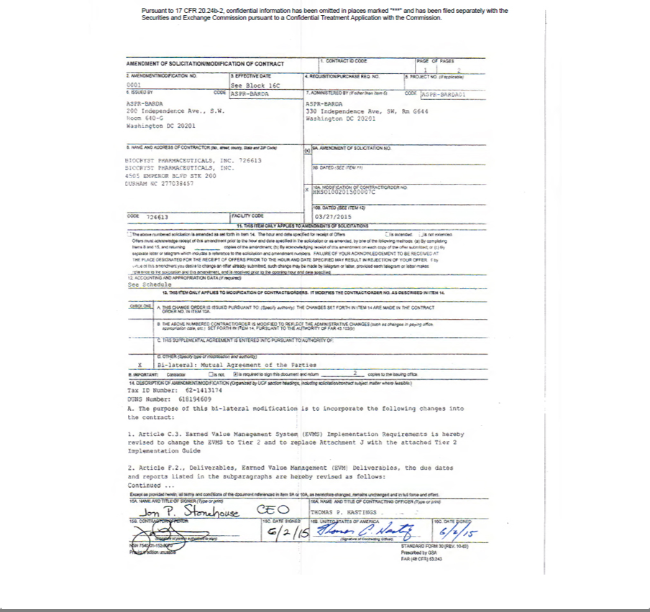

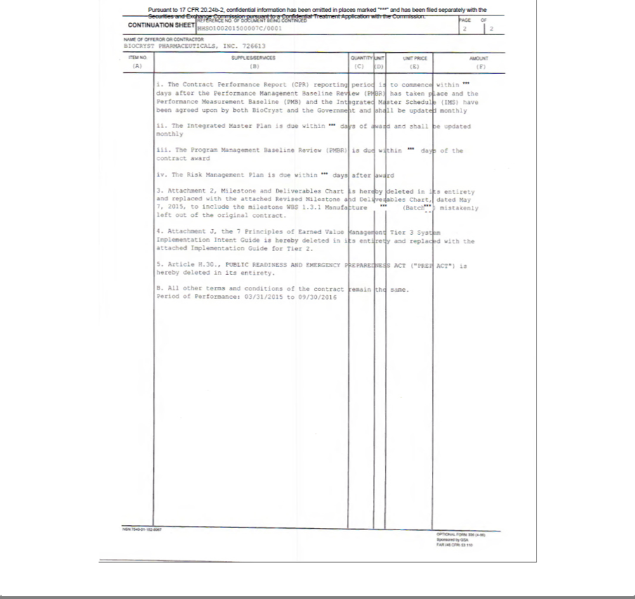

Pursuant to 17 CFR 20.24b-2, confidential information has been omitted in places marked “***” and has been filed separately with the Securities and Exchange Commission pursuant to a Confidential Treatment Application with the Commission.

ATTACHMENT 2

MILESTONE AND DELIVERABLES CHART

May 7, 2015

HHSO100201500007C

WBS | Milestone | Deliverable | Success Criteria |  | Timing | Go/No-Go
 |  |  |  |  |  | for initiation
 | CLIN 0001 - MANUFACTURE OF CLINICAL TRIAL MATERIAL
1.2.1 | Process Improvements Report | Report on Process Development | Process Developed |  | ***
1.2.2 | Determination of Sufficient | Evaluation report | BARDA approval of |  | *** | N/A
 | Process for Commercial Scale up |  | developed process
1.3.1 | Manufacture ***(Batch ***) | *** | Acceptable quality and |  | *** | N/A
 |  |  | yield
1.3.2 | Manufacture ***(Batch ***) | *** | Acceptable quality and |  | *** | N/A
 |  |  | yield
1.4.1 | Manufacture cGMP BCX4430 | BCX4430 DS | Acceptable quality and |  | *** | N/A
 | (***campaign DS Batch ***) | CofA, | yield
1.4.2 | Manufacture cGMP BCX4430 | BCX4430 DS | Acceptable quality and |  | *** | N/A
 | (*** campaign DS Batch ***) | CofA, | yield
1.4.3 | Prepare a Campaign Summary | Campaign Reports (DS Batches ***) | Completion of DS |  | *** | N/A
 | Reports |  | Campaigns
1.4.4 | Drug substance stability study | Initial Report on stability activities | Stability data |  | ***
1.5 | Drug Product Development | DP Process Development Report (WBS | Completion of Studies |  | *** | N/A
 |  | 1.5.4)
 |  | Pre-formulation and Physicochemical
 |  | Report (WBS1.5.5)
 |  | Extractable/Leachable Report (WBS 1.5.7)
1.5.8 | Excipient Compatibility Report for | Compatibility Report | IV formulation |  | ***
 | IV Formulation |  | completed
1.6.1 | Manufacture cGMP DP (CTM | BCX4430 DP | Acceptable quality and |  | *** | Accepted GMP DS
 | Batch *** ***) | CofA, | yield
1.6.2 | Manufacture cGMP DP (CTM | BCX4430 DP | Acceptable quality and |  | *** | Accepted GMP DS
 | Batch *** ***) | CofA, | yield

Pursuant to 17 CFR 20.24b-2, confidential information has been omitted in places marked “***” and has been filed separately with the Securities and Exchange Commission pursuant to a Confidential Treatment Application with the Commission.

1.6.3 | Prepare a Campaign Summary | Campaign Reports (CTM Batches ***) | Completion of DP |  | *** | N/A
 | Reports |  | Campaigns
1.6.4 | Drug Product stability study | Initial Report on stability activities | Stability Data |  | ***
1.6.5 | Comparability Study | Comparability Protocol and Report | Completion of DS and |  | ***
 |  |  | DP Campaigns
1.7.1 | Manufacture cGMP BCX4340 | BCX4430 DS | Acceptable DS process |  | *** | N/A
 | (*** campaign DS Batch ***) | CofA
1.7.2 | Prepare a Campaign Summary | Campaign Reports (DS Batch***) | Completion of DS |  | *** | N/A
 | Report |  | Campaign
1.7.2 | Manufacture cGMP DP (CTM | BCX4430 DP | Acceptable quality and |  | *** | Accepted GMP DS
 | Batch *** ***) | CofA, | yield
1.7.4 | Prepare a Campaign Summary | Campaign Report (CTM Batches ***) | Completion of DS |  | *** | N/A
 | Report |  | Campaigns
1.7.5 | Drug Substance and Drug Product | Initial report on stability activities | Stability Data |  | *** | Manufacture of 1.7.1
 | stability study |  |  |  |  | drug substance and
 |  |  |  |  |  | 1.7.2 drug product
1.7.6 | Comparability Study | Comparability Protocol and Report | Comparable DS and DP |  | *** | N/A
 |  |  | profiles
 | CLIN 0002 – COMMERCIAL SCALE UP AND NDA REGISTRATION BATCHES
 | Go/No Go Criteria to Initiate: WBS 1.2.2 BARDA approval of process developed
2.2 | Drug Substance Process Scale-up | Process Development Report (WBS 2.2.4) | Selection of the |  | *** | *** process
 |  |  | optimized
 |  |  | manufacturing process
2.3.1 | Manufacture BCX4340 DS (DS | BCX4430 Registration | Acceptable quality and |  | *** | *** process
 | Registration Batch ***) | DS | yield
 |  | CofA
2.3.2 | Manufacture BCX4340 DS (DS | BCX4430 Registration DS | Acceptable quality and |  | *** | *** process
 | Registration Batch ***) | CofA, | yield
2.3.3 | Manufacture BCX4340 DS (DS | BCX4430 Registration DS | Acceptable quality and |  | *** | *** process
 | Registration Batch ***) | CofA, | yield
2.3.4 | Prepare a Campaign Summary | Campaign Reports (DS Batches ***) | Completion of DS |  | *** | N/A
 | Report |  | Campaign
2.4.1 | Manufacture BCX4430 DP (DP | BCX4430 DP | Acceptable quality and |  | *** | Accepted GMP DS
 | Registration Batch ***) | CofA, | yield

Pursuant to 17 CFR 20.24b-2, confidential information has been omitted in places marked “***” and has been filed separately with the Securities and Exchange Commission pursuant to a Confidential Treatment Application with the Commission.

2.4.2 | Manufacture BCX4430 DP (DP | BCX4430 DP | Acceptable quality and |  | *** | Accepted GMP DS
 | Registration Batch ***) | CofA, | yield
2.4.3 | Manufacture BCX4430 DP (DP | BCX4430 DP | Acceptable quality and |  | *** | Accepted GMP DS
 | Registration Batch ***) | CofA, | yield
2.4.4 | Prepare a Campaign Summary | Campaign Report (CTM Registration | Completion of DS |  | *** | N/A
 | Report | Batches ***) | Campaigns
2.5 | Drug substance and Drug Product | Report on stability activities | Stability Data |  | ***
 | stability study
2.6 | Comparability Study | Comparability Protocol and Report | Comparable DS and DP |  | *** | Accepted GMP DS
 |  |  | profiles
 | CLIN 0003 – NONCLINICAL NDA-ENABLING TOXICOLOGY - IM
 | Go/No Go Criteria to Initiate: WBS 1.4.1 Completion of Manufacture cGMP BCX4430 (*** campaign DS Batch ***)
3.1.1 | Complete GLP *** IM Tox Study | Study Report | Established NOAEL |  | *** | Drug Substance
 | - *** |  |  |  |  | confirming to release
 |  |  |  |  |  | criteria
3.1.2 | Complete GLP *** IM Tox Study | Study Report | Established NOAEL |  | *** | Drug Substance
 | - *** |  |  |  |  | confirming to release
 |  |  |  |  |  | criteria
3.2.1 | Conduct *** assessment in *** | Study Report | No significant findings |  | *** | N/A
 | and *** |  |  |  |  | N/A
3.2.2 | Conduct *** Dose Range Finding | Study Report | No significant findings |  | *** | N/A
 | Studies in the *** |  |  |  |  | N/A
3.2.3 | Conduct Definitive *** toxicology | Study Report | No significant findings |  | *** | N/A
 | in the *** |  |  |  |  | N/A
3.2.4 | Conduct *** toxicology *** | Study Report | No significant findings |  | *** | N/A
3.3.1 | Conduct Radiolabeled ADME | Study Report | Characterize drug |  | *** | Acceptable Radiolabel
 | study - *** |  | disposition |  |  | Material
3.3.2 | Conduct Radiolabeled ADME – | Study Report | Characterize drug |  | *** | Acceptable Radiolabel
 | *** |  | disposition |  |  | Acceptable Radiolabel
 | *** |  | disposition |  |  | Material
 |  | CLIN 0004 – IN VITRO EXPERIMENTS – IV
 | Go/No Go to Initiate: WBS 1.5.8 Completion of Excipient compatibility studies for IV formulation
4.1. | Conduct *** Test – IV | Study Report | No effect on *** |  | *** | IV formulation WBS
 |  |  |  |  |  | 1.5.8
4.2. | Conduct *** Test – IV | Study Report | No effect on *** |  | *** | N/A

Pursuant to 17 CFR 20.24b-2, confidential information has been omitted in places marked “***” and has been filed separately with the Securities and Exchange Commission pursuant to a Confidential Treatment Application with the Commission.

4.3 | *** IV experiments | Study report on all *** assays with | No toxicology *** |  | ***
 |  | recommendation to proceed CLIN0005
 | CLIN 0005 – NONCLINICAL NDA-ENABLING TOXICOLOGY – IV
 | Go/No Go to Initiate: WBS 4.3 Completion of *** IV toxicology studies
5.1.1 | Complete GLP *** IV Tox Study - | Study Report | Established NOAEL |  | *** | Drug Substance
 | *** |  |  |  |  | confirming to release
 |  |  |  |  |  | criteria
5.1.2 | Complete GLP ***IV Tox Study - | Study Report | Established NOAEL |  | *** | Drug Substance
 | *** |  |  |  |  | confirming to release
 |  |  |  |  |  | criteria
5.2.1 | Conduct *** assessment in *** | Study Report | No significant findings |  | *** | N/A
5.2.2 | Conduct *** Dose Range Finding | Study Report | No significant findings |  | *** | N/A
 | Studies in the *** |  |  |  |  | N/A
5.2.3 | Conduct Definitive *** toxicology | Study Report | No significant findings |  | *** | N/A
 | in the *** |  |  |  |  | N/A
5.2.4 | Conduct *** toxicology *** | Study Report | No significant findings |  | *** | N/A

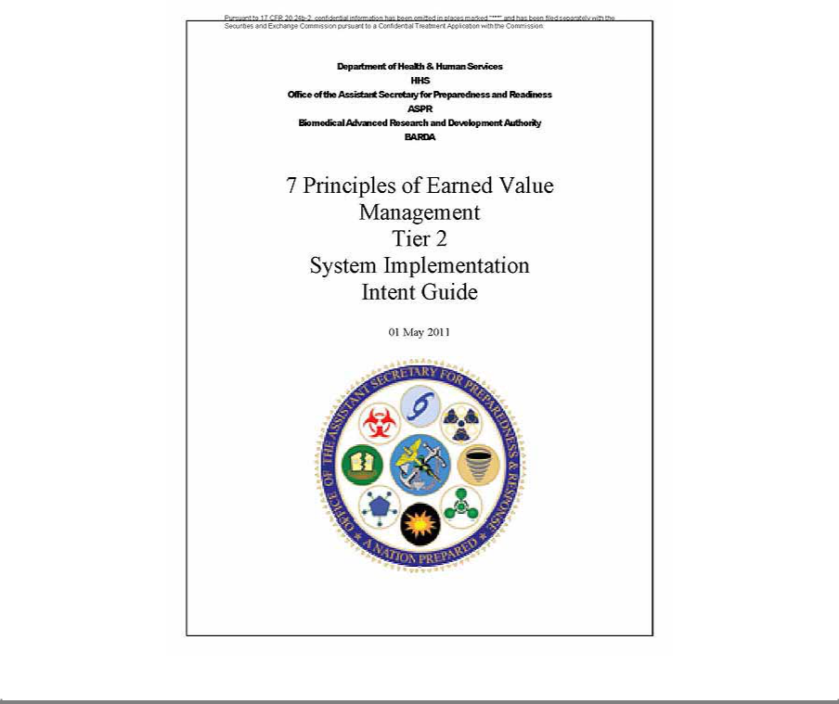

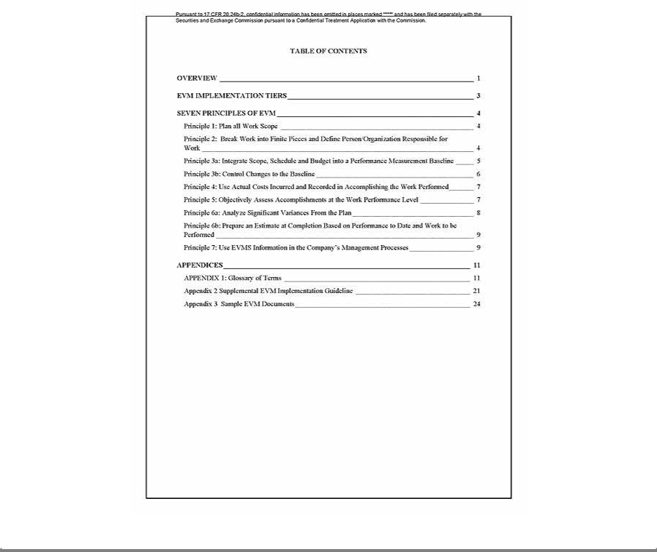

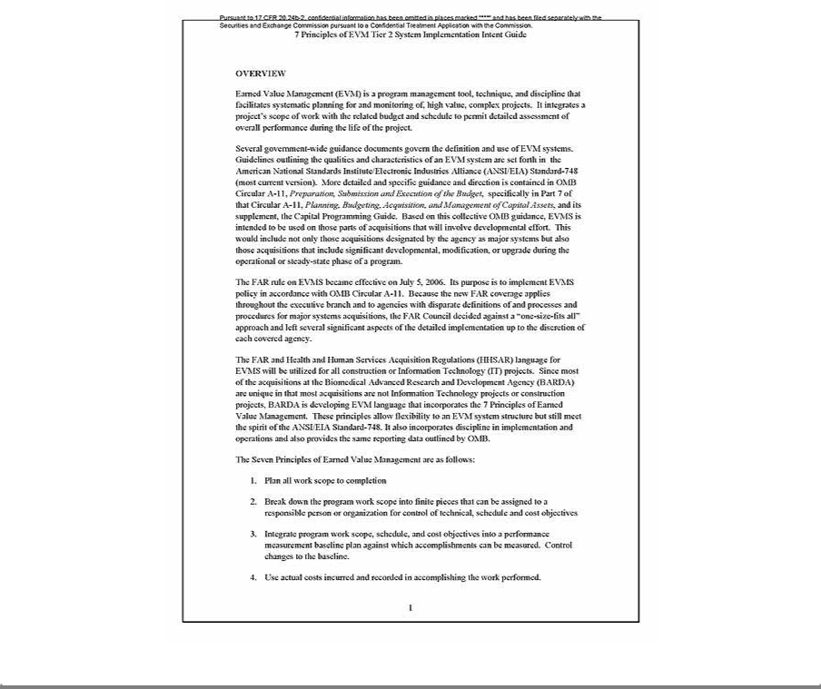

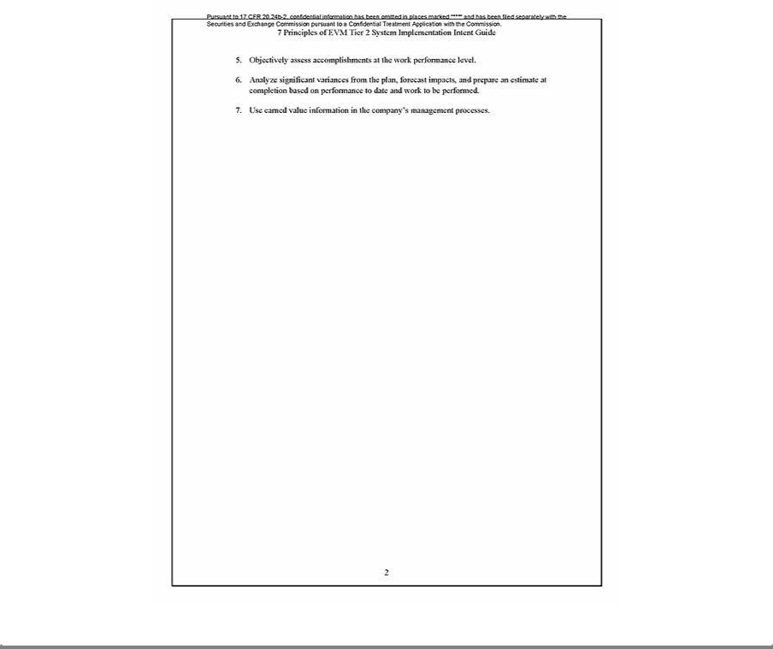

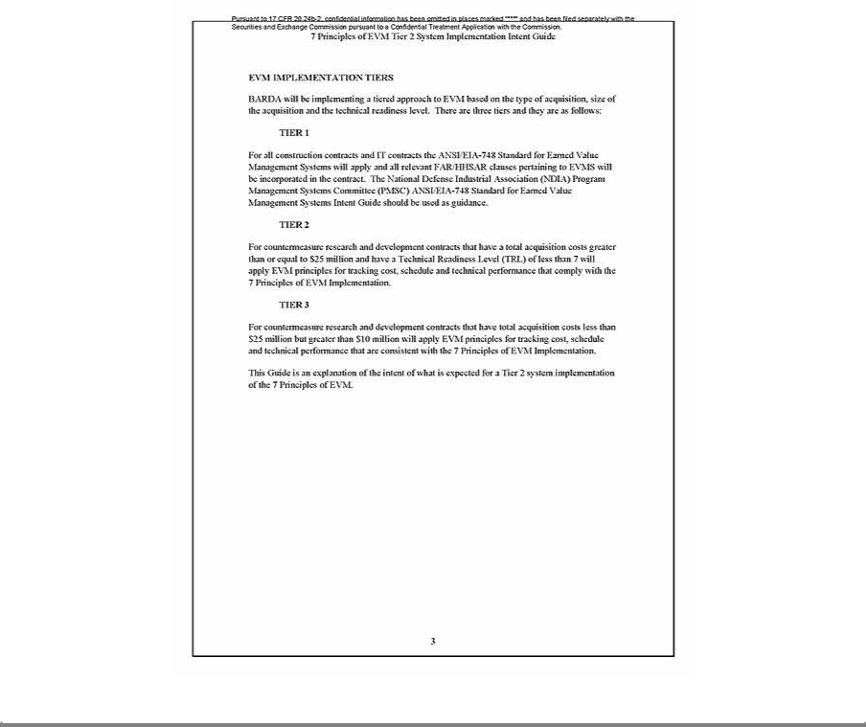

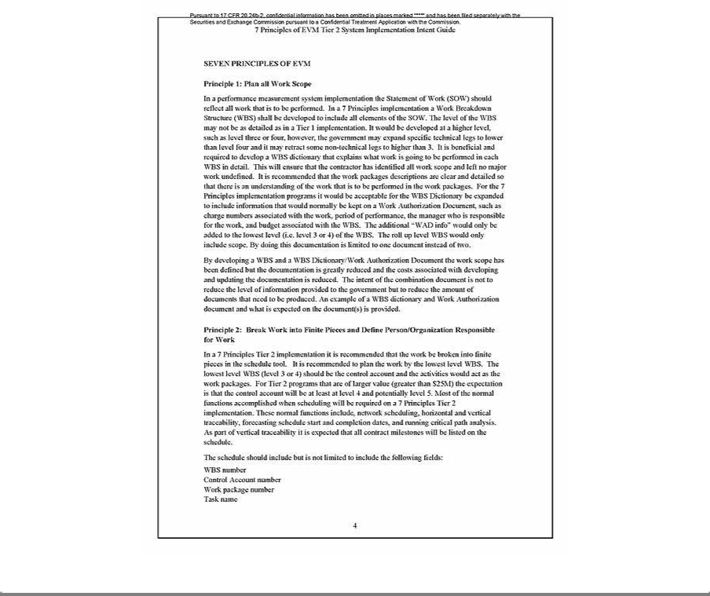

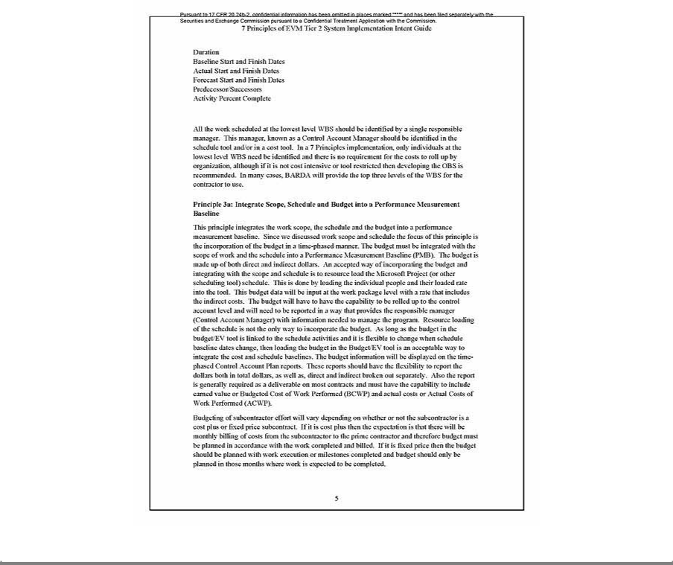

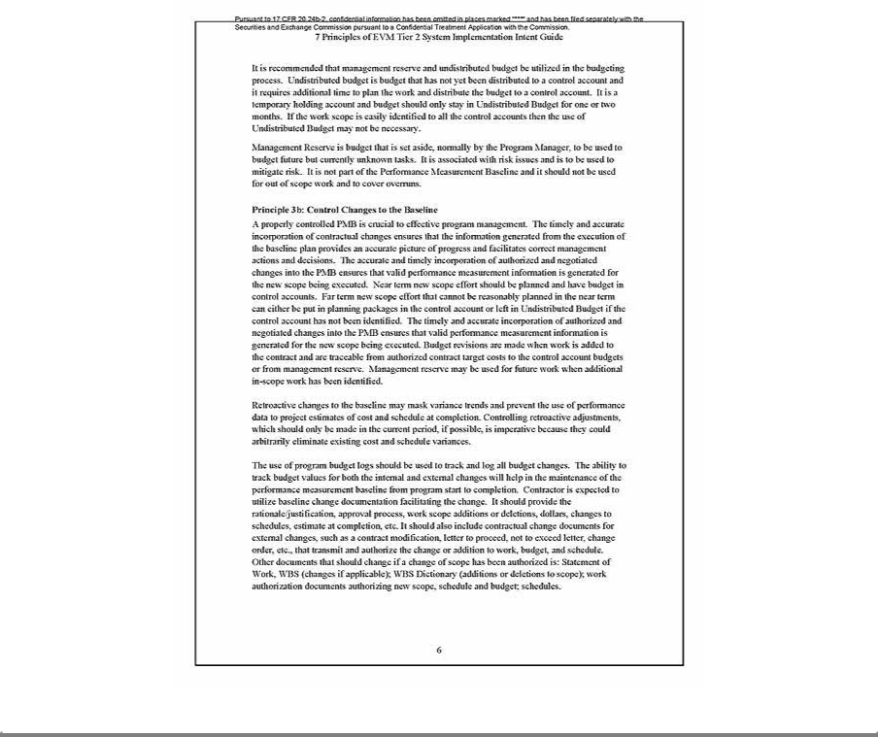

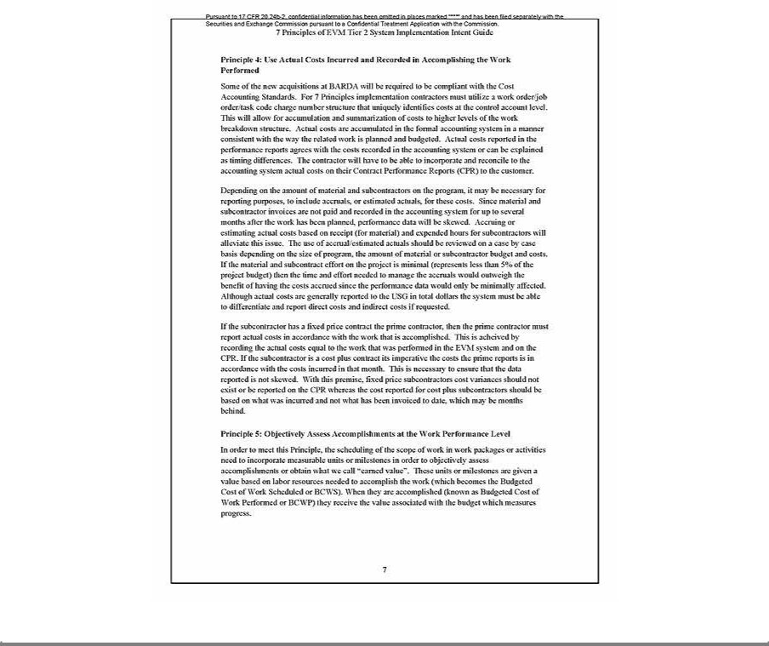

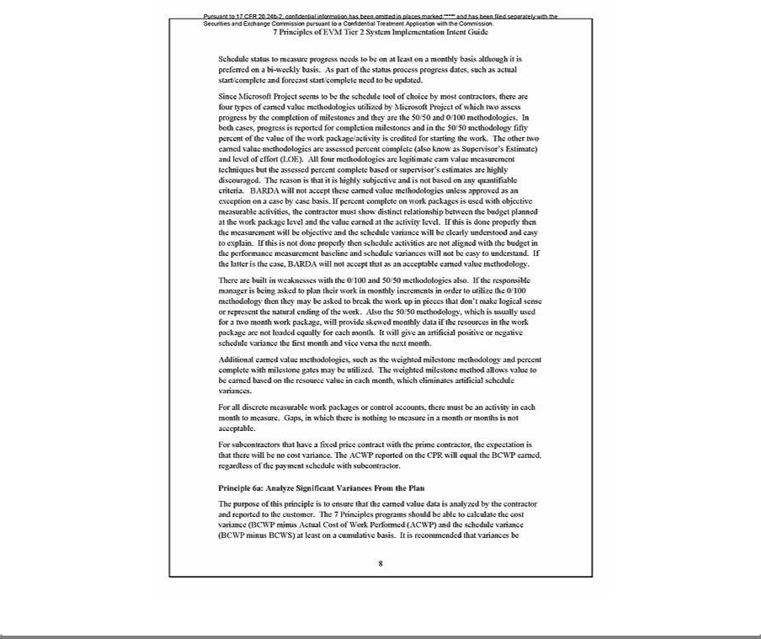

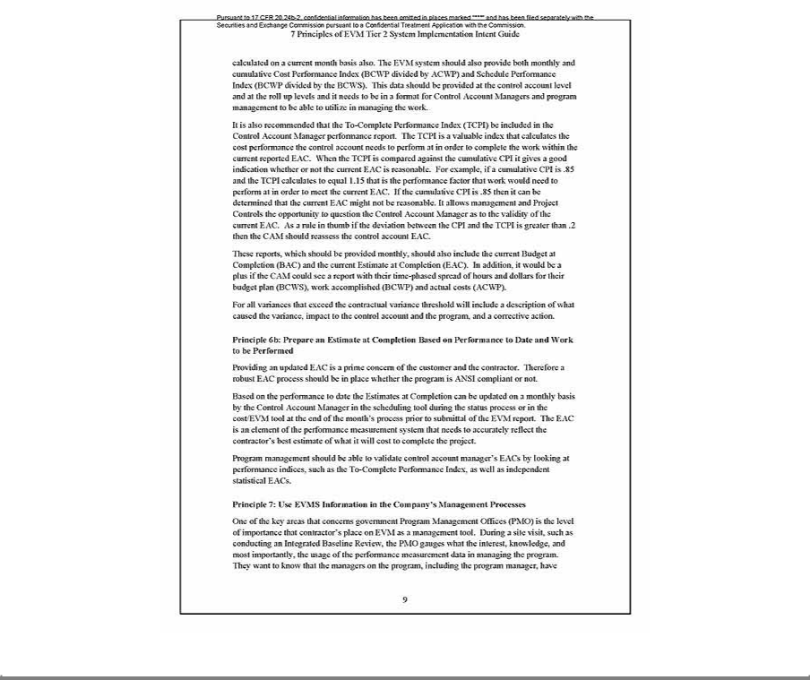

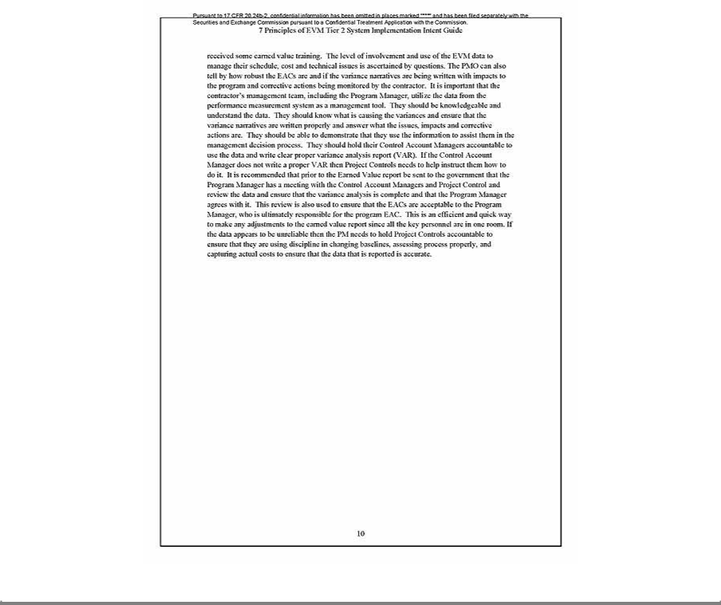

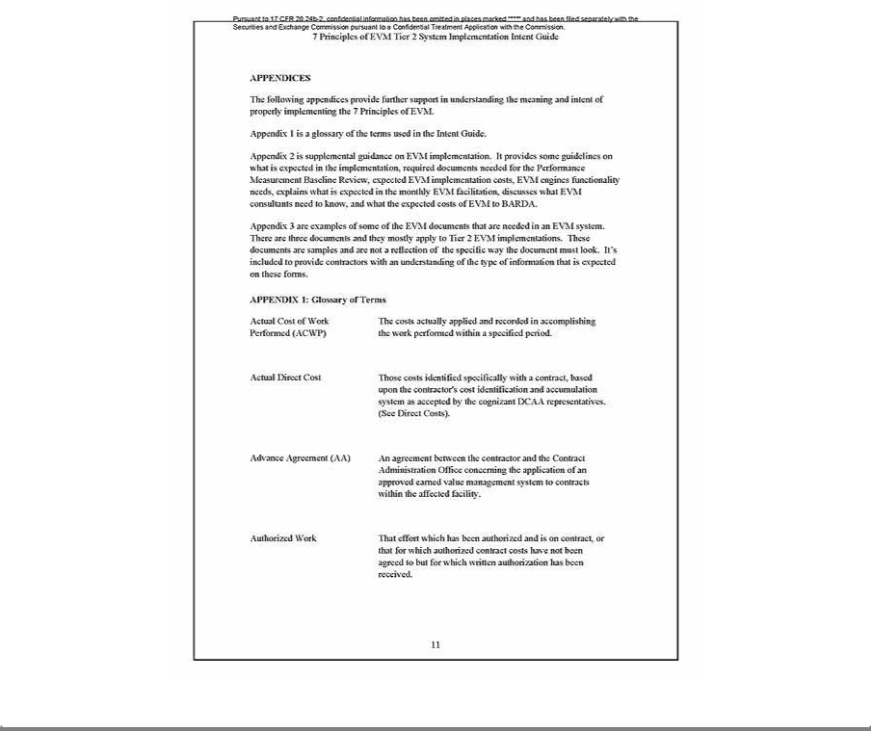

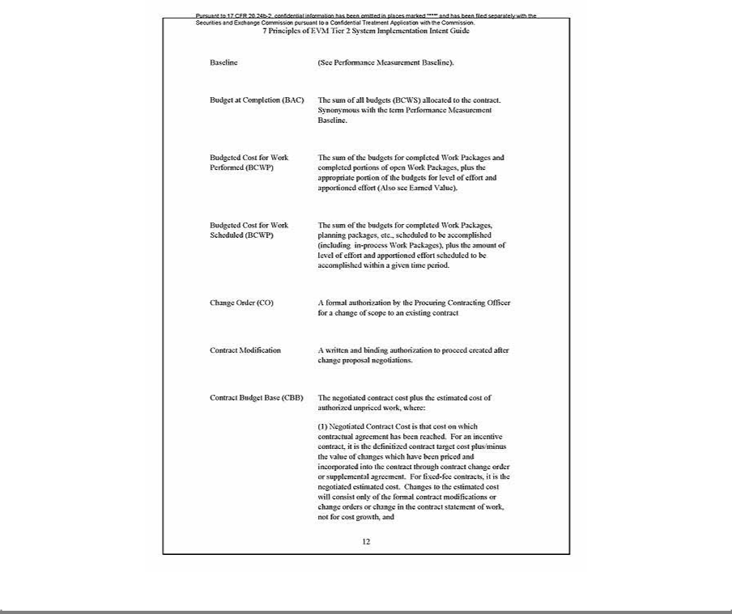

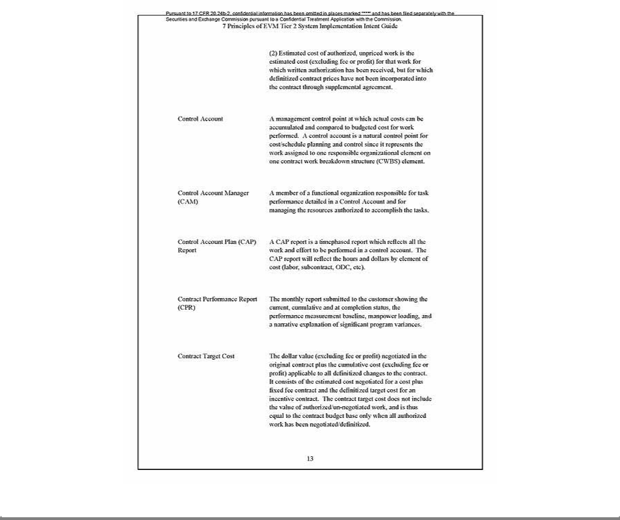

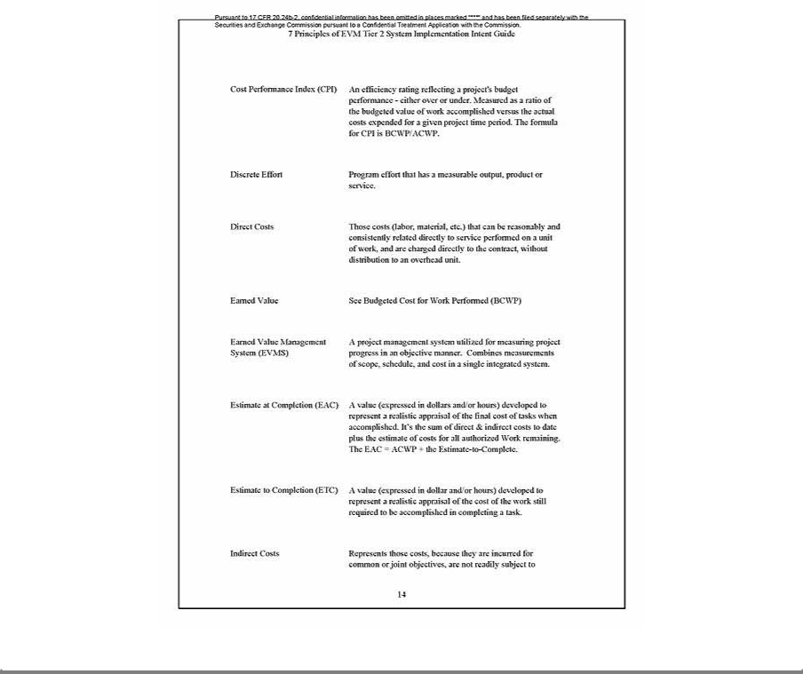

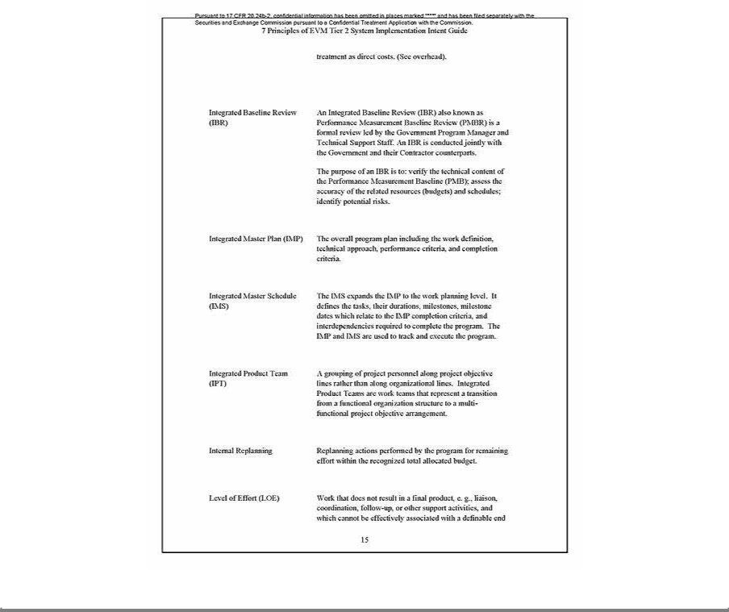

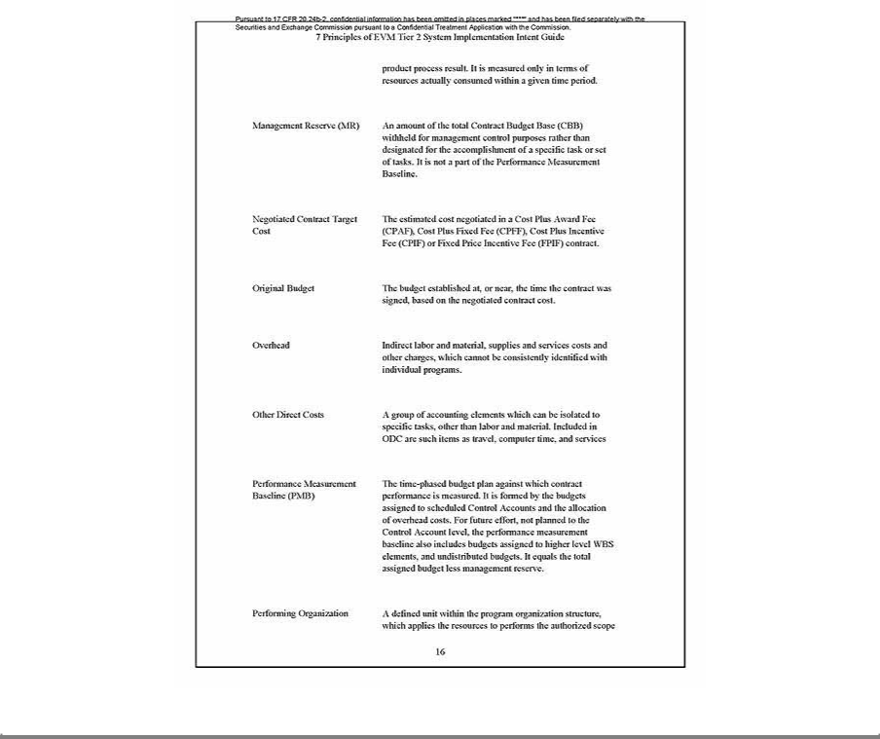

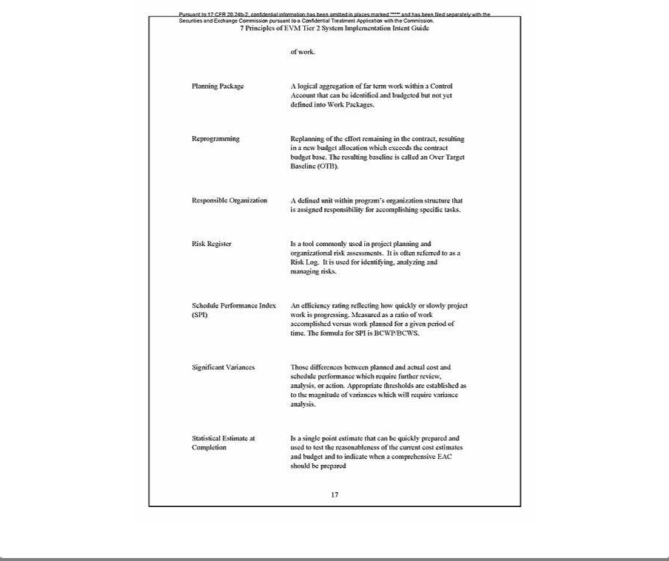

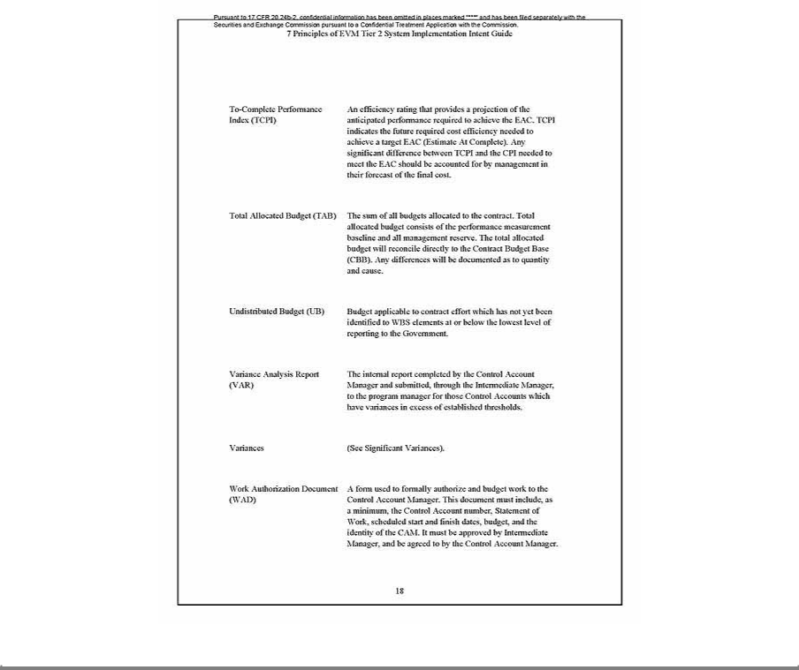

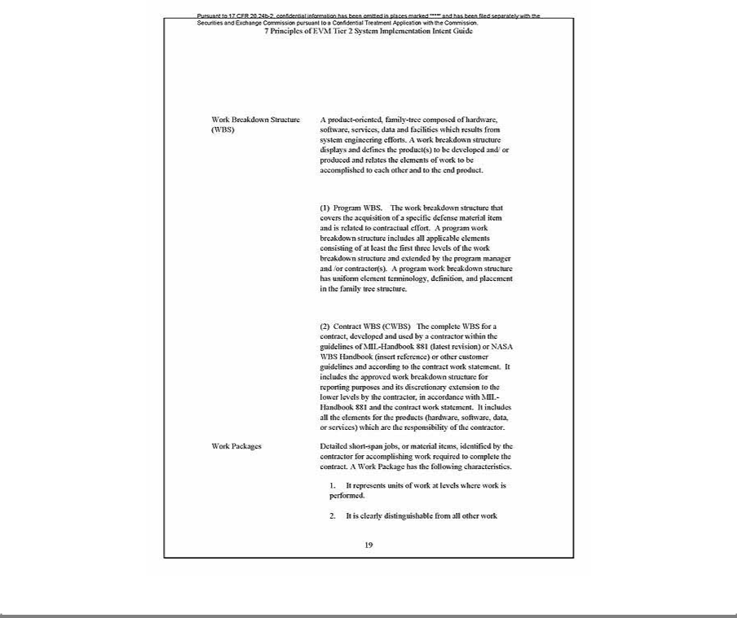

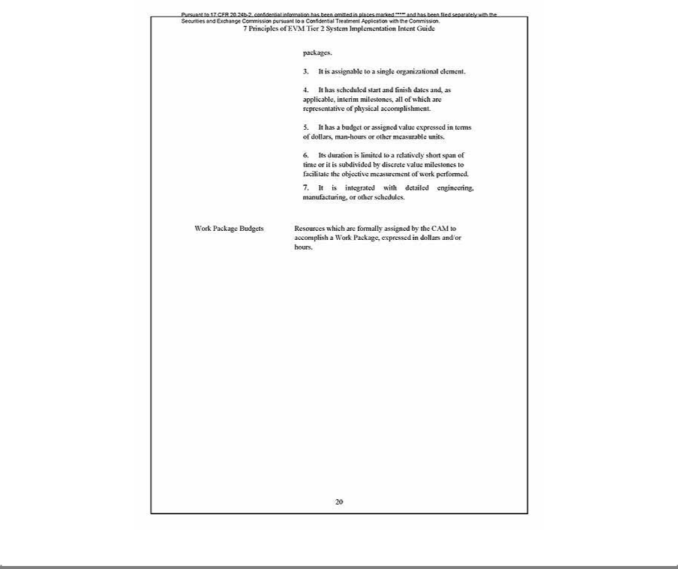

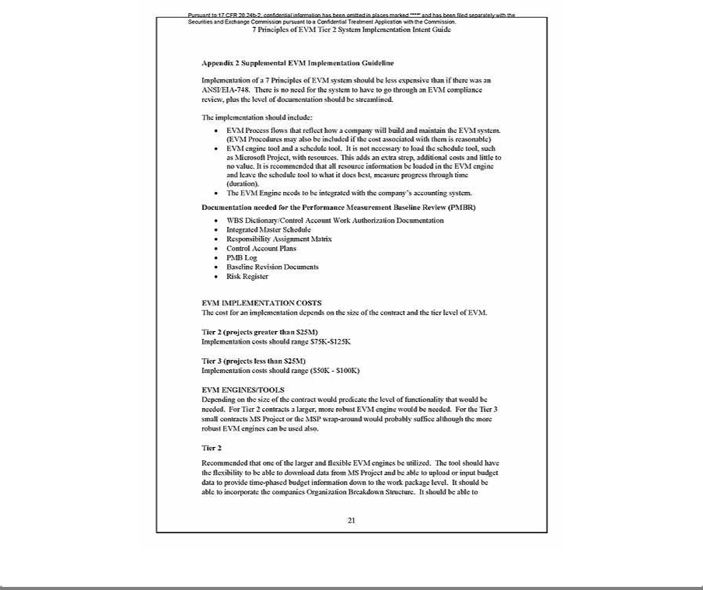

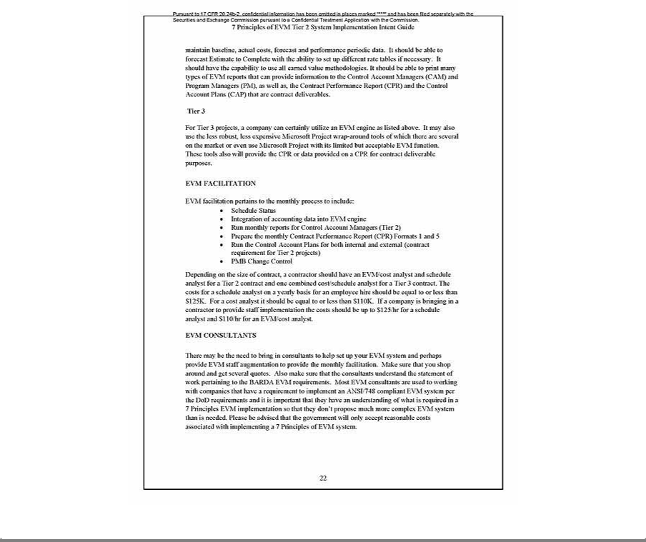

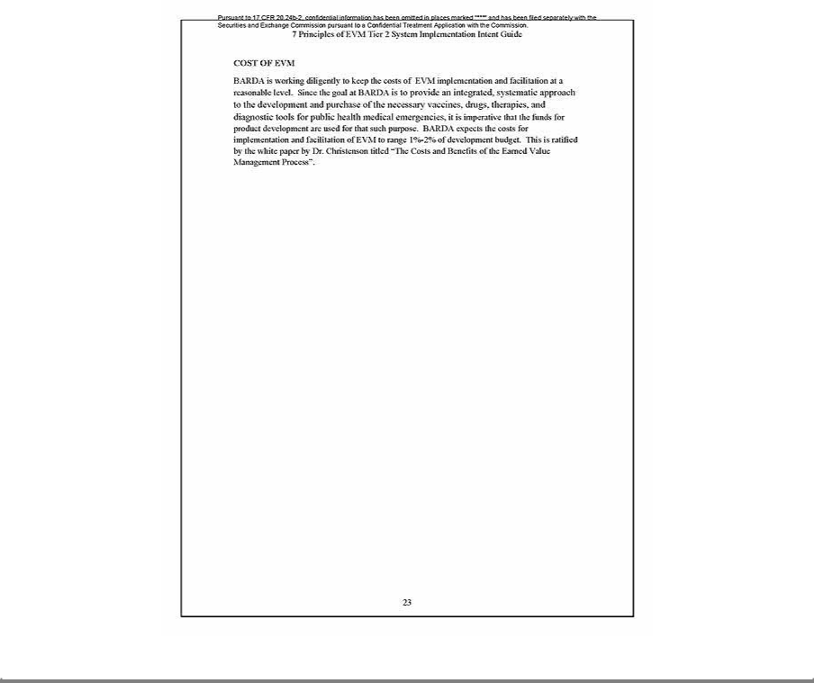

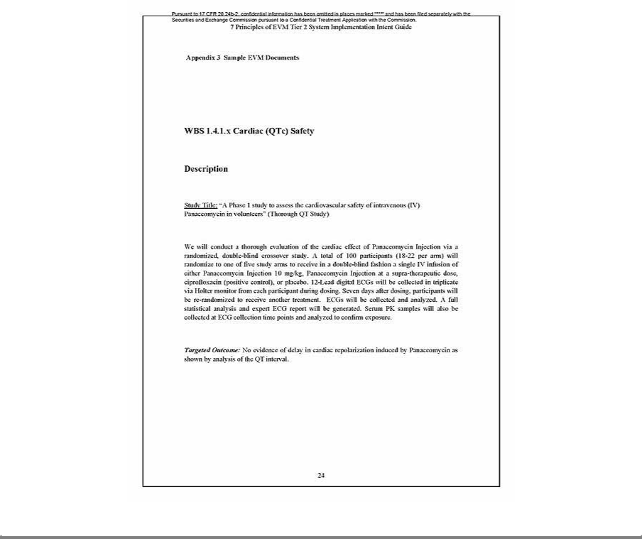

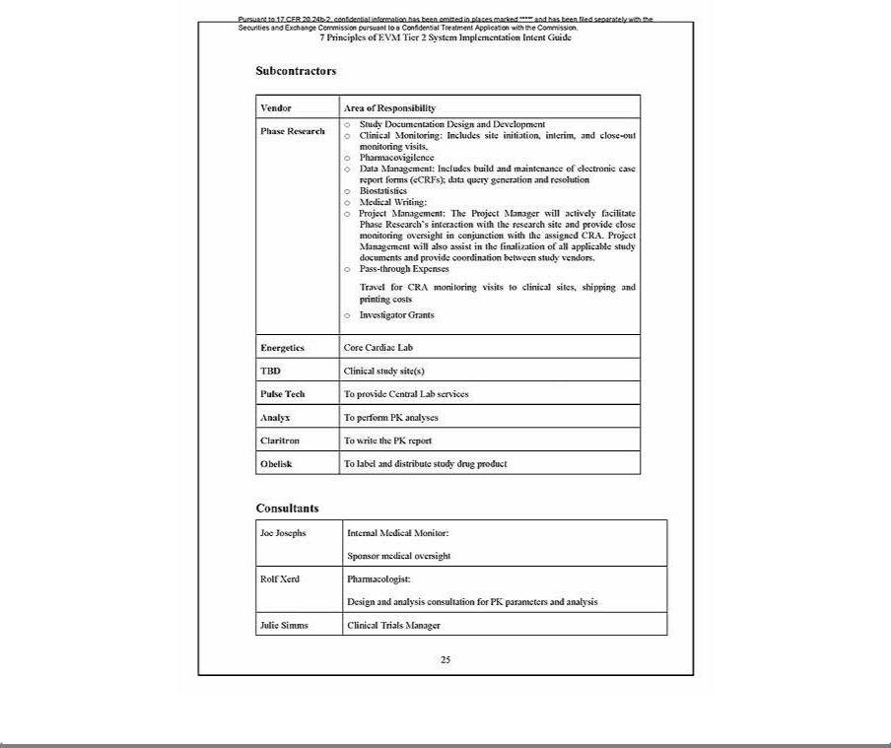

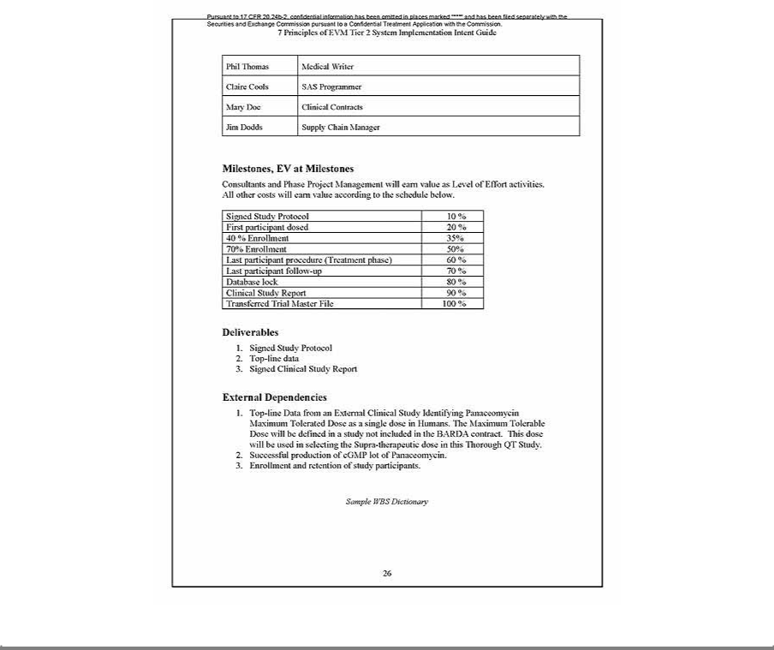

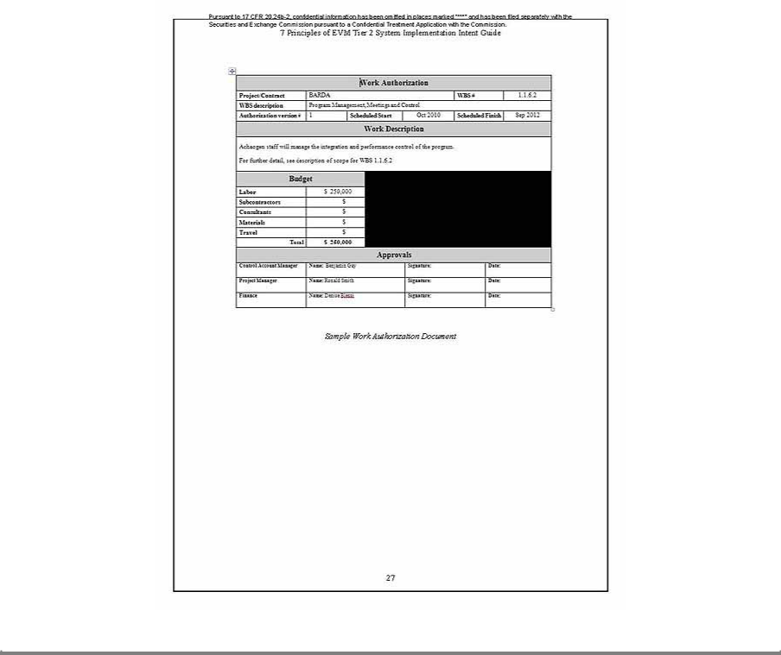

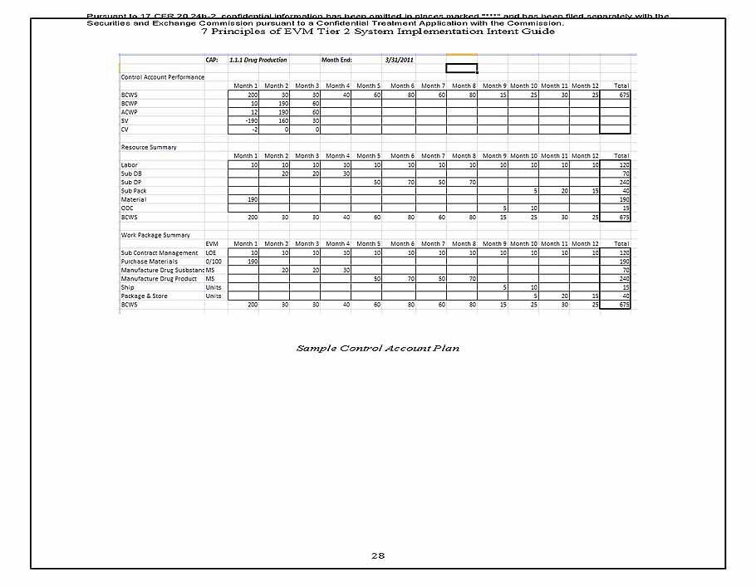

Exhibit 10.2
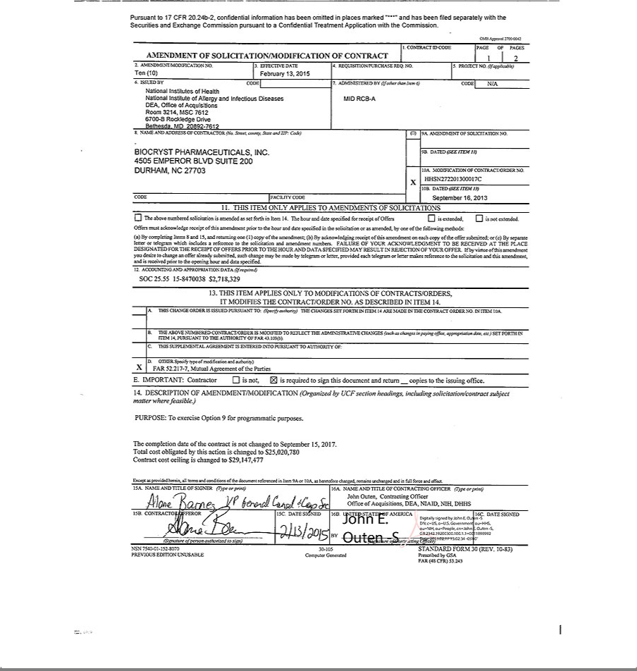

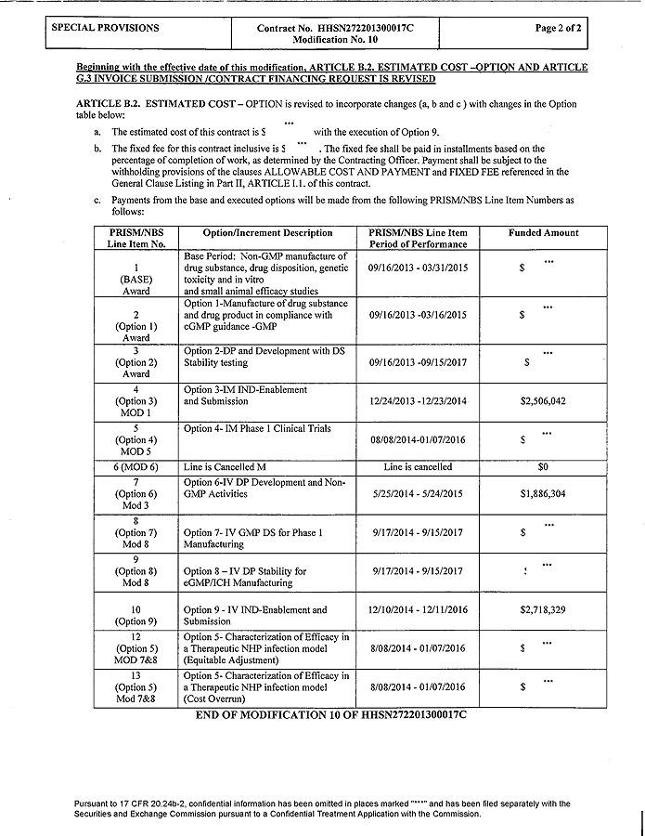

Exhibit 10.3
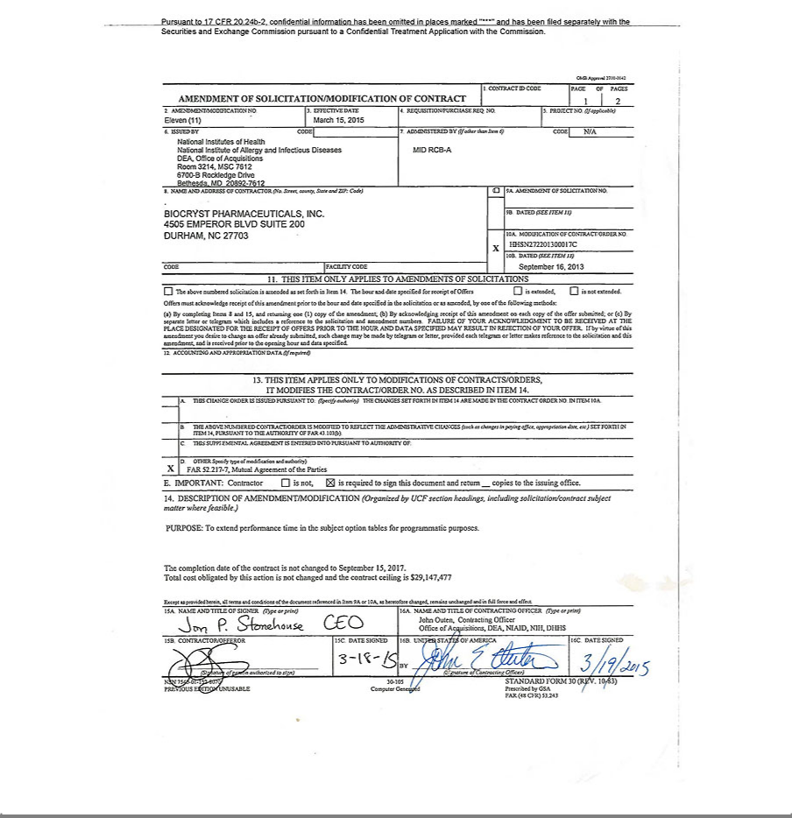

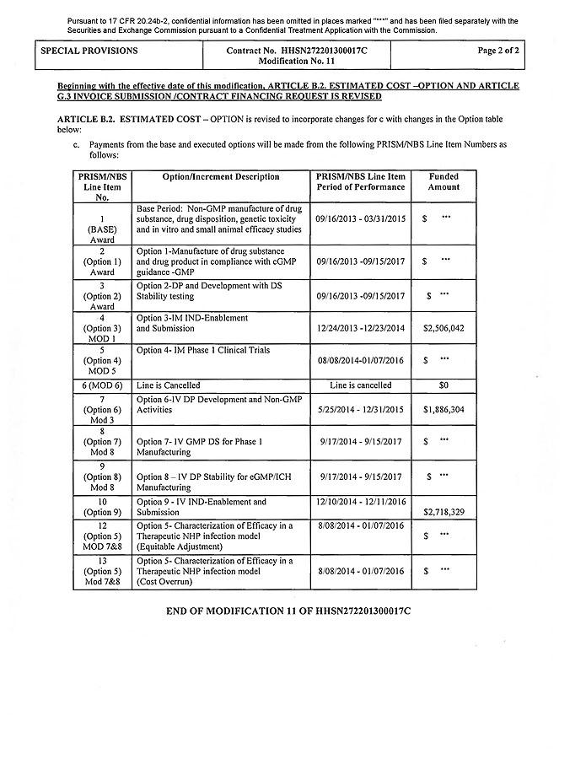

Exhibit 10.4
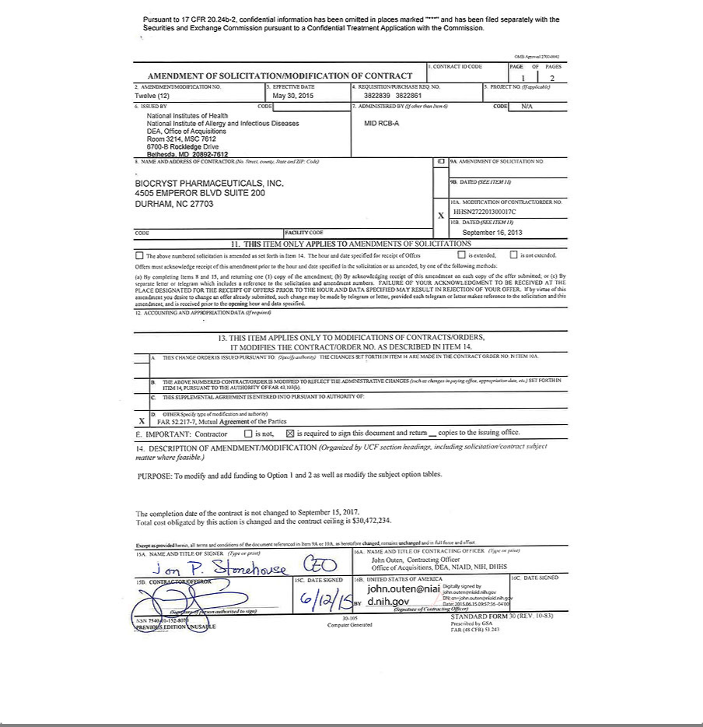

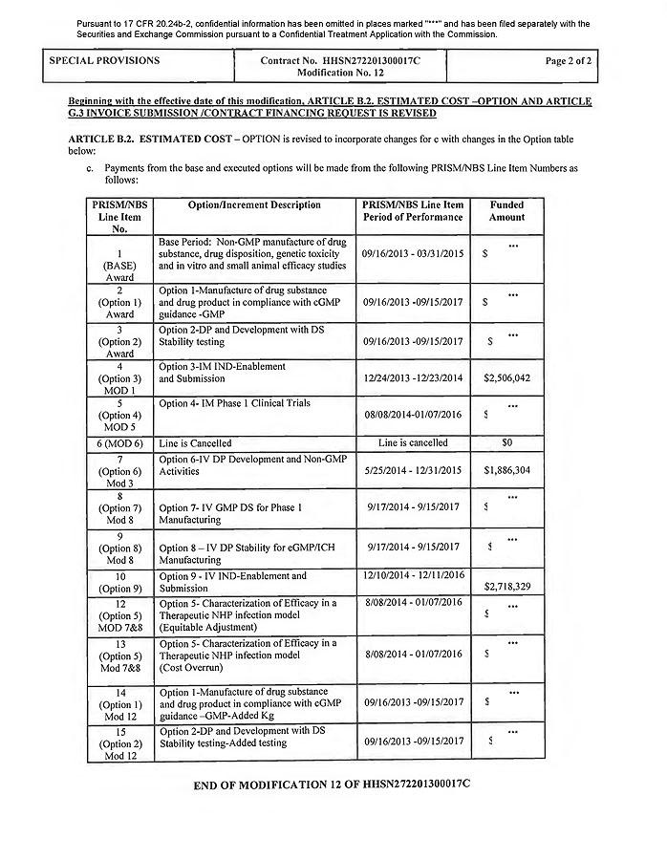

Exhibit 10.5
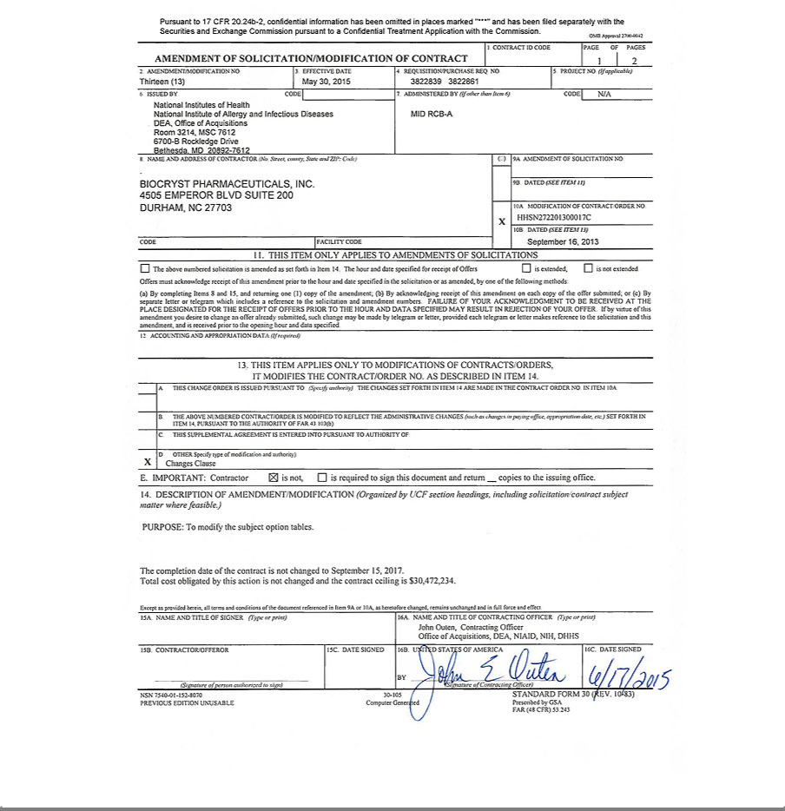

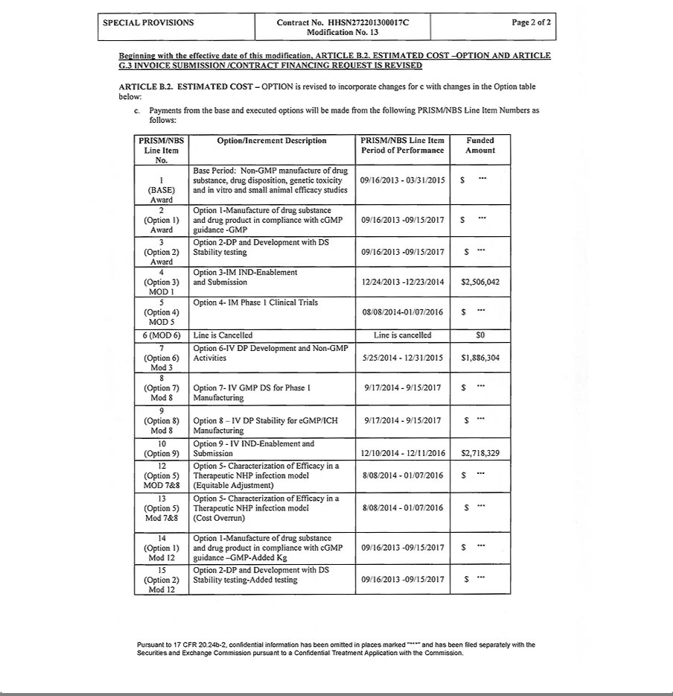

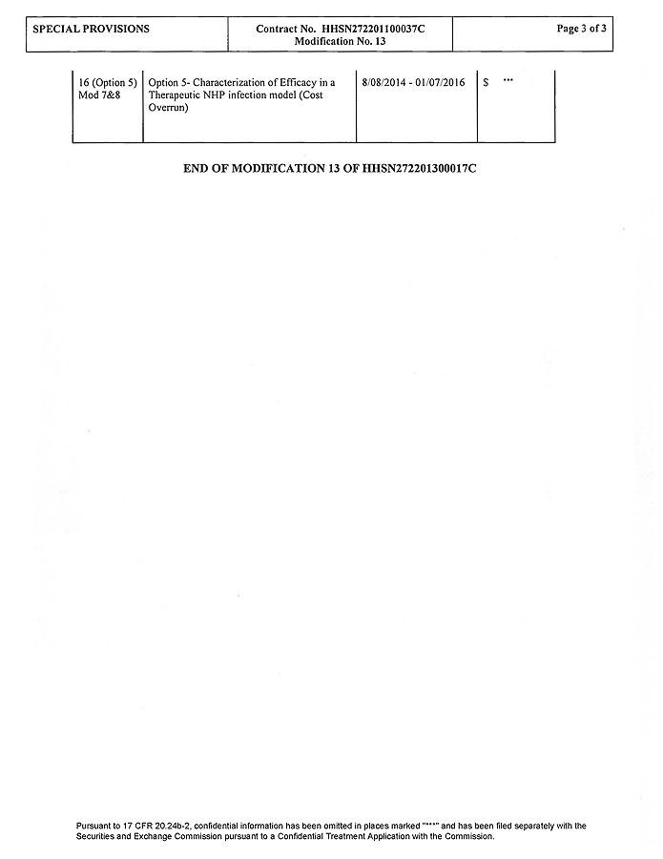

Exhibit 10.6
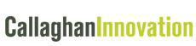

NOVATION AGREEMENT

PARTIES

Albert Einstein College of Medicine of Yeshiva University, a Division of Yeshiva University, of 1300 Morris Park Ave, Bronx, NY 10461,United States of America (AECOM); BioCryst Pharmaceuticals Inc of 4505 Emperor Blvd, Suite 200, Durham, NC27703, United States of America (BioCryst); Mundipharma International Corporation Limited (the permitted assignee of Mundipharma International Holdings Limited) of Mundipharma House, 14 Par-la Ville Road, Hamilton, Bermuda HMJX (Mundipharma), (each a Continuing Party and collectively, the Continuing Parties);

and

Callaghan Innovation Research Limited (formerly called Industrial Research Limited) registered in New Zealand under number 545472 (Retiring Party);

and

Victoria Link Limited, a wholly owned subsidiary of Victoria University of Wellington, registered in New Zealand under company number 540316 (Substitute Party);

together referred to as the Parties.

BACKGROUND

- Callaghan Innovation Research Limited hastransferred its Carbohydrate Chemistry Research Team and related intellectual property to Victoria Link Limited and agreements exist between Callaghan Innovation Research Limited and Victoria University of Wellington.

- Albert Einstein College of Medicine of Yeshiva University, a Division of Yeshiva University, BioCryst Pharmaceuticals Inc, Mundipharma International Corporation Limited and Callaghan Innovation Research Limitedare parties to the Novated Contracts (as defined below).

- The Parties have agreed to release and discharge:

  - Callaghan Innovation Research Limited from the obligations and liabilities of Callaghan Innovation Research Limited to the Continuing Parties under the Novated Contracts on the condition that Victoria Link Limited agrees to assume each and every obligation and liability of Callaghan Innovation Research Limited to the Continuing Parties under the Novated Contracts and

  - The Continuing Parties from their obligations and liabilities to the Retiring Party

as of the Effective Date in accordance with the terms and conditions set forth herein.

-1-

IT IS AGREED AS FOLLOWS

- DEFINITIONS AND INTERPRETATION

In this Agreement:

1.1 Agreement means this Agreement and all its schedules and attachments.

1.2 Continuing Parties means AECOM, BioCryst and Mundipharma, each of whom will continue to be bound under the Novated Contracts.

1.3 Effective Date means 6 January 2014.

1.4 Novated Contracts means the contract or contracts marked and annexed as Schedule 1 to this Agreement, including, but not limited to, the Insolvency Letter dated February 1, 2006 (as amended pursuant to the First Amendment to Insolvency Letter dated November 11, 2011) (the “Insolvency Letter”).

1.5 Retiring Party means Callaghan Innovation Research Limited, who is releasing and discharging the obligations and liabilities under the Novated Contracts to the Substitute Party in accordance with the terms and conditions set forth herein.

1.6 Substitute Party means Victoria Link Limited who is assuming the obligations and liabilities of the Retiring Party under the Novated Contracts in accordance with the terms and conditions set forth herein.

1.7 Working Day means any day on which registered banks are open for general banking business in Wellington, other than a Saturday, Sunday, public holiday in Wellington, New Zealand, or a day on which Victoria University of Wellington is closed (as identified in its calendar).

- NOVATION

2.1 With effect from the Effective Date, and subject to clauses 3.1 and 7.1, the Parties novate the Novated Contracts and the Substitute Party undertakes to the

Continuing Parties that it will:

- replace the Retiring Party and be bound by the Novated Contracts; and

- discharge all of the obligations of the Retiring Party under the Novated Contracts and observe all the provisions of the Novated Contracts to the extent they ariseon or after the Effective Date; and

- be liable to the Continuing Parties for the performance of any obligations on the part of the Retiring Party under or in connection with the Novated Contractson or after the Effective Date.

-2-

- RELEASE OF RETIRING PARTY’S OBLIGATIONS

3.1 In consideration of the undertaking by the Substitute Party under clause 2.1 above, and subject to clause 7.1 and 7.2, with effect fromthe Effective Date the Continuing Parties release and discharge the Retiring Party from further performance of its obligations under the Novated Contracts and from all liabilities, claims and demands of any kind arising under or in connection with the Novated Contracts on or after the Effective Date but not prior to the Effective Date. The Retiring Party will continue to be liable to the Continuing Parties for all of its acts and omissions which occurred before the Effective Date as if this Agreement had never been executed.

- CONTINUING PARTIES’ OBLIGATIONS

4.1 Each Continuing Party undertakes to the Substitute Party that it will with effect from the Effective Date:

  - discharge all of its respective obligations under the Novated Contracts and observe all the provisions of the Novated Contracts; and

  - be liable to the Substitute Party for the performance of its respective obligations under or in connection with the Novated Contracts arising on or after the Effective Date.

- CESSATION OF RETIRING PARTY’S RIGHTS

5.1 Without prejudice to clauses 2.1 and 4.1 above, with effect fromthe Effective Date, the Retiring Party:

- shall cease to have any rights under the Novated Contracts in respect of any acts or omissions of the Continuing Partieson or after the Effective Date arising under or in connection with the Novated Contracts; and

- shall cease to be a third party beneficiary pursuant to section 13.6 (Pre-Existing Third Party License) of the Amended and Restated Development and License Agreement dated November 11th, 2011 by and Between BioCryst and MundiPharma (the “2011 DLA”) and shall cease to be entitled to enforce BioCryst’s rights thereunder in respect of anyacts or omissions of Mundipharma on or after the Effective Date arising under or in connection with the 2011 DLA.

Accordingly:

- the Retiring Party releases and discharges each Continuing Party from further performance of its respective obligations underthe Novated Contracts and from all liabilities, claims and demands of any kind arising under or in connection with the Novated Contracts on or after the Effective Date; and

- the Retiring Party releases and discharges Mundipharma from further performance of its obligations under the 2011 DLA and from all liabilities, claims and demands of any kind arising under or in connection with the 2011 DLA on or after the Effective Date.

-3-

- WARRANTIES AND ACKNOWLEDGEMENT

6.1 Each Continuing Party and the Retiring Party warrants to the Substituting Party that as at the Effective Date:

- the Novated Contracts constitute the entire agreement between the Continuing Party and the Retiring Party relating to the subject matter of the Novated Contracts with the understanding that a separate novation addresses certain additional agreements entered into by the AECOM, BioCryst, Substitute Party and Retiring Party; and

- so far as it is aware neither the Retiring Party nor the Continuing Parties is in default under the Novated Contracts which could lead to termination of the Novated Contracts.

6.2 The Continuing Parties and the Substitute Party acknowledge and agree that the Novated Contracts continue in full force and effect on and after the Effective Date in accordance with their terms as novated by this Agreement.

6.3 The Retiring Party and the Substitute Party each warrant to each Continuing Party that

- they have completed the appropriate documents and transfer so that each Continuing Partyis released of obligations from the Retiring Party for obligations going forward on and after the Effective Date of this Agreement; Contracts; and

- the Novated Contracts as set forth in Schedule I make reference to each and every agreement entered into by the Continuing Parties and the Retiring Party (subject to Section 6.1(a) of this Agreement) such that the Continuing Parties will enjoy the same rights and benenfits and assume the same obligations and liabilities as would be the case if the Continuing Parties had not entered into this Agreement.

6.4 The Substitute Party warrants to each Continuing Party that:

  - It is a viable going concern and has the personnel, expertise and resources to carry out it obligations and responsibilities under the Novated Contracts and has the financial resources to assume any and all liabilities under the Novated Contracts; and

  - the Substitute Party has the right to grant the rights and licences under the Novated Contracts, including the right to grant the rights and licensesunder the “Agreement Patents” (as defined in the Insolvency Letter).

- CONFIDENTIALITY

7.1 Pursuant to section 13.6 of the 2011 DLA, Mundipharma grants its consent for BioCryst to disclose Mundipharma’s Confidential Information (as defined in the 2011 DLA) to the Substitute Party. The Continuing Parties and the Substitute Party acknowledge and agree that such disclosure of Mundipharma’s Confidential Information shall be deemed to be “Licensee Confidential Information” subject to paragraph 5.03 of the AECOM/IRL License Agreement dated June 27, 2000 (as amended) (the 2000 LA).

-4-

7.2 Notwithstanding the novation effected by this Agreement, the Retiring Party will continue to be bound by any obligations of confidentiality and non-disclosure that the Retiring Party would have been under had the Retiring Party continued to be a Party of theNovated Contracts, including any such obligations pursuant to the 2000 LA.

- ASSIGNMENT AND AMENDMENT

8.1 Without the prior written approval of the Continuing Parties and the Substitute Party, which approval shall not be unreasonably withheld, no Continuing Party or Substitute Party will assign this Agreement except to a successor in title of by merger or sale of all or substantially all of such Party’s business to which this Agreement relates.

8.2 No amendment to this Agreement shall be binding unless in writing and agreed to and signed by the respective Parties.

- ENTIRE AGREEMENT

9.1 This Agreement, together with any documents referred to in it, constitutes the whole agreement between the Parties relating to its subject matter and supersedes and extinguishes any prior drafts, agreements, undertakings, representations, warranties and arrangements of any nature, whether in writing or oral, relating to such subject matter.

- NOTICES

10.1 Any communication including any notice, consent, information, application or request that must or may be given or made to a Party under this Agreement, can be:

- in writing and sent to the physical address of the Party as listed in the Novated Contracts, or, with respect to the Retiring Party and the Substitute Party, as listedat clause 10.3, and marked for the attention of the person or office holder (if any) from time to time designated for that purpose by the relevant Party;

- in writing and sent to the email address of the Party as listed at clause 10.3 or of the person or office holder (if any) from time to time designated for that purpose by the relevant Party and followed by a hard copy sent by post in accordance with clause 10.1(a);

- in writing and delivered in person to the physical address of the Party as listed at clause 10.3, and marked for the attention of the person or office holder (if any) from time to time designated for that purpose by the relevant Party.

10.2 A communication including any notice, consent, information, application or request will be deemed to be received:

- by post, on the third Working Day after posting;

- by email,

-5-

  - where it is transmitted on a Working Day, on the Working Day on which it is transmitted and at the time the email enters the recipient’s information system as evidenced by a delivery receipt requested by the sender and it is not returned undelivered as an error; or

  - where it is transmitted on a day other than a Working Day, at 9:00 a.m. on the subsequent Working Day after the date of transmission; c. by personal delivery, at the date and time it was delivered.
10.3 The physical address, email address and relevant person or office holder of the Retiring Party and the Substitute Party are set out below:

The University

Name:

Address:

Vice Provost Research and Chairman of VicLink

Victoria University of Wellington

PO Box 600

Wellington 6140

Email address:

kate.mcgrath@vuw.ac.nz

With a copy to:

In-house Solicitor

Victoria University of Wellington

PO Box 600

Wellington 6140

simon.johnson@vuw.ac.nz

Callaghan Innovation Research Limited

Name:

Address:

Email address:

General Manager Research and Technical Services

Callaghan Innovation

PO Box 31310

Lower Hutt 5040

Richard.Templer@callaghaninnovation.govt.nz

With a copy to:

Solicitor

Callaghan Innovation

PO Box 31310

Lower Hutt 5040

Pauline.Zumbach@callaghaninnovation.govt.nz

- GENERAL

11.1 A failure by a Party to enforce a provision of this Agreement will not constitute a waiver of any right to future enforcement of that or any other provision.

-6-

11.2 If any part of this Agreement is unenforceable, invalid or illegal, the other terms will remain in force.

11.3 This Agreement may be signed in counterparts, including by facsimile or email, all of which, when taken together, will constitute one and the same document.

11.4 This Agreement will be governed and construed under the laws of New York, without regard to its choice of law principles.The Parties hereby irrevocably submit to the jurisdiction of the courts located in the County and State of New York.

Executed as an Agreement:


Signed by Albert Einstein College of Medicine of Yeshiva University, a Division of Yeshiva University:

/s/ John L. Harb

Signature

John L. Harb

Name of authorised signatory

Assistant Dean

Scientific Operations

Position of authorised signatory

Date: 6 May 2015

-7-


Signed by BioCryst Pharmaceuticals Inc:

/s/ Alane Barnes

Signature

Alane Barnes

Name of authorised signatory

VP, General Counsel & Corporate Secretary

Position of authorised signatory

Date: 18 May 2015


Signed by Mundipharma International Corporation Limited:

/s/ Douglas Docherty

Signature

Douglas Docherty

Name of authorised signatory

Director / General Manager

Position of authorised signatory

Date: 6 May 2015

-8-

 | Signed by Callaghan Innovation Research Limited:
 | /s/ Monica Roach
 | Witness Signature |  |  | /s/ Richard Templer
 |  |  |  | Signature of Attorney
 | Monica Roach |  |  | Name: Richard Templer
 | Name of Witness |  |  | Position: General Manager Research and Technical Services
 | Wellington, New Zealand
 | Location of Witness
 |  |  |  | Date: 1 May 2015
 | Solicitor
 | Occupation of Witness
 | Signed by Victoria Link Limited:
 | /s/ Simone Smith |  |  | /s/ G.A. Todd
 | Witness Signature |  |  | Signature
 | Simone Smith |  |  | G.A. Todd
 | Name of Witness |  |  | Name of authorised signatory
 | Wellington, New Zealand |  |  | Managing Director
 | Location of Witness |  |  | Position of authorised signatory
 | Administration Manager
 | Occupation of Witness
 |  |  |  | Date: 6 May 2015
 |  | -9-

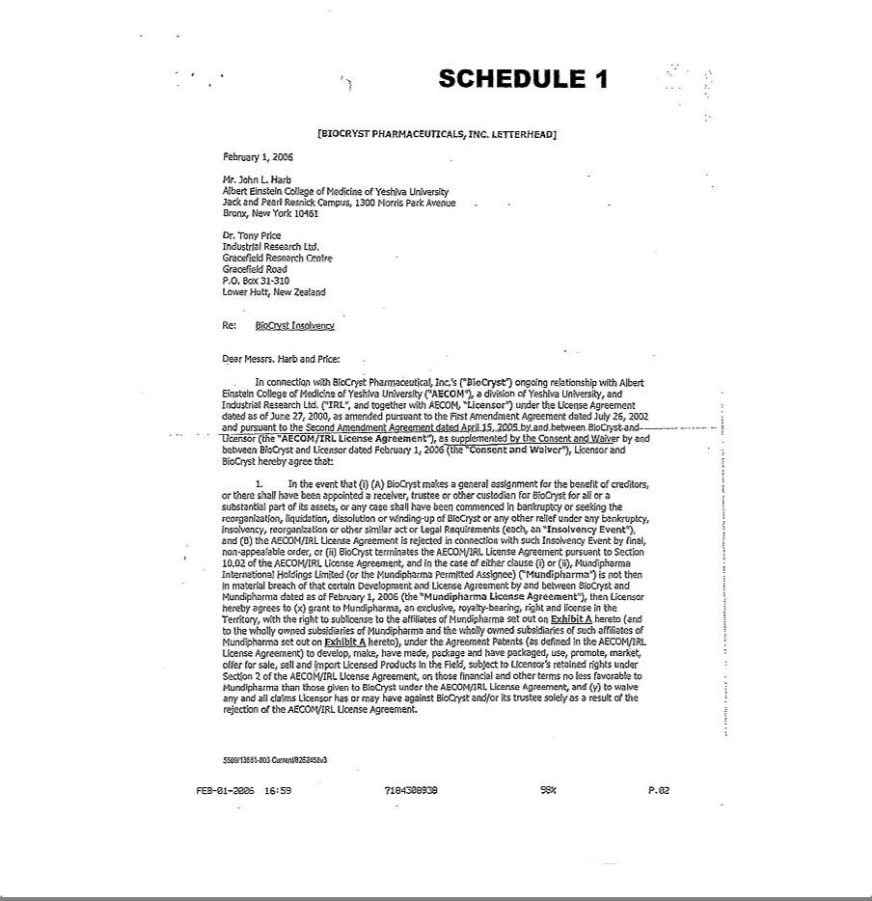

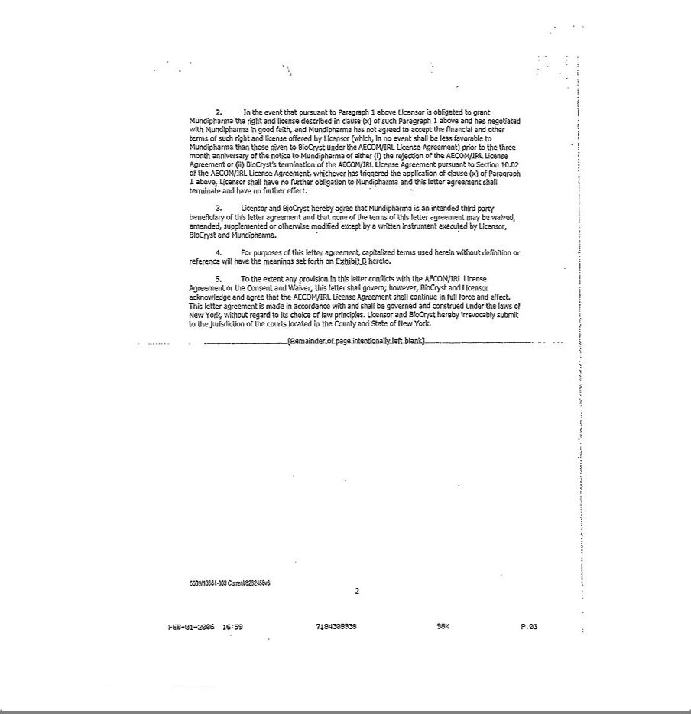

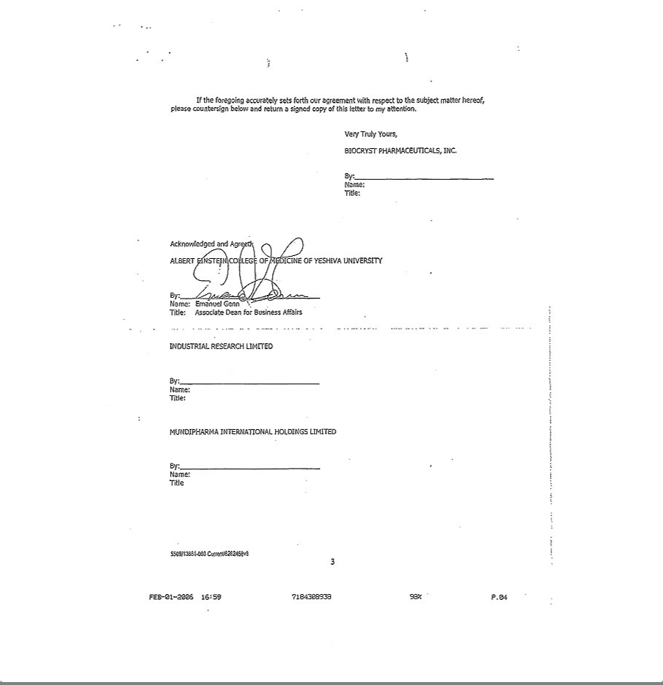

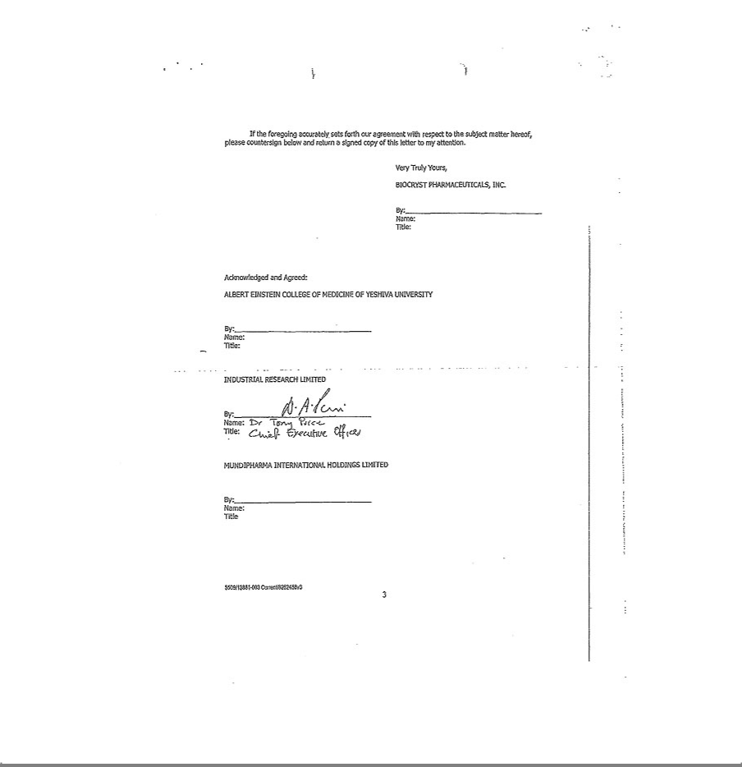

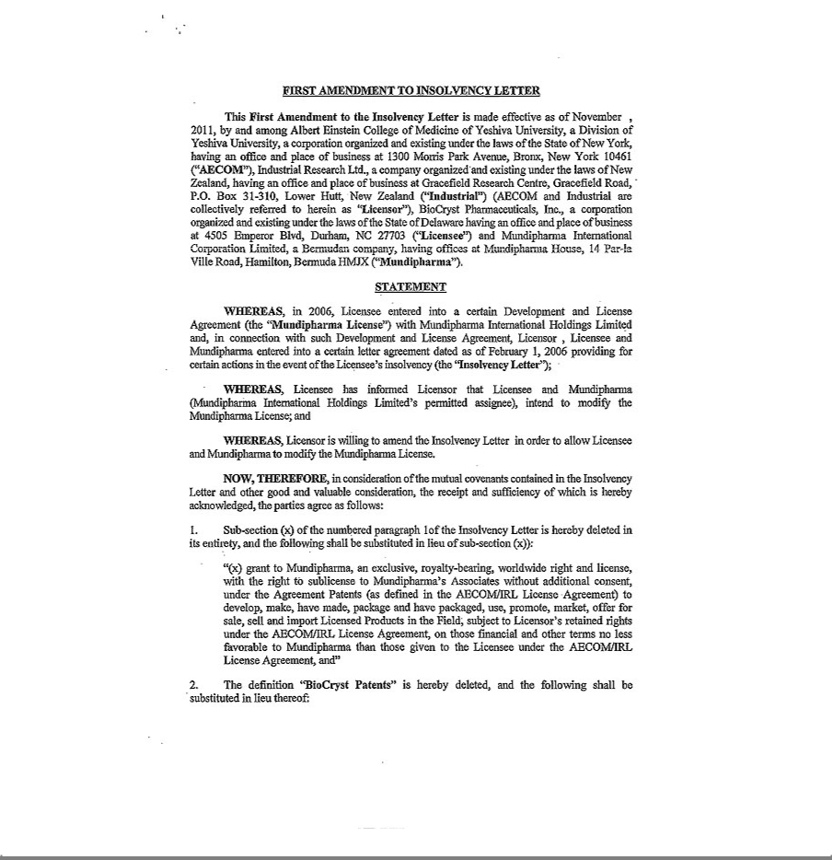

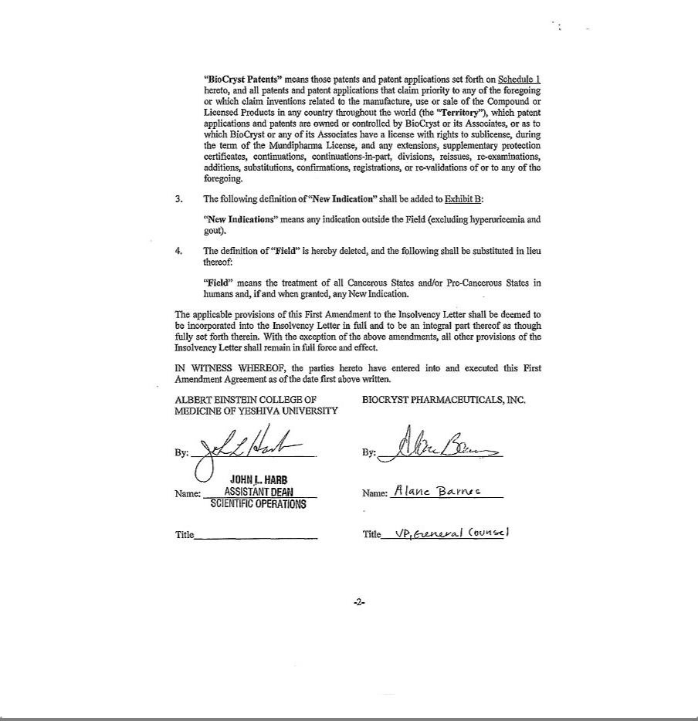

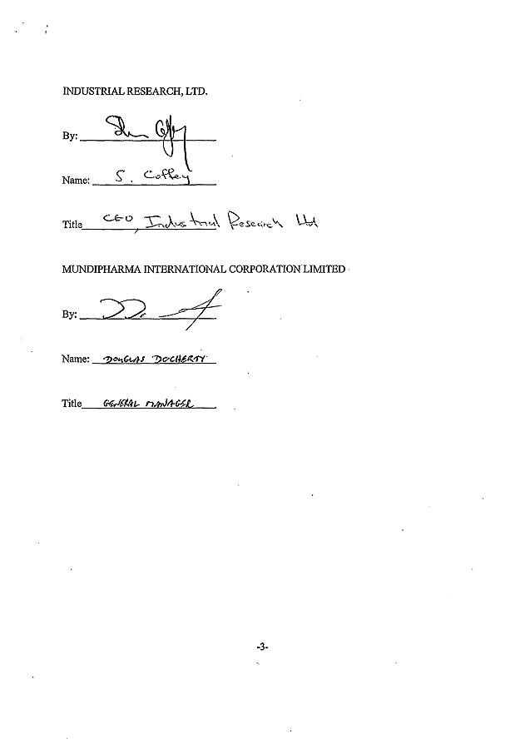

Exhibit 10.7

NOVATION AGREEMENT

PARTIES

Albert Einstein College of Medicine of Yeshiva University, a Division of Yeshiva University, of 1300 Morris Park Ave, Bronx, NY 10461,United States of America; BioCryst Pharmaceuticals Inc. of 4505 Emperor Blvd, Suite 200, Durham, NC27703, United States of America (each a Continuing Party and together the Continuing Parties);

and

Callaghan Innovation Research Limited (formerly called Industrial Research Limited) registered in New Zealand under number 545472 (Retiring Party);

and

Victoria Link Limited, a wholly owned subsidiary of Victoria University of Wellington, registered in New Zealand under company number 540316 (Substitute Party);

together referred to as the Parties.

BACKGROUND

- Callaghan Innovation Research Limited has transferred its Carbohydrate Chemistry Research Teamand the related intellectual property toVictoria Link Limited and agreements exist between Callaghan Innovation Research Limited and Victoria University of Wellington (the “Transfer Agreements”).

- Albert Einstein College of Medicine of Yeshiva University, a Division of Yeshiva University, BioCryst Pharmaceuticals Inc. and Callaghan Innovation Research Limitedare parties to the Novated Contracts (as defined below).

- The Parties have agreed to release and discharge:

  - Callaghan Innovation Research Limited from the obligations and liabilities of Callaghan Innovation Research Limited to the Parties under the Novated

Contracts on the condition that the Substitute Party agrees to assume each and every obligation and liability of Callaghan Innovation Research Limited to the Continuing Parties under the Novated Contracts, and

  - The Continuing Parties from their obligations and liabilities to the Retiring Party

as of the Effective Date in accordance with the terms and conditions set forth herein.

IT IS AGREED AS FOLLOWS

- DEFINITIONS AND INTERPRETATION

In this Agreement:

1.1 Agreement means this Agreement and all its schedules and attachments.

1.2 Continuing Parties means the original party or parties, AECOM and BioCryst, who will continue to be bound under the Novated Contracts.

1.3 Effective Date means 6 January 2014.

1.4 Novated Contracts means the contract or contracts marked and annexed as Schedule 1 to this Agreement, including, but not limited to, the Consent and Waiver dated as of February 1, 2006 (as amended pursuant to the First Amendment to the Consent and Waiver dated October 27, 2011) as well as the AECOM/IRL License Agreement dated June 27, 2000 (as amended pursuant to the First Amendment having an effective date of July 26, 2002; the Second Amendment having an effective date of April 15, 2005; the Third Amendment having an effective date of December 11, 2009; the Fourth Amendment having an effective date of May 5, 2010; the Fifth Amendment having an effective date of November 17, 2011; and the Sixth Amendment having an effective date of 19 June, 2012).

1.5 Retiring Party means Callaghan Innovation Research Limited, who is releasing and discharging its obligations and liabilities under the Novated Contracts, in accordance with the terms and conditions set forth herein.

1.6 Substitute Party means Victoria Link Limited, who is assuming the obligations and liabilities of Retiring Party under the Novated Contracts in accordance with the terms and conditions set forth herein.

1.7 Working Day means any day on which registered banks are open for general banking business in Wellington, other than a Saturday, Sunday, public holiday in Wellington, New Zealand, or a day on which Victoria University of Wellington is closed (as identified in its calendar).

- NOVATION

2.1 With effect on or after the Effective Date, and subject to clauses 3.1 and 7.1, the Parties novate the Novated Contracts and the Substitute Party undertakes to the

Continuing Parties that it will:

- replace the Retiring Party and be bound by the Novated Contracts as set forth in this Agreement; and

- discharge all of the obligations of the Retiring Party under the Novated Contracts and observe all the provisions of the Novated Contracts to the extent they ariseon or after the Effective Date; and

-2-

  - be liable to the Continuing Parties for the performance of any obligations on the part of the Retiring Party under or in connection with the Novated Contractson or afterthe Effective Date.

- RELEASE OF RETIRING PARTY’S OBLIGATIONS

3.1 In consideration of the undertaking by the Substitute Party under clause 2.1 above, and subject to clause 7.1, with effect on or afterthe Effective Date, the Continuing Parties release and discharge the Retiring Party from further performance of its obligations under the Novated Contracts and from all liabilities, claims and demands of any kind arising under or in connection with the Novated Contracts on or after the Effective Date but not prior to the Effective Date. The Retiring Party will continue to be liable to the Continuing Parties for all of its acts and omissions which occurred before the Effective Date as if this Agreement of Novation had never been executed.

- CONTINUING PARTIES’ OBLIGATIONS

4.1 Each of theContinuing Partiesundertake to the Substitute Party that it will on or after the Effective Date:

  - discharge all of its respective obligations under the Novated Contracts and observe all the provisions of the Novated Contracts; and

  - be liable to the Substitute Party for the performance of its respectiveobligations under or in connection with the Novated Contracts arising on or after the Effective Date.

- CESSATION OF RETIRING PARTY’S RIGHTS

5.1 Without prejudice to clauses 2.1 and 4.1 above, with effect on or after the Effective Date, the Retiring Party shall cease to have any rights under the Novated Contracts in respect of any acts or omissions of the Continuing Parties on or after the Effective Date arising under or in connection with the Novated Contracts.

Accordingly, the Retiring Party releases and discharges each Continuing Party from further performance of its respective obligations under the Novated Contracts and from all liabilities, claims and demands of any kind arising under or in connection with the Novated Contracts on or after the Effective Date.

- WARRANTIES AND ACKNOWLEDGEMENT

6.1 Each of the Continuing Parties and the Retiring Party warrants to the Substituting Party that as at the Effective Date:

-3-

- the Novated Contracts constitute the entire agreement between the Continuing Parties and the Retiring Party relating to the subject matter of the Novated Contracts with the understanding that a separate agreement addresses certain additional agreements entered into by the Continuing Parties, Substitute Party, Retiring Party and Mundipharma International Corporation; and

- so far as it is aware neither the Retiring Party nor the Continuing Parties is in default under the Novated Contracts which could lead to termination of the Novated Contracts; and

- all fees and payments which have become due to the Continuing Parties or the Retiring Party respectively have been duly paid by the Party responsible for payment.

6.2 The Continuing Parties and the Substitute Party acknowledge and agree that the Novated Contracts continue in full force and effect on and afterthe Effective Date in accordance with their terms as novated by this Agreement.

6.3 The Retiring Party and the Substitute Party each warrant to eachContinuing Party that;

- they have completed the appropriate documents and transfer so that each Continuing Party is released of obligations from the Retiring Party for obligations going forward on or after the Effective Date of this Agreement;

- the Transfer Agreements contain appropriate assignments of all patents and patent applications which relate to the Novated Contracts and that such assignments will be promptly recorded in each country; and

- the Novated Contracts as set forth in Schedule I make reference to each and every agreement entered into by the Continuing Parties and the Retiring Party (subject to Section 6.1(a) of this Agreement) such that each of the Continuing Parties will enjoy the same rights and benenfits and assume the same obligations and liabilities as would be the case if the Continuing Parties had not entered into this Agreement.

6.4 The Substitute Party warrants to each Continuing Party that:

  - it is a viable going concern and has the personnel, expertise and resources to carry out it obligations and responsibilities under the Novated Contracts and has the financial resources to assume any and all liabilities under the Novated Contracts; and

  - the Substitute Party has the right to grant the rights and licences under the Novated Contracts.

- CONFIDENTIALITY

7.1 Notwithstanding the novation effected by this Agreement, the Retiring Party will continue to be bound by any obligations of confidentiality and non-disclosure that the Retiring Party would have been under had the Retiring Party continued to be a Party of the Novated Contracts.

-4-

- ASSIGNMENT AND AMENDMENT

8.1 Without the prior written approval of the Continuing Parties and the Substitute Party, which approval shall not be unreasonably withheld, no Continuing Party or Substitute Party will assign this Agreement except to a successor in interest by merger or sale of all or substantially all of the such Party’s business to which this Agreement relates.

8.2 No amendment to this Agreement shall be binding unless in writing and agreed to and signed by the respective Parties.

- ENTIRE AGREEMENT

9.1 This Agreement, together with any documents referred to in it, constitutes the whole agreement between the Parties relating to its subject matter and supersedes and extinguishes any prior drafts, agreements, undertakings, representations, warranties and arrangements of any nature, whether in writing or oral, relating to such subject matter.

- NOTICES

10.1 Any communication including any notice, consent, information, application or request that must or may be given or made to a Party under this Agreement, can be:

- in writing and sent to the physical address of the Party as listed in the Novated Contracts, or, with respect to the Retiring Party and the Substitute Party, as listed at clause 10.3, and marked for the attention of the person or office holder (if any) from time to time designated for that purpose by the relevant Party;

- in writing and sent to the email address of the Party as listed at clause 10.3 or of the person or office holder (if any) from time to time designated for that purpose by the relevant Party and followed by a hard copy sent by post in accordance with clause 10.1(a);

- in writing and delivered in person to the physical address of the Party as listed at clause 10.3, and marked for the attention of the person or office holder (if any) from time to time designated for that purpose by the relevant Party.

10.2 A communication including any notice, consent, information, application or request will be deemed to be received:

- by post, on the third Working Day after posting;

- by email,

  - where it is transmitted on a Working Day, on the Working Day on which it is transmitted and at the time the email enters the recipient’s information system as evidenced by a delivery receipt requested by the sender and it is not returned undelivered as an error; or

-5-

ii.where it is transmitted on a day other than a Working Day, at 9:00 a.m. on the subsequent Working Day after the date of transmission;

- by personal delivery, at the date and time it was delivered.

10.3 The physical address, email address and relevant person or office holder of the Retiring Party and the Substitute Party are set out below:

The University

Name:

Address:

Deputy Vice-Chancellor (Research)

Victoria University of Wellington

PO Box 600

Wellington 6140

Email address:

neil.quigley@vuw.ac.nz

With a copy to:

In-house Solicitor

Victoria University of Wellington

PO Box 600

Wellington 6140

simon.johnson@vuw.ac.nz

Callaghan Innovation Research Limited

Name:

Address:

Email address:

General Manager Research and Technical Services

Callaghan Innovation

PO Box 31310

Lower Hutt 5040

Richard.Templer@callaghaninnovation.govt.nz

With a copy to:

Solicitor

Callaghan Innovation

PO Box 31310

Lower Hutt 5040

Pauline.Zumbach@callaghaninnovation.govt.nz

- GENERAL

11.1 A failure by a Party to enforce a provision of this Agreement will not constitute a waiver of any right to future enforcement of that or any other provision.

11.2 If any part of this Agreement is unenforceable, invalid or illegal, the other terms will remain in force.

11.3 This Agreement may be signed in counterparts, including by facsimile or email, all of which, when taken together, will constitute one and the same document.

-6-

11.4 This Agreement will be governed and construed under the laws of New York, without regard to its choice of law principles. The Parties hereby irrevocably submit to the jurisdiction of the courts located in the County and State of New York.

Executed as an Agreement:

Signed by Albert Einstein College of Medicine of Yeshiva University, a Division of Yeshiva University:

/s/ John L. Harb

Signature

John L. Harb

Name of authorised signatory

Assistant Dean

Scientific Operations

Position of authorised signatory

Date: 17 June 2015

-7-

Signed by BioCryst Pharmaceuticals Inc:

/s/ Alane Barnes

Signature

Alane Barnes

Name of authorised signatory

VP, General Counsel

Position of authorised signatory

Date: 17 June 2015


Signed by Callaghan Innovation Research Limited:

 | /s/ Pauline Zumbach |  | /s/ Richard Templer
 | Witness Signature |  | Signature of Attorney
 | Pauline Zumbach |  | Name: Richard Templer
 | Name of Witness |  | Position: General Manager Research and Technical Services
 | Wellington, New Zealand
 | Location of Witness
 |  |  | Date: 8 June 2015
 | Chief Legal Advisor
 | Occupation of Witness
 |  | -8-

Signed by Victoria Link Limited:

/s/ Simone Smith

Witness Signature

Simone Smith

Name of Witness

Wellington, New Zealand

Location of Witness

Administration Manager

Occupation of Witness

/s/ G.A. Todd


Signature

G.A. Todd

Name of authorised signatory

Managing Director

Position of authorised signatory

Date: 24 June 2015

-9-

Schedule 1

License Agreement dated as of June 27, 2000, by and among Albert Einstein College of Medicine, Industrial Research, Ltd. and BioCryst Pharmaceuticals, Inc., as amended by the First Amendment Agreement dated as of July 26, 2002 and the Second Amendment Agreement dated as of April 15, 2005. Filed as Exhibit 10.1 to the Company’s Form 8-K filed November 30, 2005.

Third Amendment Agreement by and among Albert Einstein College of Medicine, Industrial Research, Ltd. and BioCryst Pharmaceuticals, Inc., dated as of December 11, 2009. Filed as Exhibit 10.33 to the Company’s Form 10-K filed March 9, 2010.

Fourth Amendment Agreement by and among Albert Einstein College of Medicine, Industrial Research, Ltd. and BioCryst Pharmaceuticals, Inc., dated as of May 5, 2010. Filed as Exhibit 10.1 to the Company’s Form 10-Q filed August 6, 2010.

Fifth Amendment Agreement by and among Albert Einstein College of Medicine, Industrial Research, Ltd. and BioCryst Pharmaceuticals, Inc., dated as of November 17, 2011. Filed as Exhibit 10.36 to the Company’s Form 10-K filed March 6, 2012.

Sixth Amendment Agreement by and among Albert Einstein College of Medicine, Industrial Research, Ltd. and BioCryst Pharmaceuticals, Inc., dated as of June 19, 2012. Filed as Exhibit 10.1 to the Company’s Form 10-Q filed August 8, 2012.

Consent and Waiver dated February 1, 2006 relating to the License Agreement among Albert Einstein College of Medicine, Industrial Research, LTD and BioCryst Pharmaceuticals, Inc. dated as of June 27, 2000, as amended pursuant to the First Amendment Agreement dated July 26, 2002 and pursuant to the Second Amendment Agreement dated April 15, 2005. [ATTACHED]

First Amendment to Consent and Waiver dated October 27, 2011 by and among Albert Einstein College of Medicine of Yeshiva University, Industrial Research Ltd., and BioCryst Pharmaceuticals, Inc. [ATTACHED]

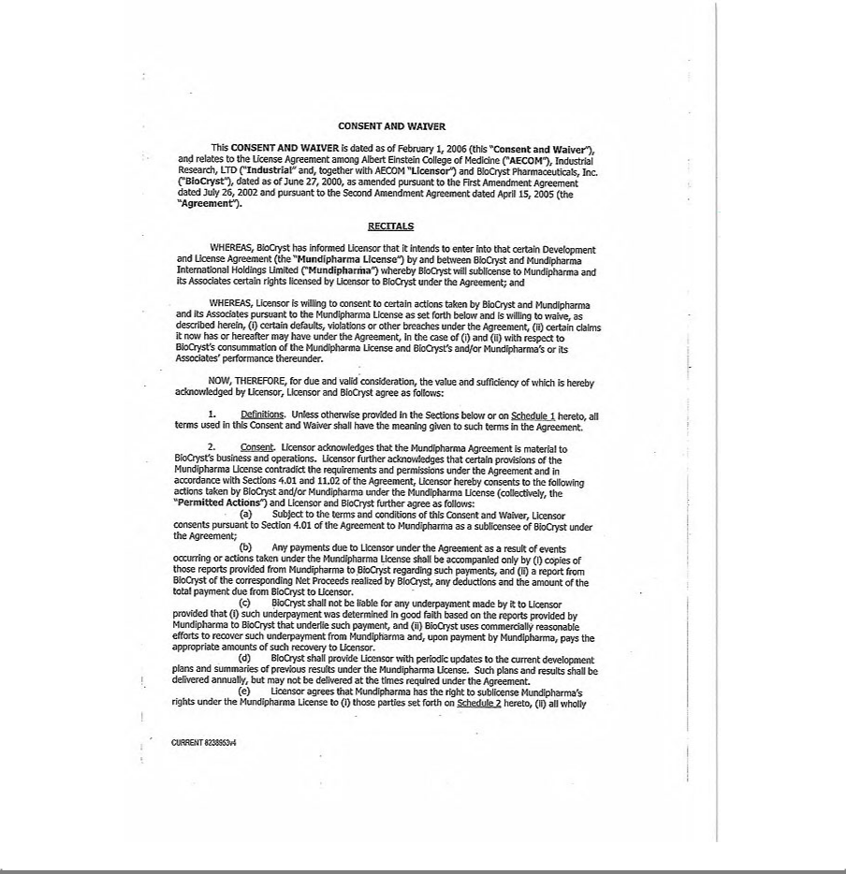

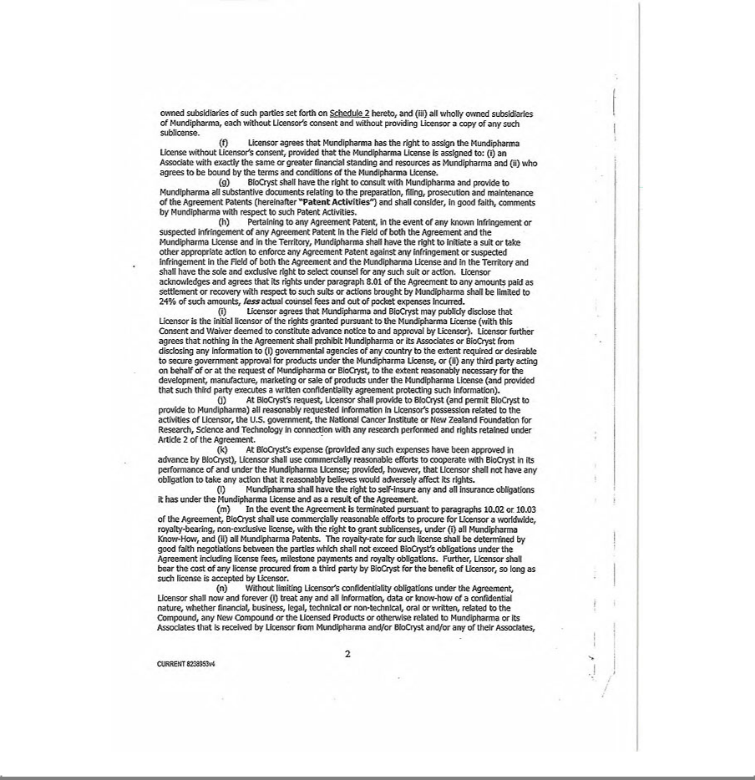

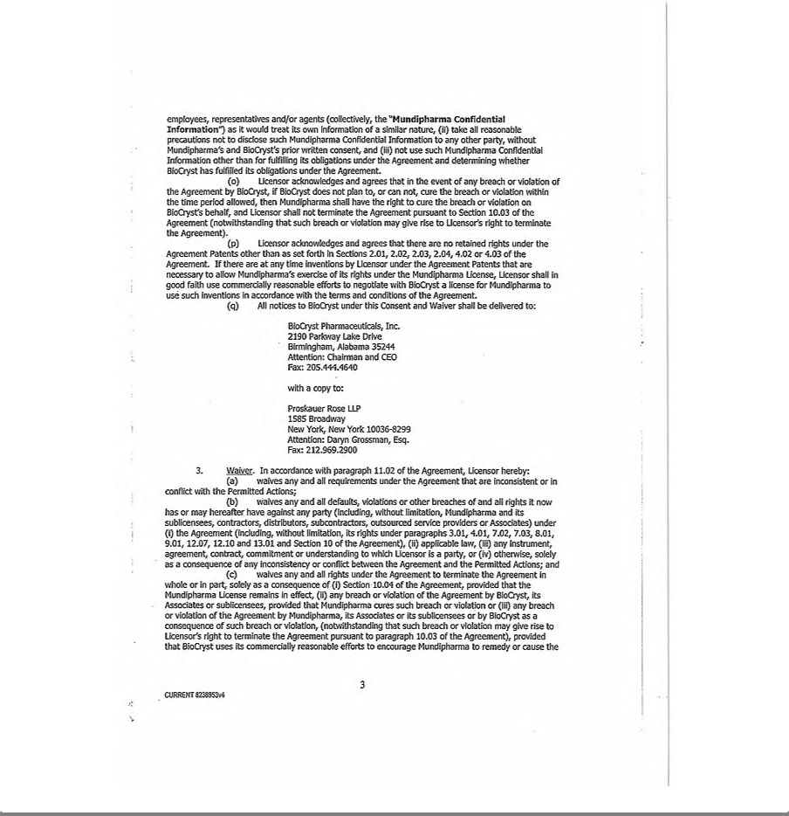

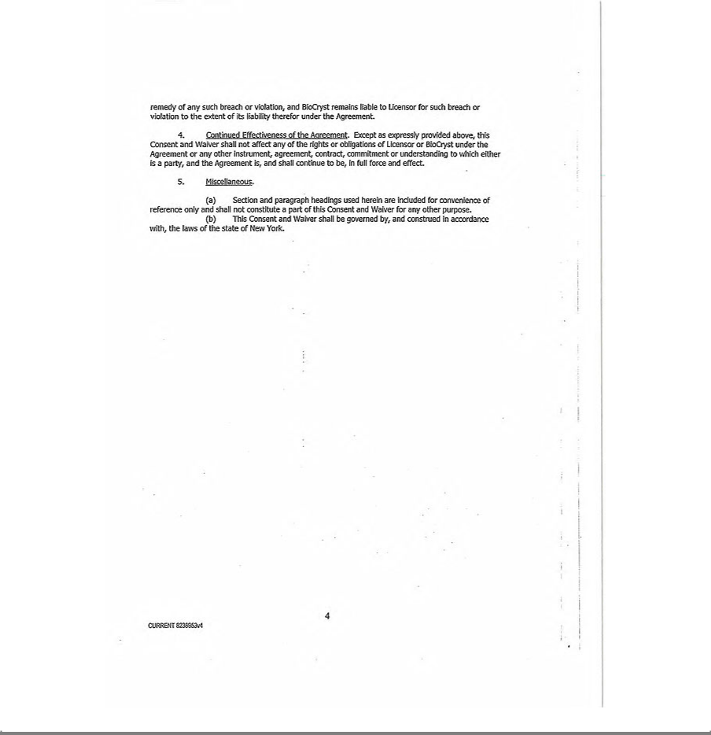

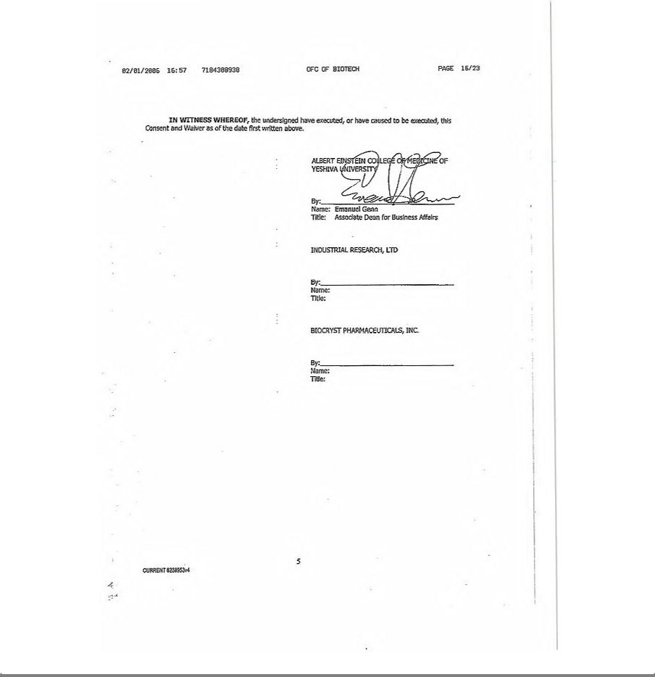

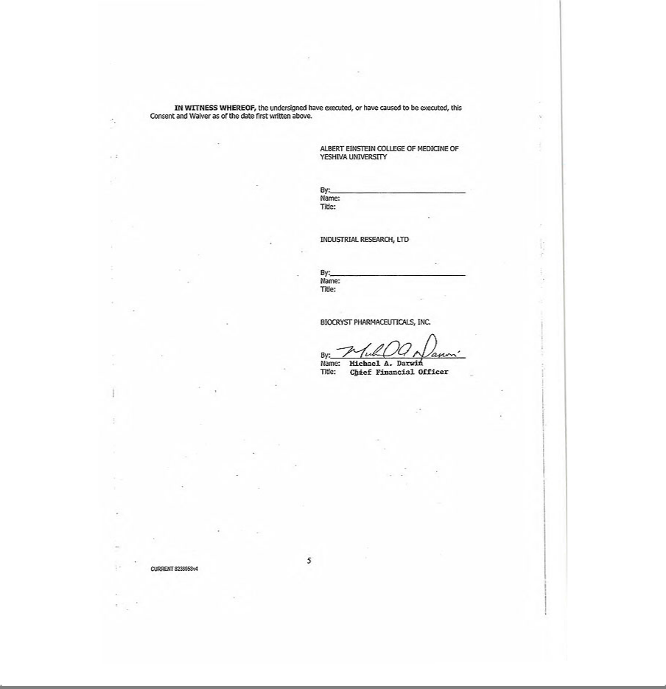

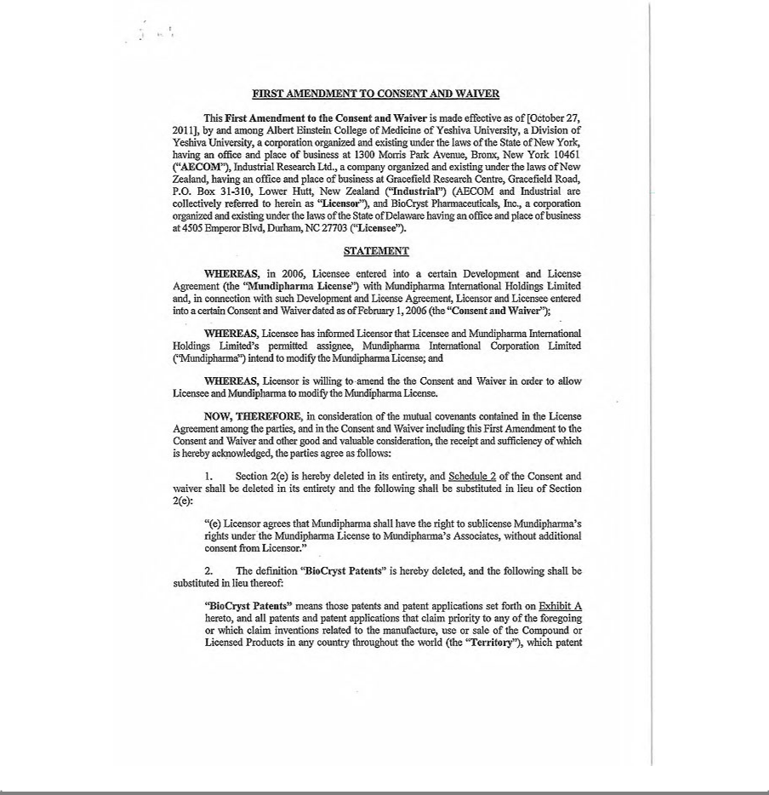

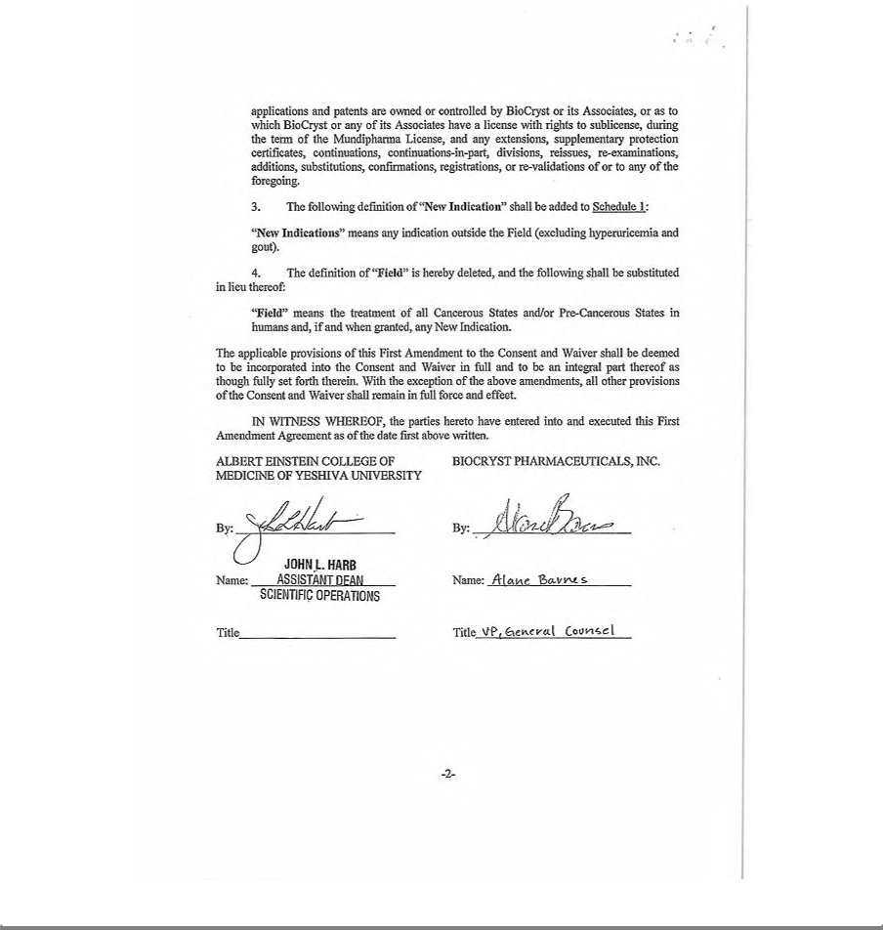

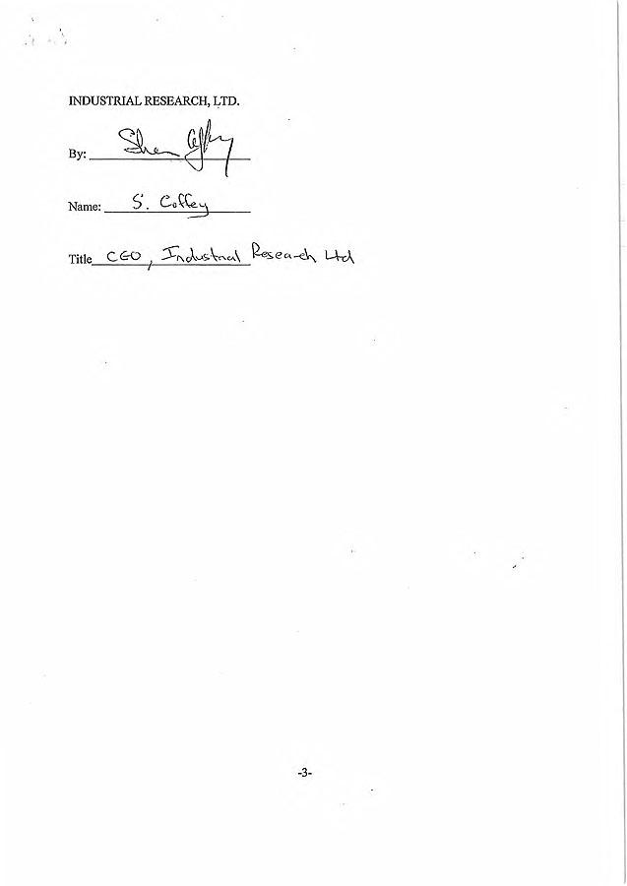

Exhibit 10.8

Pursuant to 17 CFR 20.24b-2, confidential information has been omitted in places marked "***" and has been filed separately with the Securities and Exchange Commission pursuant to a Confidential Treatment Application with the Commission.

LICENSE AGREEMENT

by and between

BIOCRYST PHARMACEUTICALS, INC.

and

SEQIRUS UK LIMITED

Dated as of June 16, 2015

Pursuant to 17 CFR 20.24b-2, confidential information has been omitted in places marked "***" and has been filed separately with the Securities and Exchange Commission pursuant to a Confidential Treatment Application with the Commission.

 | TABLE OF CONTENTS
Article 1 DEFINITIONS |  | 1
1.1. | Defined Terms | 1
Article 2 LICENSE GRANT, RETAINED RIGHTS AND PROVISION OF DATA |  | 12
2.1. | License Grant; Reservation of Rights | 12
2.2. | Manufacturing | 13
2.3. | Retained Rights | 13
2.4. | Stockpile Sales | 14
2.5. | Transfer of BioCryst Know-How | 14
2.6. | Covenants re Commercialization of Certain Products | 14
2.7. | Purchase and Sale of Compound | 15
2.8. | Right of First Negotiation | 15
Article 3 REGULATORY MATTERS; DATA; SUPPLY |  | 15
3.1. | General and Post-Marketing Commitments | 19
3.2. | Data | 18
3.3. | Cooperation | 19
3.4. | Sale and Purchase of Existing Licensed Product Inventory | 19
3.5. | Target Sales Forecast | 20
3.6. | Use of Contractors | 20
Article 4 GOVERNANCE |  | 20
4.1. | Joint Steering Committee | 20
4.2. | JSC Membership; Appointment of Alliance Manager | 20
4.3. | JSC Co-Chairs | 21
4.4. | JSC Meetings | 21
4.5. | Day-to-Day Decision-Making Authority | 21
Article 5 DEVELOPMENT. |  | 21
Article 6 COMMERCIALIZATION. |  | 22
6.1. | General | 22
6.2. | Commercialization Plan | 22
6.3. | Amendments | 23
6.4. | Costs of Commercialization | 23
6.5. | Promotional Material | 23
6.6. | Trademark, Domain Names and other Intellectual Property | 23
6.7. | Commercialization Inside and Outside of Territory | 24
6.8. | Assumption of Price Reporting Obligations | 24

-i-

Pursuant to 17 CFR 20.24b-2, confidential information has been omitted in places marked "***" and has been filed separately with the Securities and Exchange Commission pursuant to a Confidential Treatment Application with the Commission.

Article 7 ADVERSE EVENT AND PRODUCT COMPLAINT REPORTING; RECALL |  | 24
7.1. | Before the Global PV Transfer Date | 24
7.2. | Global PV Transfer Date | 25
7.3. | After the Global PV Transfer Date | 25
7.4. | Recall | 25
7.5. | Pharmacovigilance Agreement | 26
Article 8 INSURANCE |  | 26
8.1. | Required Insurance | 26
8.2. | Premium | 26
8.3. | Evidence of Coverage | 27
Article 9 PAYMENTS |  | 27
9.1. | Signing Fee | 27
9.2. | Milestone Payments | 27
9.3. | Royalty Payments | 27
9.4. | Payments | 30
9.5. | Taxes | 30
9.6. | Audit Rights | 31
Article 10 INTELLECTUAL PROPERTY |  | 31
10.1. | Prosecution and Maintenance of BioCryst Patents | 31
10.2. | Inventions; License of CSL Intellectual Property Rights | 32
10.3. | Infringement and Post-Grant Proceedings by Third Party | 32
10.4. | Claimed Infringement | 34
Article 11 PUBLICITY; CONFIDENTIALITY. |  | 35
11.1. | Press Releases and Other Disclosures | 35
11.2. | Publications | 35
11.3. | Confidential Information | 35
11.4. | SEC Disclosure of this Agreement | 36
11.5. | Authorized Disclosure | 36
11.6. | Application to Earlier Information | 37
11.7. | Specific Performance | 37
11.8. | Return of Confidential Information | 37

-ii-

Pursuant to 17 CFR 20.24b-2, confidential information has been omitted in places marked "***" and has been filed separately with the Securities and Exchange Commission pursuant to a Confidential Treatment Application with the Commission.

Article 12 REPRESENTATIONS, WARRANTIES AND COVENANTS |  | 38
12.1. | By BioCryst | 38
12.2. | By Both Parties | 39
12.3. | Disclaimer | 40
12.4. | Exclusion of Consequential Damages; Limitation of Remedy | 40
Article 13 TERM AND TERMINATION |  | 41
13.1. | Term | 41
13.2. | Termination By BioCryst | 41
13.3. | Termination By CSL | 41
13.4. | Effect of Termination | 42
Article 14 DISPUTE RESOLUTION |  | 45
14.1. | General | 45
14.2. | Informal Mediation | 45
14.3. | Escalation | 46
14.4. | Arbitration | 46
14.5. | No Arbitration of Intellectual Property Issues | 46
Article 15 INDEMNIFICATION |  | 46
15.1. | Indemnification by CSL | 46
15.2. | Indemnification by BioCryst | 47
15.3. | Indemnification Procedures | 47
Article 16 MISCELLANEOUS |  | 48
16.1. | Assignment | 48
16.2. | Section 365(n) | 48
16.3. | Governing Law; Venue | 49
16.4. | Severability | 49
16.5. | Notices | 50
16.6. | No Waiver | 51
16.7. | Further Assurances | 51
16.8. | No Third-Party Beneficiaries | 51
16.9. | Relationship of the Parties | 51
16.10. | Government Funding | 51
16.11. | Cost | 51
16.12. | Interpretation | 52
16.13. | No Modifications | 52
16.14. | Entire Agreement | 52
16.15. | Force Majeure | 53
16.16. | Counterparts | 53

-iii-

Pursuant to 17 CFR 20.24b-2, confidential information has been omitted in places marked "***" and has been filed separately with the Securities and Exchange Commission pursuant to a Confidential Treatment Application with the Commission.

LICENSE AGREEMENT

This LICENSE AGREEMENT, including any schedules, annexures, attachments or exhibits hereto (this “Agreement”) is entered into as of June 16, 2015 (the

“Effective Date”) by and between BIOCRYST PHARMACEUTICALS, INC., a corporation organized and existing under the laws of the State of Delaware having offices at 4505 Emperor Blvd., Suite 200, Durham, NC 27703 (“BioCryst”), and SEQIRUS UK LIMITED, a limited company organized under the laws of the United Kingdom, having a business address at 100 New Bridge Street, London, England, EC4V 6JA (“CSL”). BioCryst and CSL are each referred to herein by name or individually as a “Party” or collectively as the “Parties.”

BACKGROUND

WHEREAS, BioCryst owns or controls patents, know-how and other intellectual property related to a compound known as Peramivir.

WHEREAS, CSL or its Affiliates have expertise in the manufacture, sale and distribution of pharmaceutical products in the Territory (as defined below).

WHEREAS, CSL wishes to obtain from BioCryst, and BioCryst wishes to grant to CSL, in the Territory only, certain rights and licenses under certain of BioCryst’s patents, know-how and trademarks to manufacture and sell Licensed Products (as defined below) in the Territory, all on the following terms and conditions.

NOW, THEREFORE, in consideration of the premises and mutual covenants herein below, and for other good and valuable consideration, the receipt and sufficiency of which are hereby acknowledged, the Parties hereby agree as follows:

ARTICLE 1

DEFINITIONS.

1.1. Defined Terms. As used in this Agreement, the following terms shall have the meanings indicated:

- “Act” means both the US Federal Food, Drug, and Cosmetic Act, as amended from time to time, and the regulations promulgated under

the foregoing.

- “Additional Finished Products” means the Licensed Products owned or controlled by BioCryst which are manufactured after the Effective Date in Finished Dosage Form for sale to CSL in accordance with Section 3.4.

- “Adult Influenza Indication” means the treatment of acute influenza in patients 18 years and older or, for a given country, such other indication as agreed between the Parties.

- “Affiliate” means any Person which is directly or indirectly controlling, controlled by or under common control of a Party, for so long as such control exists. For the purposes of this Section 1.1(d), “control” means, with respect to a Person, (a) the power to direct or cause direction of the management and policies of such Person (whether through ownership of securities or partnership or other ownership interests, by contract or otherwise), or (b) ownership of at least 50% of the voting securities (whether directly or pursuant to any vested and exercisable option, warrant or other similar arrangement) or other comparable equity interests.

For clarity, neither of the Parties shall be deemed to be an “Affiliate” of the other.

-1-

Pursuant to 17 CFR 20.24b-2, confidential information has been omitted in places marked "***" and has been filed separately with the Securities and Exchange Commission pursuant to a Confidential Treatment Application with the Commission.

- “Agreement Improvements” shall have the meaning set forth in Section 10.2.

- “Annual Forecasted Amount” shall have the meaning set forth in Section 3.5.

- “Assigned Territory” has the meaning set forth in Section 3.1(e).

- “Bankruptcy Code” means Section 101(35A) of Title 11 of the United States Code, as amended.

- “BioCryst Development Agreements” means the following agreements:

  - The agreement between BioCryst and the Department of Health and Human Services last signed 3 January 2007, with contract

number HHS0100200700032C; (ii)

the UAB Agreement.

- “BioCryst Existing Manufacturers” means BioCryst’s contract manufacturers of Licensed Product and Compound as at the Effective Date, as set forth in Schedule 1.1(i) attached hereto and their permitted licensees.

- “BioCryst FDA Post-Marketing Commitments” has the meaning set forth in Section 3.1(a).

- “BioCryst Filed NDA” has the meaning set forth in Section 3.1(a).

- “BioCryst Know-How” means Know-How owned or Controlled by BioCryst on the Effective Date or during the term of this Agreement.

- “BioCryst Indemnitees” has the meaning set forth in Section 15.1.

- “BioCryst Intellectual Property Rights” means all Intellectual Property Rights owned or Controlled by BioCryst on the Effective Date or during the term of the Agreement, including but not limited to BioCryst Know-How, the BioCryst Marks, and BioCryst Patents.

- “BioCryst-Led Regulatory Activities” has the meaning set forth in Section 3.1(b).

- “BioCryst Marks” shall have the meaning set forth in Section 6.6(a).

-2-

Pursuant to 17 CFR 20.24b-2, confidential information has been omitted in places marked "***" and has been filed separately with the Securities and Exchange Commission pursuant to a Confidential Treatment Application with the Commission.

- “BioCryst Patents” means those Patents owned or Controlled by BioCryst on the Effective Date or during the term of the Agreement that are filed or issued in the Territory, solely to the extent such Patents include claims that Cover the making, Development, Commercialization, use, manufacture, sale, offer for sale or importation of Licensed Products, which Patents existing as of the Effective Date are set forth on Schedule 1.1(r).

- “BioCryst Stockpile Sale” means a sale of Licensed Products by BioCryst or a licensee to a U.S. Government Entity solely for U.S. Government Stockpiling Purposes.

- “Business Day” means a day which is not a Saturday or Sunday or public holiday in any of London, England; Melbourne, Australia; or

Raleigh, U.S.A.

- “Channel Inventory” means the Licensed Product set forth in Schedule 1.1(u) sold by BioCryst to Third Parties prior to the Effective

Date.

- “Co-Chair” shall have the meaning set forth in Section 4.3.

- “Commercialization” means, with respect to the Licensed Products, any and all processes and activities conducted to permit, establish, promote and maintain Sales for the Licensed Products, including negotiating and obtaining pricing and reimbursement approvals, offering for sale, detailing, manufacturing, commercializing (including launch), promoting, marketing (including education and advertising activities), storing, transporting, supporting, distributing, and importing the Licensed Products. “Commercialize” and “Commercializing” shall have their correlative meanings.

- “Commercialization Plan” shall have the meaning set forth in Section 6.2.

- “Commercial Net Sales” means Net Sales of Licensed Products excluding any Net Sales resulting from CSL Stockpile Sales.

- “Compound” means the chemical compound known as “Peramivir” having the following chemical structure:

(1S,2S,3R,4R)-3-[(1S)-1-(acetylamino)-2-ethylbutyl]-4-(carbamimidoylamino)-2-hydroxycyclopentanecarboxylic acid, trihydrate including the pharmaceutically active derivatives thereof, such as, but not limited to, anhydrous forms, salts, esters, prodrugs, metabolites, tautomers, isomers, labeled compounds, conjugates, complexes, and other related compounds thereof.
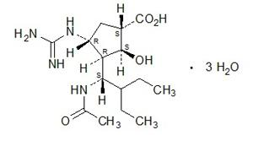

-3-

Pursuant to 17 CFR 20.24b-2, confidential information has been omitted in places marked "***" and has been filed separately with the Securities and Exchange Commission pursuant to a Confidential Treatment Application with the Commission.

- “Compulsory License” means a patent license that is ordered to be issued by a Governmental Entity to perform (or have performed) activities for the Development and Commercialization of a Licensed Product in that country, with the ultimate purpose of enabling a Third Party to market and sell such Licensed Product in the country in which such license is issued for the benefit of public health or for public policy reasons of the country in which it is issued.

- “Confidential Information” has the meaning set forth in Section 11.3.

- “Controlled” means, with reference to Intellectual Property Rights as to which a Party or any of its Affiliates is not the exclusive owner, the right of such Party or Affiliate to grant a license or sublicense with respect thereto to the other Party hereto without the consent of the person that co-owns such Intellectual Property Rights or has licensed or sublicensed such Intellectual Property Rights to such Party or Affiliate, without violating any obligation owed to that person.

- “Cost of Goods Sold” means, with respect to a Licensed Product sold by CSL or Permitted Sublicensee, the direct costs incurred by CSL or Permitted Sublicensee in manufacturing or acquiring such Licensed Product, calculated in accordance with GAAP.

- “Costs” has the meaning set forth in Section 16.11.

- “Cover”, “Covering” or “Covered” means, with respect to a compound, product, technology, process or method, that, in the absence of ownership of or a license granted under a Valid Claim, the manufacture, use, offer for sale, sale or importation of such compound or product or the practice of such technology, process or method, would infringe such Valid Claim.

- “CSL Indemnitees” has the meaning set forth in Section 15.2.

- “CSL Know-How” means all Know-How exclusively owned or Controlled by CSL that is created by CSL after the Effective Date in the exercise of its rights under this Agreement; used by CSL or any of its Affiliates in the Development, manufacture or Commercialization of a Licensed Product and that solely relates to Licensed Products or the Compound.

- “CSL Patent Rights” means all Patents in the Territory exclusively owned or Controlled by CSL that are created or acquired by CSL after the Effective Date in the exercise of its rights under this Agreement by CSL; that Cover the Development, manufacture or Commercialization of a Licensed Product and that solely relates to Licensed Products.

- “CSL Stockpile Sale” means a Sale of Licensed Products by CSL or any of its Permitted Sublicensees for Stockpiling Purposes to a Governmental Entity in any part of the Territory, other than to a U.S. Government Entity for U.S. Government Stockpiling Purposes.

-4-

Pursuant to 17 CFR 20.24b-2, confidential information has been omitted in places marked "***" and has been filed separately with the Securities and Exchange Commission pursuant to a Confidential Treatment Application with the Commission.

- “Data” means any and all research, pharmacology, medicinal chemistry, chemistry, manufacturing and controls, nonclinical, clinical and other data (including investigator reports and clinical study reports (both preliminary and final), statistical analyses, expert opinions and reports, safety and other electronic databases), medical information, pharmacovigilance information or Regulatory Information, in each case, relating to any Licensed Product.

- “Data Exclusivity Right” means the right or protection, granted by a Regulatory Authority in a jurisdiction, providing with respect to a drug product in such jurisdiction: (i) marketing exclusivity that prevents the Regulatory Authority from accepting or approving an application for Marketing Authorisation such as a an NDA(whether new or abbreviated), a Biologics License Application or an application relating to a biosimilar product submitted by a party other than the Parties (or their Affiliates, or licensees or sublicensees as applicable), for a pharmaceutical product (including a generic, biosimilar, similar medicinal product or generic or competing version of a pharmaceutical product) that is the same or a bioequivalent of the drug product, such as through new molecular entity or biological product or orphan drug or paediatric exclusivity designation by the applicable Regulatory Authority, or an exclusive right to sell pursuant to the data exclusivity provisions such as those under EC Directives 2004/27/EC and 2001/83/EC and Regulation 726/2004/EC; or (ii) data protection for regulatory data relating to the drug product against unfair commercial use or public release consistent with, or no less stringent than, Article 39.3 of the TRIPS Agreement.

- “Development” means, with respect to any Licensed Product, any and all research, development, pre-clinical, clinical and regulatory activities for such product, which may involve nonclinical studies, studies of chemistry, manufacturing and controls, clinical trials, regulatory affairs and other regulatory activities, quality of life assessments, pharmacoeconomics, post-marketing studies, label expansion studies, and further activities related to development of such product to a stage ready for Commercialization thereof, but excluding any BioCryst FDA Post-Marketing Commitments and any BioCryst-Led Regulatory Activities. “Develop” and “Developing” shall have their correlative meanings.”

- “Diligent Efforts” means, with respect to CSL, a commitment by or on behalf of CSL to use reasonable, diligent, good faith efforts to Commercialize any Licensed Product consistent with CSL’s practices in diligently and actively pursuing commercialization of its other pharmaceutical products at a similar stage of product life, with similar safety and efficacy profiles, and of similar commercial potential, taking into account product labeling or anticipated labeling, present and future market potential, past performance of such Licensed Product, financial return, medical and clinical considerations, the extent of Legal Exclusivity relating to such Licensed Product, present and future regulatory environment and competitive market conditions, all as measured by the facts and circumstances at the time such efforts are due (which practices shall be no less diligent or comprehensive than the practices which are customary in the pharmaceutical industry with respect to, and shall include at least the same level of reasonable, diligent, good faith efforts as would be devoted by, other pharmaceutical companies of a similar size to CSL in the Territory for such similar pharmaceutical products, taking into account the same factors described above).

- “Effective Date” has the meaning set forth in preamble.

-5-

Pursuant to 17 CFR 20.24b-2, confidential information has been omitted in places marked "***" and has been filed separately with the Securities and Exchange Commission pursuant to a Confidential Treatment Application with the Commission.

- “EMA” means the European Medicines Agency or any successor entity.

- “European Union” for purposes of this Agreement means the European countries in which the EMA exercises jurisdiction at any time during the term of this Agreement. As of the Effective Date, the EMA Countries are Austria, Belgium, Bulgaria, Croatia, Cyprus, Czech Republic, Denmark, Estonia, Finland, France, Germany, Greece, Hungary, Ireland, Italy, Latvia, Lithuania, Luxembourg, Malta, Netherlands, Poland, Portugal, Romania, Slovakia, Slovenia, Spain, Sweden, and United Kingdom as well as the Iceland, Liechtenstein and Norway.

- “Evaluation Period” has the meaning set forth in Section 2.8.

- “Ex-US BioCryst Filed NDA” has the meaning set forth in Section 3.1(e).

- “Existing Licensed Product Inventory” means: (i) the inventory of Licensed Products in Finished Dosage Form owned or controlled by BioCryst as of the Effective Date (to avoid doubt, including the Channel Inventory); and (ii) the inventory of Additional Finished Products, in each case in the amount set forth in Schedule 3.4.

- “FDA” means the United States Food and Drug Administration, or any successor entity thereto.

- “Field” means the diagnosis, prevention and/or treatment of all forms of influenza in humans.

- “Finished Dosage Form” means, in respect of a Licensed Product, fully-finished, packaged for sale in the United States, and in compliance with the Specifications and other requirements of Schedule 3.4.

- “Force Majeure Events” has the meaning set forth in Section 16.15.

- “GAAP” means then-current generally accepted accounting principles in the United States as established by the Financial Accounting Standards Board or any successor entity or other entity generally recognized as having the right to establish such principles, in each case consistently applied.

- “Generic Product” means, with respect to a Licensed Product, any pharmaceutical product, other than such Licensed Product that is marketed for sale other than by CSL, and (a) is approved for sale in part or sole reliance on the prior approval of such Licensed Product, as determined by the applicable Regulatory Authority or (b) is otherwise substitutable for such Licensed Product under applicable Laws by a pharmacist without the intervention of the prescribing physician.

- “Global PV Transfer Date” has the meaning set forth in Section 7.2.

- “Government Pricing Agreements” has the meaning set forth in Section 6.8. -6-

Pursuant to 17 CFR 20.24b-2, confidential information has been omitted in places marked "***" and has been filed separately with the Securities and Exchange Commission pursuant to a Confidential Treatment Application with the Commission.

- “GMP” means current Good Manufacturing Practices as defined by the regulatory authority where the Product has a Marketing Approval. In the United States, GMP shall be as defined under the rules and regulations of the FDA and in the EU, GMP is as defined in Commission Directives 91/356/EEC, as amended by Directive 2003/94/EC, and 91/412/EEC respectively, as the same may be amended from time to time.

- “Governmental Entity” means any of the following: any parliament, legislature, agency, bureau, branch, department, ministry, division, commission, court, tribunal, magistrate, justice, multi-national organization, quasi-governmental body or other similar recognized organization or body of any federal, state, provincial, county, municipal, local or foreign government or other similar recognized organization or body exercising similar powers or authority, including any agency or department thereof and any entity controlled or supervised by and acting as an instrument of such Governmental Entity.

- “Gross Profit” means the Net Sales less the Cost of Goods Sold.

- “Health Canada” means the Health Products and Food Branch of Health Canada or any successor entity.

- “ICC Rules” has the meaning set forth in Section 14.4.

- “Indemnified Party” has the meaning set forth in Section 15.3.

- “Indemnifying Party” has the meaning set forth in Section 15.3.

- “Infringement” has the meaning set forth in Section 10.3(a).

- “Infringement Costs” has the meaning set forth in Section 10.3(b).

- “Infringement Defense Costs” has the meaning set forth in Section 10.4.

- “Insolvency Event” means, with respect to any Party, the occurrence of any of the following: (i) such Party shall commence a voluntary case concerning itself under any bankruptcy, liquidation or insolvency code; (ii) an involuntary case is commenced against such Party under any bankruptcy, liquidation or insolvency code and the petition is not controverted within ten (10) business days, or is not dismissed within sixty (60) days, after commencement of the case; (iii) a custodian is appointed for, or takes charge of, all or substantially all of the property of such Party or such Party commences any other proceedings under any reorganization, arrangement, adjustment of debt, relief of debtors, dissolution, insolvency or liquidation or similar law of any jurisdiction whether now or hereafter in effect relating to such Party or there is commenced against such Party any such proceeding which remains undismissed for a period of sixty (60) days; (iv) any order of relief or other order approving any such case or proceeding is entered; (v) such Party is adjudicated insolvent or bankrupt; (vi) such Party suffers any appointment of any custodian, receiver or the like for it or any substantial part of its property to continue undischarged or unstayed for a period of sixty (60) days; (vii) such Party makes a general assignment for the benefit of creditors; (viii) such Party shall be unable to pay, its debts generally as they become due; (ix) such party shall call a meeting of its creditors with a view to arranging a compromise or adjustment of its debts; (x) such Party shall by any act or failure to act consent to, approve of or acquiesce in any of the foregoing; or (xi) any corporate, limited liability company, partnership or individual action, as applicable, is taken by such Party for the purpose of effecting any of the foregoing.

-7-

Pursuant to 17 CFR 20.24b-2, confidential information has been omitted in places marked "***" and has been filed separately with the Securities and Exchange Commission pursuant to a Confidential Treatment Application with the Commission.

- “Intellectual Property Rights” means all Patent, know-how, copyright, trade secret, trademark and other proprietary and intellectual property rights, or any application or right to apply for registration of such rights, anywhere in the world.

- “JSC” or “Joint Steering Committee” shall have the meaning set forth in Section 4.1.

- “Know-How” means all proprietary or non-public scientific and technical information, know-how, inventions, improvements, trade secrets, Data, materials and technology (whether patented, patentable or not) that relates to a Licensed Product, including but not limited to (a) medical, clinical, toxicological or other scientific Data; (b) pharmaceutical, chemical or biological materials, products or compositions, (c) tests, assays, techniques, data, methods, procedures, formulas or processes, (d) technical, medical, clinical, toxicological or other scientific data or other information relating to any of the foregoing, and (e) drawings, plans, designs, diagrams, sketches, specifications or other documents containing or relating to such information or materials, and (f) processes and analytical methodology; in each case useful in the making, use, sale, importation, Development, manufacture or Commercialization of a Licensed Product.

- “Know-How Transfer Plan” has the meaning set forth in Section 2.5.

- “Law” means, individually and collectively, any and all laws, ordinances, rules, directives and regulations of any kind whatsoever of any governmental or regulatory authority within the applicable jurisdiction.

- “Legal Exclusivity” means, with respect to a Licensed Product and a country or region, the existence of: (a) a Valid Claim that Covers such Licensed Product in such country or region, or (b) a Data Exclusivity Right applicable to the Licensed Product in such country or region.

- “Licensed Product” means all pharmaceutical preparations and methods of administration of the Compound in all dosage strengths, for use in the Field. For the avoidance of doubt, “Licensed Product” shall include any formulations and methods of administration, including intravenous, subcutaneous, intramuscular formulations and oral formulations, of any pharmaceutical preparation of the Compound.

- “Losses” has the meaning set forth in Section 15.1.

- “Manufacturing Responsibility Transfer Date” has the meaning set forth in Section 2.2.

-8-

Pursuant to 17 CFR 20.24b-2, confidential information has been omitted in places marked "***" and has been filed separately with the Securities and Exchange Commission pursuant to a Confidential Treatment Application with the Commission.

- “Marketing Approval” means, with respect to a particular product in a particular jurisdiction, all approvals, licenses, registrations or authorizations by a Regulatory Authority or other Governmental Entity necessary for the Commercialization of such product in such jurisdiction. Marketing Approval shall be deemed to have been received upon first receipt by a Party or its designee of notice from the applicable Regulatory Authority that Commercialization of such product has been approved in such jurisdiction. For the avoidance of doubt, any FDA authorization in connection with any sale of Licensed Product for emergency use under section 564 of the Federal Food, Drug, and Cosmetic Act shall not constitute a “Marketing Approval”. For the avoidance of doubt, “Marketing Approval” does not include pricing, reimbursement or formulary listings or approvals or the like, or product labeling or promotional materials approvals or the like.

- “NDA” means a New Drug Application, as defined in the Act, including all supplements and amendments thereto, or an equivalent application filed with the applicable Regulatory Authority, for the approval of a Licensed Product as a new drug by the applicable Regulatory Authority in the Territory.

- “NDA Transfer Date” has the meaning set forth in Section 3.1(a).

- “Negotiation Period” has the meaning set forth in Section 2.8.

- “Net Sales” means, with respect to a Licensed Product sold by CSL or Permitted Sublicensees, the gross amount invoiced by CSL or its Permitted Sublicensee to Third Parties that are not Permitted Sublicensees (or in the case of a Sale otherwise than at arm’s length price, the price which would have been invoiced in a bona fide arm’s length Sale), less, only as applicable to Licensed Products Sold, (a) trade, quantity and cash discounts; (b) sales, import, export, customs, and value added taxes, in each case included in the invoice or in the invoice price to such Third Parties; (c) freight, handling, insurance and other transportation or distribution charges and fees to the extent included in the invoice to such Third Parties; (d) (i) amounts repaid, credited or accrued by reason of rejections, recalls or returns (but excluding returns under CSL Stockpile Sales for any reason other than defect or order error), or (ii) because of chargebacks, allowances, adjustments, refunds or billing errors; (e) payments and rebates related to the sale of such Licensed Products accrued, paid or deducted pursuant to governmental regulations (e.g., Medicaid unit rebate amount); and (f) any amounts actually written off or specifically identified as uncollectible, in accordance with GAAP consistently applied. Use of Licensed Products for promotional, sampling or compassionate use purposes shall not be considered in determining Net Sales. Such amounts shall be determined from books and records maintained in accordance with United States GAAP in the Territory. No deductions shall be made for commissions paid to individuals, whether they are with independent sales agencies or regularly employed by CSL or Permitted Sublicensees, and on its payroll, or for the cost of collections. Sales of Licensed Product for the use in conducting research or development (including clinical trials) in order to obtain Regulatory Approvals of Licensed Product shall be excluded from Net Sales calculations for all purposes. Compassionate use shall also be excluded from Net Sales calculations for all purposes.

- “New Opportunity” has the meaning set forth in Section 2.8.

- “Outside Date” has the meaning set forth in Section 3.1(b)(ii).

-9-

Pursuant to 17 CFR 20.24b-2, confidential information has been omitted in places marked "***" and has been filed separately with the Securities and Exchange Commission pursuant to a Confidential Treatment Application with the Commission.

- “Patent” means any of the following, whether existing now or in the future anywhere in the world: (a) patents and patent applications; (b) continuations, continuations-in-part, provisionals, divisionals and substitute applications with respect to any such patent application; (c) any patents issued based on or claiming priority to any such patent applications; (d) any reissue, reexamination, renewal, patents of addition, or extension (including any supplemental patent certificate) of any such patents; and (e) any confirmation patent or registration patent or patent of addition based on any such patents.

- “Pediatric Influenza Indication” means the treatment of acute influenza in patients under 18 years of age or, for a given country, such other indication as agreed between the Parties.

- “Permitted Sublicensee” means any Affiliate or Third Party to which CSL has granted any sublicense under the licenses granted by BioCryst to CSL pursuant to Section 2.1 and 3.6.

- “Person” means any natural person or any corporation, company, partnership, joint venture, firm, Governmental Entity or other entity,

including a Party.

- “Pharmacovigilance Agreement” means a separate pharmacovigilance agreement between the Parties, in substantially the form attached

hereto as Schedule 7.5.

- “Post-Grant Proceeding” means any and all proceedings before any national patent authority that involves the review, examination, analysis or any combination thereof of any issued Patent, including without limitation post grant review proceedings, inter partes review proceedings, supplemental examinations, patent inference proceedings, opposition proceedings, and reexaminations.

- “Proceeds” has the meaning set forth in Section 10.3(b).

- “Promotional Material” means all Licensed Product packaging and labeling, and all written, printed, graphic, electronic, audio or video matter, including journal advertisements, sales visual aids, leave behind items, formulary binders, reprints, direct mail, direct-to consumer advertising, Internet postings and information on websites, training materials, broadcast advertisements and sales reminder aids, in each case created by a Party or on its behalf and used or intended for use in connection with any promotion of a Licensed Product in the Territory.

- “Publishing Party” has the meaning set forth in Section 11.2.

- “Quality Agreement” means a separate quality agreement between the Parties.

- “Rapivab Indication” means the same indications and usage as approved in the United States, as of the Effective Date.

-10-

Pursuant to 17 CFR 20.24b-2, confidential information has been omitted in places marked "***" and has been filed separately with the Securities and Exchange Commission pursuant to a Confidential Treatment Application with the Commission.

- “Regulatory Authority” means any federal, national, multinational, state, provincial or local regulatory agency, department, bureau or other Governmental Entity with authority over the Development, Commercialization or other use (including the granting of Marketing Approvals) of any Licensed Product in any jurisdiction, including the FDA.

- “Regulatory Filings” means all submissions, applications, filings and approvals by, with or from any Regulatory Authority.

- “Regulatory Information” means all regulatory and technical information which is useful and necessary in connection with applying for, obtaining and maintaining Regulatory Filings and Marketing Approvals including all clinical, preclinical, chemistry and manufacturing controls information relating to a Licensed Product, risk management plans, product safety update reports, or product quality reviews, GMP certifications in relation to the manufacture, testing, release and qualification of the Licensed Product and the Compound.

- “Reviewing Party” has the meaning set forth in Section 11.2.

- “Royalty Term” means, on a country-by-country basis, the period beginning on the Effective Date and ending on the later of: (1) the expiry of Legal Exclusivity in such country; and (2) the date that is ten (10) years from the Effective Date.

- “Sale”, “Sold” or “Sell” means the sale, transfer or disposition of any Licensed Product for value to a Third Party (whether an end user, wholesaler or otherwise) by a Party.

- “Senior Officers” has the meaning set forth in Section 14.3.

- “SEC” has the meaning set forth in Section 11.4.

- “Specifications” has the meaning set forth in Schedule 3.4.

- “Stockpiling Purposes” means, the purchase of Licensed Products by a Governmental Entity in the Territory, for the purpose of stockpiling a quantity of Licensed Products in preparation for a possible future outbreak of pandemic influenza and not for the purpose of satisfying seasonal demand for Licensed Products in the ordinary course.

- “Stockpile Sale” means a sale of Licensed Products to a Governmental Entity for Stockpiling Purposes.

- “Target Sales Forecast” shall have the meaning set forth in Section 3.5.

- “Territory” means worldwide, excluding Israel, Japan, South Korea and Taiwan.

- “Third Party” means any entity other than CSL or BioCryst or their respective Affiliates. -11-

Pursuant to 17 CFR 20.24b-2, confidential information has been omitted in places marked "***" and has been filed separately with the Securities and Exchange Commission pursuant to a Confidential Treatment Application with the Commission.

  - “Third-Party Claim” has the meaning set forth in Section 15.3.

  - “Transfer” has the meaning set forth in Section 16.1.

  - “UAB License” means the agreement dated as of November 23, 1994 by and between, on the one hand, The UAB Research Foundation (“UAB”) and, on the other hand, BioCryst, as amended and as it may be hereafter amended from time to time.

  - “U.S. Government Entity” means the federal government of the United States of America and any of its branches and instrumentalities, including its departments, agencies, bureaus, commissions, boards, courts, corporations, offices, and other entities, and any divisions or units thereof (and for the purposes of U.S. Government Stockpiling Purposes includes any U.S. state, county, municipal, or local government body, including any agency or department thereof and any entity controlled or supervised by and acting as an instrument of any such body).

  - “U.S. Government Stockpiling Purposes” means purchase of Licensed Products by a U.S. Government Entity for use in the United States:

- pursuant to the U.S. Government ‘Strategic National Stockpile’ program (or any successor program), or (ii) for the purpose of stockpiling a quantity of Licensed Products in preparation for a possible future outbreak of pandemic influenza and not for the purpose of satisfying seasonal demand for Licensed Products in the ordinary course.

  - “Valid Claim” means a claim in any BioCryst Patent that is either: (1) contained in an unexpired and issued Patent that has not been revoked or held invalid by a final unappealable decision of a court or governmental agency of competent jurisdiction and which is not appealable or has not been appealed within the time allowed for appeal, and which has not been abandoned, disclaimed, denied or admitted to be invalid or unenforceable through reissue, re-examination, disclaimer or otherwise, or (2) contained in a pending Patent application that has not been pending for more than seven years from the applicable priority date and that has not been abandoned.

ARTICLE 2

LICENSE GRANT, RETAINED RIGHTS AND PROVISION OF DATA.

2.1 License Grant; Reservation of Rights. Subject to all of the rights retained by BioCryst under Sections 2.2 and 2.3, BioCryst hereby grants CSL an exclusive, sublicensable (to the extent set forth below in this Section 2.1 and Section 3.6), transferable (to the extent set forth in Section 16.1), right and license under the BioCryst Patents and BioCryst Know-How to make, have made, use, sell, offer for sale, import, Develop, have Developed, manufacture, have manufactured, Commercialize and have Commercialized Licensed Products solely in the Field and in the Territory; including in connection with any CSL Stockpile Sales. BioCryst acknowledges and agrees that the license and sublicense rights granted by BioCryst under this Agreement may be exercised by CSL’s Affiliates, without the need for any further agreement to be put in place between the Parties or the relevant CSL Affiliate, provided, however, that CSL shall remain liable for the acts and omissions of all such Affiliates, as if all such acts or omissions were made directly by CSL. Other than as expressly set forth in herein, no other licenses to the BioCryst Intellectual Property Rights or otherwise (including but not limited to rights in BioCryst Intellectual Property Rights outside the Field and outside the Territory) are granted in this Agreement. If CSL desires to sublicense all or any portion of the rights and licenses granted to CSL under this Section 2.1 (other than a limited sublicense as permitted under Section 3.6, which shall not require the prior approval of BioCryst), CSL may grant such sublicense following receipt of the prior written approval of BioCryst, which approval shall not be unreasonably withheld or delayed. Subject to the foregoing, CSL shall not be permitted to grant sublicenses under the licenses granted to CSL under this Section 2.1.

-12-

Pursuant to 17 CFR 20.24b-2, confidential information has been omitted in places marked "***" and has been filed separately with the Securities and Exchange Commission pursuant to a Confidential Treatment Application with the Commission.

2.2. Manufacturing. The Parties anticipate that any Licensed Product required for sale by or for CSL in the Territory, beyond the Existing Licensed Product Inventory, shall be manufactured by or on behalf of CSL. Upon request by CSL, BioCryst will consent to and cooperate in facilitating and use commercially reasonable efforts to procure direct manufacturing, supply or services relationships between CSL and BioCryst Existing Manufacturers, or other Third Parties with whom BioCryst has existing contractual relationships relating to the Compound (which may include other licensees) on no less favorable price terms than are made available to BioCryst, and will otherwise reasonably cooperate with CSL in connection with CSL undertaking the manufacture of Licensed Product (other than Existing Licensed Products Inventory). CSL shall provide BioCryst with at least *** days’ notice of the date on which BioCryst will no longer be responsible for the manufacturing of Licensed Product to be sold by or on behalf of CSL (such date being the “Manufacturing Responsibility Transfer Date”), provided that the Manufacturing Responsibility Transfer Date must be no earlier than *** days after the Effective Date and no later than the *** anniversary of the Effective Date. BioCryst provides its consent to CSL and any other valid rights holder outside the Territory for the manufacture outside the Territory and supply to CSL of Licensed Product, and BioCryst shall waive its right to receive royalties or like payment in connection with such manufacture and supply, provided that CSL obtains the consent of the relevant rights holder, notifies such consent to BioCryst and CSL otherwise complies with its obligations under this Agreement in respect of the Licensed Product so supplied (including without limitation in respect of the payment of royalties under Article 9). In the period prior to the Manufacturing Responsibility Transfer Date, CSL shall purchase Existing Licensed Product Inventory from BioCryst pursuant to Section 3.4 unless otherwise agreed. BioCryst agrees to reserve for a twelve-month period from the Effective Date active pharmaceutical ingredient to manufacture approximately *** finished doses of the Licensed Product. At its option, CSL may extend such twelve-month period by an additional *** years by written request.

2.3. Retained Rights. All rights granted to CSL hereunder are subject to (i) BioCryst’s retained exclusive rights to Develop and Commercialize Licensed Products in any field outside the Territory, (ii) the rights reserved by and/or granted to UAB or the U.S. Government pursuant to a BioCryst Development Agreement, provided that BioCryst shall not exercise such rights itself or grant any further rights permitting such rights to be exercised by any Third Party other than UAB and the U.S. Government without CSL’s prior written consent, (iii) BioCryst’s non-exclusive rights to make or have made Licensed Products in the Field in the Territory solely for BioCryst Stockpile Sales, sales outside the Territory, or for sale to CSL under this Agreement, (iv) BioCryst’s retained exclusive rights to negotiate and consummate BioCryst Stockpile Sales in the United States, and (v) BioCryst’s rights to take such actions as may be reasonably necessary to satisfy the BioCryst FDA Post-Marketing Commitments, including ongoing stability studies of the Compound and/or Licensed Products. Subject to Section 2.1, Section 2.2, and Section 2.6(a) and the following sentence, CSL specifically understands and agrees that BioCryst shall have the unrestricted and fully unfettered right under the BioCryst Intellectual Property Rights outside of the Field in the Territory and outside of the Territory in the Field, including in connection with the testing, Development, manufacture and Commercialization of products Covered by the BioCryst Patents and BioCryst Know-How. Notwithstanding anything in this Agreement to the contrary, BioCryst will provide notice to CSL of any proposed development activities with respect to a Licensed Product outside the Territory within a reasonable period of time after commencement of any such development activities. Neither Party will conduct (itself or through an Affiliate or Third Party) any development activities with respect to any Licensed Product that reasonably would be expected to have an adverse impact on the Development or Commercialization of a Licensed Product by the other Party in the Field.

-13-

Pursuant to 17 CFR 20.24b-2, confidential information has been omitted in places marked "***" and has been filed separately with the Securities and Exchange Commission pursuant to a Confidential Treatment Application with the Commission.

2.4. Stockpile Sales. Notwithstanding any provision contained herein to the contrary, the Parties agree and acknowledge that BioCryst, at its cost, will have the exclusive right to negotiate and consummates sales of Licensed Product to a U.S. Government Entity solely for U.S. Government Stockpiling Purposes. CSL agrees to provide to BioCryst any administrative assistance reasonably requested by BioCryst with respect to negotiating and consummating any BioCryst Stockpile Sales, to the extent permitted by applicable Law. CSL, at its cost, will lead all discussions and negotiations with the applicable Governmental Entity regarding possible CSL Stockpile Sales. BioCryst agrees to provide to CSL any administrative assistance reasonably requested by CSL with respect to negotiating and consummating any CSL Stockpile Sales. BioCryst will ask the U.S. Government if it is possible to label Stockpile Product as "SNS Only" or with a similar statement; provided, however, both parties recognize the decision regarding labeling of any stockpile order is a U.S. Government decision.

2.5. Transfer of BioCryst Know-How. BioCryst shall transfer or otherwise make available to CSL all Data and other BioCryst Know-How in BioCryst’s possession or Control (whether in direct Control, or through Affiliates and/or subcontractors) on the Effective Date and provide such assistance that is reasonably necessary for CSL to perform its obligations and exercise its rights hereunder as set out in a transfer plan (the “Know-How Transfer Plan”). The Know-How Transfer Plan will adhere to the principles set out in Schedule 2.5, and will be mutually prepared and finalized by the Parties within *** days after the Effective Date. Notwithstanding the above, CSL may, from time to time, reasonably request that BioCryst provide such Data or BioCryst Know-How in BioCryst’s possession or Control or other assistance as reasonably requested by CSL (and in no event later than *** days of such request) in order for CSL to perform its obligations and exercise its rights hereunder, or answer questions or provide additional information relating to the BioCryst Know-How previously provided. Without limiting the foregoing, if requested by CSL, BioCryst shall use to procure the assistance of any of BioCryst’s Existing Manufacturers in connection with the transfer of manufacturing of Licensed Product, provided that CSL shall reimburse BioCryst for any reasonable fees charged to BioCryst by such third party manufacturer relating to that assistance.

2.6. Covenants re Commercialization of Certain Products.

- During the term of the Agreement, and except as contemplated by this Agreement, neither BioCryst nor any of its Affiliates shall, alone or in collaboration with any Person, Develop or Commercialize *** or grant a license to any Person other than CSL to Develop or Commercialize ***.

-14-

Pursuant to 17 CFR 20.24b-2, confidential information has been omitted in places marked "***" and has been filed separately with the Securities and Exchange Commission pursuant to a Confidential Treatment Application with the Commission.

- During the term of the Agreement, and except as contemplated by this Agreement, neither CSL nor any of its Affiliates shall, alone or in collaboration with another Person, Develop or Commercialize ***, or grant a license to any other Person to Develop or Commercialize ***.

2.7. Purchase and Sale of Compound. If requested by CSL after the Effective Date, BioCryst and CSL shall mutually agree on a quantity of Compound in BioCryst’s possession or control that may be sold to CSL hereunder (which quantity has not been sold to a Third Party or is reasonably anticipated to be needed by BioCryst, and the sale of which to CSL will not reasonably prejudice BioCryst’s compliance with its contractual obligations to Third Parties). The price of Compound to be sold to CSL hereunder shall not exceed the direct Third Party costs incurred by BioCryst in manufacturing and storing the Compound, plus a margin of ***%.

2.8. Right of First Negotiation. CSL shall have a right of first refusal to the grant of any rights in the Field after the Effective Date to BioCryst

Intellectual Property Rights in territories outside the Territory (each such proposed grant being a “New Opportunity”). When BioCryst is ready to grant rights to a New Opportunity, BioCryst shall submit to CSL a reasonably detailed description of such New Opportunity, together with a financial proposal for the grant of rights to the New Opportunity. BioCryst shall promptly respond to all reasonable requests of CSL for additional information required in connection with CSL's exercise of the right granted under this Section 2.8. CSL will have *** Business Days starting from the date of receipt of BioCryst’s proposal (the “Evaluation Period”) to evaluate such proposal and to submit a counterproposal to BioCryst. In the event that CSL shall submit a written counterproposal to BioCryst prior to the expiration of the Evaluation Period, then during the *** Business Days period from the date of submission of CSL’s counterproposal to BioCryst (the “Negotiation Period”), the Parties shall discuss in good faith the acceptable market terms for the grant of rights to CSL in respect of the New Opportunity. During the Evaluation Period and the Negotiation Period (up to *** Business Days in the aggregate, which may be extended by mutual agreement) BioCryst shall not directly or indirectly propose, grant or negotiate with any third party any rights relating to the relevant New Opportunity. To the extent that BioCryst and CSL shall not reach an agreement regarding the New Opportunity prior to the expiration of the Negotiation Period, BioCryst shall be free to negotiate and effect any transaction with any third party regarding the relevant New Opportunity.

ARTICLE 3

REGULATORY MATTERS; DATA; SUPPLY.

3.1. General and Post-Marketing Commitments.

- United States Regulatory Matters. BioCryst shall initially retain ownership of the NDA filed by BioCryst for a Licensed Product prior to the Effective Date (“BioCryst Filed NDA”). During the period prior to the pre NDA Transfer Date (defined below), BioCryst shall be responsible for and use commercially reasonable efforts to conduct, ***, the-post marketing approval requirements as of the Effective Date, as described in the approval letter from the FDA to BioCryst for NDA 206426, dated December 19, 2014 as further described in Schedule 3.1(a) hereto or as otherwise agreed with the FDA by BioCryst (the “BioCryst FDA Post-Marketing Commitments”). BioCryst, ***, shall be responsible for preparing and filing, and shall prepare and file, in BioCryst’s name any Regulatory Filings with the FDA in connection with the BioCryst FDA Post-Marketing Commitments. At any time following completion of the BioCryst FDA Post-Marketing Commitments, BioCryst shall immediately notify CSL and in accordance with 21CFR 314.72 shall facilitate change of ownership of the NDA from BioCryst to CSL. At the time of successful transfer, CSL shall be required to accept the BioCryst Filed NDA and responsibility for Regulatory Filings in the United States (the date of such assignment being, the “NDA Transfer Date”); provided, however, that the BioCryst Filed NDA and responsibility for the Regulatory Filings in the United States may be transferred to CSL at such earlier time as may be Notwithstanding anything to the contrary provided herein, BioCryst shall have no obligation to engage in any studies or other post-marketing work or other post-marketing activities of any kind in connection with the BioCryst Filed NDA, other than the BioCryst FDA Post-Marketing Commitments as described herein and providing reasonable co-operation to CSL in respect of Regulatory Filings and related activities in the period after the NDA Transfer Date. For clarity, *** incurred in connection with the BioCryst FDA Post-Marketing Commitments, regardless of whether the cost is incurred ***. *** relating to the Licensed Product in the Field in the Territory incurred by *** during the term of this Agreement, regardless of whether such fees are incurred ***.

-15-

Pursuant to 17 CFR 20.24b-2, confidential information has been omitted in places marked "***" and has been filed separately with the Securities and Exchange Commission pursuant to a Confidential Treatment Application with the Commission.

- European and Canadian Regulatory Matters. Until assignment of Marketing Approvals under Section 3.1(e) occurs, BioCryst shall be responsible for all Regulatory Filings and leading all interactions with Health Canada and the EMA (which shall include the reference-member state(s) relating to such Regulatory Filings) with respect to all regulatory matters relating to Marketing Approval for the sale of Licensed Products in Canada and the European Union (the “BioCryst-Led Regulatory Activities”) and, while BioCryst is so responsible, BioCryst shall:

  - Subject to the final sentence of Section 3.1(a), use commercially reasonable efforts to obtain all Marketing Approvals in the European Union and Canada necessary for the sale of Licensed Product for the Rapivab Indication in the European Union and Canada;

  - use commercially reasonable efforts to make the Regulatory Filings and obtain the Marketing Approvals by no later than ***

after the target dates set forth below (each, an “Outside Date”):

Activity |  | Target Date
Filing for EMA Marketing Approval |  | ***
EMA first Marketing Approval |  | ***
Filing for Canadian Marketing Approval |  | ***
Canadian first Marketing Approval |  | ***
Pediatric Indication Approval Date |  | ***
 | -16-

Pursuant to 17 CFR 20.24b-2, confidential information has been omitted in places marked "***" and has been filed separately with the Securities and Exchange Commission pursuant to a Confidential Treatment Application with the Commission.

  - in advance of any Regulatory Filing for Marketing Approval by BioCryst in the European Union or Canada, consult with CSL as to the proposed indications and labelling; and

  - agree a pediatric investigation plan in relation to Licensed Products with the EMA and use commercially reasonable efforts to complete any activities set out in such plan insofar as they relate to the information held or planned to be delivered by BioCryst as part of their Post-Marketing Commitments as at the Effective Date. If information is required by the EMA that is not held or planned to be delivered by BioCryst as part of their BioCryst FDA Post Marketing Commitments as at the Effective Date, the Parties will discuss and agree how the pediatric investigation plan will be implemented.

- Expense Sharing. BioCryst and CSL shall be responsible for paying the filing fee owing at the time such Regulatory Filings are made with Health Canada and the EMA on a *** basis, but *** for all other fees of Health Canada and the EMA following the grant of the Market Approval in those territories (including any annual fees) that are payable in connection with such Regulatory Filings. Subject to this Section 3.1(c), each Party shall bear its own costs of carrying out its responsibilities and obligations under Section 3.1.

- Cooperation of Parties. CSL shall reasonably cooperate with BioCryst in BioCryst’s preparation of all Regulatory Filings and correspondence with the FDA, Health Canada and EMA relating to Licensed Products as contemplated in Sections 3.1(a) and 3.1(b). In furtherance of the foregoing: (i) CSL shall be given reasonable notice and have the right to attend and actively participate in all meetings, conferences and discussions with the FDA, Health Canada and EMA (or other Regulatory Authority) with respect to the sale of Licensed Products for the Field in the United States, Canada and the European Union, (ii) BioCryst shall promptly provide CSL with: (a) copies of all Regulatory Filings proposed to be submitted to the FDA, Health Canada and EMA relating to Licensed Products reasonably in advance of submission (including an electronic copy, if requested by CSL), and CSL will have the right to comment on such Regulatory Filings, such comments not to be unreasonably rejected by BioCryst, and (b) copies of material correspondence with FDA, Health Canada and EMA (or other Regulatory Authority) (including minutes of meetings, telephone conferences and/or discussions with such Regulatory Authority) relating to Licensed Products, and (iii) BioCryst shall keep CSL reasonably informed of all material regulatory developments relating to Licensed Products in the United States, Canada and the European Union, and shall summarize all such regulatory developments at each JSC meeting.

-17-

Pursuant to 17 CFR 20.24b-2, confidential information has been omitted in places marked "***" and has been filed separately with the Securities and Exchange Commission pursuant to a Confidential Treatment Application with the Commission.

- Assignment of Marketing Approvals. On a territory-by-territory basis (each of the EU and Canada being considered a separate ‘territory’ for this purpose), within *** days following the initial grant of Marketing Approval for a Licensed Product in that territory (an “Assigned Territory”), as applicable, or earlier if requested by CSL, BioCryst shall assign the BioCryst-filed application for Regulatory Approval in the Assigned Territory (each, an “Ex-US BioCryst Filed NDA”) and any related Regulatory Filings made with, and Marketing Approvals from, Health Canada and the EMA in the name of BioCryst to CSL, in which case, CSL agrees within such *** day period to accept any such transfer of the Ex-US BioCryst Filed NDA and such related Regulatory Filings and Marketing Approvals. Following any such transfer of an Ex-US BioCryst Filed NDA or any such Regulatory Filings: (i) CSL shall thereafter be responsible for all Regulatory Filings and Marketing Approvals in such Assigned Territory and leading all interactions with the applicable Regulatory Authorities in the Assigned Territory with respect to all regulatory matters relating to the sale of Licensed Products in the Assigned Territory, (ii) BioCryst shall reasonably cooperate with CSL in CSL’s preparation of all Regulatory Filings and correspondence with the applicable Regulatory Authorities relating to Licensed Products in the Assigned Territory, (iii) CSL may invite BioCryst to attend and/or actively participate in meetings, conferences or discussions with Regulatory Authorities in the Assigned Territory with respect to the sale of Licensed Products for the Field in such territory, and (iv) CSL shall keep BioCryst reasonably informed of all material regulatory developments relating to Licensed Products in each Assigned Territory through regular reports at the JSC meetings.

- Other Territories. CSL shall be responsible for preparing and filing in CSL’s name and maintaining any Regulatory Filings and taking all other actions required in connection therewith anywhere else in the Territory (other than the BioCryst FDA Post-Marketing Commitments and the BioCryst-Led Regulatory Activities in the United States, Canada and the European Union) and any approval for any product labeling or promotional materials relating to the sale by CSL of Licensed Products anywhere in the Territory, all of which shall be owned by CSL ***. CSL shall be responsible for leading all interactions with all Regulatory Authorities with respect to all regulatory matters relating to the sale of Licensed Products in the Territory other than the United States, Canada and the European Union. BioCryst shall reasonably cooperate with CSL in CSL’s preparation of all Regulatory Filings and correspondence with the applicable Regulatory Authorities (other than the FDA, Health Canada and EMA) relating to Licensed Products and, (a) BioCryst shall have the right to attend and actively participate in all meetings, conferences and discussions with Regulatory Authorities with respect to the sale of Licensed Products for the Field in the Territory (other than the United States, Canada and the European Union); (b) CSL shall promptly provide BioCryst with: (i) copies of all Regulatory Filings relating to the Territory (other than the United States, Canada and the European Union) proposed to be submitted by CSL at least 14 days in advance of submission, and BioCryst will have the right to comment on such Regulatory Filings within 7 days of receipt of such Regulatory Filing, such comments not to be unreasonably rejected by CSL; and (ii) copies of material correspondence with Regulatory Authorities in the Territory (other than the United States, Canada and the European Union) (including minutes of meetings, telephone conferences and/or discussions with such Regulatory Authority), and (c) CSL shall keep BioCryst reasonably informed of all material regulatory developments relating to Licensed Products in the Territory (other than the United States, Canada and the European Union), and shall summarize all such regulatory developments at each JSC meeting.

-18-

Pursuant to 17 CFR 20.24b-2, confidential information has been omitted in places marked "***" and has been filed separately with the Securities and Exchange Commission pursuant to a Confidential Treatment Application with the Commission.

3.2. Data. Subject to Article 13, CSL shall own all Data created by or on behalf of CSL during the term of this Agreement. BioCryst shall own all Data created by or on behalf of BioCryst during the term of this Agreement and such Data shall constitute part of the BioCryst Know-How and be promptly, and free of charge, disclosed to CSL. CSL acknowledges that, as of the Effective Date, BioCryst has granted to the U.S. Government certain non-exclusive rights in Data owned by BioCryst pursuant to the BioCryst Development Agreements.

3.3. Cooperation.

- Each Party agrees, at its cost, to make its personnel reasonably available, upon reasonable notice by the other Party, at their respective places of employment to consult with the other Party on issues arising related to the activities conducted in accordance with this Article 3 or otherwise relating to regulatory matters involving the Licensed Products, including any request from any Regulatory Authority, including regulatory, scientific, technical and clinical testing issues, or otherwise. The Parties agree to reasonably cooperate with each other to enable the applicable Party to comply with specific requests of a Regulatory Authority, with respect to Data supplied or to be supplied by one Party to the other for filing with such Regulatory Authority. Each Party shall ensure that its sublicensees, contractors and Affiliates comply with the obligations imposed on such Party under this Section 3.3(a).

- Without limiting either Party’s obligations as otherwise provided in this Agreement, each Party agrees that, at its cost and so long as it is not the NDA holder, such Party will take such actions as may be reasonably required to be performed by the other Party, or which may be reasonably necessary or requested by the other Party so that the other Party, as the holder of the NDA, can ensure that it remains in compliance with all FDA rules and regulations applicable to the Development or Commercialization of Licensed Product (including in Stockpile Sales) in the Field in the Territory and that all concerns that may be raised by the FDA with respect thereto are adequately addressed, with respect to: (i) any recall of Licensed Product, or (ii) any Promotional Materials related to the Licensed Product. Without limiting BioCryst’s obligations under Section 3.3(a), within 30 days of the Effective Date, BioCryst shall provide CSL with an electronic copy of the BioCryst Filed NDA and, following a request from CSL, provide any Regulatory Information requested by CSL within 10 days of such request, to the extent reasonably necessary for CSL to be able to exploit the rights granted to it hereunder.

3.4. Sale and Purchase of Existing Licensed Product Inventory.

- CSL agrees to purchase from BioCryst, and BioCryst agrees to sell to CSL, the Existing Licensed Product Inventory pursuant to the terms and conditions set forth in Schedule 3.4 hereto.

- CSL agrees to purchase from BioCryst: (i) all of the Existing Licensed Product Inventory (including the Channel Inventory) other than the Additional Finished Products by no later than *** days after the Effective Date, and (ii) the Additional Finished Products by no later than *** days after the date that the Additional Finished Products have been released for commercial sale.

-19-

Pursuant to 17 CFR 20.24b-2, confidential information has been omitted in places marked "***" and has been filed separately with the Securities and Exchange Commission pursuant to a Confidential Treatment Application with the Commission.

- To avoid doubt, CSL will not be required to purchase from BioCryst any Existing Licensed Product Inventory that is not in Finished Dosage Form or is in excess of the quantities specified in Schedule 3.4.

- In support of the arrangements set out in this Section 3.4 and Schedule 3.4, and without limiting any other obligations set out herein, BioCryst warrants and represents to CSL that: (a) BioCryst will purchase back from distributors and other Third Parties the Channel Inventory on the terms of Schedule 3.4 (which will then be sold to CSL and which CSL may on sell); and (b) after the Effective Date, BioCryst will not sell any Licensed Products in the Territory other than the Existing Licensed Product Inventory in accordance with this Section and the BioCryst Stockpile Sales and BioCryst, within fourteen days of this Agreement, will cause its distributors to do the same.

3.5. Target Sales Forecast. Set forth on Schedule 3.5 hereto is CSL’s target sales forecast (the “Target Sales Forecast”) for Sales of Licensed Product in the Territory (the amount of such target sales for each annual period covered by the Target Sales Forecast being referred to as the “Annual Forecasted Amount”) of Licensed Product in the Territory (it being agreed that the amount of such target sales for annual periods after the period set forth in Schedule 3.5 will be agreed by the JSC for subsequent years at least twelve (12) months in advance).

3.6. Use of Contractors. Subject to the terms of this Agreement, CSL shall have the right to use the services of Third Party contractors, including contract research organizations, contract sales forces, distributors and the like, to assist CSL in fulfilling its obligations and exercising its rights under this Agreement and may grant limited sub-licenses to BioCryst Patents and BioCryst Know-How to Third Party contractors solely for such purpose, provided that each such Third Party is bound by a written agreement, that is consistent with terms of this Agreement, including confidentiality and intellectual property ownership provisions consistent with those set forth therein, and provided further that CSL shall remain responsible for the acts and omissions of all such contractors as if such acts or omissions were taken directly by CSL.

ARTICLE 4

GOVERNANCE.

4.1. Joint Steering Committee. Promptly following the Effective Date, but no later than forty-five (45) days after the Effective Date, the Parties shall establish a joint steering committee (the “Joint Steering Committee” or “JSC”) to oversee, review and coordinate the conduct and progress of the Commercialization of Licensed Products in the Territory and any additional Development that may be undertaken in the Territory.

-20-

Pursuant to 17 CFR 20.24b-2, confidential information has been omitted in places marked "***" and has been filed separately with the Securities and Exchange Commission pursuant to a Confidential Treatment Application with the Commission.

4.2. JSC Membership; Appointment of Alliance Manager. The JSC shall be comprised of an equal number of representatives from each of BioCryst and CSL. These representatives shall have appropriate technical credentials, experience and knowledge to the matters to be discussed at the JSC. The exact number of such representatives shall initially be three (3) for each of BioCryst and CSL, or such other number as the Parties may agree. Either Party may replace its respective committee representatives at any time with prior written notice to the other Party. In the event a JSC member from either Party is unable to attend or participate in a JSC meeting, the Party who designated such representative may designate a substitute representative for the meeting in its sole discretion. Each Party will appoint a representative who will serve as such Party’s alliance manager for purposes of this Agreement and who will be responsible for coordinating such Party’s performance of its obligations under this Agreement with the other Party and communicating with the other Party regarding matters relating to this Agreement.

4.3. JSC Co-Chairs. Each Party shall appoint one of its members to the JSC to co-chair the JSC’s meetings (each, a “Co-Chair”). The Co-Chairs shall (i) ensure the orderly conduct of the JSC’s meetings, and (ii) alternate in preparing and issuing (or designate another JSC representative of such Party to prepare and issue) written minutes of each meeting within thirty (30) days thereafter accurately reflecting the discussions of the JSC. In the event the Co-Chair from either Party is unable to attend or participate in a JSC meeting, the Party who designated such Co-Chair may designate a substitute Co-Chair for the meeting in its sole direction.

4.4. JSC Meetings. The JSC shall meet quarterly or on such other frequency as may be agreed by the Parties. Unless otherwise agreed, JSC meetings will be face-to-face at least once every calendar year until three years following the Effective Date and otherwise may be conducted by telephone, videoconference or in person as determined by the Co-Chairs. As appropriate, other employee representatives of the Parties may attend JSC meetings as nonvoting observers if mutually agreed by the Parties. Each Party may also call for special meetings of the JSC to resolve particular matters requested by such Party and within the areas of responsibility of the JSC. Each Co-Chair shall ensure that its JSC members receive adequate notice of such meetings.

4.5. Day-to-Day Decision-Making Authority. BioCryst shall have decision making authority in its reasonable discretion with respect to the BioCryst FDA Post-Marketing Commitments and the BioCryst-Led Regulatory Activities in the United States, Canada and the European Union, provided that such decisions are not inconsistent with the express terms and conditions of this Agreement and provided that such decision making authority will transfer to CSL on a territory-by-territory basis (each of the U.S.A, the EU and Canada being considered a separate territory for this purpose) when CSL assumes responsibility for the NDA or other Marketing Approval (as is relevant) in that territory in accordance with this Agreement. CSL shall have all other decision making authority with respect to the Development and Commercialization of Licensed Products in the Territory, provided that such decisions are not inconsistent with the express terms and conditions of this Agreement. Subject to the terms of this Agreement, BioCryst shall have sole decision-making authority with regard to the Development and Commercialization of Licensed Products outside the Territory (and subject to Section 2.2, no other rights under this Agreement are granted to CSL outside the Territory).

-21-

Pursuant to 17 CFR 20.24b-2, confidential information has been omitted in places marked "***" and has been filed separately with the Securities and Exchange Commission pursuant to a Confidential Treatment Application with the Commission.

ARTICLE 5

DEVELOPMENT.

BioCryst shall keep the JSC promptly and reasonably informed of progress and results the BioCryst FDA Post-Marketing Commitments and any BioCryst-Led Regulatory Activities and CSL shall keep the JSC reasonably informed of progress and results of its Development activities through its members on the JSC. Without limiting Section 2.3, BioCryst also shall keep the JSC promptly and reasonably informed of progress and results of its activities and the activities of its licensees with respect to the development of the Licensed Product outside of the Territory or Field. In the case of any material changes or delays relating to the performance of BioCryst FDA Post-Marketing Commitments and any BioCryst-Led Regulatory Activities or with respect to material changes to the development of Licensed Products outside the Territory, BioCryst shall notify the JSC within 5 days. CSL shall be responsible for all costs associated with CSL’s Development of Licensed Products in the Territory. BioCryst shall be responsible for all costs associated with BioCryst’s Development of Licensed Products outside the Territory.

ARTICLE 6

COMMERCIALIZATION.

6.1. General. CSL undertakes that it will use Diligent Efforts to Commercialize a Licensed Product in the Territory, and carry out its obligations hereunder, in compliance with all applicable Laws. BioCryst shall carry out its obligations hereunder, and its other responsibilities and activities relating to Licensed Products (including the Commercialization of Licensed Products outside the Territory) in compliance with all applicable Laws. CSL shall use Diligent Efforts to Commercialize a Licensed Product in the United States, Canada and the European Union. Subject to the supply by BioCryst of Licensed Product and Existing Licensed Product Inventory in accordance with this Agreement and without limiting the generality of the foregoing, CSL agrees to use Diligent Efforts (i) to commence the sale of a Licensed Product in the United States in commercial quantities within *** days after the Effective Date; (ii) to commence the sale of a Licensed Product in Canada in commercial quantities within *** days after formulary listing and Marketing Approval of a Licensed Product in the Field for an Adult Influenza Indication is obtained from Health Canada; and (iii) to commence the sale of a Licensed Product in the European Union in commercial quantities within *** days after approval of reimbursement is achieved in a country in the EU following Marketing Approval of a Licensed Product in the Field for an Adult Influenza Indication is obtained from the EMA. CSL shall keep the JSC reasonably informed of progress and results of its Commercialization activities through its members on the JSC. BioCryst shall keep the JSC reasonably informed of progress and results of its activities and the activities of its licensees with respect to the commercialization of the Licensed Products outside of the Territory.

6.2. Commercialization Plan. Each year during the term of this Agreement, on a schedule reasonably determined by CSL, CSL shall prepare and submit to the JSC for its review a plan for the Commercialization of one or more Licensed Products in the Field in the United States and, following receipt of the requisite Marketing Approval in such jurisdiction, Canada and the European Union (each, a “Commercialization Plan”). Each Commercialization Plan submitted to the JSC by CSL shall include a reasonably detailed description of the Commercialization activities to be conducted in the Territory thereunder.

-22-

Pursuant to 17 CFR 20.24b-2, confidential information has been omitted in places marked "***" and has been filed separately with the Securities and Exchange Commission pursuant to a Confidential Treatment Application with the Commission.

6.3. Amendments. CSL shall review the then-current Commercialization Plan on a regular basis during each calendar year and shall promptly submit any material modifications of such plan to the JSC for review.

6.4. Costs of Commercialization. Except as expressly provided in this Agreement, *** associated with the Commercialization of Licensed Products within the Territory, including all costs associated with the sales teams and their promotion of the Licensed Products in the Territory, including costs associated with reimbursement and formulary listings.

6.5. Promotional Material. Within *** days of the Effective Date, BioCryst shall provide to CSL with all Promotional Material in BioCryst’s control or possession as of the Effective Date. CSL will be responsible for creating all advertising and promotional materials in compliance with Licensed Product labeling and for submitting to the FDA’s Office of Prescription Drug Promotion, as needed. CSL shall only provide copies of such Promotional Material to BioCryst promptly upon BioCryst’s written request thereof. Notwithstanding BioCryst’s right to request copies of Promotional Material used by CSL, BioCryst has no responsibility with respect to any Promotional Material used by CSL. As promptly as practicable, and in any event within *** days after the Effective Date, BioCryst will provide CSL with copies of all correspondence with the U.S. Office of Drug Promotion concerning the Licensed Product, and will inform the U.S. Office of Drug Promotion in writing that CSL, as distributor, will be responsible for submitting advertising & promotional materials to the US Office of Drug Promotion. In the event that any action or inaction by CSL results in a request or administrative action from the U.S. Office of Drug Promotion or any other similar agency in the Territory, then CSL will provide BioCryst with prompt notice of such action or request, and will take prompt remedial action to address the matter.

6.6. Trademark, Domain Names and other Intellectual Property.

- BioCryst hereby assigns the RAPIVAB trademark (including related trademarks, trade names and logos, the “BioCryst Mark’) and all Intellectual Property Rights therein throughout the Territory, together with the goodwill associated therewith, to CSL and CSL will, ***, use commercially reasonable efforts to maintain in effect the BioCryst Mark in the United States and prepare and make all necessary filings to do so throughout the term of this Agreement. BioCryst shall take all actions reasonably necessary (including signing relevant transfer documents) to assign such Intellectual Property Rights to CSL promptly following request by CSL, and in any event, within *** days of such request.

- For so long as CSL is the owner of the BioCryst Mark, CSL grants to BioCryst a *** non-exclusive right and license for the use of the BioCryst Mark solely for the purpose of BioCryst Stockpile Sales or sales of Licensed Product outside the Territory.

- If CSL elects to not use the BioCryst Mark in connection with the Licensed Products, CSL shall have the right to select the trademark to be used in connection with the Commercialization of the Licensed Products in the Territory. Any such trademark selected by CSL will be owned by CSL. If CSL elects to not use the BioCryst Mark after it has taken an assignment under Section 6.6(a), it will assign back to BioCryst the BioCryst Mark, together with the goodwill associated therewith.

-23-

Pursuant to 17 CFR 20.24b-2, confidential information has been omitted in places marked "***" and has been filed separately with the Securities and Exchange Commission pursuant to a Confidential Treatment Application with the Commission.

- BioCryst hereby assigns to CSL all rights in the <rapivab.com> domain name and associated domain names and all Intellectual Property Rights therein and grants to CSL a non-exclusive right to use all content and all Intellectual Property Rights therein available at such domain names as of the Effective Date. Without limiting the foregoing, BioCryst shall transfer the domain names licenses for the <rapivab.com> domain name and associated domain names within ***
days of the Effective Date.

6.7. Commercialization Inside and Outside of Territory. CSL shall use commercially reasonable efforts to ensure that no Licensed Products are Commercialized outside of the Territory by or on behalf of CSL or its Permitted Sublicensees. BioCryst shall use commercially reasonable efforts to ensure that no Licensed Products are commercialized inside of the Territory in the Field by or on behalf of BioCryst or its Affiliates other than BioCryst Stockpile Sales.

6.8. Assumption of Price Reporting Obligations. Within *** days from the Effective Date, the Parties shall cooperate to assign all rights and responsibilities arising out of the National Drug Code for the Licensed Product. Additionally, CSL and BioCryst shall cooperate as promptly as practicable after the Effective Date to obtain approval from government authority payors for CSL to submit and be responsible for government pricing data. CSL shall appropriately list the Licensed Product on its own Medicaid Rebate Program agreement, PHS 340B Program agreement, VA Master Agreement, FSS agreement, TriCare Rebate Program agreement, and Medicare Part D Coverage Gap Discount Program agreement (collectively "Government Pricing Agreements") as soon as practicable after execution of the Agreement. BioCryst shall bear no responsibility for BioCryst failure to continue such agreements or list the Licensed Product on its Government Pricing Agreements.

ARTICLE 7

ADVERSE EVENT AND PRODUCT COMPLAINT REPORTING; RECALL.

7.1. Before the Global PV Transfer Date. After the Effective Date and until the Global PV Transfer Date:

- CSL will promptly in accordance with the Pharmacovigilance Agreement (i) provide BioCryst with all Licensed Product complaints, adverse event information and safety data from any Development by CSL or any clinical studies carried out by CSL and Commercialization in its control; and (ii) report all such adverse events in the Territory, and provide such information to BioCryst;

- BioCryst shall (i) collect information relating to all Licensed Product complaints, adverse event information and safety data from any Development of Licensed Products or any clinical studies and Commercialization anywhere in the world; and (ii) report all such adverse events; and (iii) maintain a world-wide adverse event database for the Licensed Products; and

-24-

Pursuant to 17 CFR 20.24b-2, confidential information has been omitted in places marked "***" and has been filed separately with the Securities and Exchange Commission pursuant to a Confidential Treatment Application with the Commission.

- BioCryst shall provide to CSL information and reports regarding data in such database as may reasonably be necessary to comply with all applicable Laws in the Territory.

7.2. Global PV Transfer Date. BioCryst may at any time after the NDA Transfer Date provide CSL with a notice nominating a date on which CSL is to assume global pharmacovigilance responsibilities in relation to the Licensed Products (“PV Notice”), such date to be at least 30 days after the date of receipt of the PV Notice by CSL (“Global PV Transfer Date”). Prior to sending the PV Notice, BioCryst must have satisfied the following conditions to CSL’s reasonable satisfaction: (a) BioCryst has procured the written assignment to CSL of all pharmacovigilance agreements with its partners in territories other than the Territory or entry by its partners in territories other than the Territory into new pharmacovigilance agreements with CSL; b) BioCryst has provided to CSL within 3 months prior to the date of receipt of the PV Notice a written report of the results of an audit carried out by an independent third party (at BioCryst’s cost) of BioCryst’s worldwide adverse events database in respect of the Licensed Products; (c) at the date of receipt of the PV Notice, BioCryst has resolved any outstanding pharmacovigilance related matters with Regulatory Authorities and has notified CSL of the details and status of such issues; (d) within 30 days of the date of receipt of the PV Notice, BioCryst has undertaken a quality control assessment of its worldwide adverse events database in relation to the Licensed Products, provided the results of such assessment to CSL and confirmed to CSL that the database is accurate, complete and up to date in all material respects; and (e) entered into (or agreed to enter into) a pharmacovigilance agreement on equivalent terms to that set out in Schedule 7.5, except that the roles and responsibilities of each Party will be reversed.

7.3. After the Global PV Transfer Date. From the receipt by CSL of the adverse events database from BioCryst following the Global PV Transfer Date, CSL shall maintain a world-wide adverse event database for the Licensed Products.

7.4. Recall. Except as set forth below, CSL shall be responsible for managing any recalls of Licensed Products (other than Existing Licensed Products Inventory) manufactured by or on behalf of CSL in the Territory; provided that CSL will reasonably cooperate with BioCryst with respect to any recalls in the United States, Canada and the European Union relating to Licensed Products manufactured by or on behalf of CSL so long as BioCryst retains ownership of the BioCryst Filed NDA and any Marketing Approvals filed with Health Canada and the European Union, as applicable. Notwithstanding the foregoing, prior to the NDA Transfer Date and assignment of the Marketing Approvals, as applicable, BioCryst shall be responsible for managing any recalls of Licensed Products in the United States and shall include CSL in all discussions with the FDA regarding all aspects of the recall decision and the execution thereof. All cost and expenses incurred in connection with any recall of Licensed Products in the Territory manufactured by BioCryst shall be borne by BioCryst except for any recall that results from the negligence or willful misconduct of CSL, and all cost and expenses incurred in connection with any recall of Licensed Products in the Territory manufactured by CSL shall be borne by CSL, except for any recall that results from the negligence or willful misconduct of BioCryst.

-25-

Pursuant to 17 CFR 20.24b-2, confidential information has been omitted in places marked "***" and has been filed separately with the Securities and Exchange Commission pursuant to a Confidential Treatment Application with the Commission.

7.5. Pharmacovigilance Agreement. Within forty-five (45) days after the Effective Date, the Parties will enter into the Pharmacovigilance Agreement in substantially the form attached as Schedule 7.5.

ARTICLE 8

INSURANCE.

8.1. Required Insurance. Each Party shall obtain and maintain, for the term of this Agreement, the following insurances with reputable and financially secure insurance carriers (rated A, Class X or better by A.M. Best Company) in a form and at levels as specified below:

- Commercial General Liability insurance on an occurrence basis, or, in the case of claims-made coverage, for the term of this agreement and for *** years after expiration or termination of this Agreement, with a minimum *** per occurrence limit for bodily injury, property damage, personal and advertising injury, and a *** general aggregate limit. This insurance must include coverage for the hazards of Contractual Liability including the tort liability of another assumed in a business contract and Broad Form Property Damage;

- Product Liability insurance on an occurrence basis, or, in the case of claims-made coverage, for the term of this agreement and for *** years after expiration or termination of this Agreement, including coverage for any product undergoing clinical trials and for any Licensed Products being sold in an amount not less than *** per occurrence and *** in the aggregate on a worldwide basis;

- Workers’ Compensation insurance (US) complying with the coverage limits and in all other respects with applicable state workers’ compensation laws covering its employees and/or agents for work related injuries suffered by such employees and/or agents;

- Employers’ Liability insurance to include a minimum of ***limit per employee, per accident and *** in the aggregate; and

- Excess (Umbrella) Liability insurance all on an occurrence basis, or, in the case of claims-made coverage, for the term of this agreement and for *** years after expiration or termination of this Agreement, with an occurrence/aggregate minimum limit of *** all to be following form over underlying insurance described above in Sections (a) and (d) above.

All general liability and products liability policies held by BioCryst shall: (i) name CSL as an additional insured (including ongoing and completed operations coverage), except Workers Compensation; and (ii) be primary and non-contributory over any insurance maintained by CSL.

8.2. Premium. The premium of any insurance will be borne by the party effecting insurance.

-26-

Pursuant to 17 CFR 20.24b-2, confidential information has been omitted in places marked "***" and has been filed separately with the Securities and Exchange Commission pursuant to a Confidential Treatment Application with the Commission.

8.3. Evidence of Coverage. Each party shall furnish to the other on request certificates issued by the insurance company setting forth the amount of the liability insurance (or evidence of self-insurance). A Party must provide to the other at least thirty (30) days written notice prior to termination or modification to the material terms of coverage as required by this Article 8.

ARTICLE 9

PAYMENTS.

9.1. Signing Fees. On or before 30 June 2015, in partial consideration for , CSL shall pay or cause to be paid, a non-refundable, non-creditable payment of Thirty Three Million, Seven Hundred and Forty Thousand Dollars ($33,740,000).

9.2. Milestone Payments(a) Pediatric Indication. As additional partial consideration for the licenses and rights granted by BioCryst to CSL under this Agreement, CSL shall pay to BioCryst a one-time, non-refundable, non-creditable payment of *** Dollars ($***), no later than *** days after the grant of Marketing Approval by the FDA of a Licensed Product for a Pediatric Influenza Indication.

- European Approval. As additional partial consideration for the licenses and rights granted by BioCryst to CSL under this Agreement, CSL shall pay to BioCryst a one-time, non-refundable, non-creditable payment of *** Dollars ($***), no later than *** days after the first Marketing Approval of a Licensed Product by the EMA for an Adult Influenza Indication in the European Union.

- Canadian Approval. As additional partial consideration for the licenses and rights granted by BioCryst to CSL under this Agreement, CSL shall pay to BioCryst a one-time, non-refundable, non-creditable payment of ***Dollars ($***), no later than *** days after the first Marketing Approval of a Licensed Product by Health Canada for an Adult Influenza Indication in Canada.

9.3. Royalty Payments.

- Royalty Rates for Commercial Sales. In partial consideration for the licenses and rights granted to CSL under this Agreement, during the Royalty Term CSL shall pay to BioCryst the following royalty payments, which shall be paid within *** days after the end of each calendar quarter:

  - for annual Commercial Net Sales by CSL or any Permitted Sublicensees in the United States equal to or less than the applicable Annual Forecasted Amount in the applicable year, *** percent (***%) of such Commercial Net Sales;

  - for annual Commercial Net Sales by CSL or any Permitted Sublicensees in the United States greater than the applicable Annual Forecasted Amount in the applicable year, *** percent (***%) of such Commercial Net Sales;

-27-

Pursuant to 17 CFR 20.24b-2, confidential information has been omitted in places marked "***" and has been filed separately with the Securities and Exchange Commission pursuant to a Confidential Treatment Application with the Commission.

  - for annual Commercial Net Sales by CSL or any Permitted Sublicensees for the sale of Licensed Product in countries in the Territory other than the United States equal to or less than $*** in a given year, *** percent (***%) of such Commercial Net Sales; and

  - for annual Commercial Net Sales by CSL or any Permitted Sublicensees for the sale of Licensed Product in the countries in the Territory other than the United States greater than $*** in a given year, *** percent (***%) of such Commercial Net Sales.

  - For the purposes of this Section 9.3, “annual” or “year” refers to a twelve-month period commencing on July 1 and ending on June 30 of the following calendar year, provided that the first annual period will run from the Effective Date until 30 June 2016.

- Net Profit Share for Stockpile Sales. In partial consideration for the licenses and rights granted to CSL under this Agreement, during the Royalty Term CSL shall pay to BioCryst for CSL Stockpile Sales *** percent (***%) of the Gross Profit in respect of the CSL Stockpile Sales (the “Profit Share”), which shall be paid within *** days after the end of each calendar quarter.

- Royalty Adjustments.

  - Failure to Achieve Marketing Approval. In the event that the first Marketing Approval of a Licensed Product by the EMA in the European Union is not granted by ***, then the royalty rate payable under Sections 9.3(a)(i) and 9.3(a)(ii) shall be reduced by ***% until the ROW Recovery Amount is equal to *** Dollars ($***), after which time the reduction in the royalty rate shall end, where:

A = (B + C)

where:

A = ROW Recovery Amount;

B = in countries in the Territory other than the United States, the aggregate Commercial Net Sales received by CSL or Permitted Sublicensees, less any Royalties paid under Sections 9.3(a)(iii) or 9.3(a)(iv), less Cost of Goods Sold in respect of such Commercial Net Sales; and

C = In respect of CSL Stockpile Sales, the aggregate Gross Profit received by CSL, less any Profit Share paid under Section 9.3(b).

For the avoidance of doubt, nothing in this Section 9.3(c)(i) limits in any way BioCryst’s obligations in connection with achieving Marketing Approval of a Licensed Product.

-28-

Pursuant to 17 CFR 20.24b-2, confidential information has been omitted in places marked "***" and has been filed separately with the Securities and Exchange Commission pursuant to a Confidential Treatment Application with the Commission.

  - Loss of Exclusivity. Subject to the limitations set forth in Section 9.3(c)(vi), if at any time during the Royalty Term, at the time of sale of a Licensed Product, both: (A) the manufacture or therapeutic use of such Licensed Product is not Covered by a Valid Claim of a Licensed Patent in the country of sale, and (B) there is no Data Exclusivity Right applying to the Licensed Product in the country, then, if both such conditions are satisfied, notwithstanding Sections 9.3(a) and 9.3(b), the applicable royalty payable on annual Commercial Net Sales or Gross Profits (as is relevant) in respect of the sale of such Licensed Product shall be reduced by *** percent (***%).

  - Generic Product Adjustment. Subject to the limitations set forth in Section 9.3(c)(vi), upon the commencement of sales of a Generic Product in a given country, then notwithstanding Sections 9.3(a) and 9.3(b), the applicable royalty rate payable on annual Commercial Net Sales or Gross Profits (as is relevant) in respect of the sale of Licensed Product in such country shall be reduced by *** percent (***%) of the royalty rates otherwise payable hereunder at such time.

  - Compulsory License Adjustment. Subject to the limitations set forth in Section 9.3(c)(vi), upon a Compulsory License being granted within a given country in the Territory to a Third Party, then notwithstanding Sections 9.3(a) and 9.3(b), the applicable royalty rates payable on annual Commercial Net Sales or Gross Profits (as is relevant) in respect of Net Sales in such country shall be reduced by *** percent (***%) for the calendar year(s) in which such Compulsory License is in effect.

  - Infringement Costs and Infringement Defense Costs. Subject to the limitation set forth in Section 9.3(c)(vi), that portion of any Infringement Costs and/or Infringement Defense Costs funded by CSL pursuant to Article 10 that are specified as being borne by BioCryst under Article 10 will be reimbursed solely through deductions by CSL from milestone, royalty and Profit Share payments that are then due and payable or thereafter become due and payable under this Agreement, up to a total reduction of *** percent (***%) of any individual milestone, royalty or Profit Share payment otherwise due, with the remainder to carry forward to reduce subsequent milestone, royalty and Profit Share payments (it being agreed that CSL’s right to be reimbursed through such deductions is the sole remedy available to CSL for obtaining reimbursement or payment of any amounts for which BioCryst is responsible pursuant to Article 10).

  - Limitations on Royalty Adjustments. Notwithstanding anything herein to the contrary, in no event shall the cumulative royalty adjustments arising under Sections 9.3(c)(ii) – (v), inclusive, ever result in an aggregate reduction of more than *** percent (***%) of the unadjusted milestone, royalty or Profit Share payments, as applicable, otherwise due under Section 9.3.

- Net Sales Reports. CSL shall provide to BioCryst, within *** days after the end of each calendar quarter, a written report in the form of Schedule 9.3(c) showing the Net Sales of CSL or Permitted Sublicensees for such quarter. Without limiting CSL’s obligation to timely provide a written report in the form of Schedule 9.3(c) showing the Net Sales of CSL or Permitted Sublicensees for the last month in any calendar quarter, all royalty payments shall be accompanied by a written report from CSL to BioCryst, showing for the calendar quarter for which such payment applies, all information required by BioCryst to verify the royalty payments payable hereunder, including but not limited to the information set forth on Schedule 9.3(c) and any other information customarily provided with such reports in accordance with industry standards. Additionally, within *** days of each month-end (excluding month-ends that are also quarter-ends), CSL shall provide BioCryst with an estimate of Net Sales and gross sales of Licensed Products in the prior month; such estimates are solely for BioCryst’s internal accounting purposes and are not binding for any purpose under this Agreement.

-29-

Pursuant to 17 CFR 20.24b-2, confidential information has been omitted in places marked "***" and has been filed separately with the Securities and Exchange Commission pursuant to a Confidential Treatment Application with the Commission.

- Compensation for Compulsory License. CSL shall pay to BioCryst ***% of any royalty or other payments it receives in respect of any Compulsory License issued in respect of any BioCryst Intellectual Property and, notwithstanding any other term of this Agreement, such payment will be CSL’s sole obligation to account to BioCryst for payments received from such Compulsory License or Licensed Product sold or otherwise transferred under such Compulsory License.

9.4. Payments. All amounts referenced herein are in United States Dollars for payments from royalties originating within the United States, and Euros for those payments of royalties and Profit Share from sales originating outside the United States. Unless otherwise specified, all payments under this Agreement shall be made within *** days of the date of invoice, in United States Dollars or European Union Euros, by wire transfer to a bank and to an account designated by BioCryst or CSL, as the case may be. For the purpose of determining the amount of any payment under Section 9.3, the amount of Net Sales in any foreign currency shall be converted into Euros in accordance with the prevailing rates of exchange for the relevant month in accordance with GAAP. With each payment in Euros, CSL shall disclose the basis for the rates of exchange used for purposes of assuring that such rates reflect prevailing rates of exchange. Any payments or portions thereof due hereunder which are not paid when due shall bear interest equal to the lesser of (i) the thirty (30) day U.S. dollar LIBOR rate effective for the date that payment was due (as published in the Wall Street Journal) plus *** per annum, computed for the actual number of days after the date of the notice of any late payment or (ii) the maximum rate permitted by Law, calculated on the number of days such payment is delinquent. This Section 9.4 shall in no way limit any other remedies available to either Party.

9.5. Taxes.

- All payments by a Party to the other Party hereunder shall be made in full without any deduction or withholding whatsoever and free and clear of and without any deduction or withholding for or on account of any taxes, except to the extent that any such deduction or withholding is required by law in effect at the time of payment and a Party is required by law to make payment subject to any taxes. Any tax required to be withheld on amounts payable under this Agreement shall promptly be paid by the Party on behalf of the other Party to the appropriate governmental authority, and the Party shall furnish the other Party with proof of such payment of taxes.

- The Parties shall do all such lawful acts and things and sign all such lawful deeds and documents as either Party may reasonably request from the other Party to enable the Parties to take advantage of any applicable legal provision or any double taxation treaties with the object of the other Party’s enjoyment of full tax credit for amount deducted or withheld by a party pursuant to Section 9.5(a) above.

-30-

Pursuant to 17 CFR 20.24b-2, confidential information has been omitted in places marked "***" and has been filed separately with the Securities and Exchange Commission pursuant to a Confidential Treatment Application with the Commission.

- If a goods and services tax, value added tax, sales and use tax or similar taxes applies to any supply (including service) made under or in connection with this Agreement, the supplier Party may, to the extent that the consideration otherwise provided for that supply is not stated to include an amount in respect of that tax on the supply, increase the consideration otherwise provided for that supply by the amount of that tax or otherwise recover from the recipient Party the amount of that tax. The supplier Party must provide appropriate invoices, other documentation and information and do all things necessary so that a claim can be made for any input tax credit, set off, rebate or refund for or in relation to any tax included in any payment under or in connection with this Agreement.

9.6. Audit Rights. Each Party shall have the right, at its own expense, to inspect the other Party’s (or, in the case of CSL and its Permitted Sublicensees’) relevant financial books and records through an independent certified public accountant designated by the auditing Party and reasonably acceptable to the Party being audited upon at least fifteen (15) Business Days advance written notice for the purpose of confirming the audited Party’s compliance with the terms of this Agreement in respect of one or more fiscal years of the audited Party. No period shorter than an entire fiscal year of the audited Party may be audited and, once the auditing Party completes its audit of a particular fiscal year, such fiscal year shall not thereafter be the subject of any further audit by the auditing Party. Each Party and its Affiliates shall keep full, true and accurate books of account containing all particulars that may be necessary for the purpose of calculating all royalties and other payments payable under this Agreement and shall retain such books of account for a minimum of seven (7) years after the applicable reporting period. Audit results and findings shall be shared by the auditing Party with the audited Party. If the audit reveals an underpayment, the audited Party shall make up such underpayment within *** days, plus interest at the rate set forth in Section 9.4. If the audit reveals an overpayment, the auditing Party shall return such overpayment within *** days, plus interest at a rate of

***% per month. If the audit reveals an underpayment or overpayment in the amount of ***% or more for any 12-month period, then the audited Party shall reimburse the auditing Party for the reasonable out-of-pocket costs of the audit. If CSL grants any sublicenses under this Agreement, CSL will ensure that each sublicense agreement contains adequate provisions to permit BioCryst to have substantially similar audit rights contemplated by this Section 9.6 with respect to the relevant activities of the relevant sublicensees.

ARTICLE 10

INTELLECTUAL PROPERTY.

10.1. Prosecution and Maintenance of BioCryst Patents. BioCryst shall have the exclusive right to prosecute and maintain the BioCryst Patents, as BioCryst determines in good faith. In the event that BioCryst determines not to continue to prosecute or maintain any of the BioCryst Patents, BioCryst shall notify CSL sufficiently in advance of any deadlines to afford CSL an opportunity to pursue at its *** and discretion the prosecution or maintenance of such patent application or patent, subject to the license grant set forth above; provided that BioCryst shall in any event promptly notify CSL of any decision to cease prosecution of any patent application included in the BioCryst Patents. If BioCryst elects not to continue to prosecute or maintain a BioCryst Patent, such BioCryst Patent ***. Notwithstanding the previous two sentences, CSL will not have the right to pursue the prosecution or maintenance of any BioCryst Patent which BioCryst determines not to continue to prosecute or maintain based on a bona fide patent strategy decision made by BioCryst for the purpose of maximizing the scope of patent protection for Licensed Products in the Territory and provided CSL receives prior written notice summarizing the basis thereof and, if requested by CSL within 30 days of receiving such notice, the parties meet to discuss BioCryst’s decision. In prosecuting a BioCryst Patent pursuant to this Section 10.1, BioCryst will use commercially reasonable efforts to apprise CSL of any significant developments in the prosecution or maintenance of any BioCryst Patent and shall provide copies of all substantive documents proposed to be filed in the Territory in connection with the prosecution of the BioCryst Patents, and will not unreasonably reject CSL’s comments thereon. The Parties shall reasonably cooperate with each other in gaining patent term extension(s) or the like applicable to the BioCryst Patents in the Territory.

-31-

Pursuant to 17 CFR 20.24b-2, confidential information has been omitted in places marked "***" and has been filed separately with the Securities and Exchange Commission pursuant to a Confidential Treatment Application with the Commission.

10.2. Inventions; License of CSL Intellectual Property Rights.

- The ownership of any improvements or modifications to the BioCryst Intellectual Property Rights (including any Patents and any other BioCryst Intellectual Property Rights, whether patentable or not) to the extent solely related to the Compound or a Licensed Product (or the Development or Commercialization thereof) or any modification thereof, BioCryst Patents or the BioCryst Know-How, or that Covers the Compound or a Licensed Product, whether made by or for BioCryst (“Agreement Improvements”) shall be owned exclusively by BioCryst and promptly notified to CSL and, at the written election of CSL, shall be deemed included in the license in Section 2.1. To avoid any doubt, any improvements or modifications to the BioCryst Intellectual Property Rights made by or on behalf of CSL shall be owned by CSL (and are not Agreement Improvements).

- Any Intellectual Property Rights other than Agreement Improvements that are invented by either Party, its Affiliates or Third Parties acting on such Party’s behalf shall be owned by such Party. For purposes of this Section 10.2(b), inventorship shall be determined in accordance with United States patent laws and the judicial interpretations thereof.

10.3. Infringement and Post-Grant Proceedings by Third Party.(a) Each Party shall notify the other Party promptly of any conduct on the part of Third Parties that it deems to be a potential infringement, misappropriation, act of unfair competition, dilution or other violation of BioCryst Intellectual Property Rights Covering the Licensed Product or relating to the BioCryst Marks, the filing of a Post Grant Proceeding (whether by BioCryst or a Third Party) or receipt of any certification filed pursuant to 21 U.S.C. § 355(b)(2)(A) or 355(j)(2)(A)(vii)(IV) or its successor provisions or any similar provision in a country in the Territory other than the United States claiming that any BioCryst Patent Rights are invalid or otherwise unenforceable (which shall include any Post-Grant Proceeding initiated by a Third Party), or that infringement of BioCryst Patent Rights will not arise from the manufacture, use, import or sale of a product by a Third Party (“Infringement”).

-32-

Pursuant to 17 CFR 20.24b-2, confidential information has been omitted in places marked "***" and has been filed separately with the Securities and Exchange Commission pursuant to a Confidential Treatment Application with the Commission.

  - CSL will have the initial right (but not the obligation), at its sole discretion, to take any and all action it deems necessary to stop any Infringement or respond to a Post-Grant Proceeding, including the bringing of an action (or counterclaim(s) in a declaratory judgment action) based on the BioCryst Intellectual Property Rights or for unfair competition with respect thereto in the Territory. CSL will exclusively control the prosecution or settlement of any such action, as well as any response to a Post-Grant Proceeding initiated by a Third Party to challenge the BioCryst Intellectual Property Rights in consultation with BioCryst. CSL will be permitted to bring or defend such action in the name of BioCryst only or in the name of both BioCryst and/or CSL. BioCryst shall have the right (but not obligation, other than use of its name as set forth in the immediately preceding sentence) to participate in such action in a consultative capacity through its own counsel

***. BioCryst will provide all reasonable cooperation and assistance requested by CSL in connection with any action taken by CSL with respect to such Infringement or Post Grant Proceeding, including by making relevant employees and inventors available to CSL. The reasonable and documented out-of-pocket costs and legal expenses incurred by CSL and BioCryst in such action or proceeding contemplated in this Section 10.3, excluding (x) any costs associated with the time expended by employees of a Party and (y) any expenses incurred by Party as a result of its own election to participate in a consultative capacity through its own counsel in any such action brought by the other Party (“Infringement Costs”), and any monetary proceeds, damages and other relief obtained by CSL in connection with such action (“Proceeds”) will be treated as follows:

    - CSL will bear ***% of the Infringement Costs and BioCryst will bear ***% of the Infringement Costs (subject to Section 9.3(c) (vi)); provided that BioCryst’s share of such Infringement Costs will be funded by CSL, with CSL being reimbursed for BioCryst’s share of such Infringement Costs solely through deductions from the milestone , royalty and Profit Share payments that are then due and payable or thereafter become due and payable under this Agreement, in accordance with Section 9.3(c)(v); and

    - CSL will retain ***% of the Proceeds and CSL shall pay to BioCryst, and BioCryst shall retain, ***% of the Proceeds.

  - If CSL does not commence any such action based on the BioCryst Intellectual Property Rights or for unfair competition with respect thereto and such Infringement or other violation otherwise has not been abated, BioCryst will have the right (but not the obligation), at its sole discretion and expense, to take any and all action it deems necessary to stop such violation, including the bringing of an action based on the BioCryst Intellectual Property Rights or for unfair competition with respect thereto in the Territory. BioCryst will exclusively control the prosecution or settlement of any such action and will bring such action in the name of BioCryst only or in the name of both BioCryst and CSL. CSL shall have the right (but not obligation, other than use of its name as set forth in the immediately preceding sentence) to participate in such action in a consultative capacity through its own counsel at its cost. BioCryst shall be entitled to retain for its sole benefit

***% of any Proceeds in connection with such action, provided that BioCryst shall reimburse any of CSL’s reasonable and documented out-of-pocket costs (excluding

- any costs associated with the time expended by employees of a Party and (z) any expenses incurred by Party as a result of its own election to participate in a consultative capacity through its own counsel in any such action brought by the other Party) in participating in the action out of such Proceeds.

-33-

Pursuant to 17 CFR 20.24b-2, confidential information has been omitted in places marked "***" and has been filed separately with the Securities and Exchange Commission pursuant to a Confidential Treatment Application with the Commission.

10.4. Claimed Infringement. In the event that any action is brought or threatened against BioCryst or CSL or any Affiliate of either Party alleging the infringement or other violation of the Intellectual Property Rights of a Third Party by reason of the making, use, sale, importation, Development, manufacture or Commercialization of the Licensed Product in the Field and in or for the Territory after the Effective Date, CSL shall have the right to defend or settle such action and shall control the defense of such action. CSL will bear *** percent (***%) of and BioCryst shall bear *** percent (***%) of the (i) reasonable and documented out-of-pocket costs and legal expenses incurred by CSL and BioCryst in such defense, excluding (x) any costs associated with the time expended by employees of a Party and

- any expenses incurred by Party as a result of its own election to participate in a consultative capacity through its own counsel in any such action, and (ii) any damage award entered in favor of such Third Party in any such action based on such infringement or violation and any upfront and deferred payments, royalties and license fees in any settlement agreement that relate to CSL’s making, having made, using, selling, offering for sale, importing, Developing, having Developed, manufacturing, having manufactured, Commercializing and having Commercialized the Compound or Licensed Products in the Field in the Territory (“Infringement Defense Costs”); provided that BioCryst’s share of such Infringement Defense Costs will be funded by CSL, with CSL being reimbursed for BioCryst’s share of such Infringement Defense Costs solely through deductions from the milestone, royalty and Profit Share payments that are then due and payable or thereafter become due and payable under this Agreement, in accordance with Section 9.3(c)(v). BioCryst shall have the right to participate in such action through its own counsel at its cost in a consultative capacity. The Parties shall provide all reasonable assistance to each other and reasonably cooperate to defend or settle such action. CSL shall not compromise, settle or otherwise dispose of any such action without BioCryst’s prior consent, provided that BioCryst shall not unreasonably withhold its consent. Further, if the practice of the BioCryst Patents by or on behalf of CSL in accordance with this Agreement would, in the absence of any license or other agreement, infringe the Intellectual Property Rights of any Third Party, CSL may deduct from milestone payments, royalties and Profit Share due to BioCryst *** percent (***%) of the arms’ length payments made by CSL to such Third Party in respect of the infringed Intellectual Property Rights, subject to Section 9.3(c)(v). Prior to agreeing to make any payment to a Third Party, CSL shall notify BioCryst and consider in good-faith any comments from BioCryst. Notwithstanding the foregoing, CSL’s obligations under this Section 10.4 shall not apply to any Losses for which BioCryst is obligated to indemnify CSL under Section 15.2 or limit any right or remedy of CSL in connection with such Losses. The Parties shall provide all reasonable assistance to each other and reasonably cooperate to defend or settle such action.

-34-

Pursuant to 17 CFR 20.24b-2, confidential information has been omitted in places marked "***" and has been filed separately with the Securities and Exchange Commission pursuant to a Confidential Treatment Application with the Commission.

ARTICLE 11

PUBLICITY; CONFIDENTIALITY.

11.1. Press Releases and Other Disclosures. The Parties hereby each approve the form of press release set forth in Schedule 11.1 and will cooperate in the release thereof as soon as practicable after the Effective Date. The Parties also recognize that each Party may from time to time desire to issue additional press releases and make other like public statements or disclosures regarding the subject matter of this Agreement. In such event, the Party desiring to issue an additional press release or make a like public statement or disclosure shall provide the other Party with a copy of the proposed press release, statement or disclosure for review and approval in advance (except that neither Party shall have any obligation to disclose Confidential Information except to the extent required or permitted pursuant to this Article 11). The Parties shall further agree upon a Question & Answer outline for use in responding to inquiries about the Agreement; thereafter, the Parties may each disclose to Third Parties the information contained in such Question & Answer outline without the need for further approval by the other. No other public statement or disclosure concerning the existence or terms of this Agreement shall be made, either directly or indirectly, by either Party, without first obtaining the written approval of the other Party. Once any public statement or disclosure has been approved in accordance with this Section 11.1, then either Party may appropriately communicate information contained in such permitted statement or disclosure.

11.2. Publications. Unless otherwise mutually agreed upon by the Parties or as expressly provided for in this Agreement, (A) the Party desiring to publish or present any information relating to the Development, manufacture or Commercialization of the Licensed Product (the “Publishing Party”) shall transmit to the other Party (the “Reviewing Party”) for review and comment a copy of the proposed publication or presentation, at least fifteen (15) Business Days prior to the submission of the proposed publication or presentation to any Third Party; (B) the Publishing Party shall postpone the publication or presentation for up to an additional fifteen (15)

Business Days upon request by the Reviewing Party in order to allow the Reviewing Party to consider appropriate patent applications or other protection to be filed on information contained in the publication or presentation; (C) upon request of the Reviewing Party, the Publishing Party shall remove all Confidential Information of the Reviewing Party from the information intended to be published or presented; and (D) the Publishing Party shall consider all reasonable comments made by the Reviewing Party to the proposed publication or presentation. Notwithstanding the foregoing, the Parties recognize the desirability of publishing and publicly disclosing the results of clinical trials of pharmaceutical products. Accordingly, CSL shall be free to publicly disclose the results of clinical trials involving a Licensed Product in accordance with customary industry practice.

11.3. Confidential Information. Except to the extent expressly authorized by this Agreement or otherwise agreed in writing, the Parties agree that the receiving Party shall keep confidential and shall not publish or otherwise disclose or use for any purpose, other than as reasonably necessary for the exercise of its right and performance of its obligations as provided for in this Agreement, any confidential and proprietary information or materials of the other Party furnished to it by the other Party pursuant to this Agreement (collectively, “Confidential Information”) during the term hereof and for a period of five (5) years following the expiration or earlier termination of this Agreement. For the avoidance of doubt, (a) Agreement Improvements shall be deemed to be the Confidential Information of BioCryst; (b) Data generated by or on behalf of a Party will be the Confidential Information of that Party; and (c) the terms of this Agreement shall be deemed the Confidential Information of each party. Notwithstanding the foregoing, Confidential Information shall not include any information to the extent that it can be established by competent proof of the receiving Party that such information:

-35-

Pursuant to 17 CFR 20.24b-2, confidential information has been omitted in places marked "***" and has been filed separately with the Securities and Exchange Commission pursuant to a Confidential Treatment Application with the Commission.

- was already known to the receiving Party, other than under an obligation of confidentiality (except to the extent such obligation has expired or an exception is applicable under the relevant agreement pursuant to which such obligation established), at the time of disclosure;

- was available to the public or otherwise part of the public domain at the time of its disclosure to the receiving Party;

- became available to the public or otherwise part of the public domain after its disclosure and other than through any act or omission of the receiving Party in breach of this Agreement;

- was disclosed to the receiving Party by a Third Party who, to the receiving Party’s knowledge, had no obligation to the disclosing Party not to disclose such information to others; or

- was independently developed by a Party without use of or reliance on the disclosing Party’s Confidential Information.

11.4. SEC Disclosure of Agreement. In addition to the other provisions of this Agreement, with respect to complying with the disclosure requirements of the U.S. Securities and Exchange Commission (the “SEC”) in connection with any required filing with the SEC of this Agreement, the filing Party shall provide to the other Party a copy of the proposed filing and the Parties shall work cooperatively in good faith, taking into consideration the other Party’s suggestions, regarding the text of the disclosure as well as information for which the filing Party will seek to obtain confidential treatment.

11.5. Authorized Disclosure. Except as expressly provided otherwise in this Agreement, each Party may disclose Confidential Information of the other Party as follows: (i) under appropriate confidentiality provisions substantially equivalent to those in this Agreement, to its employees and officers, Affiliates, any employee, officer or contractor of its Affiliates, or in the case of CSL only, to permitted Third Party contractors or Permitted Sublicensees or proposed Third Party contractors or sub-licensees; (ii) to the extent such disclosure is reasonably necessary in filing or prosecuting patent, copyright and trademark applications in accordance with this Agreement, prosecuting or defending litigation, complying with applicable governmental regulations, obtaining regulatory approval or fulfilling post-approval regulatory obligations, or otherwise required by Law, provided, however, that if a Party is required by Law to make any such disclosure of the other Party’s Confidential Information it will, except where impracticable for necessary disclosures (for example, in the event of medical emergency), give reasonable advance notice to the other Party of such disclosure requirement (and otherwise promptly notify the other Party of disclosure) and, except to the extent inappropriate (for example, in the case of patent applications), will use its commercially reasonable efforts to secure confidential treatment of such Confidential Information required to be disclosed and co-operate with the other Part regarding same; (iii) in communication with advisors (including lawyers and accountants) on a need to know basis, in each case under appropriate confidentiality provisions substantially equivalent to those of this Agreement; or (iv) to the extent mutually agreed to by the Parties; (v) each Party may disclose the terms of this Agreement to the extent necessary to comply with the terms of agreements with Third Parties existing as of the Effective Date under appropriate confidentiality provisions substantially equivalent to those in this Agreement; (vi) CSL may disclose the BioCryst Intellectual Property Rights and BioCryst Confidential Information as it deems necessary or useful, at all times acting reasonably and in good faith, in connection with its making, use, sale, importation, Development, manufacture or Commercialization of Licensed Products. Notwithstanding the foregoing and for the avoidance of doubt, CSL acknowledges and agrees that BioCryst may disclose to a Regulatory Authority all Data received from CSL and BioCryst acknowledges and agrees that CSL may disclose to a Regulatory Authority all Data received from BioCryst.

-36-

Pursuant to 17 CFR 20.24b-2, confidential information has been omitted in places marked "***" and has been filed separately with the Securities and Exchange Commission pursuant to a Confidential Treatment Application with the Commission.

11.6. Application to Earlier Information. Without limiting the operation of this Agreement, this Agreement applies to all Confidential Information whether or not any Confidential Information of a Party was disclosed to or accessed by the other Party before the Effective Date, and applies to information disclosed pursuant to the Confidentiality Agreement last signed *** between bioCSL Inc. (an Affiliate of CSL) and BioCryst.

11.7. Specific Performance. Each Party acknowledges that:

- the value of the other Party's Confidential Information is unique and difficult to assess in monetary terms;

- a breach by it of any of its obligations of confidentiality under this Agreement may irreparably harm the Party disclosing such Confidential Information, and damages may not be an adequate remedy for any such breach; and

- therefore, if it actually breaches or threatens to breach the confidentiality obligations set forth in this Agreement, the Party whose Confidential Information is the subject of such breach, or who is affected by such breach, may seek to enforce this Agreement by way of injunctive relief or specific performance as a remedy (in addition to any other available relief) without proof of actual or special damage.

11.8. Return of Confidential Information.

- Upon expiry or termination of this Agreement, except to the extent specifically set out in this Agreement, each Party must return all Confidential Information of the other Party to that Party and destroy any copies of such Confidential Information, except for one copy which may be retained solely for the purpose of proving compliance with this Agreement.

- Section 11.8(a) does not apply to the directors' papers of a Party or an Affiliate of such Party, or the minutes of the board of the Party or an Affiliate of such Party or any committee of any such board, or as otherwise required by Law or by legal proceedings.

- A Third Party who is a professional adviser to the a Party may retain in its files such copies of the Confidential Information of the other Party as are reasonably necessary to support any advice given to the first-mentioned Party or as required to comply with any professional standards or ethical requirements.

-37-

Pursuant to 17 CFR 20.24b-2, confidential information has been omitted in places marked "***" and has been filed separately with the Securities and Exchange Commission pursuant to a Confidential Treatment Application with the Commission.

ARTICLE 12

REPRESENTATIONS, WARRANTIES AND COVENANTS.

12.1. By BioCryst. BioCryst hereby represents and warrants to, and covenants with, CSL as follows:

- To the knowledge of BioCryst, as of the Effective Date, all information of which BioCryst is aware and which could be reasonably considered to be material to CSL’s decision to enter into this Agreement has been disclosed to CSL.

- All of the studies, tests and pre-clinical and clinical trials of the Compound conducted by BioCryst prior to, or being conducted as of, the Effective Date have been and are being conducted in material compliance with applicable Laws.

- It has and will have the full right, power and authority to grant all of the right, title and interest in the licenses granted or to be granted to CSL under this Agreement and, except as expressly provided for in this Agreement, it has not granted to any Third Party any right that conflicts with the licenses granted or to be granted to CSL under this Agreement.

- Neither BioCryst nor any of its Affiliates has knowingly employed any person used in any capacity in connection with the Development of Compound or known Licensed Products who has been debarred pursuant to Section 306 of the United States Federal Food, Drug, and Cosmetic Act, or who is the subject of a conviction described in such section.

- BioCryst has sufficient rights in the BioCryst Intellectual Property Rights to enable it to carry out its obligations under this Agreement and to grant the licenses granted, or contemplated to be granted, herein and it has not granted any license, right or interest in, to or under the BioCryst Patents or BioCryst Know-How to any Third Party that would conflict with the rights granted to CSL hereunder.

- Schedule 1.1(r) is a complete and correct list of all BioCryst Patents exclusively owned or Controlled by BioCryst as of the Effective Date and BioCryst (i) is not aware of any claim made against it in writing asserting the invalidity, misuse, unregisterability, unenforceability or non-infringement of any such BioCryst Patents and (ii) is not aware of any claim made against it challenging BioCryst’s Control of such BioCryst Patents or making any adverse claim of ownership or the rights of BioCryst to such BioCryst Patents.

- To the best of BioCryst’s knowledge as of the Effective Date, there is no actual or threatened infringement by a Third Party of any BioCryst Patent, or any infringement or threatened infringement by a Third Party that would adversely affect CSL’s rights under this Agreement.

- To the best of BioCryst’s knowledge as of the Effective Date, the development, use, import and sale of Licensed Products in the Field and in the Territory will not infringe or conflict with the Intellectual Property Rights of a Third Party in any respect and does not breach any obligation of confidentiality or non-use owed by BioCryst to a Third Party.

-38-

Pursuant to 17 CFR 20.24b-2, confidential information has been omitted in places marked "***" and has been filed separately with the Securities and Exchange Commission pursuant to a Confidential Treatment Application with the Commission.

- As at the Effective Date, there are no claims, judgments or settlements against or owed by BioCryst and, to the best of BioCryst’s knowledge, there are no pending or threatened claims or litigation; in each case relating to the BioCryst Patents or BioCryst Know-How or Licensed Products.

- To the best of BioCryst’s knowledge as of the Effective Date, the issued patents encompassed within the BioCryst Patents are existing, valid and enforceable, in whole or part. BioCryst has not received any written notice from any Third Party challenging the validity or enforceability of the BioCryst Patents (including through the institution or written threat of institution of interference, nullity, revocation or similar invalidity proceedings before the U.S. Patent and Trademark Office or any equivalent foreign entity).

- The making, Development, Commercialization, use, manufacture, sale, offer for sale or importation in the Territory of Licensed Product (and any Compound therein) which is manufactured in accordance with the NDA will not infringe the Intellectual Property Rights of a Third Party.

- To the best of BioCryst’s knowledge and belief, the following information is true and correct in all material respects:

  - information available at the domain name <Rapivab.com> as at the Effective Date;

  - all Data and Regulatory Information provided to CSL at the time such information is provided.

- To the best of BioCryst’s knowledge and belief as at the Effective Date, there are no material safety issues relating to a Licensed Product or the Compound that are not disclosed in the Data and/or Regulatory Information prior to the Effective Date.

- The UAB Agreement is in full-force and effect as at the Effective Date and during the term of the Agreement, BioCryst shall not take action to cause the UAB Agreement to be terminated.

12.2. By Both Parties. Each Party hereby represents and warrants to, and covenants with, the other Party as follows:

- Such Party is duly organized and validly existing under the Laws of its jurisdiction of incorporation and has full corporate power and authority, and has taken all corporate action necessary, to enter into and perform its obligations under this Agreement.

- This Agreement is a legal, valid and binding obligation of such Party, enforceable against such Party in accordance with its terms. Neither the execution and delivery of this Agreement by such party, nor the performance by such Party of its obligations hereunder, conflicts with any agreement, instrument or understanding, oral or written, by which such Party is bound and will not violate any applicable Laws.

-39-

Pursuant to 17 CFR 20.24b-2, confidential information has been omitted in places marked "***" and has been filed separately with the Securities and Exchange Commission pursuant to a Confidential Treatment Application with the Commission.

- Such Party has the right to enter into and perform its obligations under this Agreement.

- Neither the execution and delivery of this Agreement nor the performance hereof by such Party requires such Party to obtain any permit, authorization or consent from any governmental authority (except for any Regulatory Approvals, pricing or reimbursement approvals, manufacturing-related approvals or similar approvals necessary for Development, manufacture or Commercialization of Licensed Product(s)), or from any other person.

- Neither such Party nor any of its Affiliates nor any of their employees have been debarred or the subject of debarment proceedings by any Regulatory Authority. Neither such Party nor any of its Affiliates nor any of their employees shall knowingly use in connection with the Development or Commercialization of any Licensed Product any employee, consultant or investigator that has been debarred or the subject of debarment proceedings by any Regulatory Authority.

12.3. Disclaimer. EXCEPT AS EXPRESSLY PROVIDED IN THIS AGREEMENT, ALL PATENTS, KNOW-HOW, DATA AND OTHER INTELLECTUAL PROPERTY RIGHTS, AND ALL LICENSED PRODUCT AND COMPOUND PROVIDED HEREUNDER IS PROVIDED AS-IS. NEITHER PARTY MAKES ANY REPRESENTATION OR WARRANTY WITH REGARD TO ANY PATENT, KNOW-HOW, DATA, LICENSED PRODUCT, COMPOUND OR OTHERWISE IN CONNECTION WITH THIS AGREEMENT EXCEPT AS SPECIFICALLY SET FORTH IN THIS AGREEMENT. EXCEPT AS EXPRESSLY PROVIDED IN THIS AGREEMENT AND TO THE EXTENT PERMITTED BY LAW, EACH PARTY DISCLAIMS, AND WAIVES ALL WARRANTIES OF AND TO, THE OTHER, EXPRESS OR IMPLIED, ARISING BY LAW OR OTHERWISE, WITH RESPECT TO ANY LICENSED PRODUCT, BIOCRYST INTELLECTUAL PROPERTY RIGHTS OR OTHERWISE IN CONNECTION WITH THIS AGREEMENT, INCLUDING, BUT NOT LIMITED TO, ANY IMPLIED WARRANTY OF MERCHANTABILITY OR FITNESS FOR A PARTICULAR PURPOSE, IMPLIED WARRANTY ARISING FROM COURSE OF PERFORMANCE, COURSE OR DEALING OR USAGE OF TRADE, AND ANY IMPLIED WARRANTY OF NONINFRINGEMENT.

12.4. Exclusion of Consequential Damages; Limitation of Remedy. OTHER THAN IN CONNECTION WITH A PARTY’S INDEMNITY OBLIGATIONS WITH RESPECT TO THIRD PARTY CLAIMS, IN NO EVENT SHALL EITHER PARTY BE LIABLE TO THE OTHER PARTY FOR ANY INDIRECT, INCIDENTAL, CONSEQUENTIAL, EXEMPLARY, SPECIAL OR PUNITIVE DAMAGES WHATSOEVER RESULTING OR ARISING FROM ANY CAUSE OR CLAIM WHATSOEVER, WHETHER BY TORT, OR CONTRACT OR OTHERWISE, INCLUDING BUT NOT LIMITED TO LOSS OF PROFITS AND LOSS OF SAVINGS, BUSINESS DATA, OR GOODWILL.

-40-

Pursuant to 17 CFR 20.24b-2, confidential information has been omitted in places marked "***" and has been filed separately with the Securities and Exchange Commission pursuant to a Confidential Treatment Application with the Commission.

ARTICLE 13

TERM AND TERMINATION.

13.1. Term. The term of this Agreement shall commence on the Effective Date and shall continue on a country by country basis until the expiration of the last-to-expire Royalty Term in any such country in the Territory. Upon expiry of the Royalty Term with respect to a country, the licenses granted in Section 2.1 with respect to such country, ***.

13.2. Termination By BioCryst. Without limiting any other rights or remedies either Party may have under this Agreement or otherwise, BioCryst shall have the right to terminate this Agreement: (i) upon notice to CSL, at any time in the event that CSL, itself or through an Affiliate, commences legal action or an administrative proceeding with any patent office that challenges the validity of any BioCryst Patents; or (ii) if CSL breaches, in any material respect, any of its representations, warranties or obligations under this Agreement, and, if curable, such breach is not cured within ninety (90) days after CSL’s receipt of written notice of such breach; or (iii) if CSL suffers an Insolvency Event. Notwithstanding clause (ii) above, if such breach is not capable of being cured within the stated period but is capable of being cured within a reasonable period and CSL uses commercially reasonable efforts to cure such breach during such ninety (90) day period and presents a mutually agreeable remediation plan for such breach prior to the expiration of such ninety (90) day period, this Agreement shall not terminate and the cure period shall be extended for such reasonable period provided in the remediation plan as long as CSL continues to use commercially reasonable efforts to pursue the cure as provided in such remediation plan. In the event CSL disputes in good faith the existence of a material breach, termination of this Agreement shall not be deemed to occur unless and until such dispute has been referred for resolution in accordance with Article 14, material breach of the Agreement has been established by an arbitration thereunder and, if such breach can be cured by the payment of money or the taking of specific remedial actions within a reasonable period of time, CSL does not pay the amount so determined to be due within ten (10) days of receipt of the arbitration decision or otherwise diligently undertake and complete such remedial actions within a reasonable period of time established by such arbitration decision.

13.3. Termination By CSL. Without limiting any other rights or remedies either Party may have under this Agreement or otherwise, CSL shall have the right to terminate this Agreement (i) upon written notice to BioCryst, if BioCryst breaches, in any material respect, any of its representations, warranties or obligations under this Agreement, and, if curable, such breach is not cured within ninety (90) days after BioCryst’s receipt of written notice of such breach; or (ii) if BioCryst suffers an Insolvency Event. Notwithstanding the immediately preceding sentence, if such breach is not capable of being cured within the stated period but is capable of being cured within a reasonable period and BioCryst uses commercially reasonable efforts to cure such breach during such ninety (90) day period and presents a mutually agreeable remediation plan for such breach prior to the expiration of such ninety (90) day period, this Agreement shall not terminate and the cure period shall be extended for such reasonable period provided in the remediation plan as long as BioCryst continues to use commercially reasonable efforts to pursue the cure as provided in such remediation plan. In the event BioCryst disputes in good faith the existence of a material breach, termination of this Agreement shall not be deemed to occur unless and until such dispute has been referred for resolution in accordance with Article 14, material breach of the Agreement has been established by an arbitration thereunder and, if such breach can be cured by the payment of money or the taking of specific remedial actions within a reasonable period of time, BioCryst does not pay the amount so determined to be due within ten (10) days of receipt of the arbitration decision or otherwise diligently undertake and complete such remedial actions within a reasonable period of time established by such arbitration decision.

-41-

Pursuant to 17 CFR 20.24b-2, confidential information has been omitted in places marked "***" and has been filed separately with the Securities and Exchange Commission pursuant to a Confidential Treatment Application with the Commission.

13.4. Effect of Termination.

- Any Termination or Expiration.

  - The termination or expiration of this Agreement shall not affect any payment of any debts or obligations accruing prior to such date of termination or expiration. Sections 6.7, and Article 1, Article 7, Article 8, Article 9, Article 10, Article 11, Article 12, Article 13, Article 14, Article 15 and Article 16 shall survive the termination or expiration of this Agreement in accordance with their terms.

  - Upon any termination of this Agreement by BioCryst pursuant to Section 13.2, where CSL has granted any sublicense as permitted under Section 2.1, all such sublicenses shall terminate, provided that if requested by a sublicensee who is not otherwise in breach of the terms of this Agreement, BioCryst will use commercially reasonable efforts to negotiate with such sublicensee for the grant of a direct license to the rights granted under this Agreement on equivalent terms to those in the relevant sublicense.

- Any Termination for Breach. In the event of termination of this Agreement by a Party for the other Party’s uncured material breach, such termination shall not affect the terminating Party’s right to claim damages against the breaching Party for such breach. In the event the non-breaching Party waives its right under Section 13.2 or Section 13.3 to terminate, such non-breaching Party shall not be prevented from seeking damages for a material breach by the breaching Party during the term of this Agreement.

- Termination by BioCryst for Cause.

  - Upon termination of this Agreement in its entirety by BioCryst pursuant to Section 13.2, all licenses and rights granted to CSL shall terminate, and CSL shall terminate all activities related to the Licensed Products and cease all use of the BioCryst Intellectual Property Rights. At BioCryst’s written request, CSL shall promptly sell to BioCryst all Licensed Product which it holds in stock at the time of such termination. In the absence of such request, CSL may continue to market and sell Licensed Product which it holds in stock at the time of such termination for a period of either: (A) ***, if termination occurs within four years of the Effective Date; or (B) ***, if termination occurs after the fourth anniversary of the Effective Date; provided in each case that CSL shall continue to pay royalties in accordance with Article 9, after which time it shall destroy all remaining Licensed Product in stock. CSL shall use commercially reasonable efforts to provide to BioCryst all assistance reasonably necessary in order to assist BioCryst in transitioning to BioCryst all aspects of the Parties’ relationship hereunder, including but not limited to all work in progress, Agreement Improvements and CSL Know-How to BioCryst.

-42-

Pursuant to 17 CFR 20.24b-2, confidential information has been omitted in places marked "***" and has been filed separately with the Securities and Exchange Commission pursuant to a Confidential Treatment Application with the Commission.

- Upon any termination of this Agreement by BioCryst pursuant to Section 13.2, where CSL has granted any sublicense as permitted under Section 2.1, all such sublicenses shall terminate, provided that if requested by a sublicensee who is not otherwise in breach of the terms of this Agreement, BioCryst will use commercially reasonable efforts to negotiate with such sublicensee for the grant of a direct license to the rights granted under this Agreement on equivalent terms to those in the relevant sublicense.

- In the event of termination of this Agreement by BioCryst under Section 13.2, CSL shall grant or assign, and shall cause any applicable Affiliate to grant or assign, to BioCryst all or any combination of the following elected by BioCryst in its sole discretion, in each case to the extent applicable to the Territory and the Licensed Products:

  - Regulatory and Intellectual Property Matters. Ownership of all Regulatory Filings and Marketing Approvals relating to Licensed Products, including related correspondence with Regulatory Authorities, and provide copies thereof.

  - Pre-clinical and Clinical Matters. Ownership and possession of all Data, including pre-clinical and clinical data, pharmacology and biology data, and Intellectual Property Rights therein in CSL’s Control exclusively relating to Licensed Products, and reasonable access to and right to use (only for purposes of the Development and Commercialization of Compounds and Licensed Products) such Data solely relating to Licensed Products, subject in each case to any applicable Laws that may limit CSL’s ability to assign such Data to BioCryst and BioCryst indemnifying and holding harmless CSL and its Affiliates in respect of any costs, losses, expenses, damages or claims arising for such for such access and use.

  - Manufacturing Matters. At BioCryst’s option, to be exercised no later thirty (30) days after the effective date of termination of this Agreement in its entirety:

    - for a period of up to *** months following the effective date of termination *** (except as set forth below) use of commercially reasonable efforts by CSL and its Affiliates to effect the assignment of each manufacturing agreement specific and exclusive to Compounds or Licensed Products to BioCryst, if such agreement is then in effect and such assignment is permitted under such agreement or by the applicable Third Party; provided that CSL shall be released, to the extent the applicable Third Party will permit, from any obligation arising out of such agreement following such assignment and BioCryst shall execute such documentation reasonably satisfactory to CSL to effectuate such agreement;

-43-

Pursuant to 17 CFR 20.24b-2, confidential information has been omitted in places marked "***" and has been filed separately with the Securities and Exchange Commission pursuant to a Confidential Treatment Application with the Commission.

  - for a period of up to *** months following the effective date of termination *** (except as set forth below): (A) cooperation with BioCryst in reasonable respects to transfer manufacturing documents and materials that are used (at the time of the termination) by CSL or its Affiliates exclusively in the manufacture of Licensed Products to the extent such manufacturing documents and materials and the Intellectual Property Rights therein are within CSL’s Control, not obtained by BioCryst pursuant to the assignment of agreements pursuant to Section 13.4(c)(iii)(1) above, and (B) to provide BioCryst with reasonable access to and right to use such manufacturing documents and materials to the extent they relate to, but are not used exclusively in, the manufacture of Compounds and Licensed Products, subject to BioCryst indemnifying and holding harmless CSL and its Affiliates in respect of any costs, losses, expenses, damages or claims arising for such access and use;

  - in the event that CSL does not reasonably believe the continued use of such Licensed Products causes safety concerns, use of commercially reasonable efforts by CSL *** for a reasonable period of up to *** months to transition to BioCryst manufacturing activities as conducted by CSL prior to the effective date of termination (including the assignment of manufacturing agreements under Section 13.4(c)(iii)(1) above) and to cooperate with BioCryst to qualify an alternate manufacturer chosen by BioCryst;

- License Grant. At BioCryst’s option, to be exercised no later than *** days after the effective date of termination, grant an *** license, with the right to sublicense, under the CSL Patent Rights and CSL Know-How solely to make, have made, use, sell, offer for sale and import Licensed Products in the Field that were Developed or Commercialized under this Agreement prior to the effective date of termination; provided that, with respect to any CSL Patent Rights or CSL Know-How that CSL acquired from a Third Party (by license or otherwise), CSL shall only be required to grant to BioCryst a license to such CSL Patent Rights or CSL Know-How to the extent permitted under its agreement with such Third Party, and, if payment is due to such Third Party under any such agreement in respect of such grant to BioCryst, CSL will promptly inform BioCryst in writing of the amount of such payment, and if BioCryst elects to require CSL to grant a sublicense of CSL Patent Rights or CSL Know-How after CSL shall have informed BioCryst in writing of such payment, BioCryst shall pay CSL or such Third Party, as determined by CSL, the of amount of such payment; provided further that BioCryst shall execute such documentation reasonably requested by CSL to effectuate such agreement; and provided further that CSL shall be entitled to retain a copy of any CSL Know-How for its records. BioCryst shall indemnify and hold harmless CSL and its Affiliates in respect of any costs, losses, expenses, damages or claims arising for such BioCryst’s use of CSL Patent Rights and CSL Know-How.

-44-

Pursuant to 17 CFR 20.24b-2, confidential information has been omitted in places marked "***" and has been filed separately with the Securities and Exchange Commission pursuant to a Confidential Treatment Application with the Commission.

  - Assignment of Trademark. Assign to BioCryst all of CSL’s right, title and interest in any trademark, trade name or logo used solely and exclusively by CSL in connection with the Commercialization of Licensed Products in the Territory, along with all associated goodwill.

- Termination by CSL for Cause. In the event of termination of this Agreement by CSL under Section 13.3(i) or (ii), CSL may in its absolute discretion elect to exercise any one or more of the following:

  - all rights granted to CSL under this Agreement will remain in force and full effect;

  - CSL will continue to comply with its obligations under Article 9 and Section 2.6, provided that CSL may set-off from payments due to BioCryst any costs, losses, expenses or damages incurred by CSL or its Affiliates as a consequence of BioCryst’s breach of the Agreement;

  - all covenants and indemnities from CSL to BioCryst and from BioCryst to CSL will remain in full force and effect;

  - CSL shall take control of the prosecution and maintenance of any BioCryst Patents in respect to which CSL has been granted

rights; and

  - ownership of all Regulatory Filings and Marketing Approvals relating to Licensed Products in the Territory shall be assigned to CSL and such Regulatory Filings and Marketing Approvals shall be transferred to CSL or its nominee (to the extent not previously assigned or transferred) and BioCryst shall provide to CSL all related correspondence with Regulatory Authorities.

ARTICLE 14

DISPUTE RESOLUTION.

14.1. General. Any dispute or disagreement between the Parties arising out of, under or in connection with this Agreement shall be resolved in accordance with the provisions of this Article 14.

14.2. Informal Mediation. In the event any dispute or disagreement between the Parties arises out of, under or in connection with this Agreement, either Party may submit the dispute to the following executives for resolution: for BioCryst, Senior Executive Officer responsible for corporate development (or such successor as may be named by BioCryst); for CSL, Senior Executive Officer responsible for Commercial Operations (or such successor as may be named by CSL). Such executives shall work together in good faith for a period of ten (10) days to resolve the dispute.

-45-

Pursuant to 17 CFR 20.24b-2, confidential information has been omitted in places marked "***" and has been filed separately with the Securities and Exchange Commission pursuant to a Confidential Treatment Application with the Commission.

14.3. Escalation. In the event that a dispute is not resolved pursuant to the provisions of Section 14.2 above, the dispute or disagreement may be submitted to the Senior Officers (defined below) for resolution. In such event, either Party, by written notice to the other Party, may formally request that the dispute be resolved by the Senior Officers, specifying the nature of the dispute with sufficient specificity to permit adequate consideration by the Senior Officers. The Parties shall cause their respective Senior Officers to use commercially reasonable efforts to resolve the referred dispute in good faith within ten (10) business days of receiving such written notification, including, without limitation, by means of a face-to-face meeting if requested by either Party. “Senior Officers” means, for CSL, the CEO or President (or delegate) and for BioCryst, the CEO or President.

14.4. Arbitration. Any disputes, controversies between the Parties arising under or in connection with this Agreement not resolved through the procedures set out in the preceding sections of this Article 14 shall be finally settled by arbitration, in Wilmington, Delaware before a panel of three (3) arbitrators under the Rules of the of the International Chamber of Commerce (“ICC Rules”) existing as of the Effective Date, except to the extent the provisions of this Article 14 are contrary to the ICC Rules, in which case the provisions of the Article 14 apply. The emergency Arbitrator Provisions of the ICC Rules shall not apply. Each Party shall nominate an arbitrator, and the Party-nominated arbitrators shall agree upon the third arbitrator who will be the chair of the arbitration tribunal. The chair may be of a nationality that is the same as any or all of the parties. If the two Party-nominated arbitrators are unable to agree upon the chair within sixty (60) days, the chair shall be selected as provided in the ICC Rules. The arbitration award shall be binding upon the Parties and enforceable by any court of competent jurisdiction as set forth in Article 16.3. The arbitration award may include an award as to costs including attorney fees. These provisions shall not prevent a Party from making application to any court of competent jurisdiction seeking equitable relief in case of urgency.

14.5. No Arbitration of Intellectual Property Issues. Notwithstanding anything to the contrary contained herein, unless otherwise agreed by the Parties, disputes relating to Intellectual Property Rights or other disputes for which a Party wishes to seek injunctive or other equitable relief shall not be subject to arbitration, and shall be submitted to a court of competent jurisdiction as set forth in Article 16.3.

ARTICLE 15

INDEMNIFICATION.

15.1. Indemnification by CSL. CSL shall indemnify, defend, and hold harmless BioCryst, the Affiliates of BioCryst, and their respective officers, directors, and employees (collectively, the “BioCryst Indemnitees”) from and against all actions, causes of action, suits, debts, obligations, losses, damages, amounts paid in settlement, liabilities, costs, and expenses whatsoever, including reasonable attorneys’ fees (collectively, “Losses”), arising out of a claim by a Third Party (including any Regulatory Authority), arising out of or relating to (a) CSL’s Development or Commercialization of a Licensed Product (including all Losses involving death or bodily injury caused or allegedly caused by the use of such Licensed Product to the extent arising from such Development or Commercialization and all Losses associated with (1) any failure to comply with any requirements under Laws applicable to the pricing of Licensed Products sold by CSL or with FDA legal requirements applicable to any activities of CSL relating to such Development or Commercialization, (2) manufacturing defects of Licensed Products manufactured by or for CSL (excluding Existing Licensed Product Inventory) or (3) the marketing or labelling of Licensed Products sold by CSL), and/or (b) any breach by CSL of a representation, warranty or covenant under this Agreement, but excluding, in each case of clause (a) and (b), any Losses for which BioCryst is obligated to indemnify CSL under Section 15.2 or to the extent that the Losses arise out of or result from, directly or indirectly, any breach of, or inaccuracy in, any representation or warranty made by BioCryst in this Agreement, any breach or violation of any term of this Agreement by BioCryst or the negligence or willful misconduct of any of the BioCryst Indemnitee.

-46-

Pursuant to 17 CFR 20.24b-2, confidential information has been omitted in places marked "***" and has been filed separately with the Securities and Exchange Commission pursuant to a Confidential Treatment Application with the Commission.

15.2. Indemnification by BioCryst. BioCryst shall indemnify, defend, and hold harmless CSL, the Affiliates of CSL, and their respective officers, directors, and employees (collectively, the “CSL Indemnitees”) from and against all Losses, arising out of a claim by CSL or a Third Party (including any Regulatory Authority), arising out of or relating to (a) any breach by BioCryst of a representation, warranty or covenant under this Agreement (including in the Schedules); (b) the gross negligence or willful misconduct on the part of BioCryst; (c) any defects in a Licensed Product provided by BioCryst pursuant to Section 3.4 and/or (d) the Development or Commercialization of the Compound or a Licensed Product by BioCryst, its Affiliates or licensees or sublicensees other than CSL (including all Losses involving death or bodily injury caused or allegedly caused by the use of such a Compound or Licensed Product to the extent arising from such Development or Commercialization and all Losses associated with (1) any failure to comply with any requirements under Laws applicable to the pricing of Licensed Products sold by persons other than CSL or with FDA legal requirements applicable to any activities of persons other than CSL relating to such Development or Commercialization, (2) manufacturing defects of Licensed Products manufactured by or for persons other than CSL or (3) the marketing or labelling of Licensed Products sold by persons other than CSL); (e) all Losses involving personal injury or death arising from Licensed Product manufactured, Commercialized or Developed in accordance with the NDA or any Marketing Approval procured by BioCryst; except in each case to the extent that the Losses arise out of or result from, directly or indirectly, any breach of, or inaccuracy in, any representation or warranty made by CSL in this Agreement, any breach or violation of any term of this Agreement by CSL or the negligence or willful misconduct of any of the CSL Indemnitee.

15.3. Indemnification Procedures. If any claim, demand, action or proceeding is made or commenced by any Third Party (a “Third-Party Claim”) against any BioCryst Indemnitee or CSL Indemnitee that is entitled to be indemnified with respect thereto under this Article 15 (the “Indemnified Party”), the Indemnified Party shall give the other Party (the “Indemnifying Party”) prompt written notice thereof; the failure to give such written notice shall not affect the liability of the Indemnifying Party under this Agreement except to the extent such failure materially and adversely affects the ability of the Indemnifying Party to defend the Third-Party Claim. Subject to Section 10.3, the Indemnifying Party shall have the right to assume the defense and resolution of the Third-Party Claim, provided that (i) the Indemnified Party shall have the right to participate in the defense of the Third-Party Claim at its own expense through counsel of its choice (control of the defense will remain with the Indemnifying Party), (ii) the Indemnifying Party shall not consent to the entry of any judgment or enter into any settlement that would require any act or forbearance on the part of the Indemnified Party or which does not unconditionally release the Indemnified Party from all liability in respect of the Third-Party Claim without the prior written consent of the Indemnified Party, which consent shall not be unreasonably withheld, conditioned or delayed, and (iii) the Indemnified Party may undertake the defense of the Third-Party Claim, at the Indemnifying Party’s expense, if the Indemnifying Party fails promptly to assume and diligently to prosecute the defense.

-47-

Pursuant to 17 CFR 20.24b-2, confidential information has been omitted in places marked "***" and has been filed separately with the Securities and Exchange Commission pursuant to a Confidential Treatment Application with the Commission.

ARTICLE 16

MISCELLANEOUS.

16.1. Assignment. This Agreement and any rights granted hereunder are personal to each Party and shall not be sold, assigned, sublicensed, encumbered or otherwise transferred (each a “Transfer”) by either Party without the prior written consent of the other Party or as expressly provided for in this Agreement; provided, however, that either Party, without notice and at any time for any reason, may Transfer this Agreement in whole or in part to (i) any of its Affiliates who agree to be bound by the terms and conditions of this Agreement or (ii) to any successor of such Party by merger or sale of all or substantially all of its business assets to which this Agreement relates which agrees in writing with the other Party to be bound by the terms and conditions of this Agreement. Any attempted Transfer of this Agreement or any of the rights granted hereunder in violation of this Section 16.1 shall be void ab initio. The consent by any Party to any Transfer shall not constitute a waiver of the necessity for such consent in any subsequent Transfer.

16.2. Section 365(n).

- All rights and licenses now or hereafter granted by BioCryst to CSL under or pursuant to this Agreement, including, for the avoidance of doubt, the licenses granted to CSL pursuant to Section 2.1 are, for all purposes of Section 365(n) of the Bankruptcy Code, licenses of rights to “intellectual property” as defined in the Bankruptcy Code. Upon the occurrence of any Insolvency Event with respect to BioCryst, BioCryst agrees that CSL, as licensee of such rights under this Agreement, shall retain and may fully exercise all of its rights and elections under the Bankruptcy Code. Further, each Party agrees and acknowledges that all payments by CSL to BioCryst hereunder, other than royalty payments pursuant to Section 9.3, and the regulatory milestones pursuant to Section 9.2, do not constitute royalties within the meaning of Section 365(n) of the Bankruptcy Code or relate to licenses of intellectual property hereunder. BioCryst shall, during the term of this Agreement, create and maintain current copies or, if not amenable to copying, detailed descriptions or other appropriate embodiments, to the extent feasible, of all such intellectual property. BioCryst and CSL acknowledge and agree that “embodiments” of intellectual property within the meaning of Section 365(n) include, without limitation, laboratory notebooks, product samples and inventory, research studies and data, regulatory approvals and manufacturing know-how. If (i) a case under the Bankruptcy Code is commenced by or against BioCryst, (ii) this Agreement is rejected as provided in the Bankruptcy Code, and (iii) CSL elects to retain its rights hereunder as provided in Section 365(n) of the Bankruptcy Code, BioCryst (in any capacity, including debtor-in-possession) and its successors and assigns (including a trustee) shall:

-48-

Pursuant to 17 CFR 20.24b-2, confidential information has been omitted in places marked "***" and has been filed separately with the Securities and Exchange Commission pursuant to a Confidential Treatment Application with the Commission.

  - provide to CSL all BioCryst Intellectual Property (including all embodiments thereof) held by BioCryst and such successors and assigns, or otherwise available to them, immediately upon CSL’s written request, in each case, if and to the extent licensed under this Agreement. Whenever BioCryst or any of its successors or assigns provides to CSL any of the BioCryst Intellectual Property licensed hereunder (or any embodiment thereof) pursuant to this Section 16.2, CSL shall have the right to perform BioCryst’s obligations hereunder with respect to such BioCryst Intellectual Property , but neither such provision nor such performance by CSL shall release BioCryst from liability resulting from rejection of this Agreement or the failure to perform such obligations; and

  - not interfere with CSL’s rights under this Agreement, or any agreement supplemental hereto, to such BioCryst Intellectual Property (including such embodiments), including any right to obtain such intellectual property (or such embodiments) from another entity, to the extent provided in Section 365(n) of the Bankruptcy Code.

- All rights, powers and remedies of CSL provided herein are in addition to and not in substitution for any and all other rights, powers and remedies now or hereafter existing at law or in equity (including the Bankruptcy Code) in the event of the commencement of a case under the Bankruptcy Code with respect to BioCryst. The Parties agree that they intend the following rights to extend to the maximum extent permitted by law, and to be enforceable under Bankruptcy Code Section 365(n):

  - the right of access to any intellectual property (including all embodiments thereof) of BioCryst, or any Third Party with whom BioCryst contracts to perform an obligation of BioCryst under this Agreement, and, in the case of the Third Party, which is necessary for the manufacture, use, sale, import or export of Licensed Products in the Field in accordance with the provisions of Section 2.1; and

  - the right to contract directly with any Third Party to complete the contracted work to the extent permitted by Section 2.1.

16.3. Governing Law; Venue. This Agreement shall be governed by and construed and enforced in accordance with the laws of the State of Delaware without regard to choice-of-law principles of the State of New York. All actions arising under this Agreement which are not arbitrable shall be brought in the State and Federal Courts located in the State of Delaware. The Parties hereby irrevocably submit to the jurisdiction of such courts.

16.4. Severability. If any one or more of the provisions of this Agreement shall be held to be invalid, illegal or unenforceable, the validity, legality or enforceability of the remaining provisions hereof shall not in any way be affected or impaired thereby. In the event any provisions shall be held invalid, illegal or unenforceable, the Parties shall use best efforts to substitute a valid, legal and enforceable provision, which, insofar as practical, implements the purposes hereof.

-49-

Pursuant to 17 CFR 20.24b-2, confidential information has been omitted in places marked "***" and has been filed separately with the Securities and Exchange Commission pursuant to a Confidential Treatment Application with the Commission.

16.5. Notices. All notices, requests, demands and other communications hereunder shall be given in writing and shall be: (a) personally delivered; (b) sent by facsimile transmission; or (c) sent to the Parties at their respective addresses indicated herein by registered or certified mail, return receipt requested and postage prepaid, or by private courier service. The respective addresses to be used for all such notices, demands or requests are as follows:

If to BioCryst, to:

Jon Stonehouse

4505 Emperor Blvd, Suite 200

Durham, NC 27703

United States

Fax: (919) 859-1314

with a copy to:

Alane Barnes

4505 Emperor Blvd, Suite 200

Durham, NC 27703

United States

Fax: (919) 859-1314

or to such other person or address as BioCryst shall furnish to CSL in writing.

If to CSL, to:

***

c/o bioCSL Pty Ltd

63 Poplar Road

Parkville 3052

Australia

Fax: +61 3 389 1874

For notices relating to claims and disputes, with a copy to:

CSL Limited

Attention: Company Secretary

45 Poplar Road

Parkville 3052

Australia

Fax: +613 9387 8454

or to such other person or address as CSL shall furnish to BioCryst in writing.

-50-

Pursuant to 17 CFR 20.24b-2, confidential information has been omitted in places marked "***" and has been filed separately with the Securities and Exchange Commission pursuant to a Confidential Treatment Application with the Commission.

If personally delivered, such communication shall be deemed delivered upon actual receipt; if transmitted by facsimile pursuant to this paragraph, such communication shall be deemed delivered on the day transmitted unless it is received after 5:00 p.m., local time, or on a day which is not a business day, in which case it shall be deemed delivered on the next business day after transmission (in each case provided that the sender receives a confirmation of transmission on the transmission date); if sent by overnight courier pursuant to this paragraph, such communication shall be deemed delivered upon receipt; and if sent by mail pursuant to this paragraph, such communication shall be deemed delivered as of the date of delivery indicated on the receipt issued by the relevant postal service; or, if the addressee fails or refuses to accept delivery, as of the date of such failure or refusal. Either Party may change its address for the purposes of this Agreement by giving notice thereof in accordance with this Section 16.5.

16.6. No Waiver. None of the provisions of this Agreement can be waived except in a writing signed by the Party granting the waiver. No failure by a Party to exercise any right under this Agreement shall operate as a waiver of such right, nor shall any single or partial exercise of any right preclude any other or further exercise of that right or the exercise of any other rights. The waiver by any Party of any breach of this Agreement shall not be deemed a waiver of any prior or subsequent breach. All remedies of either Party shall be cumulative and the pursuit of one remedy shall not be deemed a waiver of any other remedy.

16.7. Further Assurances. Each Party shall execute, acknowledge and deliver, without additional consideration, such further assurances, instruments and documents, and shall take such further actions, as the other Party shall reasonably request in order to fulfill the intent of this Agreement and the transactions contemplated hereby.

16.8. No Third-Party Beneficiaries. Nothing in this Agreement is intended or shall be construed to give any other person or entity any legal or equitable right, remedy or claim under or in respect of this Agreement or any provision contained herein, other than BioCryst Indemnitees, CSL Indemnitees and any assignee permitted under Section 16.1 above and any consents or other permissions granted pursuant to Section 2.2.

16.9. Relationship of the Parties. The relationship of the Parties under this Agreement shall be solely that of independent contractors and nothing herein shall be construed to create or imply any relationship of employment, agency, joint venture, partnership or any relationship other than that of independent contractors. BioCryst and CSL acknowledge and agree that each of them is engaged in a separate and independent business and neither shall state, represent or imply any interest in or control over the business of the other.

16.10. Government Funding. Development of the Licensed Products has been funded in part with Federal funds from the Office of Public Health Emergency Preparedness, Office of Public Health Emergency Medical Countermeasures, under Contract No. HHS0100200700032C.

16.11. Cost. Unless otherwise specified herein, each Party shall bear the full Cost of its compliance with the terms of this Agreement and its respective obligations hereunder. For purposes of this Agreement, the term “Costs” when used herein means the fully allocated costs including but not limited to the fully allocated cost of goods and services and manufacturing overhead directly related to any Licensed Product, and allocation of all administrative and general expenses directly related to any Licensed Product. Costs shall be determined by generally accepted accounting principles, applied on a consistent basis.

-51-

Pursuant to 17 CFR 20.24b-2, confidential information has been omitted in places marked "***" and has been filed separately with the Securities and Exchange Commission pursuant to a Confidential Treatment Application with the Commission.

16.12. Interpretation. The captions and headings to this Agreement are for convenience only, and are to be of no force or effect in construing or interpreting any of the provisions of this Agreement. Unless specified to the contrary, references to Articles, Sections, Schedules or Exhibits mean the particular Articles, Sections, Schedules or Exhibits to this Agreement and references to this Agreement include all Exhibits and Schedules attached hereto. Each accounting term used herein that is not specifically defined herein shall have the meaning given to it under GAAP, but only to the extent consistent with its usage and the other definitions in this Agreement. Unless context otherwise clearly requires, whenever used in this Agreement: (i) the words “include” or “including” shall be construed as incorporating, also, “but not limited to” or “without limitation;” (ii) the word “day”, “month” or “year” means a calendar day, month or year unless otherwise specified; (iii) the word “notice” means notice in writing (whether or not specifically stated) and shall include notices, consents, approvals and other written communications contemplated under this Agreement; (iv) the words “hereof,” “herein,” “hereby” and derivative or similar words refer to this Agreement (including any Exhibits and Schedules); (v) provisions that require that a Party, the Parties or any committee or team hereunder “agree,” “consent” or “approve” or the like shall require that such agreement, consent or approval be specific and in writing, whether by written agreement, letter, approved minutes or otherwise; (vi) words of any gender include the other gender; and (vii) references to any specific Law or article, section or other division thereof shall be deemed to include the then-current amendments thereto or any replacement Law thereof; (viii) references to ‘non-refundable’ or ‘non-creditable’ do not limit either Party’s rights with respect to breach of contract or other remedies available at law.

16.13. No Modifications. Unless otherwise specified herein and the Exhibits attached hereto, nothing contained in this Agreement shall affect the rights and obligations of the Parties under the other License Documents, and the terms and conditions of all such agreements shall remain in full force and effect.

16.14. Entire Agreement. This Agreement and the Exhibits and Schedules attached hereto, together with the Quality Agreement and Pharmacovigilance Agreement, constitute the entire understanding between the Parties relating to the subject matter hereof, and no amendment or modification to this Agreement shall be valid or binding upon the Parties unless designated as such, made in writing and signed by the representatives of such Parties

-52-

Pursuant to 17 CFR 20.24b-2, confidential information has been omitted in places marked "***" and has been filed separately with the Securities and Exchange Commission pursuant to a Confidential Treatment Application with the Commission.

16.15. Force Majeure. The obligations of a Party under this Agreement (other than the payment of money) shall be suspended during the period and to the extent that such Party is prevented or hindered from performing such obligations due to any of the following causes beyond such Party’s reasonable control (such causes, “Force Majeure Events”): (a) acts of God; (b) flood, fire or explosion; (c) war, invasion, riot or other civil unrest; (d) any change in Law on or after the date of this Agreement; (e) actions, embargoes or blockades in effect on or after the date of this Agreement; (f) national or regional emergency other than in connection with an influenza pandemic; (g) strikes, labor stoppages or slowdowns or other industrial disturbances; or (h) shortage of adequate power or transportation facilities. The Party suffering a Force Majeure Event shall give notice of suspension as soon as reasonably practicable to the other Party stating the date and extent of such suspension and the cause thereof, and such Party shall resume the performance of its obligations as soon as reasonably practicable after the removal of the cause. Neither Party shall be liable for the nonperformance or delay in performance of its respective obligations under this Agreement when such failure is due to a Force Majeure Event.

16.16. Counterparts. This Agreement may be executed in one or more counterparts, including by electronic transmission or faxing of signature pages, each of which shall be deemed an original, and all of which together, shall constitute one and the same instrument. For the avoidance of doubt, this Agreement shall not be effective until the last of both Parties has executed the Agreement.

[The remainder of this page intentionally left blank]

-53-

Pursuant to 17 CFR 20.24b-2, confidential information has been omitted in places marked "***" and has been filed separately with the Securities and Exchange Commission pursuant to a Confidential Treatment Application with the Commission.

IN WITNESS WHEREOF, the Parties have executed and delivered this Agreement in duplicate originals by their duly authorized representatives as of the date and year first above written.

BIOCRYST PHARMACEUTICALS, INC.

SEQIRUS UK LIMITED

By:

Name:

Title:

By:

Name:

Title:

Signature Page to License Agreement

Schedule 1.1(i)

BioCryst Existing Manufacturers

***

Schedule 1.1(r)-1

SCHEDULE 1.1(r)

BioCryst Patents

SUBSTITUTED CYCLOPENTANE AND CYCLOPENTENE COMPOUNDS USEFUL AS NEURAMINIDASE INHIBITORS


Country | Patent Number | Status
AU | 2003212040 | Granted
CA | 2315262 | Granted
EP | 1040094 | Granted
PL | 196674 | Granted
RO | 121815 | Granted
US | 6,562,861 | Granted

NEW CYCLOPENTANE AND CYCLOPENTENE COMPOUNDS AND USE FOR DETECTING INFLUENZA VIRUS

Country | Patent Number | Status
US | 6,503,745 | Granted

Schedule 1.1(r)-2

 |  | ***
*** | *** |  | ***
*** | *** |  | ***
*** | *** |  | ***
 |  | ***
*** | *** |  | ***
*** | *** |  | ***
*** | *** |  | ***
 |  | ***
*** | *** |  | ***
*** | *** |  | ***
 |  | Schedule 1.1(r)-3

INTRAVENOUS ANTIVIRAL TREATMENTS


Country | Patent/Application Number | Status
BR | PI0707769-6 | Pending
CA | 2642260 | Pending
CN | 200780013022.00 | Pending
EG | 1379/2008/PCT | Pending
EA | 200870263 | Pending
IN | 3737/KOLNP/2008 | Pending
ID | W-00200802661 | Pending
MY | PI 20083086 | Pending
MX | MX/a/2008/010394 | Pending
NZ | 570538 | Granted
SG | 200805972-7 | Pending
ZA | 2008/09012 | Granted
US | 8,778,997 | Granted
US | 14/313,738 | Pending
VN | I-2008-02252 | Pending

Schedule 1.1(r)-4

Schedule 1.1(u)

Channel Inventory

Wholesaler | Activity Through | Available Quantity
*** | 6/11/2015 | ***
*** | 6/11/2015 | ***
*** | 6/11/2015 | ***
*** | 6/11/2015 | ***
*** | 6/11/2015 | ***
Total Channel Inventory |  | ***

Schedule 1.1(u)-1

Schedule 2.5

Know-How Transfer Plan

Area | Know-how includes the following | Requested date of delivery to CSL
 |  | Days from the Effective Date or
 |  | such later date requested by CSL
Manufacturing | • Letters from contract manufacturers providing same or similar commercial terms to that of | 90 days
 | BioCryst
 | • Manufacturing methods & know how for API, including RSM, for *** manufacturing
 | processes
 | • Manufacturing methods & know how for finished product
 | • Quality Control test methods & know how for API and finished product
 | • Release testing methods and specifications
 | • Contact details with all existing and previously used CMOs and raw material suppliers
 | • Contact details for *** relating to potential supply of API and Finished Product
 | • Details of all raw material suppliers
 | • Supply agreement with raw material suppliers
 | • Copy of the quote from *** to manufacture API for ***
 | • Copy of technology transfer plan/protocols for finished product fill/finish at ***
 | • Copy of *** serialisation strategy
 | • Copy of all product stability test reports since commencement of manufacture
 | • Copy of Site Master File for API (*** and Finished Product Manufacture (*** and ***)
Regulatory | • Copy of NDA for each region (Modules 1-5, including transfer of all eCTD sequences) | 30 days
 | • Copy of all correspondence with regulatory agencies, including (but not limited to)
 | evaluation reports, RFIs and responses, scientific advice, agency meeting minutes,
 | audit/inspection reports and responses, submissions other than variations to the dossier
 | (e.g. PSURs, Annual Reports) or any other information that may impact on the
 | Regulatory Authority’s decision to grant or maintain Regulatory Approval.
 | • Summary of variation and labelling histories, including agency assessment reports,
 | company responses and approvals
 | • Summary of any on-going regulatory activities, particularly any for which bioCSL will
 | take over responsibility
 | • Labelling texts and artwork
 | • Original approvals/licences and renewal details, as applicable
 | • Regulatory files pertaining to the *** change of site of manufacture, authorisation of CSL
 | as a distributor in the US and change in MAH and associated notifications
 | • Regulatory files pertaining to FDA Post Marketing Requirements and Commitments and
 | any commitments to other agencies
 | • Relevant documentation from third party consultants pertaining to registration
 | • Evidence of the GMP status of all manufacturing sites engaged in any part of the process
 | of producing the goods or of bringing the goods to their final state. This includes any
 | site engaged in the processing, assembling, packaging, labelling, storage, sterilising,
 | testing or releasing for supply of the goods, or of any component or ingredient of the
 | goods, as part of that process.
 | • Relevant documentation from manufacturing and supply chain partners pertaining to
 | registered details or product
 | • Summary and status of clinical trial disclosures
 | • Clinical Study Reports and information related to the conduct of clinical trials including
 | but not limited to ethics approval, patient records, statistical plans, statistical analyses
 | Schedule 2.5-1

Marketing and Sales | • Marketing and sales training modules | 15 days
 | • Promotional material
 | • Website
 | • Government stockpile requests and correspondence
 | • Sales reports
 | • Agreements with US distributors
 | • Minutes of advisory board meetings or any other consultation with clinical experts
 | • Images for finished Licensed Product
 | • Packaging artwork
Medical Affairs | • Clinical study reports for all company-sponsored trials pertaining to peramivir | 45 days
 | • Clinical study plans and protocols for all company-sponsored peramivir studies currently
 | underway or to be initiated within 2015, 2016 or 2017
 | • List of any ongoing or agreed-upon Investigator Initiated studies related to peramivir
 | • Publications plans for peramivir already in place for 2015, 2016 and 2017 including
 | abstract & manuscript submissions and expected meeting participation
 | • Contact details of thought leaders & top investigators involved in providing advice,
 | serving as speakers or consultants related to peramivir
 | • Set of Standard Response Letters or FAQ documents used to field Medical Information
 | inquiries regarding peramivir or antivirals
 | • List of all Medical Information queries since launch / approval related to peramivir in the
 | USA and Japan
Pharmacovigilance | • PSURs / FDA safety reports/ Japanese aggregate safety reports | 60 days
 | • US PV plan / EU RMP / Japan RMP
 | • Quality agreements with ***, ***and ***
 | • Sales figures until date of transition
 | • PVAs as applicable
 | • Answers to HAs requests
 | • Documented signals and signal evaluation reports
 | For later stage-take over of complete safety
 | • Source documents for ICSR
 | • PTC
 | • Complete Safety Database, ready for migration into bioCSL database on a pre-defined date
Quality | • Quality agreements with CMOs | 45 days
 | • Reports of all quality inspections concerning the manufacture, packaging and release of the
 | API and Finished Product
 | • Management & resolution of any quality related issues and warning letters with any CMO
Insurance | • Any claims | 30 days
 | • Insurance certifications noting CSL
Product Complaints | • Listing of all product complaints and resolution thereof | 45 days

Schedule 2.5-2

SCHEDULE 3.1(a)

BioCryst FDA Post-Marketing Commitments

Post-Marketing Commitments as described in NDA approval letter and related FDA correspondence.

[See Attached.]

Schedule 3.1(a)-1

Pursuant to 17 CFR 20.24b-2, confidential information has been omitted in places marked "***" and has been filed separately with the Securities and Exchange Commission pursuant to a Confidential Treatment Application with the Commission.

SCHEDULE 3.4

PURCHASE TERMS

FOR EXISTING LICENSED PRODUCT INVENTORY

1. DEFINITIONS

Capitalized terms that are not defined in this Schedule 3.4 shall have the meaning assigned to such terms in the Agreement and, as used in this Schedule 3.4, the following terms shall have the following meanings:

1.1 “Specifications” means the specifications and the related methods for a Licensed Product set forth in the NDA submitted by BioCryst to the United States FDA, including any amendments and or supplements thereof.

2. SALE OF EXISTING INVENTORY

2.1 On the terms and conditions of this Schedule 3.4, BioCryst shall sell to CSL, and CSL shall purchase from BioCryst, the Existing Licensed Product Inventory when and as provided below. The Existing Licensed Product Inventory will include 600-mg finished doses of Licensed Product as of the Effective Date as follows:

- (Existing Licensed Products Inventory other than Additional Finished Products):

  - *** packs (3x200mg vial) finished doses located in ***; and

  - *** packs (3x200mg vial) finished doses located in *** or with other BioCryst distributors, to be delivered within 30 days of the Effective Date; and

- (Additional Finished Products): Approximately *** packs (3x200mg vial) or the amount of finished doses produced during the validation process at ***,

to be delivered as ordered by CSL and in any event by no later than the Manufacturing Responsibility Transfer Date.

In each case in a form that meets the Specifications and other requirements of this Schedule 3.4.

Schedule 3.4-1

Pursuant to 17 CFR 20.24b-2, confidential information has been omitted in places marked "***" and has been filed separately with the Securities and Exchange Commission pursuant to a Confidential Treatment Application with the Commission.

For clarity, CSL is not required to purchase Existing Licensed Products Inventory from BioCryst in amounts exceeding the above quantities, although may elect to do so by separate written agreement with BioCryst.

2.2 The price of the Existing Licensed Product Inventory purchased by CSL hereunder shall equal the direct costs incurred by BioCryst in connection with the manufacture, storage and shipping thereof, including any royalty owing to UAB, plus a markup of ***% to cover indirect costs (including overhead) (the “Product Cost”). BioCryst will provide CSL upon request a statement showing the Product Cost of each separate lot Existing Licensed Product Inventory.

2.3 Upon shipment of the Existing Licensed Product Inventory to CSL, BioCryst(default) will invoice CSL for the total purchase price of the relevant shipment of the Existing Licensed Product Inventory. Payment of the undisputed relevant purchase price of the shipped Existing Licensed Product Inventory shall be due within *** days of the date of invoice (subject to Section 4.2 and Section 4.3 of this Schedule 3.4).

2.4 During the period starting on the Effective Date and ending on the Manufacturing Responsibility Transfer Date, CSL will place orders *** months in advance of supply that specify the purchase quantity and delivery date. BioCryst will deliver Existing Licensed Product Inventory to CSL by the agreed delivery date specified in an order. CSL will not be liable to accept nor pay for any Existing Licensed Product Inventory not delivered by the delivery date specified in the applicable order. BioCryst will be liable for *** incurred by CSL as a result of BioCryst’s failure to deliver Licensed Product in accordance with CSL’s firm orders.

2.5 BioCryst will ship the Existing Licensed Product Inventory *** to one or two centralized CSL facilities or *** and will not send Existing Licensed Product Inventory to any distributors of CSL.

2.6 BioCryst acknowledges and agrees that some of the Existing Licensed Product Inventory to be transferred to CSL may be held by distributors or other contractors of BioCryst, and BioCryst is responsible for, and must indemnify and hold harmless CSL and its Affiliates in respect of, any costs associated with the transfer of such Existing Licensed Product Inventory from BioCryst’s distributors to CSL (including any transport costs and termination fees or other compensation payable to BioCryst’s distributors).

3. QUALITY CONTROL

3.1 BioCryst warrants that Existing Licensed Product Inventory delivered by BioCryst to CSL shall:

3.1.1 be in Finished Dosage Form, in the quantities set out in this Schedule 3.4 or as otherwise ordered, and comply with the Specifications and other requirements of this Schedule 3.4, GMP, applicable Laws, the Marketing Approval in the U.S.A., requirements of the Quality Agreement and any representations, covenants or warranties given by BioCryst under Section 12.1 of the Agreement; and

3.1.2 be free from errors or Defects (as defined in Section 4.2 below); and

3.1.3 be released by BioCryst’s quality control unit and shall be accompanied by a legible Certificate of Analysis signed by an authorized representative of BioCryst certifying that such Existing Licensed Product Inventory is fully finished and has been manufactured in accordance and in compliance with the Specifications, GMP, applicable Laws, and such quality as BioCryst and CSL shall agree

Schedule 3.4-2

Pursuant to 17 CFR 20.24b-2, confidential information has been omitted in places marked "***" and has been filed separately with the Securities and Exchange Commission pursuant to a Confidential Treatment Application with the Commission.

3.1.4 not infringe the Intellectual Property Rights of any person in the United States, and nor shall the sale in, offer for sale in or importation into the United States, infringe the Intellectual Property Rights of any person..

3.2 BioCryst agrees the Existing Licensed Product Inventory supplied by BioCryst will have a shelf life of at least four years.

3.3 The Parties will execute a Quality Agreement within 30 days of the Effective Date relating to quality matters associated with Licensed Product and Compound, including the manufacture and packaging of the Existing Licensed Product Inventory by or on behalf of BioCryst.

4. SHIPMENT AND ACCEPTANCE

4.1 The Existing Licensed Product Inventory shall be delivered in BioCryst’s appropriate shipping packaging to the carrier designated by CSL. Title and risk of loss or damage to Existing Licensed Product Inventory shall pass to CSL upon delivery by BioCryst to the designated carrier, FCA BioCryst’s designated shipping point. Without limiting the provisions of Section 2.2 regarding Product Cost, shipment of Existing Licensed Product Inventory will be ***, (A or B) destination advised by CSL (Incoterms 2010).

4.2 Upon receipt of any shipment of Existing Licensed Product Inventory by CSL, CSL shall promptly inspect or have inspected by its designee each shipment to determine whether there is a shortage in such shipment and to otherwise inspect such shipment for any failure to comply with the requirements set out in Section 3.1.1 above (“Defects”). In the event of a shortage or a Defect, CSL shall give written notice thereof to BioCryst within thirty (30) days of CSL’s receipt of such shipment. Such notice shall specify the shortage or the nature of the defect, as the case may be. Upon giving BioCryst such notification of shortage, CSL shall provide BioCryst with a reasonable opportunity to inspect the shipment. Upon giving BioCryst such notice of a Defect, CSL will have no obligation to pay for the defective portions of such shipment. If BioCryst disputes whether any portion of shipment is defective, expert determination will apply to resolve the dispute. BioCryst will deliver replacement Licensed Product within 2 weeks of a rejection by CSL of defective Licensed Product. If CSL later discovers latent Defects which were not discovered within the thirty (30) day inspection period set forth above, then CSL will provide notice of such latent Defects within thirty (30) days of discovery and BioCryst will promptly refund to CSL all payments for the defective products upon confirmation that such latent defects existed at the time of shipment.

Schedule 3.4-3

Pursuant to 17 CFR 20.24b-2, confidential information has been omitted in places marked "***" and has been filed separately with the Securities and Exchange Commission pursuant to a Confidential Treatment Application with the Commission.

4.3 If there is a shortage for which BioCryst is responsible, then without limiting any other rights available to CSL under this Agreement or at Law, the price to be paid by CSL for the shipment in question shall be correspondingly reduced. If the Parties fail to agree whether there is a shortage for which BioCryst is responsible within four (4) weeks after the receipt by BioCryst of CSL’s notice of shortage pursuant to Section 4.2, such dispute regarding the proper rejection of a shipment shall be submitted for resolution to the JSC. The Parties shall use commercially reasonable efforts to resolve such dispute through the JSC within fourteen (14) days after the submission of such dispute to the JSC. In the event that the JSC determines that there is a shortage for which BioCryst is responsible, the price to be paid by CSL for the shipment shall be correspondingly reduced.

5. REPRESENTATION AND WARRANTIES

5.1 EXCEPT AS EXPRESSLY PROVIDED IN THIS AGREEMENT, ALL EXISTING LICENSED PRODUCT INVENTORY PROVIDED HEREUNDER IS PROVIDED AS-IS AND BIOCRYST MAKES NO REPRESENTATION OR WARRANTY WITH REGARD THERETO. EXCEPT AS EXPRESSLY PROVIDED IN THIS AGREEMENT AND TO THE EXTENT PERMITTED BY LAW, BIOCRYST DISCLAIMS, AND CSL WAIVES, ALL WARRANTIES, EXPRESS OR IMPLIED, ARISING BY LAW OR OTHERWISE, WITH RESPECT TO ANY EXISTING LICENSED PRODUCT INVENTORY, INCLUDING, BUT NOT LIMITED TO, ANY IMPLIED WARRANTY OF MERCHANTABILITY OR FITNESS FOR A PARTICULAR PURPOSE, IMPLIED WARRANTY ARISING FROM COURSE OF PERFORMANCE, COURSE OR DEALING OR USAGE OF TRADE, AND ANY IMPLIED WARRANTY OF NONINFRINGEMENT.

OTHER THAN IN CONNECTION WITH BIOCRYST’S INDEMNITY OBLIGATIONS UNDER THIS AGREEMENT OR AS EXPRESSLY PROVIDED IN THIS AGREEMENT, IN NO EVENT SHALL BIOCRYST BE LIABLE TO CSL FOR ANY INDIRECT, INCIDENTAL, CONSEQUENTIAL, EXEMPLARY, SPECIAL OR PUNITIVE DAMAGES WHATSOEVER RESULTING OR ARISING FROM ANY CAUSE OR CLAIM WHATSOEVER RELATING TO THE SALE OF EXISTING LICENSED PRODUCT INVENTORY HEREUNDER, WHETHER BY TORT, OR CONTRACT OR OTHERWISE, INCLUDING BUT NOT LIMITED TO LOSS OF PROFITS AND LOSS OF SAVINGS, BUSINESS DATA, OR GOODWILL.

Schedule 3.4-4

Pursuant to 17 CFR 20.24b-2, confidential information has been omitted in places marked "***" and has been filed separately with the Securities and Exchange Commission pursuant to a Confidential Treatment Application with the Commission.

SCHEDULE 3.5

TARGET FORECAST

(PACKS OF THREE VIALS)

Year | Year 1 | Year 2 | Year 3 | Year 4 | Year 5
Target Net Sales | *** | *** | *** | *** | ***
Year | Year 6 | Year 7 | Year 8 | Year 9 | Year 10*
Target Sales | *** | *** | *** | *** | ***

- The parties will agree Target Sales forecasts for subsequent years, 12 months in advance.

- Year 1 commences on the Effective Date and finishes on 30 June 2016, Year 2 commences on 1 July 2016, and each subsequent Year commences on 1 July or the relevant year.

Schedule 3.5-1

Pursuant to 17 CFR 20.24b-2, confidential information has been omitted in places marked "***" and has been filed separately with the Securities and Exchange Commission pursuant to a Confidential Treatment Application with the Commission.

SCHEDULE 7.5

FORM OF PHARMACOVIGILANCE AGREEMENT

*****

Pharmacovigilance Agreement

Between

Company Name

Address

Herein after termed ‘LICENSOR’

And

bioCSL Name (e.g. bioCSL Pty Ltd)

Address (e.g. 63 Poplar Road, Parkville, Victoria, 3052, Australia)

ABN: 26 160 735 035

Herein after termed ‘bioCSL’

Schedule 7.5-1

Pursuant to 17 CFR 20.24b-2, confidential information has been omitted in places marked "***" and has been filed separately with the Securities and Exchange Commission pursuant to a Confidential Treatment Application with the Commission.

- PURPOSE OF AGREEMENT

This Pharmacovigilance Agreement (Agreement) defines the post-marketing pharmacovigilance responsibilities between bioCSL and LICENSOR (Parties) for the Product(s): Generic name: ___ (Brand name:____) and the Territory of (XXX), as defined in the [name of agreement] between bioCSL and the LICENSOR dated

[insert date] (Business Agreement), as amended (if applicable). This Agreement does not include pharmacovigilance for clinical studies being conducted with the Product(s) in the Territory.

The purpose of this agreement is to define the procedures, timeframes and responsibilities for the exchange of safety data and to ensure that LICENSOR is promptly made aware of any spontaneously-reported suspected adverse events/adverse drug reactions (AEs/ADRs) in association with the Product(s) that is sold, or intended for sale in the Territory by bioCSL.

In the event of any conflict or inconsistency between a term of this Agreement and any other agreement regarding Pharmacovigilance matters relating to the Product(s), the terms of this Agreement shall prevail.

- PHARMACOVIGILANCE RESPONSIBILITIES

The pharmacovigilance responsibilities between bioCSL and LICENSOR are defined in Appendix 01 of this Agreement.

The pharmacovigilance responsible persons from each party are listed in Appendix 02 of this Agreement.

Both Parties are subject to applicable global regulations, directives and guidelines for the conduct of pharmacovigilance for the Product(s). These include inter alia and irrespective of the Territory:

- Australian Guideline for Pharmacovigilance Responsibilities of Sponsors of Registered Medicines Regulated by Therapeutic Goods Administration

- Applicable current EU Directive and Regulations regarding Pharmacovigilance (GVP)

- Code of Federal Regulations Title 21

- ICH Topic E 2 A – Clinical Safety Data Management: Definitions and Standards for Expedited Reporting

- ICH Topic E 2 D Post Approval Safety Data Management: Definitions and Standards for Expedited Reporting

- DEFINITIONS

3.1 AEs/ADRs

Definitions of AEs/ADRs are as per the ICH guidelines and should always include the following circumstances:

- Any AE/ADR associated with the Product(s) from any source;

- Any AE/ADR associated with a product technical complaint.

Schedule 7.5-2

Pursuant to 17 CFR 20.24b-2, confidential information has been omitted in places marked "***" and has been filed separately with the Securities and Exchange Commission pursuant to a Confidential Treatment Application with the Commission.

AEs/ADRs are also understood to include the following circumstances, whether or not associated patient harm has occurred:

- Prospective and retrospective reports of product exposure during pregnancy (maternal and paternal), irrespective of pregnancy outcome. This includes abnormal, normal and unknown pregnancy outcome;

- Neonatal exposure via breast milk;

- Lack of efficacy;

- Overdose;

- Maladministration/ Medication error;

- Misuse/ Abuse;

- Off label use;

- Occupational exposure

- Suspected adverse reactions related to quality defect or falsified Product (counterfeit)

- Suspected transmission of an infectious agent

- Unintended therapeutic benefit

- Drug interactions

- Compassionate Use

3.2 The minimum criteria for a valid AE/ADR case report are:

- At least one AE/ADR;

- A suspect product;

- An identifiable patient;

- An identifiable reporter.

3.3 Non-valid AE/ADR case reports

Non-valid AE/ADR case reports are reports which do not meet the minimum criteria as specified in Section 3.2.

All available information on non-valid AE/ADR case reports shall be:

- It shall be forwarded to LICENSOR as per Section 4;

- It shall be tracked and recorded;

- bioCSL shall perform follow up with the reporter for all non-valid AE/ADR Case Reports to gather missing information (see Section 4.1).

Schedule 7.5-3

Pursuant to 17 CFR 20.24b-2, confidential information has been omitted in places marked "***" and has been filed separately with the Securities and Exchange Commission pursuant to a Confidential Treatment Application with the Commission.

3.4 Date of first receipt

The date of first receipt:

- Is defined as the calendar date at which any employee or contractor of either company becomes aware of an AE/ADR that is associated with the Product(s);

- Shall be clearly labelled on all AE/ADR case reports.

3.5 AE/ADR case reports

This includes both valid and non-valid AE/ADR case reports.

3.6 Day 0

The reporting time clock is considered to start on the date when the AE/ADR case report received (see Section 3.5), fulfils minimum criteria. In general, this date is considered as day 0, and shall be clearly stated on any AE/ADR case report.

3.7 Significant safety issue

Significant safety issues may require judgment but would generally include, but not be limited to, any matter about the safety of the Product(s) which results in:

- Withdrawal or suspension of availability of the Product(s);

- Addition of a contraindication, warning or precaution statement to the Reference Safety Information (RSI);

- Modification for safety reasons of an existing contraindication, warning or precaution statement in the RSI as well as the modification or removal of an indication for safety reasons.

3.8 Global database

LICENSOR is responsible for the management of the global safety database for the Products.

3.9 Working day

Working day shall be defined as a day (other than a Saturday, Sunday or public holiday), when banks within the Territory are open for business.

3.10 Further abbreviations

- EEA: European Economic Area

- ICSR: Individual Case Safety Report

- INN: International non-proprietary name

Schedule 7.5-4

Pursuant to 17 CFR 20.24b-2, confidential information has been omitted in places marked "***" and has been filed separately with the Securities and Exchange Commission pursuant to a Confidential Treatment Application with the Commission.

- Local Competent Regulatory Authority: the body responsible for regulation and reporting of all PV related matters within the Territory

- PSUR: Periodic Safety Update Report

- QPPV: Qualified Person for Pharmacovigilance (applicable for the EU and Australia)

- RMP: Risk Management Plan

- MANAGEMENT OF AES/ADR CASE REPORTS

4.1 Collection of AEs / ADR case reports

If bioCSL receives AE/ADR case reports (serious, non-serious, valid or non-valid) in association with the Product(s), from any source within the Territory, bioCSL shall forward the unassessed AE/ADR case reports via source documents (see Appendix 03 for examples) to LICENSOR by email or fax within two (2) working days from the date of first receipt. The exchange of all AE/ADR information shall be in the English language. LICENSOR shall acknowledge receipt of report within two (2) working days of receipt.

LICENSOR shall assess all AE/ADR case reports for causality, seriousness and expectedness.

For AE/ADR case reports assessed as serious, LICENSOR shall provide bioCSL with a final CIOMS form within calendar days of the date of first receipt. bioCSL shall use this CIOMS form to report to the Local Competent Regulatory Authority, in accordance with applicable local regulatory requirements.
bioCSL shall follow-up cases in accordance with bioCSL Standard Operating Procedures. The follow up information shall be sent to LICENSOR according to the processes for initial information, as detailed above.

LICENSOR is responsible for the global literature surveillance for the Product(s). This includes data entry of all identified published AE/ADR case reports, and subsequent follow-up as required.

bioCSL shall forward any AE/ADR case reports related to the Product(s), it may become aware of from relevant local medical or scientific literature published in the Territory.

4.2 Reporting of AEs /ADR case reports

bioCSL shall conduct expedited reporting of AE/ADR case reports for initial and significant follow-up information for the Product(s) within the Territory, in compliance with local regulatory requirements.

bioCSL shall submit a CIOMS form provided by LICENSOR to the Local Competent Regulatory Authority within regulatory timelines.

- RECONCILIATION

For reconciliation purposes, bioCSL shall provide a line listing of all AE/ADR case reports sent to LICENSOR in the previous xxx (X) months. LICENSOR shall reconcile the line listing and advise bioCSL of any discrepancies. Any missing AE/ADR case reports shall be provided by bioCSL within two (2) working days.

Schedule 7.5-5

Pursuant to 17 CFR 20.24b-2, confidential information has been omitted in places marked "***" and has been filed separately with the Securities and Exchange Commission pursuant to a Confidential Treatment Application with the Commission.

For reconciliation purposes, LICENSOR shall forward a line listing of all AE/ADR Case Reports received by bioCSL at xxx (X) monthly intervals. Any missing AE/ADR Case Reports identified by bioCSL shall be resent to the LICENSOR within two (2) working days.

LICENSOR shall forward a listing of all serious AE/ADR case reports - sent to bioCSL as CIOMS forms - which have occurred within the Territory in the previous xxx

- months. bioCSL shall verify receipt and notify LICENSOR of any missing serious AE/ADR case reports. Any missing case reports shall be forwarded by LICENSOR within two (2) working days.

- PERIODIC SAFETY UPDATE REPORTS (PSURS)

LICENSOR will provide annual PSURs to bioCSL for submission to the Local Competent Regulatory Authority if required, in accordance with applicable local regulatory requirements.

LICENSOR will provide annual PSURs, in accordance with the requirements of the Australian Regulatory Guidelines for Prescription Medicines, to bioCSL for submission to the Local Competent Regulatory Authority.

- RISK MANAGEMENT ACTIVITIES

LICENSOR is responsible for risk management activities (detection, assessment, management and communication) relating to the Product(s). bioCSL is obliged to reasonably support LICENSOR regarding the exchange of safety information with the Local Competent Regulatory Authority in the Territory, in accordance with the Business Agreement.

LICENSOR is responsible for the preparation of Risk Management Plans (RMPs) for the Product(s). As soon as a final RMP version is available, LICENSOR will provide bioCSL with the completed RMP and updates thereof for submission to the Local Competent Regulatory Authority if required, in accordance with applicable regulatory requirements.

LICENSOR is responsible for the identification of new confirmed safety signals, Significant Safety Issues relating to the Product(s), and informing bioCSL within one

- working day (by phone and/or email) and provide any supporting documentation within five (5) calendar days.

- REGULATORY ISSUES INCLUDING REGULATORY AUTHORITY REQUESTS FOR PROVISION OF PHARMACOVIGILANCE INFORMATION

LICENSOR must inform bioCSL promptly of changes regarding the marketing authorization status of the Product(s) which may have impact on bioCSL’s reporting obligations in the Territory.

Both Parties will within one (1) working day inform each other of any pharmacovigilance requests, Significant Safety Issues (including any quality defects resulting in any potential Significant Safety Issues) or decisions from the Local Competent Regulatory Authority. LICENSOR is responsible for the preparation of pharmacovigilance-related regulatory response documents. In liaison with LICENSOR, bioCSL will submit responses to the Local Competent Regulatory Authority in accordance with the applicable regulatory requirements.

Schedule 7.5-6

Pursuant to 17 CFR 20.24b-2, confidential information has been omitted in places marked "***" and has been filed separately with the Securities and Exchange Commission pursuant to a Confidential Treatment Application with the Commission.

- LICENSOR AUDIT

Upon request, and as agreed by bioCSL, LICENSOR shall have the right to perform pharmacovigilance audits of bioCSL records and documentation in terms of the provisions of this Agreement, during normal business hours within the Territory at LICENSOR’s expense.

10 FINAL PROVISIONS

This Agreement constitutes the entire agreement and understanding between the parties with respect to its subject matter. It replaces all previous agreements between, or undertakings by either of, the parties with respect to its subject matter.

This Agreement will become effective immediately upon receipt of a signed copy by both Parties or the date the Business Agreement is effective, whichever is the later.

This agreement shall terminate on termination of the Business Agreement. However, upon request, if bioCSL receives AE/ADR case reports for the Product(s) within one (1) year after termination of this Agreement, bioCSL shall send the original reports as received by bioCSL to LICENSOR.

If any dispute arising between the Parties relating to this Agreement cannot be resolved by their respective Pharmacovigilance staff, such dispute will be referred promptly to the respective senior management who will make a good faith effort to resolve the matter within timely fashion from the date of such referral.

Any changes to this Agreement may only be made in writing, and must be mutually agreed upon by both Parties. The revised Agreement will become effective immediately upon receipt of a signed copy by both Parties.

11 REVIEW

This Agreement shall be reviewed as required by the Partner, in order to assess whether there are changes to the regulations/guidelines, or the processes within either company, which may require amendment to this Agreement.

12 HISTORY OF CHANGES

Version XX (20XX)

Schedule 7.5-7

Pursuant to 17 CFR 20.24b-2, confidential information has been omitted in places marked "***" and has been filed separately with the Securities and Exchange Commission pursuant to a Confidential Treatment Application with the Commission.

13 SIGNATURE

bioCSL

Name:

Title:

Signature: ___________________________

Date: _____________

Name:

Title:

Signature: ___________________________

Date: _____________

[LICENSOR]

Name:

Title:

Signature: _________________________

Date: ____________

Name:

Title:

Signature: _________________________

Date: ____________

Schedule 7.5-8

Pursuant to 17 CFR 20.24b-2, confidential information has been omitted in places marked "***" and has been filed separately with the Securities and Exchange Commission pursuant to a Confidential Treatment Application with the Commission.

APPENDIX 01: SUMMARY OF PHARMACOVIGILANCE RESPONSIBILITIES

Pharmacovigilance Responsibilities | bioCSL | LICENSOR
QPPV in [Territory] | X*
Collection of AEs/ADRs associated with the Product(s), occurring in the Territory, and notification | X
to LICENSOR | X
Assessment of AE/ADR case reports for causality, seriousness and expectedness |  | X
Provision of CIOMS form for serious cases |  | X
Expedited reporting to the Local Competent Regulatory Authority | X*
Requesting follow-up information for AE/ADR case reports associated with the Product(s) within | X
the Territory | X
Management of the global safety database for the Product(s) |  | X
Global literature surveillance for the Product(s) |  | X
Preparation of Periodic Safety Update Reports for the Product(s) |  | X
Submission of Periodic Safety Update Reports to the Local Competent Regulatory Authority | X*
Risk Management activities relating to the Product(s), including preparation of Risk Management |  | X
Plans |  | X
Submission of Risk Management Plans to the Local Competent Regulatory Authority if required | X*
Identification of safety signals for the Product(s) |  | X
Notification to either party of pharmacovigilance requests, significant safety issues or decisions | X | X
from the Local Competent Regulatory Authority | X | X
Preparation of pharmacovigilance responses for the Product(s) |  | X
Submission of pharmacovigilance responses to the Local Regulatory Authority | X*
- Applies in instances where bioCSL acts within the Territory as Marketing Authorization Holder on behalf of the Licensor. Schedule 7.5-9

Pursuant to 17 CFR 20.24b-2, confidential information has been omitted in places marked "***" and has been filed separately with the Securities and Exchange Commission pursuant to a Confidential Treatment Application with the Commission.

APPENDIX 02: PHARMACOVIGILANCE RESPONSIBLE PERSONS

bioCSL

Contact for exchange of AE/ADR information
Name

Title

e-Mail

Phone

Fax

Contact for all other safety enquires

Name
Title | Qualified Person for Pharmacovigilance
e-Mail
Phone
Fax
[LICENSOR]
Contact for exchange of AE/ADR information
Name
Title
e-Mail
Phone
Fax
Contact for all other safety enquires
Name
Title | Qualified Person for Pharmacovigilance
e-Mail
Phone
Fax
 | Schedule 7.5-10

Pursuant to 17 CFR 20.24b-2, confidential information has been omitted in places marked "***" and has been filed separately with the Securities and Exchange Commission pursuant to a Confidential Treatment Application with the Commission.

APPENDIX 03: EXAMPLE AE/ADR CASE REPORT FORM

[See Attached.]

Schedule 7.5-11

Pursuant to 17 CFR 20.24b-2, confidential information has been omitted in places marked "***" and has been filed separately with the Securities and Exchange Commission pursuant to a Confidential Treatment Application with the Commission.
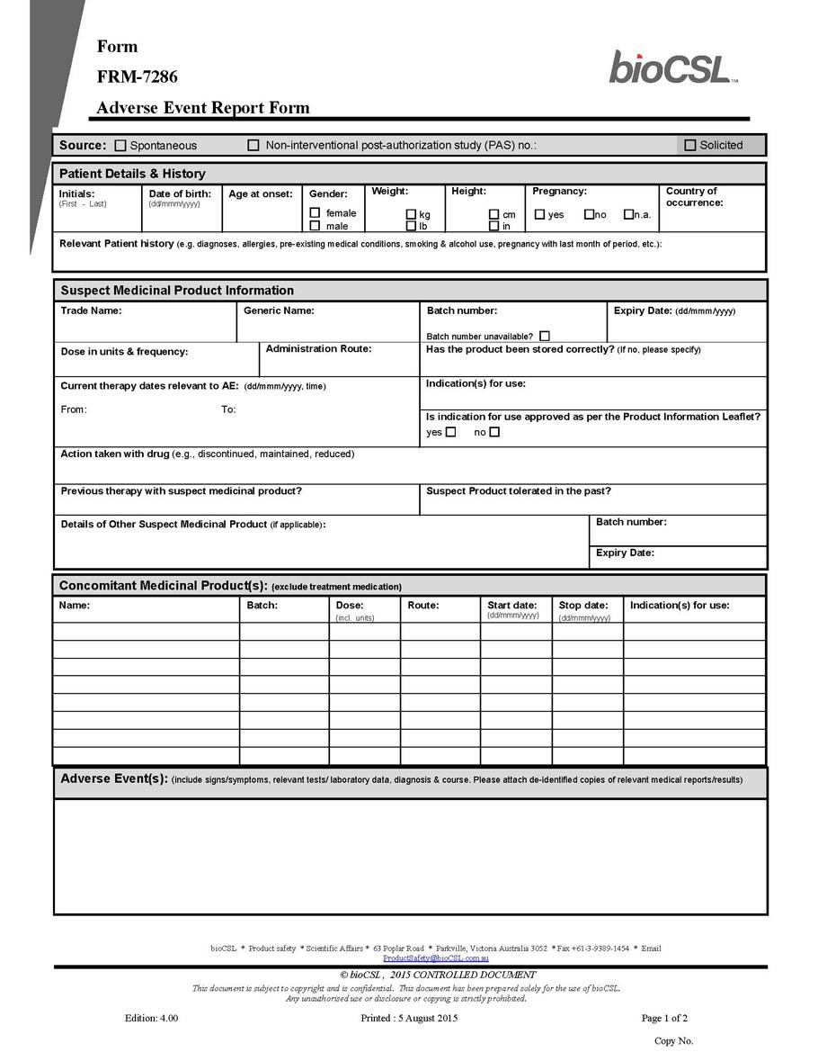

Schedule 7.5-12

Pursuant to 17 CFR 20.24b-2, confidential information has been omitted in places marked "***" and has been filed separately with the Securities and Exchange Commission pursuant to a Confidential Treatment Application with the Commission.
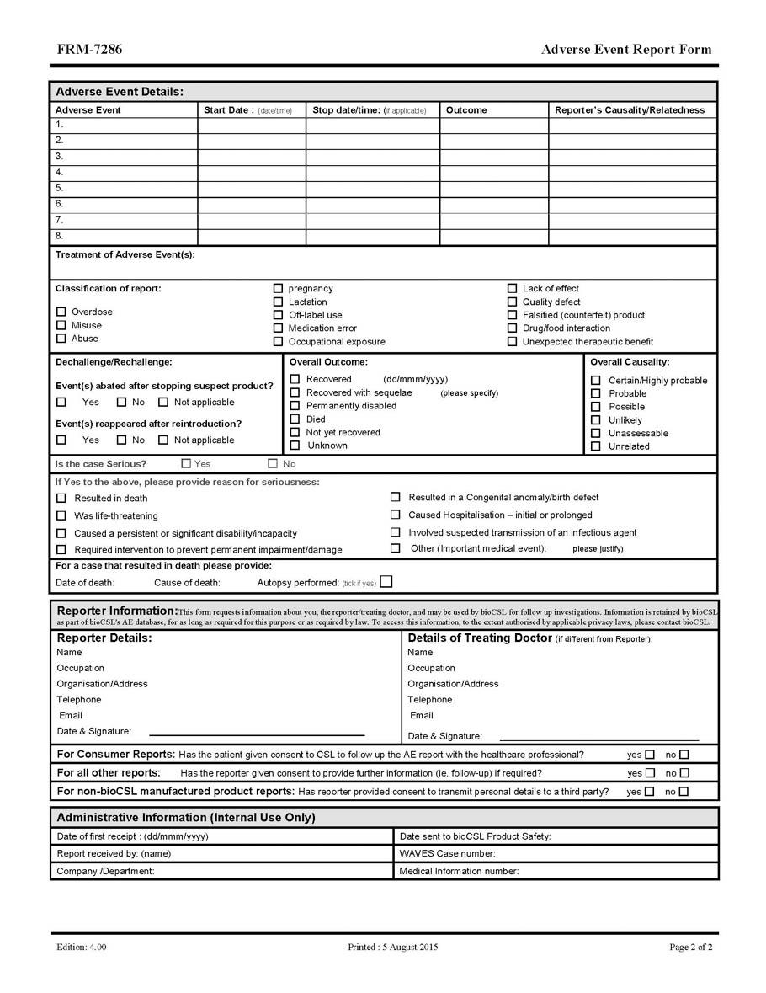

Schedule 7.5-13

Schedule 9.3(c)

Form of Net Sales Report

Period ended: _________________

 |  | Total
Gross Sales (Excluding Stockpile Sales) |  | $
Deductions from Commercial Gross Sales:¹ |  | $
(a) trade discounts |  | $
(b) quantity discounts |  | $
(c) cash discounts |  | $
(d) excise, sales and other consumption taxes and custom duties to the extent included in the invoice price |  | $
(e) freight, handling, insurance and other transportation or distribution charges and fees to the extent included in the invoice price |  | $
(f) amounts repaid, credited or accrued by reason of rejections or recalls (but not other returns) or because of chargebacks, allowances, |  | $
adjustments, refunds or billing errors
(g) payments and rebates related to the sale of such Licensed Products accrued, paid or deducted pursuant to agreements (including, but not |  | $
limited to, managed care agreements) with Third Parties or governmental regulations;
(h) any amounts actually written off or specifically identified as uncollectible, in accordance with GAAP consistently applied; |  | $
(i) any other similar and customary deductions taken in accordance with GAAP consistently applied and other deductions expressly permitted |  | $
under the Agreement
 | Total deductions from Gross Sales (Excluding Stockpile Sales) | $
Current Period Commercial Net Sales | $ | Current Period Net Sales
 |  | $
 | Royalty Payment Due²
Gross Sales from Stockpile Sales |  | $
Deductions from Gross Sales from Stockpile Sales: |  | $
(a) trade discounts |  | $

Schedule 9.3(c)-1

Pursuant to 17 CFR 20.24b-2, confidential information has been omitted in places marked "***" and has been filed separately with the Securities and Exchange Commission pursuant to a Confidential Treatment Application with the Commission.
(b) quantity discounts | $
(c) cash discounts | $
(d) excise, sales and other consumption taxes and custom duties to the extent included in the invoice price | $
(e) freight, handling, insurance and other transportation or distribution charges and fees to the extent included in the invoice price | $
(f) amounts repaid, credited or accrued by reason of rejections, recalls or returns (but excluding returns under CSL Stockpile Sales other than | $
defect or order error) or because of chargebacks, allowances, adjustments, refunds or billing errors
(g) payments and rebates related to the sale of such Licensed Products accrued, paid or deducted pursuant to agreements (including, but not | $
limited to, managed care agreements) with Third Parties or governmental regulations;
(h) any amounts actually written off or specifically identified as uncollectible, in accordance with GAAP consistently applied; | $
(i) any other similar and customary deductions taken in accordance with GAAP consistently applied and other deductions expressly permitted | $
under the Agreement
Total deductions from | $
Gross Sales from Stockpile Sales
Current Period Net Sales
from Stockpile Sales
Royalty Payment Due for Stockpile Sales
Total Royalty Due | $

________________________

1 For purposes of clarification, if a particular deduction falls under more than one category set forth above, such deduction shall only be taken once.

2 Royalty Payment Due shall be included only in the Net Sales report provided following the end of any calendar quarter.

Schedule 9.3(c)-2

Pursuant to 17 CFR 20.24b-2, confidential information has been omitted in places marked "***" and has been filed separately with the Securities and Exchange Commission pursuant to a Confidential Treatment Application with the Commission.

Schedule 11.1

Press Release – Approved by CSL for release by BioCryst

BIOCRYST LICENSES WORLDWIDE RIGHTS TO COMMERCIALIZE RAPIVAB® INFLUENZA TREATMENT TO CSL LIMITED

Research Triangle Park, North Carolina, BioCryst Pharmaceuticals, Inc., (NASDAQ: BCRX) and CSL Limited (ASX:CSL; USOTC:CSLLY) – June 17, 2015 – BioCryst Pharmaceuticals, Inc., a pharmaceutical company focused on the development and commercialization of treatments for rare diseases, announced today that it has licensed RAPIVAB (peramivir injection) for the treatment of influenza to CSL Limited, a global biopharmaceutical company.

RAPIVAB is an intravenous (I.V.) treatment indicated in the U.S. for acute uncomplicated influenza in adults 18 years and older. It is also currently licensed for use in Japan and Korea, and is the first and only approved intravenous influenza treatment in the world.

RAPIVAB will be commercialized by CSL’s subsidiary, bioCSL, which specializes in influenza prevention through the supply of seasonal and pandemic influenza vaccine to global markets.

Under the terms of the agreement, bioCSL obtains worldwide rights to commercialize RAPIVAB, with the exception of Japan, Korea, Taiwan and Israel. BioCryst retains all rights to pursue pandemic stockpiling orders for RAPIVAB from the U.S. government, while bioCSL is responsible for government stockpiling outside the U.S.

“We are delighted to add RAPIVAB to our product portfolio,” said Dr John Anderson, General Manager and Senior Vice-President of bioCSL. “RAPIVAB is a specialty pharmaceutical that addresses an unmet medical need for the treatment of acute influenza in the hospital emergency room setting. It provides us with the exciting opportunity to enter a new market segment and extend our reach to a different customer group for the management of influenza-infected patients.”

Under the terms of the agreement, BioCryst will receive an upfront payment of $33.7 million from bioCSL, and may receive up to $12.0 million in additional payments related to the successful achievement of certain regulatory milestones. BioCryst will receive tiered royalties that are contingent upon certain net sales thresholds in the U.S. and the rest of the world, as well as a percentage of proceeds from government stockpiling purchases outside the U.S. In addition, bioCSL will purchase existing and in-process inventory of RAPIVAB for treatment of influenza patients in upcoming flu seasons.

Schedule 11.1-1

Pursuant to 17 CFR 20.24b-2, confidential information has been omitted in places marked "***" and has been filed separately with the Securities and Exchange Commission pursuant to a Confidential Treatment Application with the Commission.

“With its expertise and global scale in influenza, bioCSL is the ideal partner to commercialize RAPIVAB in the U.S. and to work with us to pursue additional approvals in Europe, Canada and other rest of world markets. bioCSL has strong pandemic franchises and has successfully negotiated a number of significant government influenza product stockpiling contracts around the globe,” said Jon P. Stonehouse, President & Chief Executive Officer of BioCryst. “This transaction maximizes the potential value of RAPIVAB and provides non-dilutive capital to BioCryst to fund our rare disease programs.”

About RAPIVAB® (peramivir injection)

Approved by FDA in December 2014, RAPIVAB (peramivir injection) is an intravenous (I.V.) viral neuraminidase inhibitor for the treatment of acute uncomplicated influenza in patients 18 years and older who have been symptomatic for no more than two days. Efficacy of RAPIVAB is based on clinical trials of naturally occurring influenza in which the predominant influenza infections were influenza A virus; a limited number of subjects infected with influenza B virus were enrolled. The efficacy of RAPIVAB could not be established in patients with serious influenza requiring hospitalization. In clinical studies, side effects with RAPIVAB were similar to placebo. The most common adverse reaction was diarrhea (RAPIVAB 8% vs 7% placebo). Similar to other neuraminidase inhibitors, there is a risk of neuropsychiatric events (confusion, delirium) and serious skin reactions. Visit www.rapivab.com to learn more.

In January 2010, Shionogi & Co., Ltd. launched intravenous peramivir in Japan under the name RAPIACTA® and in August 2010, Green Cross Corporation announced that it had received marketing and manufacturing authorization for I.V. peramivir in Korea under the name PeramiFlu®. It is estimated that more than one million patients have received peramivir treatment to date. In the U.S., RAPIVAB was developed under contract number HHSO10020070032C from the Biomedical Advanced Research and Development Authority (BARDA/HHS), a $234.8 million contract.

About BioCryst

BioCryst Pharmaceuticals designs, optimizes and develops novel small molecule drugs that block key enzymes involved in rare diseases. BioCryst currently has several ongoing development programs: oral inhibitors of plasma kallikrein for hereditary angioedema, including BCX4161, BCX7353 and several second generation compounds; and BCX4430, a broad spectrum viral RNA polymerase inhibitor. For more information, please visit the Company's website at www.BioCryst.com.

About CSL

CSL Limited (ASX:CSL) is a global biopharmaceutical company that develops, manufactures and markets biotherapies to prevent and treat rare and serious human diseases. CSL owns major facilities in Australia, Germany, Switzerland and the US, and employs over 13,000 people in 27 countries. CSL operates two subsidiary businesses, CSL Behring and bioCSL, which are underpinned by a significant Research and Development effort. For more information, please visit www.csl.com.au

Schedule 11.1-2

Pursuant to 17 CFR 20.24b-2, confidential information has been omitted in places marked "***" and has been filed separately with the Securities and Exchange Commission pursuant to a Confidential Treatment Application with the Commission.

About bioCSL

Headquartered in Australia, bioCSL has been developing and manufacturing influenza vaccines for more than 50 years. It operates one of the world’s largest influenza vaccine production facilities and supplies both seasonal and pandemic influenza vaccines to global markets. bioCSL also markets a comprehensive range of vaccines and pharmaceuticals in the Australasia region and manufactures specialised Products of National Significance for Australia. Find more information at www.biocsl.com.au

Forward-Looking Statements

This press release contains forward-looking statements, including statements regarding future results, performance or achievements. These statements involve known and unknown risks, uncertainties and other factors which may cause our actual results, performance or achievements to be materially different from any future results, performances or achievements expressed or implied by the forward-looking statements. These statements reflect our current views with respect to future events and are based on assumptions and subject to risks and uncertainties. Given these uncertainties, you should not place undue reliance on these forward-looking statements. Some of the factors that could affect the forward-looking statements contained herein include: that the FDA may not approve peramivir for use in pediatric patients, or that FDA approval for pediatric use may be limited; demand for RAPIVAB in this flu season is unpredictable; the supply of RAPIVAB may be limited; the Company may not be able to successfully commercialize RAPIVAB; and that RAPIVAB may never be purchased by any government entity for stockpiling. Please refer to the documents BioCryst files periodically with the Securities and Exchange Commission, specifically BioCryst’s most recent Annual Report on Form 10-K, Quarterly Reports on Form 10-Q, and Current Reports on Form 8-K, all of which identify important factors that could cause the actual results to differ materially from those contained in BioCryst’s projections and forward-looking statements.

###

BCRXW

CONTACT: Robert Bennett, BioCryst Pharmaceuticals, +1-919-859-7910

Schedule 11.1-3

Pursuant to 17 CFR 20.24b-2, confidential information has been omitted in places marked "***" and has been filed separately with the Securities and Exchange Commission pursuant to a Confidential Treatment Application with the Commission.

Press Release – Approved by BioCryst for release by CSL

NEWS RELEASE

Targeting: Business Media, Trade & Medical Media, Australia

CSL Acquires Exclusive Rights to Influenza Treatment

CSL Limited (ASX:CSL) today announced it has acquired exclusive rights to commercialise the influenza treatment, RAPIVAB®, from US-based company, BioCryst Pharmaceuticals Inc (NASDAQ: BCRX).

RAPIVAB (peramivir injection) is a single-dose intravenous treatment (IV) for acute uncomplicated influenza, which was developed under contract with the US Government as part of pandemic preparedness efforts. RAPIVAB It was approved for use in the US in December 2014 and is also licensed for use in Japan and South Korea. It is estimated that approximately 1 million patients have been treated with RAPIVAB to date.

RAPIVAB will be commercialised by CSL’s subsidiary, bioCSL, which specializes in influenza prevention through the supply of seasonal and pandemic vaccine to global markets.

Under the terms of the agreement, bioCSL will obtain exclusive worldwide rights to commercialise RAPIVAB, with the exception of Japan, Korea, Taiwan and Israel. BioCryst will retain responsibility for pandemic stockpiling of RAPIVAB in the US while bioCSL will have exclusive rights to pursue pandemic stockpiling outside the US.

“We are delighted to add RAPVIAB to our product portfolio” said Dr John Anderson, General Manager and Senior Vice-President of bioCSL. “RAPIVAB is a specialty pharmaceutical that addresses an unmet medical need for the treatment of acute influenza in the hospital emergency room setting. It provides us with the opportunity extend our influenza franchise to include both prevention and treatment options in seasonal and pandemic settings”.

Under the terms of the agreement, BioCryst will receive an upfront payment of $33.7 million which bioCSL will capitalize at the time of payment and subsequently amortize. BioCryst may receive up to $12 million in additional payments related to the successful achievement of certain regulatory milestones. BioCryst will also receive tiered royalties that are contingent upon certain net sales thresholds in the US and rest of the world, and a payment on proceeds from stockpiling purchases outside the US.

“With its expertise and global scale in influenza, bioCSL is the ideal partner to commercialize RAPIVAB in the US and to pursue additional approvals in other markets around the world. bioCSL’s strong pandemic experience with national governments in various regions means it is also well placed to expand RAPIVAB as a stockpiling option,” said Jon P. Stonehouse, President & Chief Executive Officer of BioCryst.

Pursuant to 17 CFR 20.24b-2, confidential information has been omitted in places marked "***" and has been filed separately with the Securities and Exchange Commission pursuant to a Confidential Treatment Application with the Commission.

Press Release – Approved by BioCryst for release by CSL

About RAPIVAB® (peramivir injection)

Approved by FDA in December 2014, RAPIVAB (peramivir injection) is an intravenous (IV) viral neuraminidase inhibitor for the treatment of acute uncomplicated influenza in patients 18 years and older who have been symptomatic for no more than two days. In January 2010, Shionogi & Co., Ltd. launched IV peramivir in Japan under the name RAPIACTA® and in August 2010, Green Cross Corporation announced that it had received marketing and manufacturing authorization for IV peramivir

in Korea under the name PeramiFlu®. It is estimated that more than one million patients have received peramivir treatment to date. The recommended dose of RAPIVAB in most adult patients 18 years of age or older with acute uncomplicated influenza is a single 600 mg dose, administered via intravenous infusion for 15 to 30 minutes. RAPIVAB was developed under contract number HHSO10020070032C from the Biomedical Advanced Research and Development Authority (BARDA/HHS), a $234.8 million contract.

RAPIVAB is not approved or available in Australia.

About BioCryst

BioCryst Pharmaceuticals designs, optimizes and develops novel small molecule drugs that block key enzymes involved in rare diseases. BioCryst currently has several ongoing development programs: oral inhibitors of plasma kallikrein for hereditary angioedema, including BCX4161, BCX7353 and several second generation compounds; and BCX4430, a broad spectrum viral RNA polymerase inhibitor. For more information, please visit www.biocryst.com.

About CSL Limited

CSL Limited (ASX:CSL) is a global biopharmaceutical company that develops, manufactures and markets biotherapies to prevent and treat rare and serious human diseases. CSL owns major facilities in Australia, Germany, Switzerland and the US, and employs over 13,000 people in more than 27 countries. CSL operates two subsidiary businesses, CSL Behring and bioCSL, which are underpinned by a significant Research and Development effort. For more information, please visit www.csl.com.au.

About bioCSL

Headquartered in Australia, bioCSL has been developing and manufacturing influenza vaccines for more than 50 years. It operates one of the world’s largest influenza vaccine production facilities and supplies both seasonal and pandemic influenza vaccines to global markets. bioCSL also markets a comprehensive range of vaccines and pharmaceuticals in the Australasia region and manufactures specialised Products of National Significance for Australia. Find more information at www.biocsl.com.au.

Exhibit 31.1

CERTIFICATIONS

I, Jon P. Stonehouse, certify that:

- I have reviewed this quarterly report on Form 10-Q of BioCryst Pharmaceuticals, Inc.;

- Based on my knowledge, this report does not contain any untrue statement of a material fact or omit to state a material fact necessary to make the statements made, in light of the circumstances under which such statements were made, not misleading with respect to the period covered by this report;

- Based on my knowledge, the financial statements, and other financial information included in this report, fairly present in all material respects the financial condition, results of operations and cash flows of the registrant as of, and for, the periods presented in this report;

- The registrant’s other certifying officer(s) and I are responsible for establishing and maintaining disclosure controls and procedures (as defined in Exchange Act Rules 13a-15(e) and 15d-15(e)) and internal control over financial reporting (as defined in Exchange Act Rules 13a-15(f) and 15d-15(f)) for the registrant and have:

  - designed such disclosure controls and procedures, or caused such disclosure controls and procedures to be designed under our supervision, to ensure that material information relating to the registrant, including its consolidated subsidiaries, is made known to us by others within those entities, particularly during the period in which this report is being prepared;

  - designed such internal control over financial reporting, or caused such internal control over financial reporting to be designed under our supervision, to provide reasonable assurance regarding the reliability of financial reporting and the preparation of financial statements for external purposes in accordance with generally accepted accounting principles;

  - evaluated the effectiveness of the registrant’s disclosure controls and procedures and presented in this report our conclusions about the effectiveness of the disclosure controls and procedures, as of the end of the period covered by this report based on such evaluation; and

  - disclosed in this report any change in the registrant’s internal control over financial reporting that occurred during the registrant’s most recent fiscal quarter (the registrant’s fourth fiscal quarter in the case of an annual report) that has materially affected, or is reasonably likely to materially affect, the registrant’s internal control over financial reporting; and

- The registrant’s other certifying officer(s) and I have disclosed, based on our most recent evaluation of internal control over financial reporting, to the registrant’s auditors and the audit committee of the registrant’s board of directors (or persons performing the equivalent functions):

  - all significant deficiencies and material weaknesses in the design or operation of internal control over financial reporting which are reasonably likely to adversely affect the registrant’s ability to record, process, summarize and report financial information; and

  - any fraud, whether or not material, that involves management or other employees who have a significant role in the registrant’s internal control over financial reporting.

Date: August 7, 2015 | /s/ Jon P. Stonehouse
 | Jon P. Stonehouse
 | President and Chief Executive Officer

Exhibit 31.2

CERTIFICATIONS

I, Thomas R. Staab, II, certify that:

- I have reviewed this quarterly report on Form 10-Q of BioCryst Pharmaceuticals, Inc.;

- Based on my knowledge, this report does not contain any untrue statement of a material fact or omit to state a material fact necessary to make the statements made, in light of the circumstances under which such statements were made, not misleading with respect to the period covered by this report;

- Based on my knowledge, the financial statements, and other financial information included in this report, fairly present in all material respects the financial condition, results of operations and cash flows of the registrant as of, and for, the periods presented in this report;

- The registrant’s other certifying officer(s) and I are responsible for establishing and maintaining disclosure controls and procedures (as defined in Exchange Act Rules 13a-15(e) and 15d-15(e)) and internal control over financial reporting (as defined in Exchange Act Rules 13a-15(f) and 15d-15(f)) for the registrant and have:

  - designed such disclosure controls and procedures, or caused such disclosure controls and procedures to be designed under our supervision, to ensure that material information relating to the registrant, including its consolidated subsidiaries, is made known to us by others within those entities, particularly during the period in which this report is being prepared;

  - designed such internal control over financial reporting, or caused such internal control over financial reporting to be designed under our supervision, to provide reasonable assurance regarding the reliability of financial reporting and the preparation of financial statements for external purposes in accordance with generally accepted accounting principles;

  - evaluated the effectiveness of the registrant’s disclosure controls and procedures and presented in this report our conclusions about the effectiveness of the disclosure controls and procedures, as of the end of the period covered by this report based on such evaluation; and

  - disclosed in this report any change in the registrant’s internal control over financial reporting that occurred during the registrant’s most recent fiscal quarter (the registrant’s fourth fiscal quarter in the case of an annual report) that has materially affected, or is reasonably likely to materially affect, the registrant’s internal control over financial reporting; and

- The registrant’s other certifying officer(s) and I have disclosed, based on our most recent evaluation of internal control over financial reporting, to the registrant’s auditors and the audit committee of the registrant’s board of directors (or persons performing the equivalent functions):

  - all significant deficiencies and material weaknesses in the design or operation of internal control over financial reporting which are reasonably likely to adversely affect the registrant’s ability to record, process, summarize and report financial information; and

  - any fraud, whether or not material, that involves management or other employees who have a significant role in the registrant’s internal control over financial reporting.

Date: August 7, 2015 | /s/ Thomas R. Staab, II
 | Thomas R. Staab, II
 | Senior Vice President, Chief Financial Officer and Treasurer

Exhibit 32.1

CERTIFICATION PURSUANT TO

18 U.S.C. SECTION 1350,

AS ADOPTED PURSUANT TO

SECTION 906 OF THE SARBANES-OXLEY ACT OF 2002

In connection with the Quarterly Report of BioCryst Pharmaceuticals, Inc. (the “Company”) on Form 10-Q for the period ending June 30, 2015 as filed with the Securities and Exchange Commission on the date hereof (the “Report”), I, Jon P. Stonehouse, Chief Executive Officer of the Company, certify, pursuant to 18 U.S.C. § 1350, as adopted pursuant to § 906 of the Sarbanes-Oxley Act of 2002, that, to the best of my knowledge:

- The Report fully complies with the requirements of section 13(a) or 15(d) of the Securities Exchange Act of 1934; and

- The information contained in the Report fairly presents, in all material respects, the financial condition and result of operations of the Company.

/s/ Jon P. Stonehouse
Jon P. Stonehouse

President and Chief Executive Officer

Date: August 7, 2015

Exhibit 32.2

CERTIFICATION PURSUANT TO

18 U.S.C. SECTION 1350,

AS ADOPTED PURSUANT TO

SECTION 906 OF THE SARBANES-OXLEY ACT OF 2002

In connection with the Quarterly Report of BioCryst Pharmaceuticals, Inc. (the “Company”) on Form 10-Q for the period ending June 30, 2015 as filed with the Securities and Exchange Commission on the date hereof (the “Report”), I, Thomas R. Staab, II, Chief Financial Officer of the Company, certify, pursuant to 18 U.S.C. § 1350, as adopted pursuant to § 906 of the Sarbanes-Oxley Act of 2002, that, to the best of my knowledge:

- The Report fully complies with the requirements of section 13(a) or 15(d) of the Securities Exchange Act of 1934; and

- The information contained in the Report fairly presents, in all material respects, the financial condition and result of operations of the Company.

/s/ Thomas R. Staab, II
Thomas R. Staab, II

Senior Vice President, Chief Financial Officer and Treasurer

Date: August 7, 2015

